Run acolite:
Open terminal, in (base) laurazoffoli@lzoffoli-lt ~
cd acolite
python launch_acolite.py

select a small area because acolite and SWAMpy take long times to run

The image input needs to be a .nc file with: 2 Variables and 3 Dimensions.
The variables have to be the “wls” with all the band wavelengths and “rrs_air” that is a 3D matrix (with bands in the first dimension, lon in the second and lat in the third).
The dimensions should be called “lat”, “lon” and “wls”. (the file should be in the exact same format than the file TEST_f10nm_MC_20200128_164639_400_800.nc)
I created a matlab script (prepare_file_nc_input_with_output_acolite_S2.m) that takes the Rrs output from acolite and prepares the file to enter in SWAMPpy_nosnappy.py

SWAMpy manual (code developed by Marco Bracaglia 16/06/2020)
The new version of SWAMpy works without snappy in Python 2.7 (and Python 3.9) with netcdf file as input. The following packages are needed:
- Tkinter
- dictotxml
- datetime
- numpy
- xmltodict
- netCDF4
- os
- sys
- argparse
- time
- math
- Sambuca
- Sambuca_core
- spectral
Most of the modules are already present in the standard python versions. Sambuca and Sambuca_core must be installed as reported in previous manual versions or simply putting the two folder in the directory where the main Swampy script is stored.
The inputs can be chosen from GUI running the script from Spyder or from command line as:
- python SWAMpy_nosnappy.py
Alternatively, the input can be stored in an xml file (see swampy_run_20200616_130623.xml) choosing it from command line:
- python SWAMpy_nosnappy.py –f [path_to_xml_file]
The post processing procedure provides some additional outputs (spectra of rrs, rrs_deep, k_d, r_substrates, absorption and backscattering). This additional procedure can be run from GUI or providing an additional input from command line as:
- python SWAMpy_nosnappy.py –f [path_to_xml_file] –p True
Once the SWAMpy GUI is open:
Choose a Sentinel-2 image: Select the .nc image to run
Choose the output folder: The same directory where the modules are placed
Choose the IOPs xml file: select new_inpu_sub.xml (to run over seagrass beds. This file uses as substrates: sand, macroalgae-sargassum and seagrass-100% zostera). Otherwise, select swampy_s2_siop_Lizard.xml
Choose the sensor filter xml file: to run a S2 bands (with bands at 443, 490, 560, 665 and 705) select the file swampy_s2_5_bands_filter_nedr.xml. For a hyperspectral image with 1nm band, select the file Swampy_hyp.xml
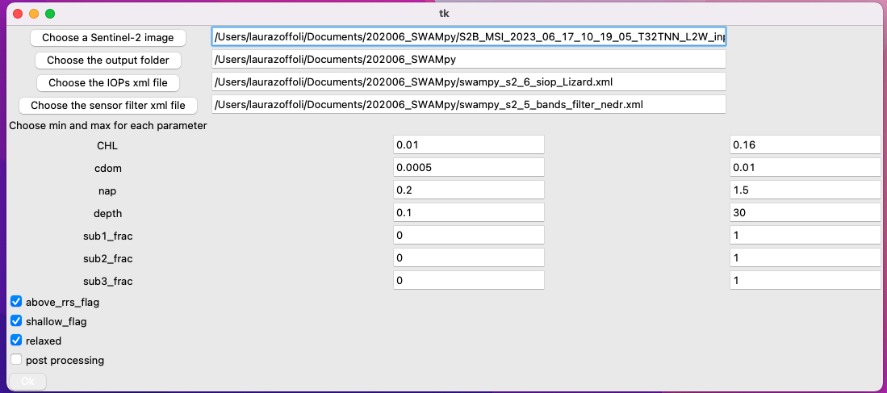

Once finished, the file can be open with the scripts “open_output_SWMApy_map_vegetation” or “open_output_SWMApy”

