Measuring Association between Facebook Use

and Self-Esteem

|  | Sigfried Gold  September 9, 2018  INST627  sigfried@sigfried |  |
| --- | --- | --- |

# INTRODUCTION

The social and psychological effects of social media use are the subject of a burgeoning literature—academic, journalistic, and online—as social media tools penetrate larger markets and the companies promulgating them have become some of the richest and most powerful organizations in the world. This paper draws on existing data to explore a possible association between Facebook use and self-esteem. Specifically, we hypothesize that heavy Facebook use is correlated with low self-esteem.

## Study Design

As the context for the current study is a homework assignment for a course in Data Analytics: IRB approval is not necessary, an existing data set has been provided, the scope of analysis will be limited to a single pair of explanatory and response variables, and the methods will not be justified by consideration of relevant literature.

The data were collected by Dr. Jessica Vitak in 2010 in the form of survey results from 437 students at Michigan State University. The survey includes 151 questions. Identifying information has been removed from the results, leaving no evidence as to whether subjects were polled repeatedly, but it appears there is only one response per subject, collected in a single survey administration. It is not apparent from the 437-response sample how the subjects were selected or what larger population they are meant to represent. Regardless of how the subjects were originally chosen or how the data were originally collected, for the context of the present analysis, the study is observational and retrospective.

The survey includes dozens of questions pertinent to our analysis, including 93 related to Facebook use and 7 directly addressing self-esteem. The bar plots in Figure 1 show that responses to the 7 self-esteem questions are relatively consistent, except for a few noticeable differences that can inform our choice of a single question for analysis.

The first two questions (Q51, “person of worth” and Q52, “good qualities”) received no “Strongly Disagree” responses, suggesting that these questions may be less sensitive to low self-esteem than the others. On that count, the two reversed questions (Q54, “failure” and Q57, “not much to be proud of”) show the greatest endorsement for low self-esteem and may capture low self-esteem better than others.

Four questions (Q51, Q52, Q54, Q57) received more Strongly Agree than agree as opposed to Q55, Q58, and Q59 which show the reverse. These latter also show higher endorsement for Neither. If we were interested in students with the lowest self-esteem, we might focus on Q54 and Q57, despite the fact that they represent a small portion of the sample. However, unless we suspect that Facebook use has a catastrophic effect on students’ self-esteem, which seems unlikely, we would do better to focus on Q55, Q58, and Q59 as they seem to do better at capturing gradations between levels of high self-esteem, which are observable in a larger portion of the sample.

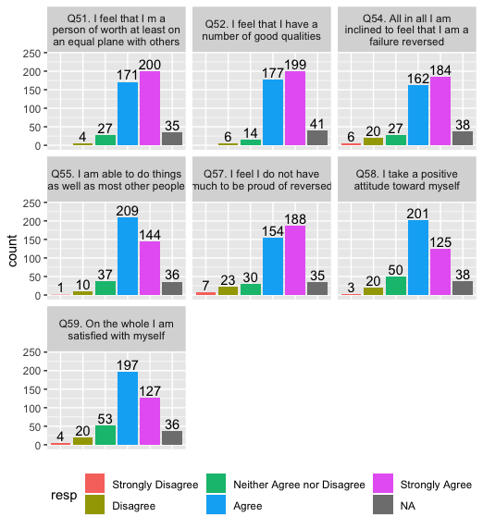

Figure : Self-esteem measures.

We have not found a good criterion for selecting one from these three, but will choose Q59, “On the whole, I am satisfied with myself,” as our response variable.

Given the great number of possible explanatory variables, we will choose Q61, “In the past week, on average, approximately how much time PER DAY have you spent actively using Facebook?”

## Exploratory Analysis

Figure 2 shows the values and their distribution for our explanatory variable. The shape of the data is somewhat right skewed with a hump towards the right.

Figure 3 shows values and distribution for our response variable. The data appears skewed to the left.

These are ordinal variables, so descriptive statistics appropriate to numeric variables (mean, median, standard deviation, etc.) are unlikely to contribute meaningful information beyond that provided in the bar plots.

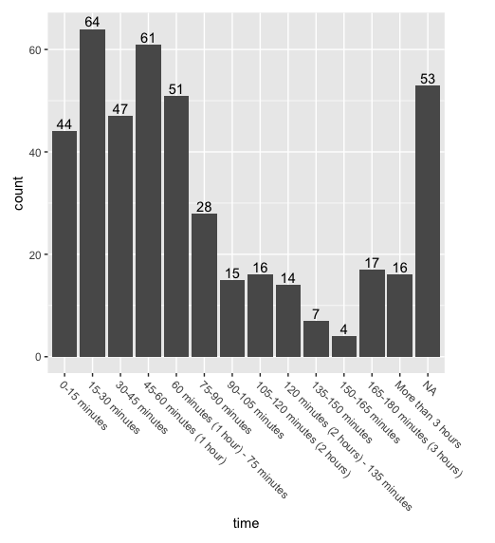

Figure : Explanatory variable, time per day on Facebook.

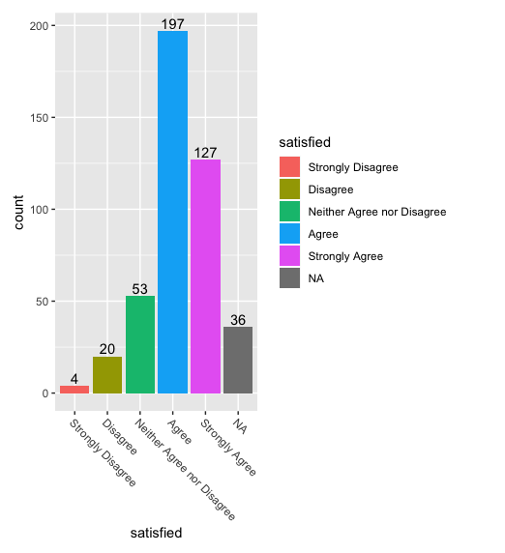

Figure 3: Response variable, satisfied.

Inspection of the Marimekko chart in Figure 4 may contradict the supposition made above that differences in self-esteem associated with Facebook use would be more significant in the finer gradations between the large groups at the positive end of the self-esteem spectrum than in the small groups at the low end. Students who choose the highest self-esteem score spend slightly more time on Facebook than those in the second highest group; while the three lower self-esteem groups appear to spend considerably more time on Facebook.

While the association is interesting, the non-experimental design disqualifies it being used as evidence for causation, and our lack of information on the original data collection precludes any generalization.

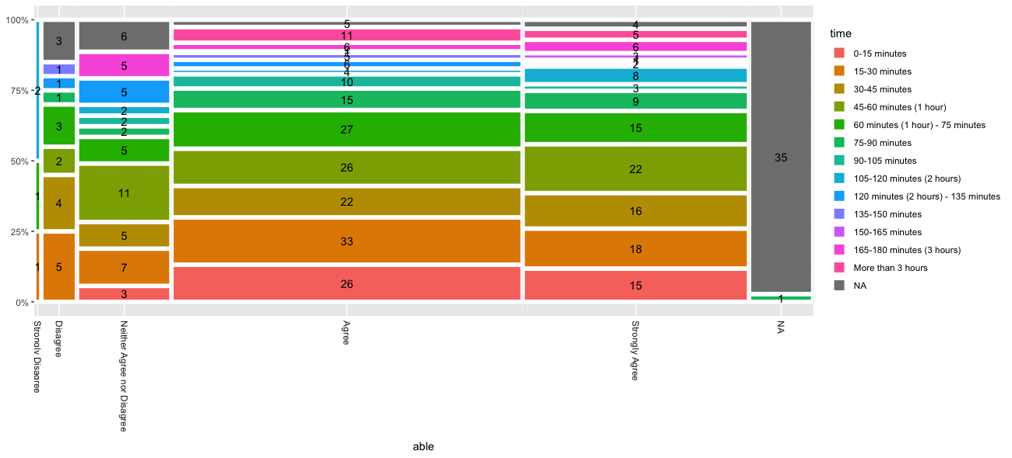

Figure 4: Response ~ Explanatory

Figure 4: