From the api/users, found the admin username.

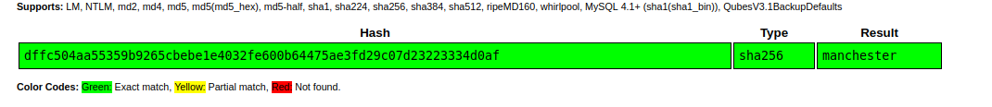

Initial Foothold –

Login to SSH



