Lukáš Randuška  Data Science · Space Weather Research  Košice, Slovakia | lukasran28@gmail.com | +421 911 619 440  ORCID: 0009-0001-3643-9854 | 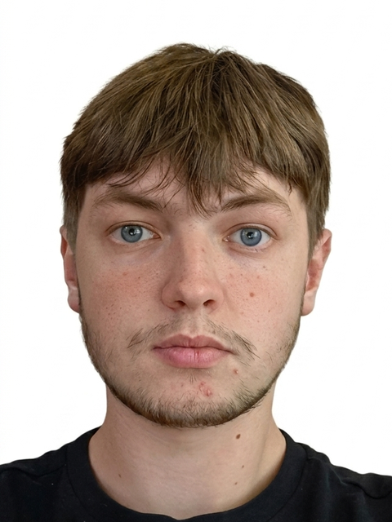

PROFILE
Undergraduate student in Data Analysis and Artificial Intelligence with a research focus on the intersection of data science and space physics. Currently a research intern at the Institute of Experimental Physics of the Slovak Academy of Sciences, working on space weather data analysis and the prediction of geomagnetic storms and coronal mass ejections (CMEs). Co-author of two peer-reviewed publications in Earth and Space Science. Strong foundation in mathematics, scientific computing, and electronics, with the goal of building professional experience in space technology and physics-driven data research.
EDUCATION
Pavol Jozef Šafárik University in Košice 2024 – present
Undergraduate studies, Data Analysis and Artificial Intelligence — Košice, Slovakia
Secondary Vocational School of Electrical Engineering, Košice 2020 – 2024
Department of Information and Network Technologies — Košice, Slovakia
- Completed with the maturita (secondary school-leaving examination).
- Final-year project and SOČ (Secondary School Professional Activity) advanced to the national finals in 2023/2024.
RESEARCH EXPERIENCE
Research Intern Jul 2023 – present
Institute of Experimental Physics, Slovak Academy of Sciences — Košice, Slovakia
- Perform data analysis of space weather and develop prediction models for geomagnetic storms.
- Estimate the propagation speed and onset times of coronal mass ejections (CMEs).
- Study solar wind behaviour and the topology and structure of CMEs.
- Apply Python-based scientific computing (NumPy, pandas, SciPy) to large heliophysics datasets.
- Contributed to research resulting in two co-authored peer-reviewed publications.
PUBLICATIONS
Co-author of the following peer-reviewed articles in Earth and Space Science (AGU):
- Mackovjak, Š., Kostárová, S., Chum, J., et al. (2026). “Dataset of Quiet Space Weather Periods for Ionospheric Studies.” Earth and Space Science, 13, e2025EA004537. DOI: 10.1029/2025EA004537
- Kisvárdai, I., et al. (2025). “Analysis of 42 Years of Cosmic Ray Measurements by the Neutron Monitor at Lomnický štít Observatory.” Earth and Space Science, 12, e2024EA003656. DOI: 10.1029/2024EA003656
PROJECTS
MWP — Music Without Pain 2023/2024
Final-year project & SOČ competition entry
- Software project developed as final-year and SOČ work; advanced to the national finals of the SOČ competition (2023/2024).
- Source code: github.com/peto59/MWP
TECHNICAL SKILLS
Programming: Python (proficient — NumPy, pandas, SciPy); Java (intermediate — two semesters of algorithms, data structures, and dynamic programming).
Focus areas: scientific computing, data analysis, space weather / heliophysics data, electronics.
LANGUAGES
Slovak (native) · English (B1) · German (Deutsches Sprachdiplom — DSD Pro I)
AWARDS & ACTIVITIES
Hack Košice — Hackathon 2021, 2022, 2023, 2026
- 2021 — 2nd place overall. · 2022 — 1st Sponsor Prize (Telekom).

