Sigilith-M Demonstration Note
Structural Separation of Three-Body Dynamical Regimes via Symbolic Recurrence Profiling
Sigilithlabs

Abstract
I present a minimal, reproducible demonstration of Sigilith-M as a structural profiling engine for symbolic dynamical sequences. Planar three-body simulations were discretized into symbolic regime sequences using pairwise distance-band encodings. Early hand-tuned runs collapsed into highly repetitive escape-dominated traces, while batch search over randomized initial conditions revealed structurally richer trajectories. Sigilith-M separated the resulting corpus into three dynamical families - collapse, constrained, and mobile - based solely on symbolic recurrence structure. The top-ranked batch result, Run 26, was classified as low_structure, with substantially lower stability and broader recurrence spacing than earlier runs. This demonstrates that Sigilith-M can distinguish dynamical regime families without direct continuous-state analysis.

1. Motivation
Classical analyses of dynamical systems rely on continuous trajectories, energy functions, phase portraits, and chaos diagnostics. Here I ask a different question: can dynamical families be separated after the continuous system is converted into symbolic sequences?
Sigilith-M profiles symbolic corpora using recurrence structure, transition diversity, drift, baseline comparison, and comparative metrics. The three-body system is an ideal test case because it naturally produces collapse-like, constrained, and mobile behaviors that remain interpretable after discretization.
The goal is not to solve the three-body problem or replace dynamical systems theory. The goal is to test whether symbolic recurrence structure alone is sufficient for regime separation.

2. Symbolic Encoding
Planar Newtonian three-body simulations were generated in normalized coordinates. At each timestep, the full pairwise state was discretized into distance-band tokens: AB1, AB2, AB3, AC1, AC2, AC3, BC1, BC2, and BC3, where band 1 denotes close separation, band 2 moderate separation, and band 3 far.
A full symbolic state was written as a composite token, for example: AB2_AC3_BC2. This produced a symbolic sequence suitable for direct profiling with Sigilith-M.

3. Batch Search for Rich Sequences
Initial hand-tuned runs collapsed into highly repetitive symbolic attractors. To identify richer candidates, I implemented a batch-search procedure: (1) generate random balanced initial conditions, (2) simulate the trajectory, (3) extract the symbolic sequence, and (4) compute a richness score from unique token count, Shannon entropy, and distinct transition count.
The richness score was defined as R = 1.0U + 2.0H + 0.5T, where U is the number of unique tokens, H is token entropy, and T is the number of distinct adjacent transitions. The top five runs were retained. The top-ranked run was Run 26.

4. Representative Structural Families

4.1 Collapse family
- stability: 0.93-0.99
- repetition ratio: approximately 0.99
- transition diversity: 0.006-0.015
- classification: high_structural_stability
These sequences rapidly settled into symbolic flatlines.

4.2 Constrained family (Run 21)
- stability: 0.4025
- repetition ratio: 0.9965
- transition diversity: 0.04026
- drift: 13.6829
- stability index: 0.7813
- classification: high_structural_stability
Run 21 shows more mobility than collapse traces but remains dominated by a restricted regime family.

4.3 Mobile family (Run 26)
- stability: 0.22225
- repetition ratio: 0.99575
- transition diversity: 0.06027
- drift: 15.76575
- normalized drift: 0.00394
- windowed drift: 0.43022
- stability index: 0.71388
- classification: low_structure
Run 26 is the first sequence to escape the structural attractor seen in earlier runs.

5. Comparative Result
Comparing Run 26 to Run 21 yields the following structural deltas:
- stability Δ = -0.18025
- transition diversity Δ = +0.00400
- drift Δ = +5.12643
- stability index Δ = -0.06433
Run 26 is less fixed, more transition-active, more widely spaced in recurrence, and less structurally consolidated. Cosine similarity remains high, but it is not the meaningful discriminator here. The structural deltas and classification labels carry the signal.

Figure 1
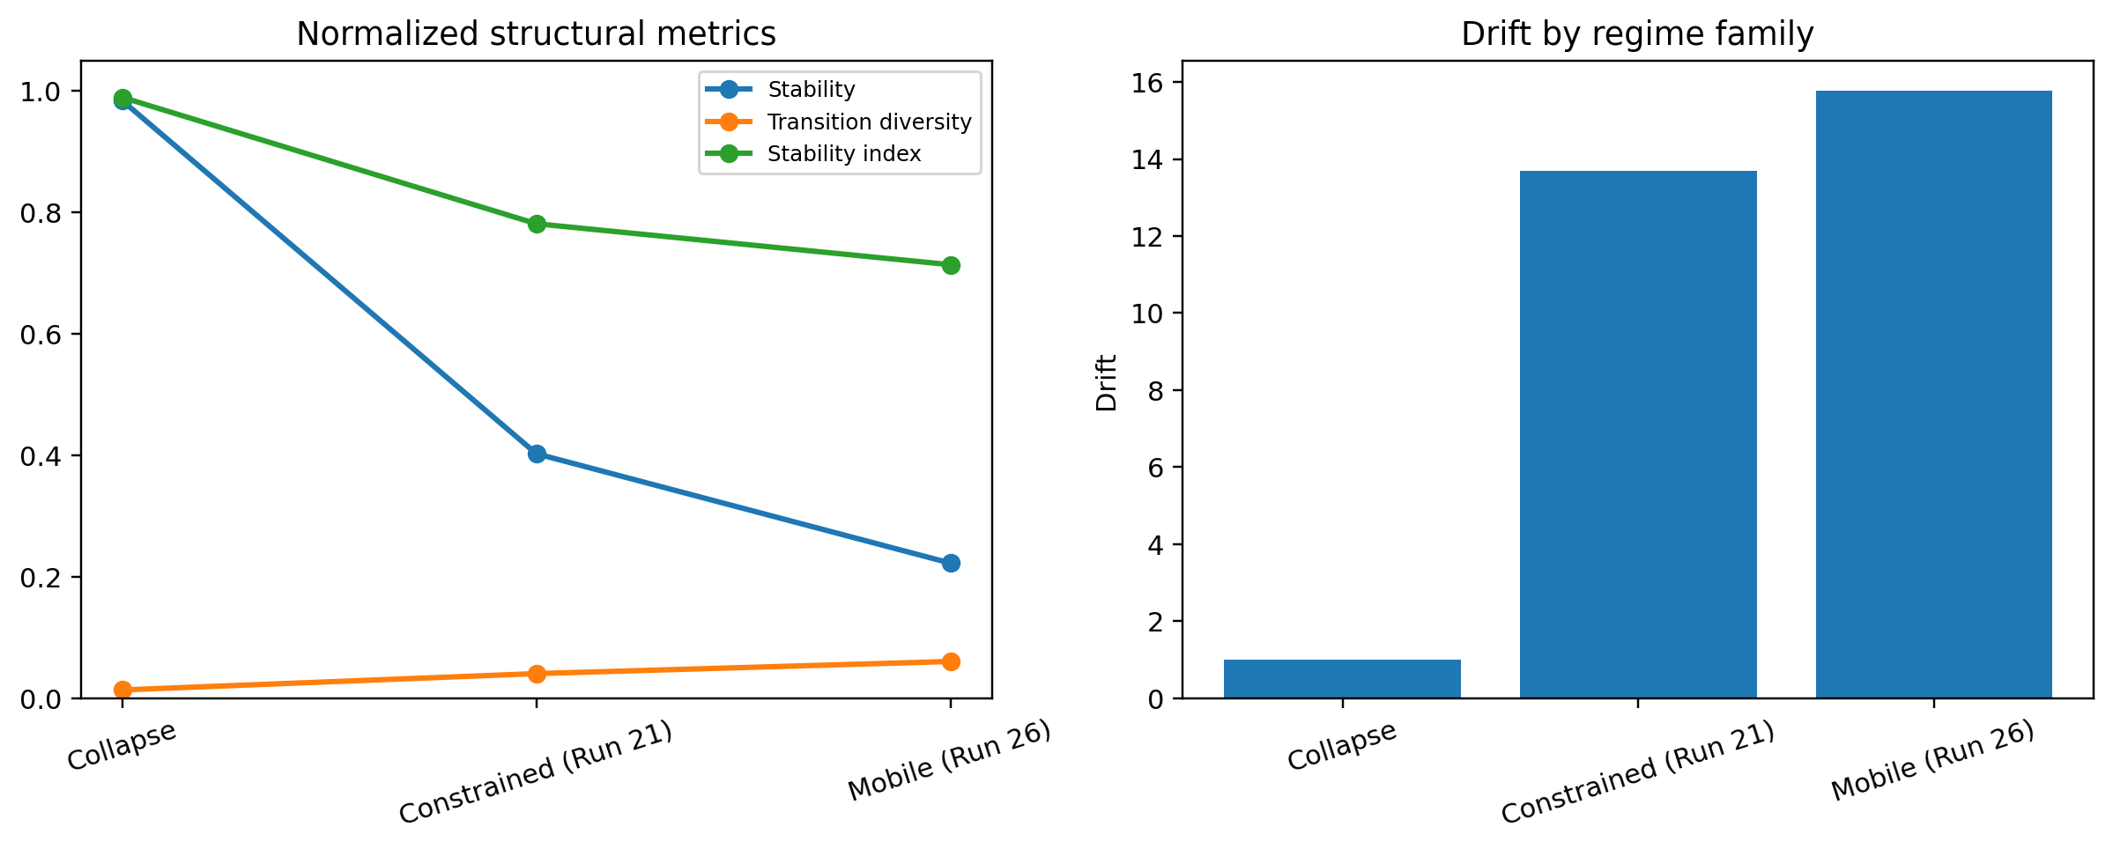
Figure 1. Structural separation of symbolic three-body regimes under Sigilith-M. Collapse runs exhibit extreme stability and low transition diversity; the constrained run retains higher fixation despite increased variation; Run 26 shows low stability, high recurrence spread, and reduced structural consolidation.

6. Interpretation
Sigilith-M separates these encoded simulations into structural families without referencing continuous trajectories. The distinction is not driven by sequence length or token frequency alone; it emerges from recurrence spacing, transition constraint, and structural consolidation.

Table 1
Family | Representative | Stability | Transition diversity | Drift | Classification
Collapse | early escape runs | 0.93-0.99 | 0.006-0.015 | approx. 1-5 | high_structural_stability
Constrained | Run 21 | 0.4025 | 0.04026 | 13.6829 | high_structural_stability
Mobile | Run 26 | 0.22225 | 0.06027 | 15.76575 | low_structure
Table 1. Representative Sigilith-M profiles for three symbolic three-body regime families. The collapse, constrained, and mobile families are separated primarily by stability, transition diversity, drift, and stability index.

7. Minimal Claim
Batch search over random three-body initial conditions revealed structurally distinct symbolic regimes. Sigilith-M classified early runs as collapse-dominated, an intermediate run as constrained but stable, and the top-ranked Run 26 as low_structure with high regime mobility. This demonstrates symbolic regime separation without direct continuous-state analysis.

8. Reproducibility
Pipeline: (1) simulate planar three-body trajectories, (2) discretize each timestep into pair-band tokens, (3) rank runs by symbolic richness, (4) profile shortlisted runs with Sigilith-M, and (5) compare representative families.
Outputs: symbolic sequence files, batch summary JSON, Sigilith-M profile JSON, and Sigilith-M comparison JSON.

9. Discussion
This demonstration does not replace classical dynamical systems tools. It does not claim analytical insight into the equations of motion. Its contribution is different: it shows that symbolic recurrence structure can function as a regime discriminator.
This extends Sigilith-M beyond manuscripts and codices into symbolic encodings of simulated or measured processes. The broader implication is that Sigilith-M may serve as a general structural engine for symbolic texts, codices, ritual sequences, cipher systems, simulations, state-machine traces, and discretized dynamic corpora.

Significance
This demonstration shows that symbolic recurrence structure is sufficient to distinguish dynamical regime families in a classical physical system. Sigilith-M identifies collapse-dominated, constrained, and mobile trajectories without access to continuous-state information, suggesting that structural profiling may serve as a general tool for analyzing symbolic encodings of dynamical processes. This extends Sigilith beyond textual corpora into the domain of simulated and measured systems, opening a path toward structural analysis of symbolic dynamics across disciplines.

Future Work
Future work should extend this demonstration in four directions. First, the same symbolic profiling pipeline can be tested on broader three-body parameter families, including longer-lived and more weakly constrained trajectories. Second, the method should be applied to other dynamical benchmarks, such as Lorenz-type and Henon-type systems, to test whether the same structural families emerge under different symbolic encodings. Third, batch-level clustering of symbolic runs could be integrated directly into the comparative engine, allowing terrain-style maps of dynamical families. Fourth, richer symbolic alphabets could be explored to capture not only distance-band relations but also exchange events, directional asymmetries, and persistence conditions.

10. Conclusion
The three-body demonstration establishes the first clear structural separation result for Sigilith-M in a non-textual dynamical domain. Early runs collapsed into fixed symbolic attractors, while batch-selected richer runs revealed distinct constrained and mobile families. Run 26, classified as low_structure, demonstrates that Sigilith-M can separate dynamical regimes using symbolic recurrence profiling alone.

One-Paragraph GitHub / arXiv Summary
This note demonstrates Sigilith-M on symbolic encodings of planar three-body simulations. After discretizing pairwise distance-band configurations into symbolic tokens, batch search identified structurally rich sequences beyond the escape-dominated collapse traces found in early hand-tuned runs. Sigilith-M separated the resulting corpus into collapse, constrained, and mobile families, with the top-ranked Run 26 classified as low_structure. The result shows that symbolic recurrence profiling can distinguish dynamical regime families without direct continuous-state analysis.

