**Objective:**

I would like a Tableau dashboard with dashboard and geographic mapping capabilities.

The data is structured across various Australian geographical hierarchies.

The first hierarchy is a spatial data structured owned by the Australian Bureau of Statistics (ABS). It is as follows:

|  |  |  |
| --- | --- | --- |
| **Name** | **Code** | **Name** |
| Australia | Yes | Yes |
| State/Territory | Yes | Yes |
| Capital City / State Balance | Yes | Yes |
| SA4 | Yes | Yes |
| SA3 | Yes | Yes |
| SA2 | Yes | Yes |
| SA1 | Yes | No |
| Meshblock | Yes | No |

The user selects a Capital City / State Bal and the SA structure auto-update to present the geographical areas within the selected region

The second hierarchy is:

|  |  |  |
| --- | --- | --- |
| **Name** | **Code** | **Name** |
| Australia | Yes | Yes  The user selects a Capital City / State Bal and the LGA’s (Local Government Councils) auto-update to present the geographical areas within the selected region |
| State/Territory | Yes | Yes |
| Capital City / State Balance | Yes | Yes |
| LGA | Yes | Yes |

The third hierarchy is:

|  |  |  |
| --- | --- | --- |
| **Name** | **Code** | **Name** |
| Australia | Yes | Yes  The user selects a Capital City / State Bal and the Postcodes auto-update to present the geographical areas within the selected region |
| State/Territory | Yes | Yes |
| Capital City / State Balance | Yes | Yes |
| Postcode | Yes | Yes |

In each case the user would arrive at the dashboard and be presented with a drop down menu of geographical choices.

For example, in hierarchy 1: the user selects a Capital City (drop down options include: Sydney, Melbourne, Brisbane, Adelaide, Perth, Hobart, Darwin, Canberra). The user selects Sydney, and the respective SA structure auto-updates to render the SA geographical areas within the selected Capital City / State Balance. Hierarchy 2 and hierarchy 3 are similar but the geographies being rendered are different (LGA and postcode).

**What is the data?**

The data is from the 2016 Census. I want the dashboard to present the changes across 2 metrics between the 2011 Census and the 2016 Census. The 2 metrics are as follows:

1. **Dwellings**
2. **Persons**

What do I want to present in the dashboard?

**Step 1:** the user selects a geographical area:

|  |
| --- |
| Australia |
| State | Territory  The user select a State | Territory then a Capital City |State Bal |
| Capital City | State Bal |
| SA4 |
| SA3 |
| SA2 |
| SA1 |
| Meshblock |
| LGA |
| Postcode |

**Step 2:** The user selects from a smaller set of geographic areas: SA4, SA3, SA2, SA1, Mesh-block, LGA, or Postcode;

The dashboard presents an initial 5 charts:

**Chart 1:** **Dwelling** growth (in selected geography) between 2011 & 2016 (counts);

This calculation is derived using the meshblocks (MB’s) in each of Sydney’s SA4’s and determines the difference (positive / negative growth) between 2011 and 2016

|  |  |  |  |  |
| --- | --- | --- | --- | --- |
| |  | | --- | |  | |  |  |  |
|  |  |  |  |
|  |  |  |  |
|  |  |  |  |
|  |  |  |  |
|  |  |  |  |
|  |  |  |  |
|  |  |  |  |
|  |  |  |  |
|  |  |  |  |
|  |  |  |  |
|  |  |  |  |
|  |  |  |  |
|  |  |  |  |

**Chart 2:** **Person** growth (in selected geography) between 2011 & 2016 (counts);

<<<**Replication of chart 1**>>>

This calculation is derived using the meshblocks (MB’s) in each of Sydney’s SA4’s and determines the difference (positive / negative growth) between 2011 and 2016

**Chart 3:** **Dwelling** growth change (in selected geography) between 2011 & 2016 (counts);

This chart ranks the Sydney SA4’s from highest to lowest. For visual purposes I have included a power trend line. As the number of geographical units increase the names are generalised, but the user will have the ability to hover over a bar and they will get information on the selected bar. SA1s and MB’s do not have names; they are just codes. If either of these geographies are selected no name will appear to the left of the chart.

At the geographical scale of SA4, the growth is positive, but for some of the smaller geographies there will possibly be some negative growth. I would like the graph to have a dotted line to distinguish locations above zero and locations below zero.

**Chart 4:** **Person** growth change (in selected geography) between 2011 & 2016 (counts);

<<<**Replication of chart 3**>>>

See comments above.

**Chart 5:** **Person/Dwelling** growth interaction (in selected geography) between 2011 & 2016 (counts);

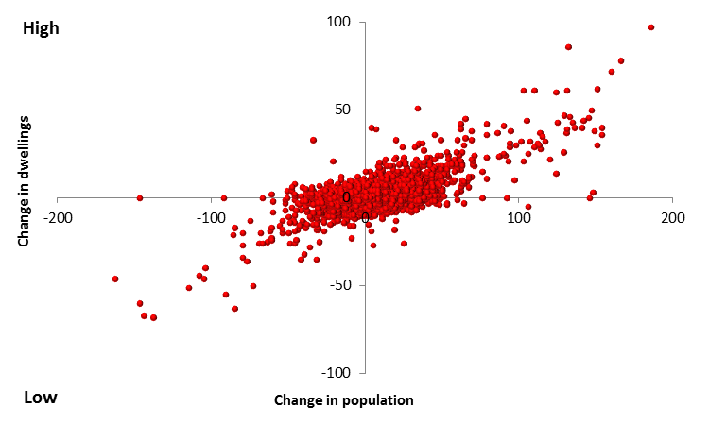

***Correlation, 0.86%***

Chart 5 is a scatter graph presenting the interaction of change in dwellings and population between 2011 and 2016. The geographical data being used in this example is meshblocks (MBs) for Sydney.

I would like the user to be able to click on a dot and the information is presented.

Another visualisation option I would be interested in seeing is the dots being coloured according to which aggregated geography they belong to (eg:- SA4, LGA); as part of the query, I would like the user to be able to select a particular SA4 or LGA – the data for the entire scatter graph would be set to a grey colour scale, but the selected geography (SA4 or LGA) would be coloured eg:- red.

I would also like the user to be informed of the correlation between the 2 metrics for the specified geography. Perhaps comparing the selected geography to the Capital City / Balance of State correlation and / or the correlation for Australia as a whole; it just allows the user to gauge the strength of the relationship between the two measures across various geographical scales.

**The next phase** of the analysis is to present the count of meshblocks (MB) in the selected aggregated geography (in this case, Sydney SA4’s) detailing where dwelling and population growth change has been positive or negative and the overall net position.

I have designed a table; but maybe Tableau has a better way of presenting such information…

See table below

**Table 1: Dwelling and population compositional change, 2011 - 2016**

|  |  |  |  |  |  |  |  |
| --- | --- | --- | --- | --- | --- | --- | --- |
| SA4 |  | Dwellings | Dwellings | Dwellings | Persons | Persons | Persons |
|  |  | ∑ Chg (+ve) | ∑ Chg (-ve) | Net | ∑ Chg (+ve) | ∑ Chg (-ve) | Net |
| Central Coast |  |  |  |  |  |  |  |
| Sydney - Baulkham Hills and Hawkesbury |  |  |  |  |  |  |  |
| Sydney - Blacktown |  |  |  |  |  |  |  |
| Sydney - City and Inner South |  |  |  |  |  |  |  |
| Sydney - Eastern Suburbs |  |  |  |  |  |  |  |
| Sydney - Inner South West |  |  |  |  |  |  |  |
| Sydney - Inner West |  |  |  |  |  |  |  |
| Sydney - North Sydney and Hornsby |  |  |  |  |  |  |  |
| Sydney - Northern Beaches |  |  |  |  |  |  |  |
| Sydney - Outer South West |  |  |  |  |  |  |  |
| Sydney - Outer West and Blue Mountains |  |  |  |  |  |  |  |
| Sydney - Parramatta |  |  |  |  |  |  |  |
| Sydney - Ryde |  |  |  |  |  |  |  |
| Sydney - South West |  |  |  |  |  |  |  |
| Sydney - Sutherland |  |  |  |  |  |  |  |

**The next phase** is to present the data cartographically.

I want to be able to showcase the information across multiple geographical scales. Here are some visuals for Inner Sydney across 5 geographies: meshblocks (MBs), SA1, SA2, SA3, SA4 (these all fit into hierarchy 1) and LGA (this fits into hierarchy 2). Postcodes and suburb-postcode combinations will also be made available (hierarchy 3).

The user will be able to select a geographical scale and visualise the data. For example:

**Chart 1:**

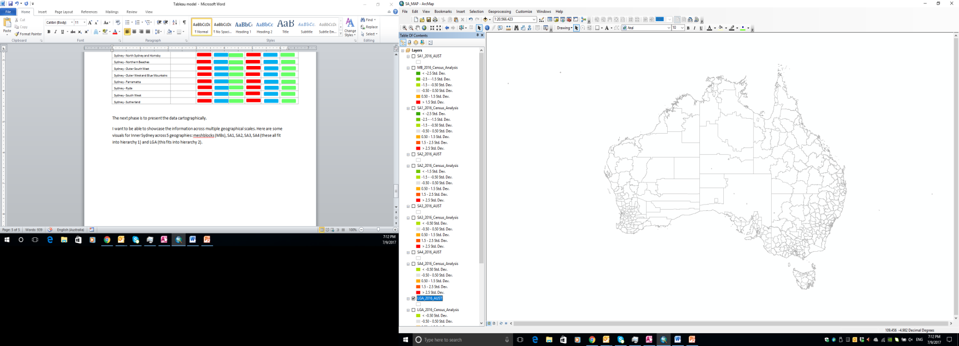

Here is a map of Australia; the user can select from one of the geographies by one of the variables (dwellings, 2016, 2011, change between the two periods; same for population).

**Chart 2:**

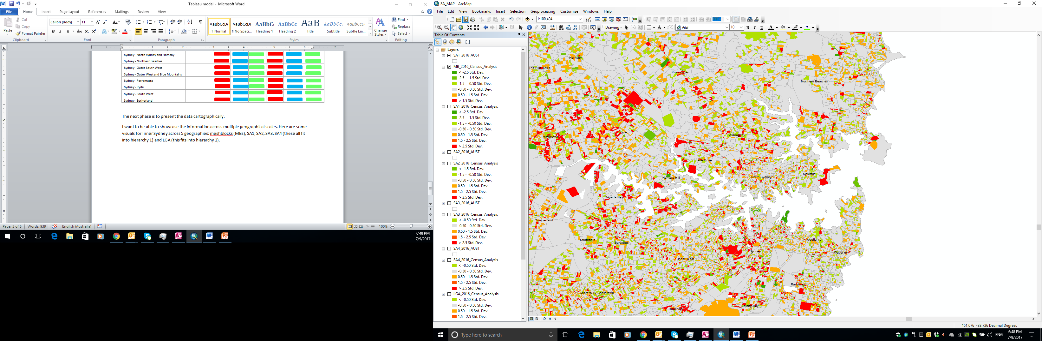

In chart 2, the smallest geographical area is presented – the meshblock (MB).

For contextual purposes, the SA1 polygon boundaries have been overlayed (the meshblock boundaries detract from the detail presented in the colour scale) and are labelled with LGA names (local government councils). Note: meshblocks don’t have names.

**Chart 3:**

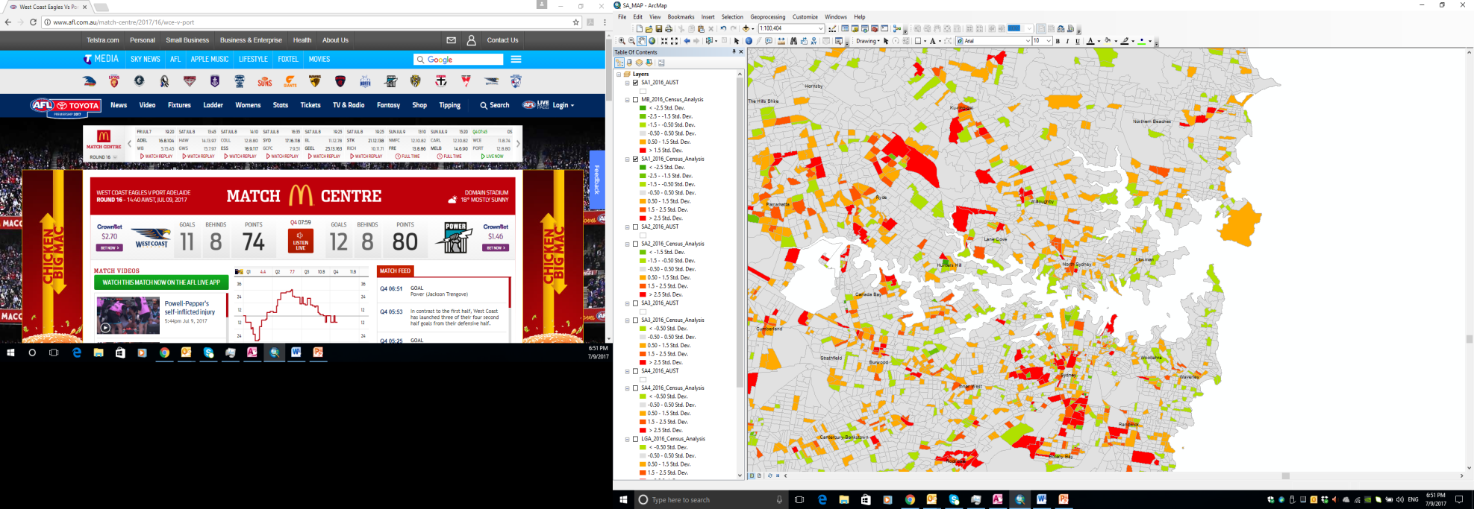

In chart 3, the SA1 geographical areas are presented – they are an aggregate of meshblocks (MB).

SA1 polygon boundaries drape the image; again, they have been labelled with LGA names ((local government councils). Note: meshblocks don’t have names.

**Chart 4:**

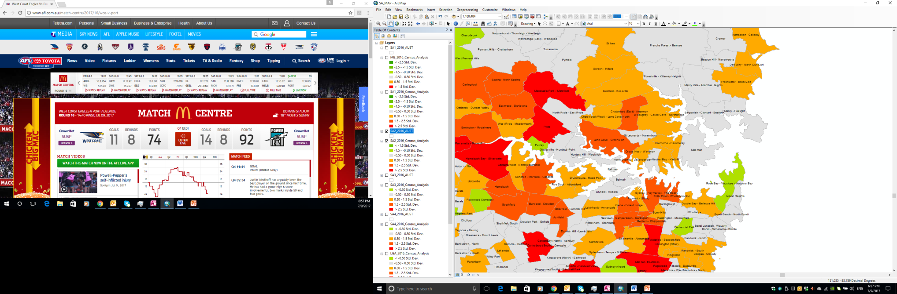

In chart 4, the SA2 geographical areas are presented – they are an aggregate of SA1’s.

SA2 polygon boundaries drape the image; they have been labelled with SA2 names.

**Chart 5:**

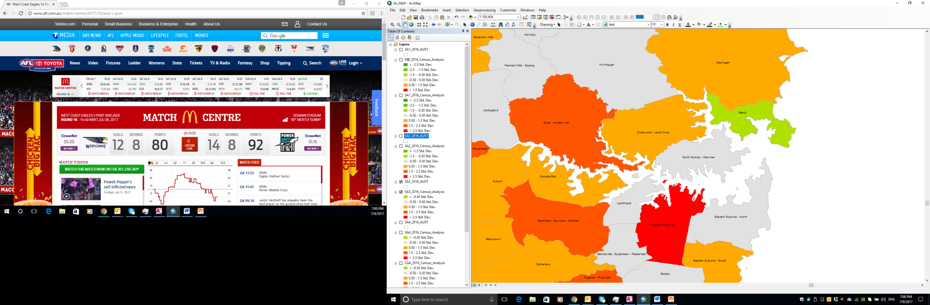

In chart 5, the SA3 geographical areas are presented – they are an aggregate of SA2’s.

SA3 polygon boundaries drape the image; they have been labelled with SA3 names.

**Chart 6:**

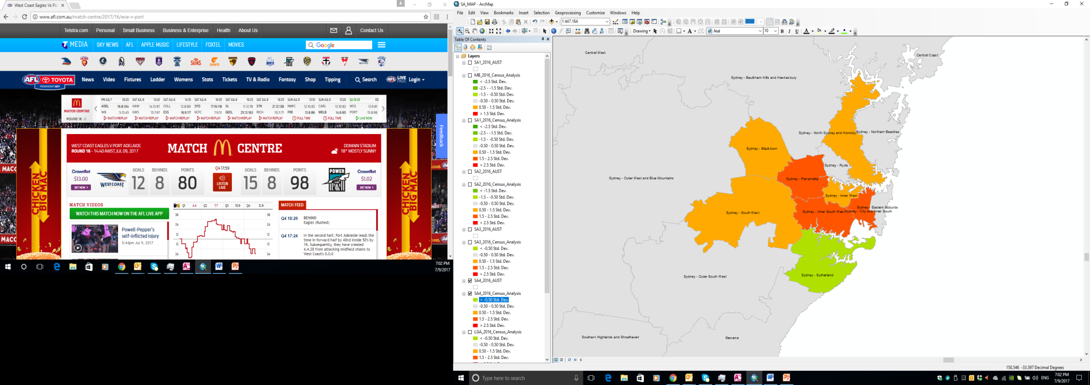

In chart 6, the SA4 geographical areas are presented – they are an aggregate of SA3’s.

SA4 polygon boundaries drape the image; they have been labelled with SA4 names.

**Chart 7:**

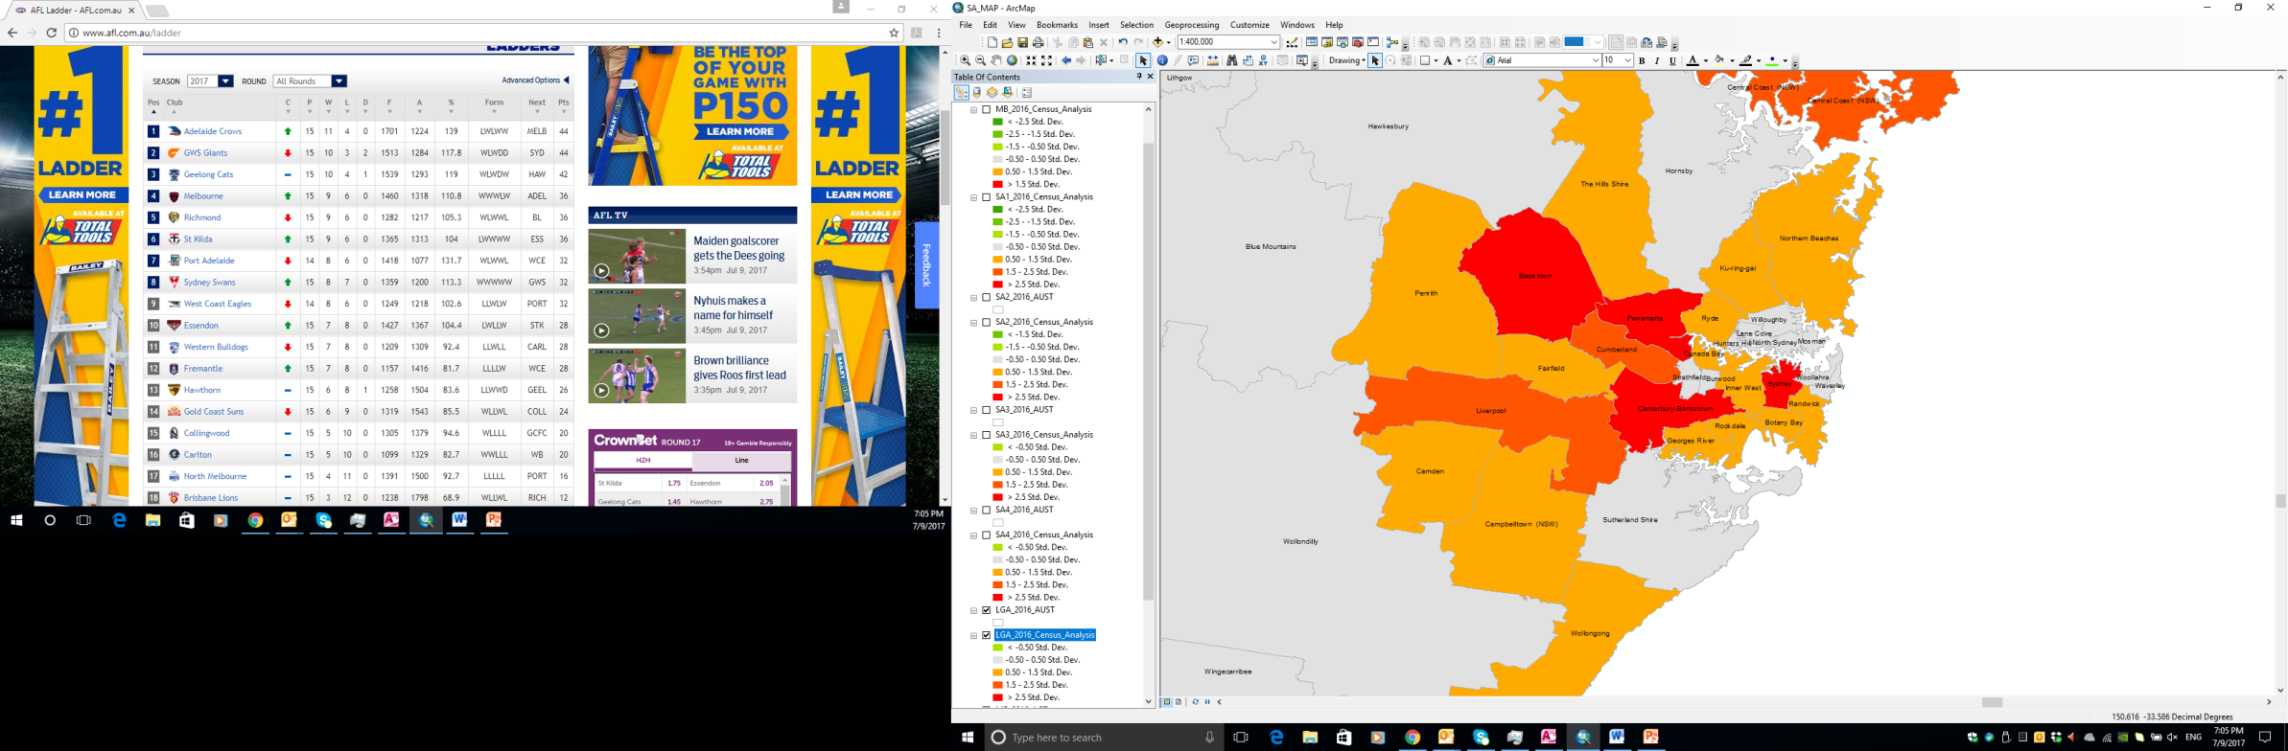

In chart 7, the LGA (local government councils) geographical areas are presented – they are not part of the SA structure; they are an independent structure, but census metrics such as population and dwellings are attributed to them.

LGA polygon boundaries drape the image; they have been labelled with LGA names.

**Chart 8:**

Not currently available; this would be postal geographies; suburbs and postcodes

**On the next page is a possible dashboard layout (it would be in landscape).**

**Cartographic mapping**

**Table**

**Chart 5**

**Chart 4**

**Chart 3**

**Chart 2**

**Chart 1**

**Select geography /data**