week.csv

week_norm_pca.csv

Week, norm(standardized) by all, pca

(User + **180 features** + 1 label) **× 67166 activities (1000 users)**

week_norm_pca_norm.csv

Week, norm(standardized) by all, pca, scale

180features+1label * 67166 activities

week_norm_pca_70.csv

Delete 70% of the (len=72, sum_ins=0) directly

data_1.0.csv (6164 rows × 182 columns)

Week, norm(standardized) by all, pca

Deleted (72, 0) (<15, 0)data

(User + **180 features** + 1 label) **× 6164 activities (136 users)**

data_2.0.csv (18038 rows × 182 columns)

Week, norm(standardized) by all, pca

Deleted (72, 0) (<15, 0)data

Augmented (slide window, random.seed(1)form[30, 60))

(User + **180 features** + 1 label) **× 18038 activities (452 users)**

data_2.1.csv (18358 rows × 182 columns)

Week, norm(standardized) by all, pca

Deleted (72, 0) (<15, 0)data

Augmented (slide window, random.seed(1)form[40, 50))

(User + **180 features** + 1 label) **× 18358 activities (452 users)**

Data_3.1.csv (19381 rows × 406 columns) - 768 users

Data_processing_2.0, no PCA

Repeat twice

**Recall: 0.71, 0.72**

Data_3.2.csv (26836 rows × 406 columns) - 1084 users

Data_processing_2.0, no PCA

Repeat third times

**Recall: 0.72, 0.44**

Data_3.3.csv (11769 rows × 406 columns) - 452 users

Data_processing_2.0, no PCA

No Repeat

**Recall: 0.70, 0.74**

Data_3.4.csv () - 1354 users (0*66, 1*640, 2*538, 3*110)

Data_processing_2.0, no PCA

Repeat [12,2,10] times, 4 classes

Data_3.5.csv (11863 rows × 406 columns) - 452 users (0*66, 1*82, 2*284, 3*20)

Data_processing_2.0, no PCA

No repeat, 4 classes

Data_3.1.csv

Session, no aug, with norm, no pca

* Avg of loss value within batch: divided by whole length. Should divided non-zero (before mask) length
* Softmax(dim=2): was dim=1, didn’t check

？？？

Same 3.1 data:

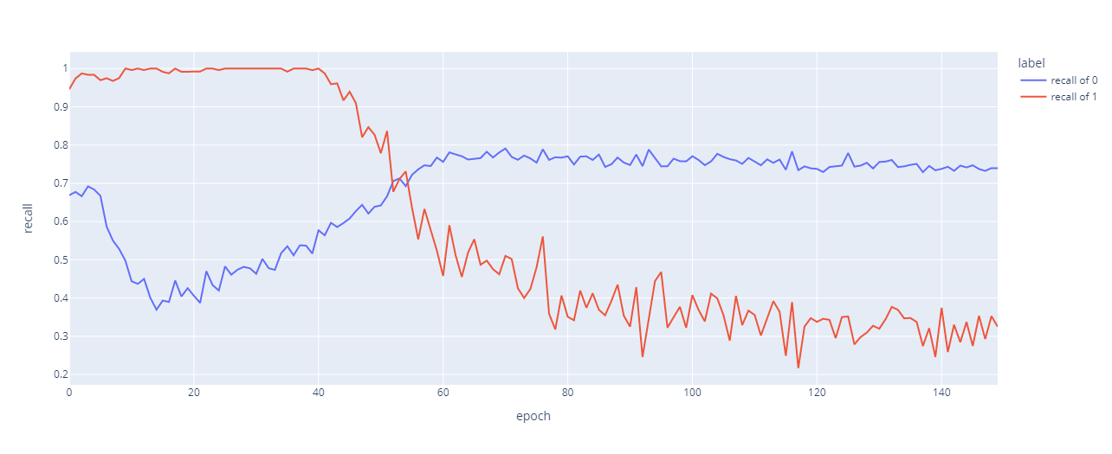

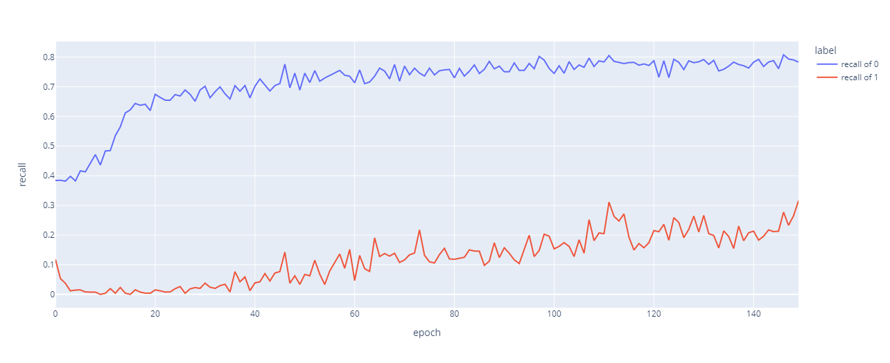

Even same dataloader:

