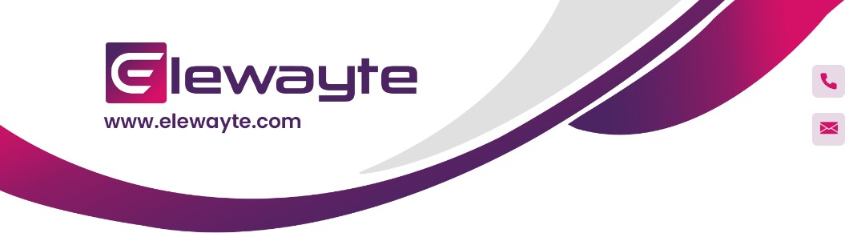

+91 6383453564



[info@elewayte.com](mailto:info@elewayte.com)

# INTERNSHIP OFFER LETTER

### 3 December 2023 OL Number: ELWT587

#### Dear Anshu Kumar Bishwas,

Welcome to Elewayte! We are excited to have you join us as a **Business Development Trainee**. This letter confirms our offer for a **6 month internship**, commencing on **5 January 2024** and concluding on **11 July 2024**, with the **potential for extension based on your performance.**

➔ **Role:** Business Development Trainee

➔ **Training Period:** 5 January 2024 - 11 January 2024

➔ **On the Job Training (OJT):** 12 January 2024 - 11 July 2024

➔ **Location:** Bangalore

#### ➔ Compensation: ₹ 17000 stipend + performance linked pay of ₹ 10000

➔ **Placement Type:** Internship + Placement

**Compensation:**

Your internship will be rewarded with a **monthly stipend of ₹ 17000**. Additionally, you have the opportunity to earn **performance incentives up to ₹ 10000**, **contingent upon the achievement of predetermined revenue targets.**

For detailed insight into how these performance-linked incentives can be attained, please refer to **Annexure - 1**. This annex provides a comprehensive breakdown of the targets and the corresponding incentive structure, guiding you towards maximizing your earnings potential during your internship.



## Internship Role and Expectations:

During your tenure, you will be immersed in various **business development activities**, assisting our team in **market research, client engagement, and project initiatives**. We anticipate your **innovative contributions** and **dedication to learning and growth**.

## Working Hours:

You will be expected to work **8 hours per day**. Your regular working hours will be from **11 AM to 8 PM**, **Tuesday through Sunday.**

## Performance Targets:

As an integral part of our team, your contributions will be pivotal in achieving our business goals. You will be entrusted with a **revenue target of ₹ 150,000.00.** We foster a performance-driven culture where meeting at least **60 - 70 % of this target is considered the minimum acceptable performance threshold**. **Regular feedback sessions** will be scheduled to review your progress towards these goals and to support your ongoing professional development. It is our intent to not only drive business success but also to facilitate a robust learning experience for you.

## Training and Development:

You will participate in a **structured training program** designed to equip you with the necessary skills and knowledge for a successful internship. **Regular check-ins with your mentor** will help you stay on track and maximize your learning experience.

## Company Policies:

As an intern, you will **adhere to all company policies** and **maintain the confidentiality of proprietary information.** Your conduct should reflect the **high standards of Elewayte.**

## Completion and Potential Opportunities:

Upon **successful completion of your internship**, there will be a **performance review**, which may lead to **opportunities for further engagement** with our team, including potential **full-time employment.**



## Next Steps:

To accept this internship offer, **sign and date this letter**, then **reply back a scanned copy of the signed document**, along with the **requested documents in Annexure - 2**, within 2 working days from the receipt of this email. Should **we not receive your acceptance** within the specified timeline, the offer will be **considered as automatically withdrawn** without any further obligation on the part of Elewayte.

If you have any questions or require further clarification on any aspect of this offer, please do not hesitate to reach out to **Priyanka at 6383453564**.

### With Regards, Madhukar M

**GM - Human Resources**

(This is an auto generated email and does not require signature)







### Note:

1. All the above said figures are subjected to full recovery of the projected revenue, defaults and quality checks by the post sales department. Initially 50% of the performance linked pay will be remitted post the quality checks with a tolerance of 85% of the remaining PLP will be remitted.
2. At any time if you wish to discontinue the training due to personal reasons , you would be required to inform us 30 Days prior. If you are unable to inform us 30 days prior you will be levied with 1 month of compensation as part of pay in lieu.
3. The company has all the rights to make amendments to the pattern from time to time and would be informed to the concerned as well.
4. It is important to note that failing to meet performance expectations may result in deductions to your compensation.
5. Specifically, not achieving at least 70% of the projected revenue may lead to a corresponding reduction in your compensation package.
6. Any changes pertaining to the compensation and the structure of the pay is fully under the control of the employer. The employee would be ratified of any such changes through an official form of communication.
7. The training period, an essential part of your career growth, is unpaid. However, the skills and experience acquired are crucial for your future success in the company.

### With Regards, Madhukar M

**GM - Human Resources**

(This is an auto generated email and does not require signature)

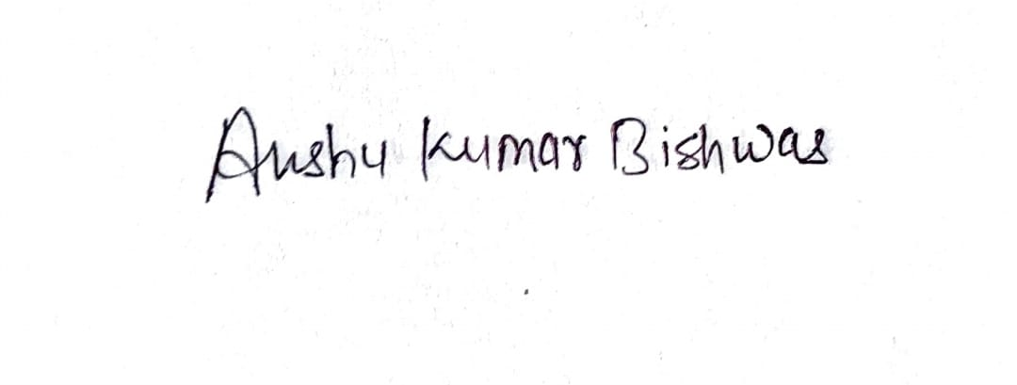



# Annexure - 1

## Variable Compensation Breakdown

In this annexure, we've detailed the variable component structure for one of the crucial roles within our organization: sales-focused roles. It's essential to understand and align with the specific breakdown relevant to your role to ensure transparency and clarity regarding your compensation.

This is applicable for individuals whose primary responsibility revolves around in house sales efforts, achieving sales targets, and maintaining customer relationships.

|  |  |  |
| --- | --- | --- |
| **VARIABLE COMPONENT (B) BREAK UP - SALES** | | |
| **TARGET : ₹ 150,000.00** | | |
| **Sl No** | **Target Achievement** | **Incentive Payout - PLP** |
| 1 | Above Primary Target | Determined as % of overachievement X  ₹ 10000 (PLP) |
| 2 | Exactly ₹ 2,20,000 | ₹ 10,000 |
| 3 | Up to ₹ 1,80,000 | ₹ 7,500 |
| 4 | Up to ₹ 1,50,000 | ₹ 5,000 |



+91 6383453564



[info@elewayte.com](mailto:info@elewayte.com)

# Annexure - 2

|  |  |
| --- | --- |
| **LIST OF DOCUMENT TO ATTACH IN THE ACCEPTANCE EMAIL** | |
| 1 | Professional / Educational Certificates and Mark Sheets towards:   * 10th standard or equivalent examination (Carry Original MS for Verification) * 12th standard or equivalent examination (Carry Original MS for Verification) * Graduation * Post-graduation / Doctorate |
| 2 | Copy of Passport Size Photograph |
| 3 | PAN Card + Voter ID or Driving License |
| 4 | Pass Book Front page with below mentioned Details :  Bank Account Details: Bank Name, Your Name as per Bank records, Account Number, IFSC Code |

## Onboarding Requirement:

Bring an original document for verification purposes at the time of onboarding.