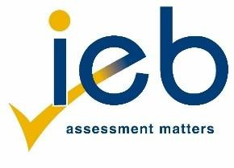
ADDENDUM A1

DESIGN
INDIVIDUAL LEARNER SBA COVER SHEET PAPER IV
7/28

Candidate's examination number: |  | {EXAM_NUM}
Centre Number: | {CENTER_NUM}

WRITTEN SCHOOL-BASED ASSESSMENT FINAL MARK/100

Checklist | SBA (100 marks) | Marks converted to: | Educator Mark | Cluster Moderated mark: | SBA Moderator mark:
 | Common Assessment Task | {cat}/50
- Rubric en Declaration of authenticity
- Plagiarism check
 | Prelim Theory Examination | {prelim}/20
 | Section A Test | {sec_A}/10
 | Section B Test | {sec_B}/10
 | Section C Test | {sec_C}/10
 | TOTAL | {total}/100

LEARNER
I, declare that the work in this portfolio is my own, original work. I have correctly referenced all material obtained for my research. I have not plagiarised.

LEARNER'S SIGNATURE: Date:

TEACHER

I have checked the references cited in the CAT for evidence of plagiarism.

TEACHER'S SIGNATURE: Date:

CLUSTER SIGNATURE: Date:

IEB Copyright © 2014–2026 NATIONAL SENIOR CERTIFICATE HANDBOOK:
IMPLEMENTATION DATE: GRADE 12, JANUARY 2026

