9/15
1.2 COVER SHEET FOR LEARNER'S FILE
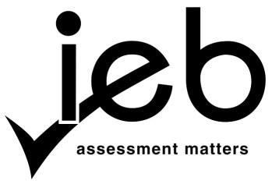
NATIONAL SENIOR CERTIFICATE ECONOMICS

School: {SCHOOL}
Learners' Name: {NAME} {SURNAME}
Exam no: {EXAM_NUMBER}

No | Date | Task | Weight % | Mark % | Final Mark
1 | {prelim_date} | Prelim Exam | 30 | {prelim_perc} | {prelim_weight}
2 | {test_date} | Controlled Tests | 12,5×2 | {test_perc} | {test_weight}
3 | {multi_date} | Multiple-Choice Controlled Test | 10 | {multi_perc} | {multi_weight}
4 | {task_date} | Data Response Task | 15 | {task_perc} | {task_weight}
5 | {oral_date} | Oral presentation | 20 | {oral_perc} | {oral_weight}
 |  |  |  | Total (100) | {total}

Educator: Learner:

Date: Date:

IEB Copyright©2014–2025 NATIONAL SENIOR CERTIFICATE HANDBOOK
IMPLEMENTATION: GRADE 12, 2025

