Predictive alkyl rate models (Random Forest Regression).
All rate constant dataset for alkyl halides were used for random forest regression to obtain predictions to rationalize the XEC reaction outcomes. The feature input excel sheet is available in modeling_input_features.xlsx, sheet ‘RF-allalkyl’. The script used for random forest regression is available in github, RF_alkyl_rates, random_forest_alkyl_rates.ipynb. The whole dataset was split into training, validation, and test in a ratio of 7:2:1 to evaluate the model’s performance on unseen data. The split was performed with random_state = 42.
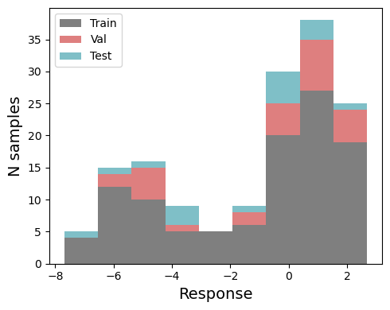
Figure SX. Data split for alkyl halide random forest model.
Following features were deleted from the total 490 features due to low interpretability:
[ 'NMR_shift_X_Boltz_alkyl', 'NMR_shift_X_min_alkyl', 'NMR_shift_X_max_alkyl']
The features were further reduced based on the collinearity with threshold of R² > 0.9 of training set, resulting 50 final features for alkyl halides and Ni(I) catalysts.
Using 50 features, an initial random forest model was performed using scikit-learn (RandomForestRegressor). Hyperparameter tuning was conducted with RandomizedSearchCV using a 5-fold cross-validation (cv=5) with scoring method of negative mean squared error (scoring=’neg_mean_squared_error’) and random_state=42. The hyperparameter search space included:
param_grid = {‘n_estimators': [50, 100, 150], 'max_depth': [3, 5, 7], 'min_samples_split': [5, 10], 'min_samples_leaf': [2, 5], 'bootstrap': [True]}
The model was fitted using the best parameters from the hyperparameter search, and training and validation performances were evaluated.
To reduce the number of features and minimize noise fitting in the model, permutation importance was calculated on the validation set using the trained random forest model. Features with a mean importance below a threshold were removed, while remaining features were used for retraining. This process was repeated iteratively until a reasonable number of features were retained for the final model. After four iterations, 11 features remained which were used to train the final model. It is important to note that the permutation importance can be slightly unstable, causing minor differences in feature importances, specifically for features with smaller importances (e.g., one or a few features may swap importance). Thus, when reproducing the model, all previously dropped features were removed, and the code was run using the same retained features.
Following features were dropped via three iterations:
Features deopped in the first round (threshold >0.0): Dropping 20 features at threshold=0: ['polar_iso(Debye)_Boltz_NiI_cat', 'Sterimol_L_Ni11_N2(Å)_morfeus_Boltz_NiI_cat', 'Buried_Sterimol_B5_C_X_5.0(Å)_Boltz_alkyl', 'volume(Bohr_radius³/mol)_Boltz_NiI_cat', 'Buried_Sterimol_L_N10_Ni11_5.0(Å)_Boltz_NiI_cat', 'Buried_Sterimol_B5_N7_Ni11_5.0(Å)_Boltz_NiI_cat', '%Vbur_N2_4.0Å_Boltz_NiI_cat', 'Sterimol_L_N2_Ni11(Å)_morfeus_Boltz_NiI_cat', 'volume(Bohr_radius³/mol)_max_NiI_cat', 'volume(Bohr_radius³/mol)_min_NiI_cat', '%Vbur_N2_2.0Å_Boltz_NiI_cat', 'dipole(Debye)_min_alkyl', 'Sterimol_B5_C_X(Å)_morfeus_min_alkyl', 'NBO_charge_C_Boltz_alkyl', 'distance_Ni11_N10(Å)_Boltz_NiI_cat', 'ChelpG_charge_C_Boltz_alkyl', 'polar_iso(Debye)_Boltz_alkyl', 'Hirsh_charge_N10_Boltz_NiI_cat', 'ChelpG_charge_N7_Boltz_NiI_cat', 'SASA_surface_area(Å²)_Boltz_NiI_cat']

Features dropped in the second round (threshold >0.0025): Dropping 10 features at threshold=0.0025: ['NBO_charge_N2_Boltz_NiI_cat', 'distance_Ni11_N2(Å)_Boltz_NiI_cat', 'ChelpG_charge_N2_Boltz_NiI_cat', 'dipole(Debye)_max_NiI_cat', 'Buried_Sterimol_B5_C_X_5.0(Å)_max_alkyl', 'Sterimol_L_C_X(Å)_morfeus_max_alkyl', 'Buried_Sterimol_B5_C_X_5.0(Å)_min_alkyl', 'Sterimol_L_N7_Ni11(Å)_morfeus_Boltz_NiI_cat', 'NMR_shift_C_Boltz_alkyl', 'polar_aniso(Debye)_min_alkyl']

Features dropped in the third round (threshold >0.01): Dropping 6 features at threshold=0.01: ['%Vbur_N10_2.0Å_Boltz_NiI_cat', 'dipole(Debye)_Boltz_NiI_cat', 'dipole(Debye)_Boltz_alkyl', 'HOMO_Boltz_alkyl', 'ω_Boltz_alkyl', 'ChelpG_charge_X_max_alkyl']
Features dropped in the fourth round (threshold >0.02): Dropping 6 features at threshold=0.02: ['polar_aniso(Debye)_Boltz_alkyl', 'ChelpG_charge_N10_Boltz_NiI_cat', 'pyramidalization_Gavrish_C(°)_Boltz_alkyl', 'Hirsh_charge_X_max_alkyl', 'ChelpG_charge_X_Boltz_alkyl', 'Hirsh_CM5_charge_N10_Boltz_NiI_cat']
Remained 8 features that were used in the final model: ['LUMO_Boltz_alkyl', 'dipole(Debye)_max_alkyl', 'NBO_charge_X_Boltz_alkyl', 'distance_C_X(Å)_Boltz_alkyl', '%Vbur_X_2.5Å_Boltz_alkyl', 'Sterimol_L_C_X(Å)_morfeus_Boltz_alkyl', 'HOMO_Boltz_NiI_cat', '%Vbur_N2_2.5Å_Boltz_NiI_cat']

With 8 features, the model was constructed with best hyperparameter of {'n_estimators': 150, 'min_samples_split': 5, 'min_samples_leaf': 2, 'max_depth': 7, 'bootstrap': True}
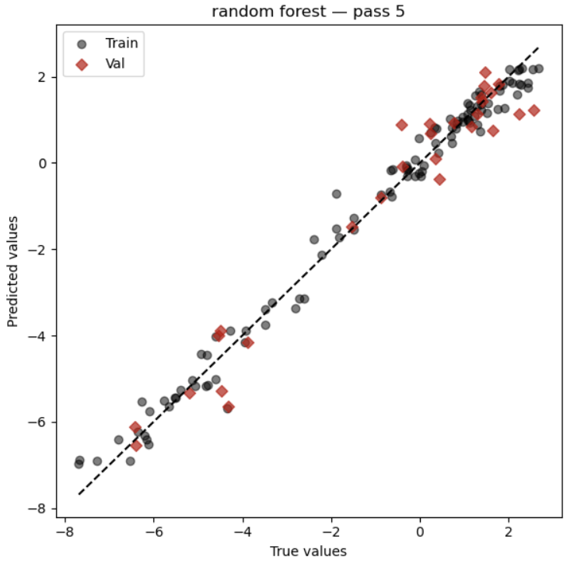
Figure SX. Random forest regression for training and validation with 8 features.
Training R²: 0.98
Training MAE: 0.28
Validation R²: 0.95
Validation MAE: 0.47
Feature importances were analyzed using SHAP.
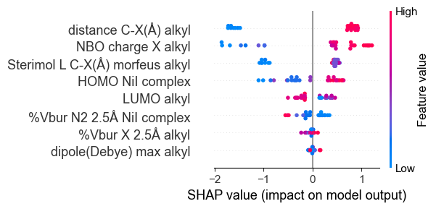
Figure SX. SHAP plot of 8 features.
The test set data was plotted on the regression.
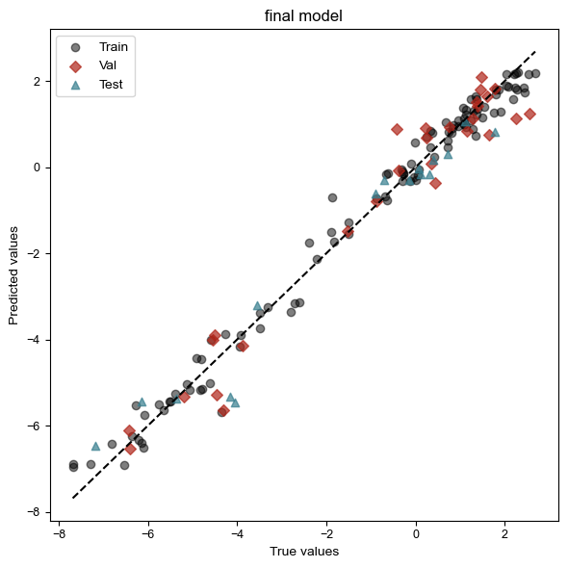
Figure SX. Random forest regression for training, validation and test with 12 features.
Training R²: 0.98
Training MAE: 0.28
Validation R²: 0.95
Validation MAE: 0.47
Test R²: 0.95
Test MAE: 0.48

Leave-one-substrate-out (LOSO) and leave-one-catalyst-out (LOCO) cross-validation were performed to identify potential outliers and assess the model’s ability to predict unseen substrates or catalysts. The model was retrained using entire data (training) except for those that were held out (validation). In LOSO, one substrate was held out at a time, while in LOCO, one catalyst was held out. The MAEs of held-out data were reported on the table below.

Held-out substrate | MAE
alkylBr01 | 0.45
alkylBr02 | 0.69
alkylBr03 | 0.42
alkylBr04 | 0.26
alkylBr05 | 0.32
alkylBr06 | 0.12
alkylBr07 | 0.50
alkylBr08 | 0.17
alkylBr09 | 0.12
alkylBr10 | 0.05
alkylBr11 | 1.01
alkylBr12 | 0.54
alkylBr13 | 1.46
alkylBr14 | 0.12
alkylBr15 | 0.23
alkylBr16 | 0.99
alkylBr17 | 0.31
alkylBr18 | 0.33
alkylBr19 | 1.59
alkylBr20 | 0.56
alkylBr21 | 1.25
alkylBr22 | 0.86
alkylBr23 | 0.47
alkylBr25 | 1.27
alkylBr26 | 0.94
alkylBr27 | 0.36
alkylBr28 | 0.37
alkylBr29 | 0.33
alkylBr30 | 0.48
alkylBr31 | 0.35
alkylBr32 | 0.16
alkylBr33 | 0.77
Table SX. LOSO analysis for alkyl bromides.

Held-out substrate | MAE
alkylCl01 | 0.35
alkylCl02 | 1.49
alkylCl03 | 1.98
alkylCl04 | 0.24
alkylCl05 | 0.59
alkylCl06 | 0.42
alkylCl07 | 0.40
alkylCl08 | 1.05
alkylCl09 | 1.48
alkylCl10 | 0.34
alkylCl11 | 1.08
alkylCl12 | 0.51
alkylCl13 | 0.65
alkylCl14 | 1.34
alkylCl15 | 0.51
alkylCl16 | 0.54
alkylCl17 | 0.70
alkylCl18 | 0.18
alkylCl19 | 0.45
alkylCl20 | 0.51
alkylCl21 | 0.93
Table SX. LOSO analysis for alkyl chlorides.
Held-out catalyst | MAE
L1 | 0.83
L2 | 0.49
L3 | 0.69
L4 | 0.81
L5 | 0.39
L6 | 0.36
L7 | 0.68
L8 | 0.69
L9 | 0.15
L10 | 0.25
L11 | 0.22
L12 | 0.29
L13 | 0.63
Table SX. LOCO analysis for alkyl halides.

