Predictive aryl rate model (Random Forest Regression).
All rate constant dataset for aryl halides were used for random forest regression to obtain predictions to rationalize the XEC reaction outcomes. The feature input excel sheet is available in modeling_input_features.xlsx, sheet ‘RF-allaryl’. The script used for random forest regression is available in github, RF_alkyl_rates, random_forest_alkyl_rates.ipynb. The whole dataset was split into training, validation, and test in a ratio of 7:2:1 to evaluate the model’s performance on unseen data. The split was performed with random_state = 47.
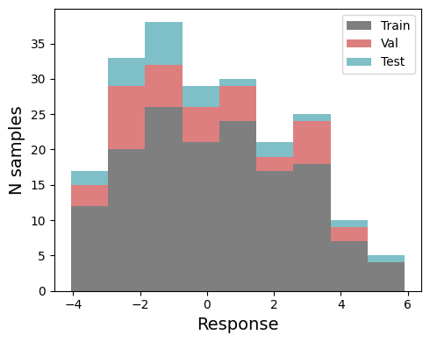
Figure SX. Data split for aryl halide random forest model.
There were initially 480 parameters before collinearity cut (116 aryl halide parameters and 364 Ni(I) catalyst parameters). To limit the number of catalyst parameters input into the model only the 3 nitrogen’s on the ligand backbone and the nickel center were parameterized.
The features were reduced based on the collinearity with threshold of R² > 0.9 of training set, resulting 37 final features(22 aryl halide parameters and 15 Ni(I) catalyst parameters).
Using 37 features, an initial random forest model was performed using scikit-learn (RandomForestRegressor). Hyperparameter tuning was conducted with RandomizedSearchCV using a 5-fold cross-validation (cv=5) with scoring method of negative mean squared error (scoring=’neg_mean_squared_error’) and random_state=42. The hyperparameter search space included:
param_grid = {‘n_estimators': [50, 100, 150], 'max_depth': [3, 5, 7], 'min_samples_split': [5, 10], 'min_samples_leaf': [2, 5], 'bootstrap': [True]}
The model was fitted using the best parameters from the hyperparameter search, and training and validation performances were evaluated.
To reduce the number of features and minimize noise fitting in the model, permutation importance was calculated on the validation set using the trained random forest model. Features with a mean importance below a threshold were removed, while remaining features were used for retraining. This process was repeated iteratively until a reasonable number of features were retained for the final model. After seven iterations, 10 features remained which were used to train the final model. It is important to note that the permutation importance can be slightly unstable, causing minor differences in feature importances, specifically for features with smaller importances (e.g., one or a few features may swap importance). Thus, when reproducing the model, all previously dropped features were removed, and the code was run using the same retained features.
Following features were dropped via three iterations:
Features dropped in the first round (threshold >0.0): 3 features
'polar_aniso(Debye)_Boltz_aryl', 'Sterimol_L_X_C(Å)_morfeus_Boltz_aryl', '%Vbur_C_2.5Å_Boltz_aryl'
Features dropped in the second round (threshold >0.01): 14 features
'dipole(Debye)_Boltz_aryl', 'η_Boltz_aryl', 'dipole(Debye)_max_NiI_complex', 'Buried_Sterimol_L_N7_Ni11_5.0(Å)_Boltz_NiI_complex', '%Vbur_C_3.0Å_Boltz_aryl', '%Vbur_N2_2.0Å_Boltz_NiI_complex', 'polar_iso(Debye)_Boltz_aryl', 'Sterimol_B1_Ni11_N2(Å)_morfeus_Boltz_NiI_complex', 'Buried_Sterimol_B5_Ni11_N7_5.0(Å)_Boltz_NiI_complex', 'dipole(Debye)_max_aryl', 'Sterimol_L_N7_Ni11(Å)_morfeus_Boltz_NiI_complex', 'distance_Ni11_N2(Å)_Boltz_NiI_complex', 'Sterimol_B1_X_C(Å)_morfeus_max_aryl', 'Sterimol_B1_X_C(Å)_morfeus_min_aryl'
Features dropped in the third round (threshold >0.025): 3 features
'SASA_surface_area(Å²)_Boltz_NiI_complex', '%Vbur_C_2.0Å_Boltz_aryl', 'dipole(Debye)_min_aryl'
Features dropped in the fourth round (threshold >0.05): 5 features
'volume(Bohr_radius³/mol)_min_NiI_complex', 'dipole(Debye)_Boltz_NiI_complex', 'HOMO_Boltz_aryl', 'Sterimol_B5_X_C(Å)_morfeus_Boltz_aryl', 'Sterimol_B1_X_C(Å)_morfeus_Boltz_aryl'
12 features remained that were used in the final model:
'LUMO_Boltz_aryl',
'NBO_charge_X_Boltz_aryl',
'NBO_charge_C_Boltz_aryl',
'NMR_shift_C_Boltz_aryl',
'%Vbur_X_2.0Å_Boltz_aryl',
'NBO_LP_occupancy_X_Boltz_aryl',
'NBO_LP_energy_X_Boltz_aryl',
'HOMO_Boltz_NiI_complex',
'polar_iso(Debye)_Boltz_NiI_complex',
'NBO_charge_N2_Boltz_NiI_complex',
'ChelpG_charge_N7_Boltz_NiI_complex',
'Sterimol_L_Ni11_N2(Å)_morfeus_Boltz_NiI_complex'
With 12 features, the model was constructed with best hyperparameter of {'n_estimators': 150, 'min_samples_split': 5, 'min_samples_leaf': 2, 'max_depth': 7, 'bootstrap': True}
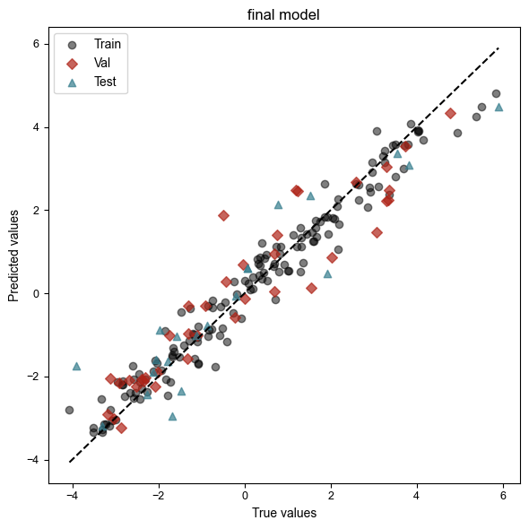
Figure SX. Random forest regression for training, validation and test with 12 features.
Training R²: 0.96
Training MAE: 0.35
Validation R²: 0.88
Validation MAE: 0.63
Test R²: 0.86
Test MAE: 0.69
Feature importances were analyzed using SHAP.
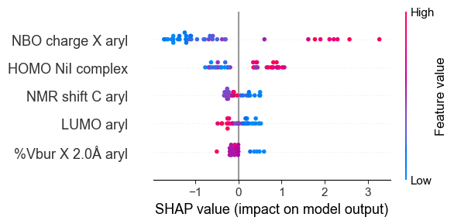
Figure SX. SHAP plot of top 5 features.
Leave-one-substrate-out (LOSO) and leave-one-catalyst-out (LOCO) cross-validation were performed to identify potential outliers and assess the model’s ability to predict unseen substrates or catalysts. The model was retrained using entire data (training) except for those that were held out (validation). In LOSO, one substrate was held out at a time, while in LOCO, one catalyst was held out. The MAEs of held-out data were reported on the table below.
Held-out substrate | Validation MAE
1 | 0.29
2 | 0.71
3 | 1.17
4 | 0.37
5 | 0.63
6 | 1.07
7 | 0.86
8 | 1.30
9 | 1.15
10 | 1.10
11 | 0.74
12 | 1.08
13 | 1.17
14 | 1.01
15 | 0.69
16 | 0.69
17 | 1.09
18 | 1.08
19 | 0.32
20 | 2.80
21 | 0.39
22 | 1.06
23 | 0.76
24 | 0.71
25 | 0.27
26 | 0.92
27 | 0.19
28 | 0.42
29 | 0.78

Table SX. LOSO analysis for aryl chlorides.
Held-out substrate | Validation MAE
30 | 0.57
31 | 0.23
32 | 2.27
33 | 0.49
34 | 0.30
35 | 0.55
36 | 1.89
37 | 1.17
38 | 0.68
39 | 2.87
40 | 0.32
41 | 0.62
42 | 0.97
43 | 0.51
44 | 0.23
Table SX. LOSO analysis for aryl bromides.

Held-out catalyst | Validation MAE
L1 | 1.05
L2 | 1.97
L3 | 1.15
L4 | 1.18
L5 | 0.98
L6 | 0.95
Table SX. LOCO analysis for aryl halides.

