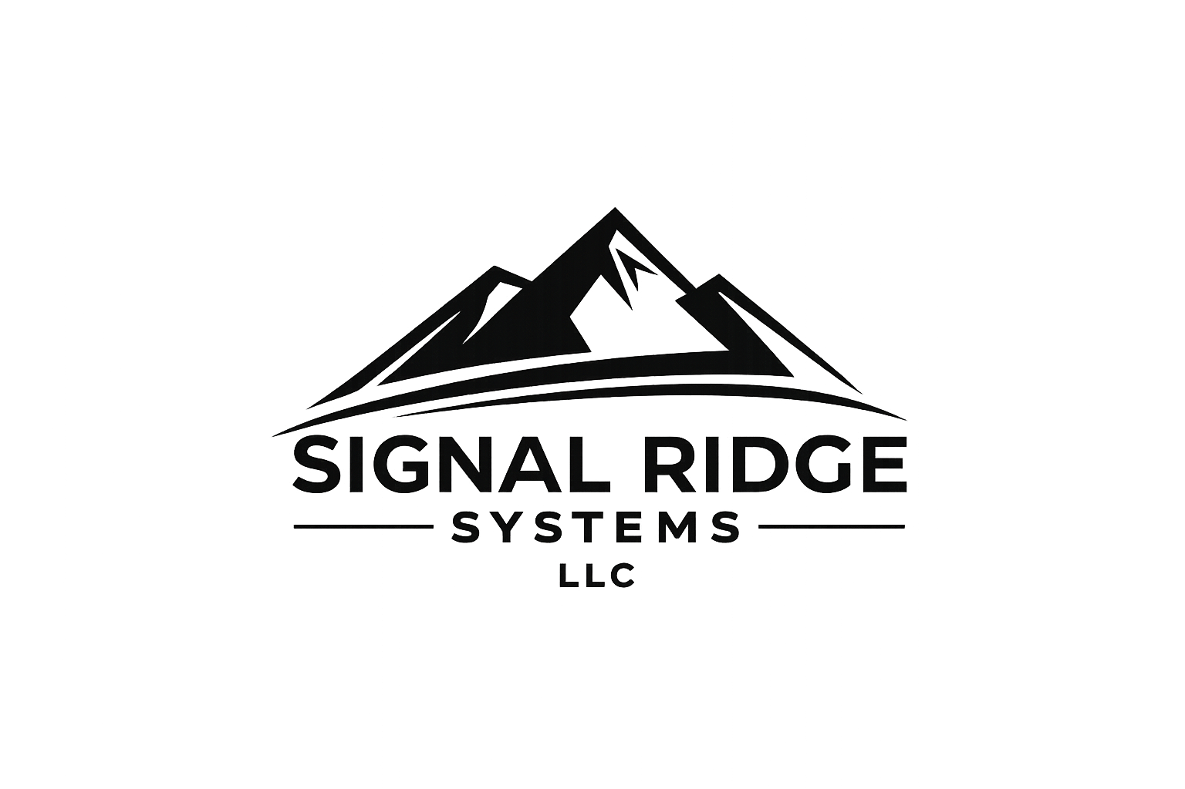

William Zade

CEO | Founder
Signal Ridge Systems LLC
Practical IT, Real World Results

Date: March 18, 2026

RESUME REVIEW REPORT
Executive-Level Assessment

Hi Ryan,
Thank you for the opportunity to review your resume.
Your background is strong and clearly aligned with Director-level roles in infrastructure and operations. You demonstrate solid experience across cloud, security, and network domains, along with exposure to leadership responsibilities and enterprise-scale initiatives.
The primary opportunity is not in your qualifications—but in how your experience is presented.

Key Observations
1. Density & Readability
Your resume is currently very information-dense, which makes it difficult to scan quickly. At the Director level, hiring managers typically review resumes in under 10 seconds, and key strengths need to be immediately visible.
Recommendation:
Reduce bullet length and simplify phrasing to improve readability and scanning efficiency.

2. Leadership Positioning
You have clear leadership experience, including team oversight, infrastructure ownership, and strategic initiatives. However, these elements are often blended with technical details, which reduces their impact.
Recommendation:
Lead each role with leadership scope:
- Team size and structure
- Strategic ownership
- Cross-functional influence
Then support with technical execution where necessary.
3. Impact vs. Responsibilities
Many of your bullet points describe responsibilities and actions, but not always the measurable outcomes or business impact.
Recommendation:
Reframe key points to emphasize results such as:
- Cost reduction
- Performance improvements
- Risk mitigation
- Scale (users, systems, environments)

4. Strong Element – Leadership Snapshot
The “Leadership Snapshot” section is a strong concept and aligns well with executive-level resumes.
Recommendation:
Expand and emphasize this section to highlight:
- Team size
- Budget responsibility
- Key initiatives (cloud migration, compliance, security frameworks)
- Measurable outcomes
This section should act as a quick “at-a-glance” summary of your leadership impact.

Example Improvement
Before:
Directed migration of 3000+ users to AWS, cutting on-prem dependency by 73% while improving system performance.
After:
Led AWS migration (3,000+ users) → reduced on-prem footprint 73% and improved overall system efficiency.

High-Impact Changes to Prioritize
If focusing on immediate improvements, prioritize the following:
- Shorten and simplify bullet points
- Elevate leadership scope and authority
- Emphasize measurable outcomes
- Improve spacing and overall readability

Final Thoughts
You already have the experience and technical foundation to compete for Senior Manager and Director-level roles. With a more refined, executive-focused presentation, your resume will communicate that value more effectively and immediately.
If you would like, I can assist with a full rewrite to further strengthen positioning and impact.

Best regards,
William Zade
CEO | Founder
Signal Ridge Systems LLC

