SignalK-ArduinoTC

This project provides the hardware description and software for an Arduino based thermocouple temperature monitor. It is intended to provide a way to measure and display the vessel engine temperature.

Hardware

The ArduinoTC is based on the Adafruit MAX31855K thermocouple amplifier and the Adafruit MAX31855K library with modest additions to provide SignalK serial output that can be directly connected to the SignalK processor. An implementation using an Arduino Uno is described here but other Aruino flavors will also work. Figure 1 below illustrates the hardware realization.

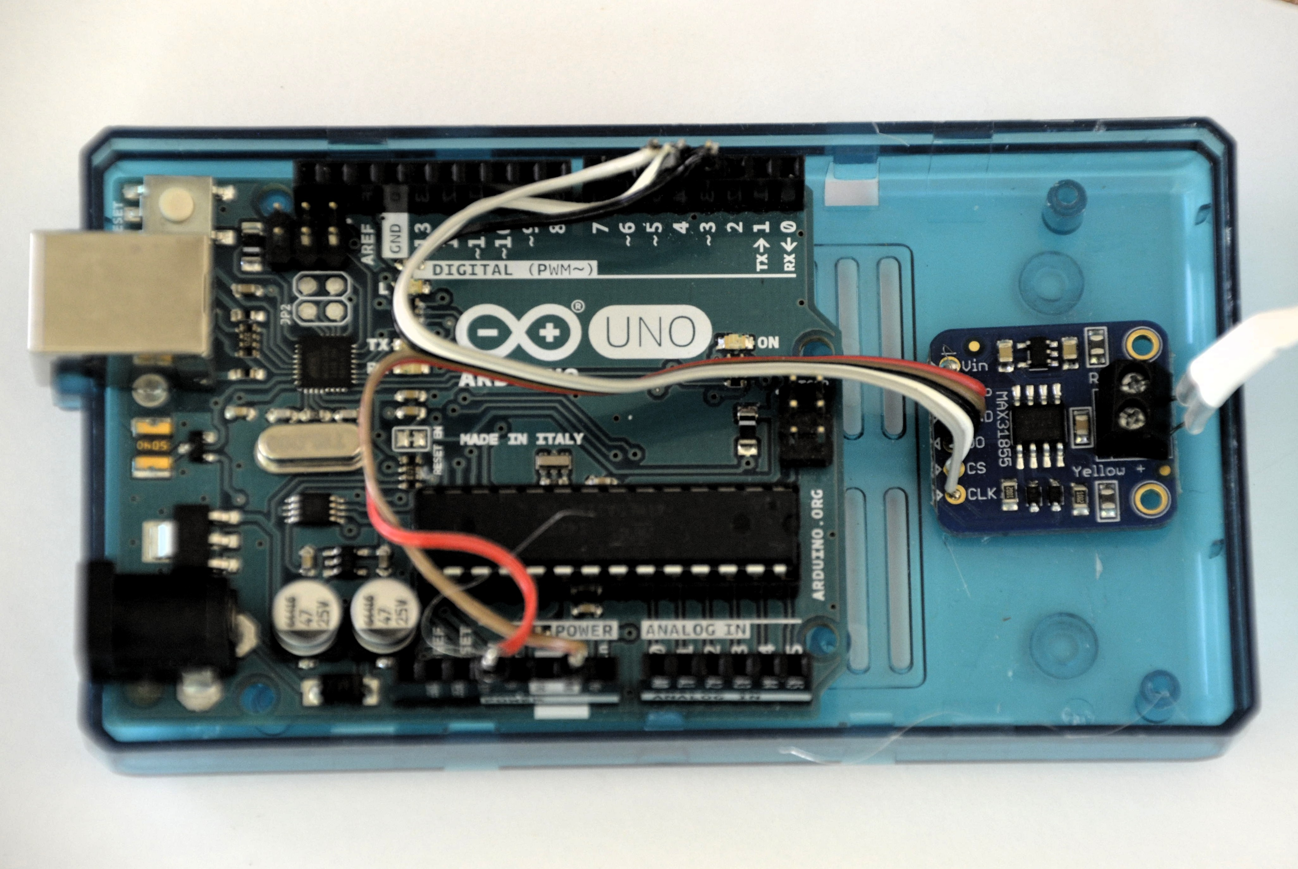Figure 1: ArduinoTC construction.

Here an Arduino Uno is mounted in an Arduino Mega case and the additional room provides just enough space to hot glue the Adafruit MAX31855K amplifier to the base of the case. The electrical hookup requires connection of power and ground, and the three signal lines for serial communications D0, CS and CLK.

Function | Arduino | TC Amplifier
Power 5 V | 5V | Vin
Ground | Gnd | Gnd
Data | 3 | DO
Chip Select | 4 | CS
Clock | 5 | Clk

Header pins have been used to make the connection with ribbon cable soldered to the pin tops. This provided the best connection. We tried bare wires of the appropriate size and Vector pins used for breadboarding but neither was reliable. An Arduino Uno “hat” could also be used but would increase the height of he assembly and make it impossible to put it all in a simple case as shown in Figure 2.

The MAX31855K cannot be used with a grounded TC so the temperature sensing tip has been covered with 2 layers of shrink tubing before it was crimped into a lug. The electrical lug can then be clamped below some bolt on the engine to sample the temperature.

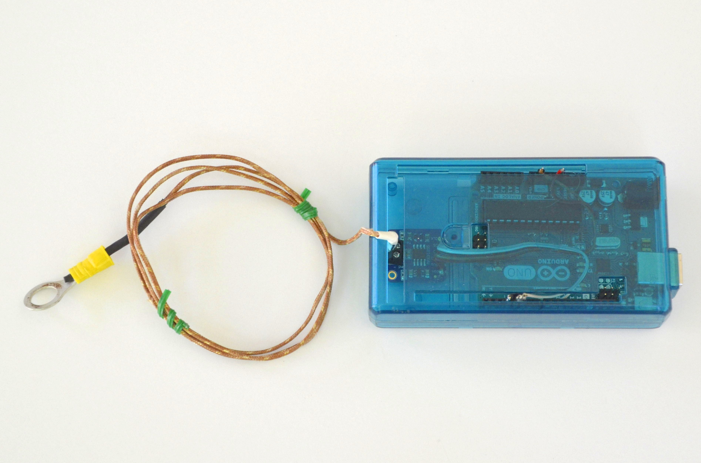Figure 2: Assembled ArduinoTC

Firmware

The Arduino Uno must be programmed to output the TC temperature measurements.

First, you must download and install the Arduino IDE. System dependent instructions for installing the Arduino IDE can be found at https://www.arduino.cc/en/Guide/HomePage .

Second, clone or download as a zip the ArduinoTC project https://github.com/SignalK. If you download the zip, unzip it so that you have access to the contents.

Third, you must add the Adafruit MAX31855K library to the IDE. Clone or download the Adafruit library from https://github.com/adafruit/Adafruit-MAX31855-library . Once you have the library on your system, follow the instructions at https://www.arduino.cc/en/guide/libraries to install it in the IDE.

Finaly, load the sketch ArduinoTC.ino from the ArduinoTC project into the IDE (File > Open and then navigate to the file).

Connect the Arduino Uno to your computer and go to Tools>Board on the IDE menu and check that your board is selected. The go to Tools>Port and select the serial port that the Aruino is connected to. On a Linux system it will be something like /dev/ttyACM0. On a Windows machine it will be COMxx (Arduino/Genuino Uno). Then go to File>Upload to compile and upload the sketch to the Arduino.

Once the sketch is uploaded, if you open the Serial monitor (Tools > Serial Monitor) you can see the output of the ArduinoTC on the screen. When formatted (https://jsonformatter.org/) the JSON output is:

{
"context": "vessels.self",
"updates": [
{
"values": [
{
"path": "propulsion.engine.coolantTemperature",
"value": 23.75
}
],
"source": {
"label": "ArduinoTC"
}
}
]
}

