4 Aug | Your Workplace Skills Plan is approved. Now what?  August is the month decision-makers either turn strategic priorities into real capability—or watch another year slip by.  The gap between planning and implementation isn't about commitment. It's about structure.  → From abstract skills priorities to specific learner cohorts  → From compliance anxiety to evidence discipline  → From good intentions to workplace-ready talent  The organisations that move first in August create competitive advantage by Q4.  BSI provides the framework, the programmes, and the implementation support that turns your skills strategy into certified capability.  Ready to move your future forward? Let's build your learner plan: bsi-institute.co.za  #BSI #SkillsDevelopment #WorkplaceSkillsPlan #HRLeadership #BBBEECompliance #LearnershipsSA #FutureOfWork #FinancialServices #PeopleStrategy #TalentDevelopment | 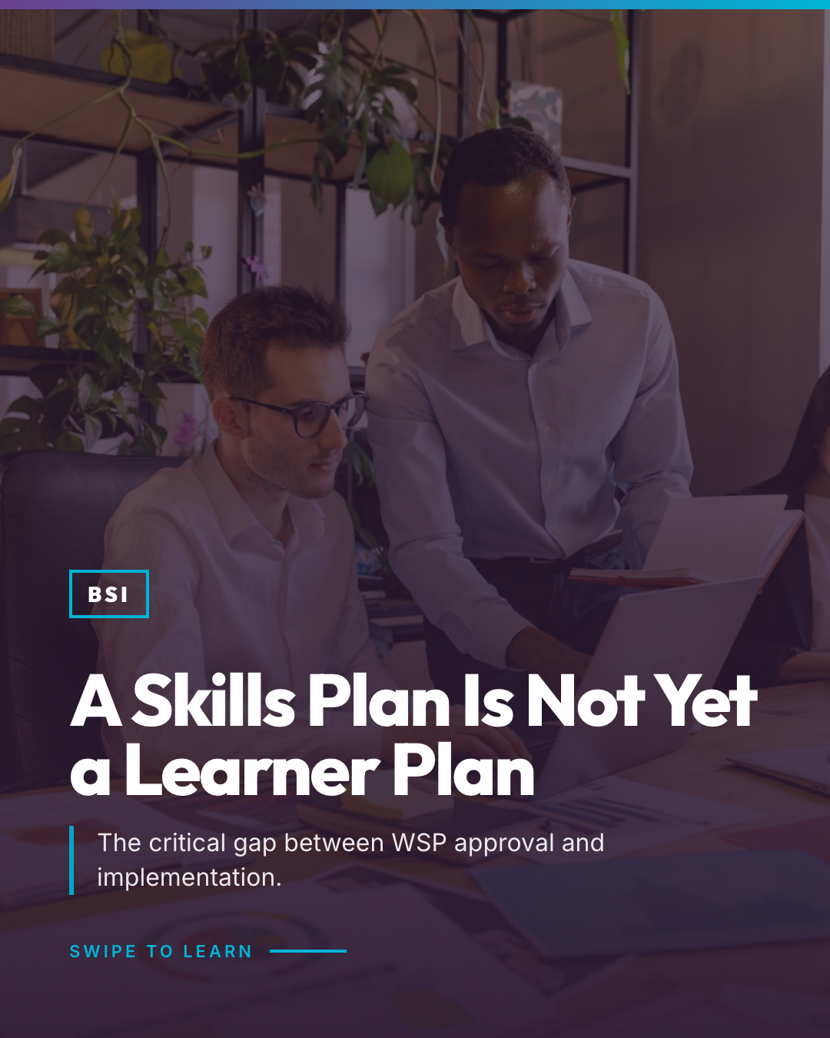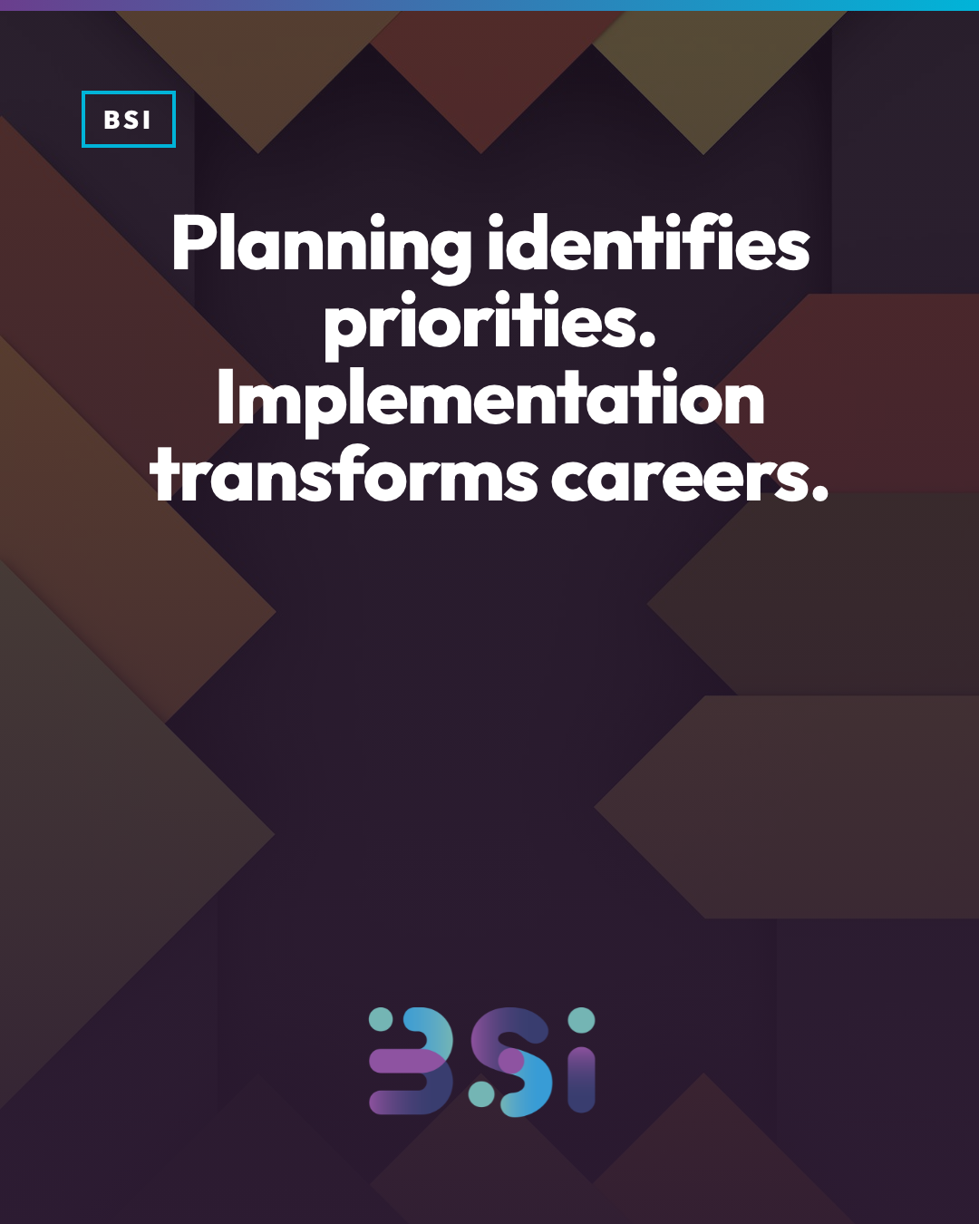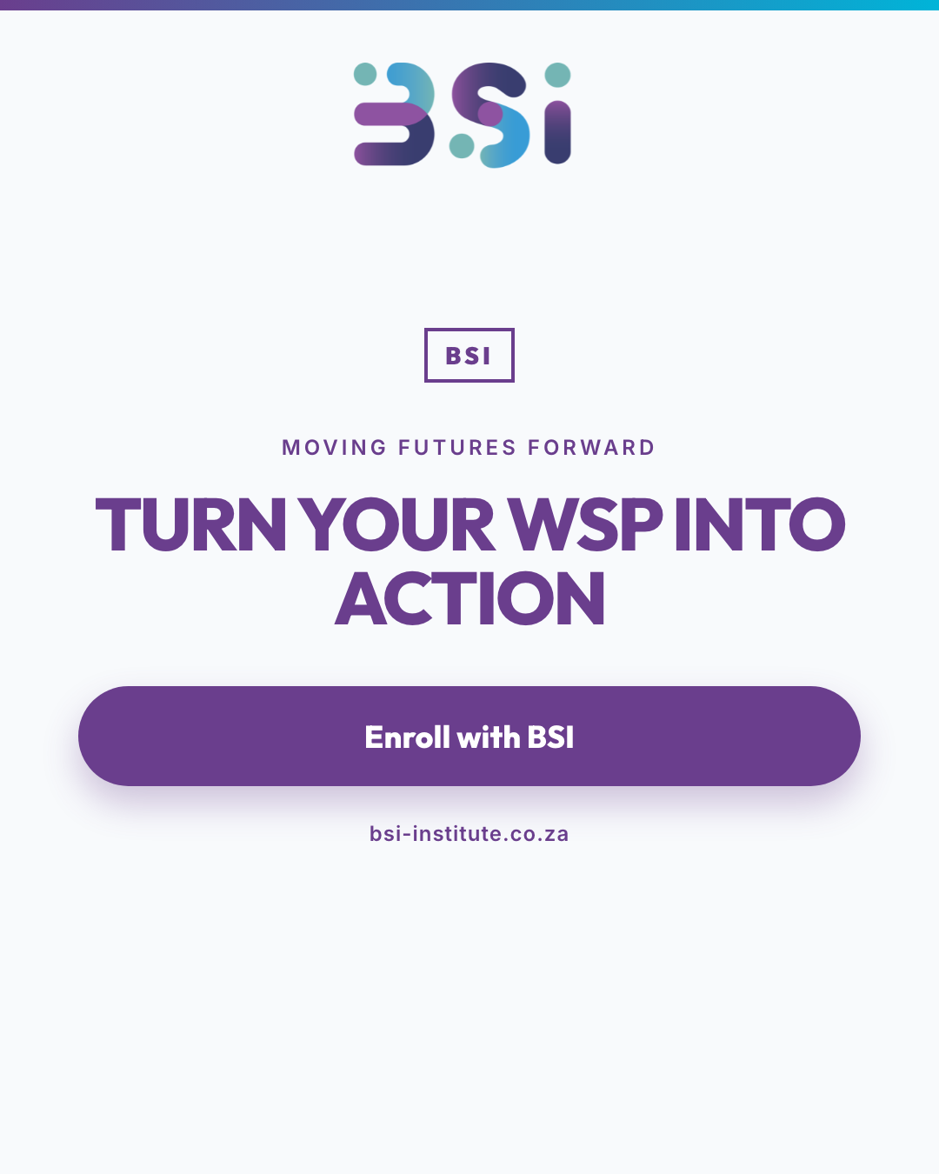
6 Aug | You have the plan. We create the pathway.  You know you need to upskill. You've seen the job postings. You've felt the industry shift.  But turning that awareness into an accredited, industry-aligned learning journey? That's where most professionals get stuck.  At BSI, we don't just train—we architect learner pathways that move you from stagnation to certification. From uncertainty to career clarity. It is important to learn the skills and capabilities employers need to build within their teams.  Banking. Cybersecurity. Debt Recovery. Leadership. Finance.  We bridge the gap between where you are and where the industry needs you to be.  Clarity is the starting point. Action creates the outcome.  Ready to move your future forward? Explore our courses at bsi-institute.co.za  #BSI #SkillsDevelopment #CareerGrowth #SouthAfrica #Learnerships #FutureReady #AccreditedTraining #ProfessionalDevelopment #CareerClarity #EducationZA | 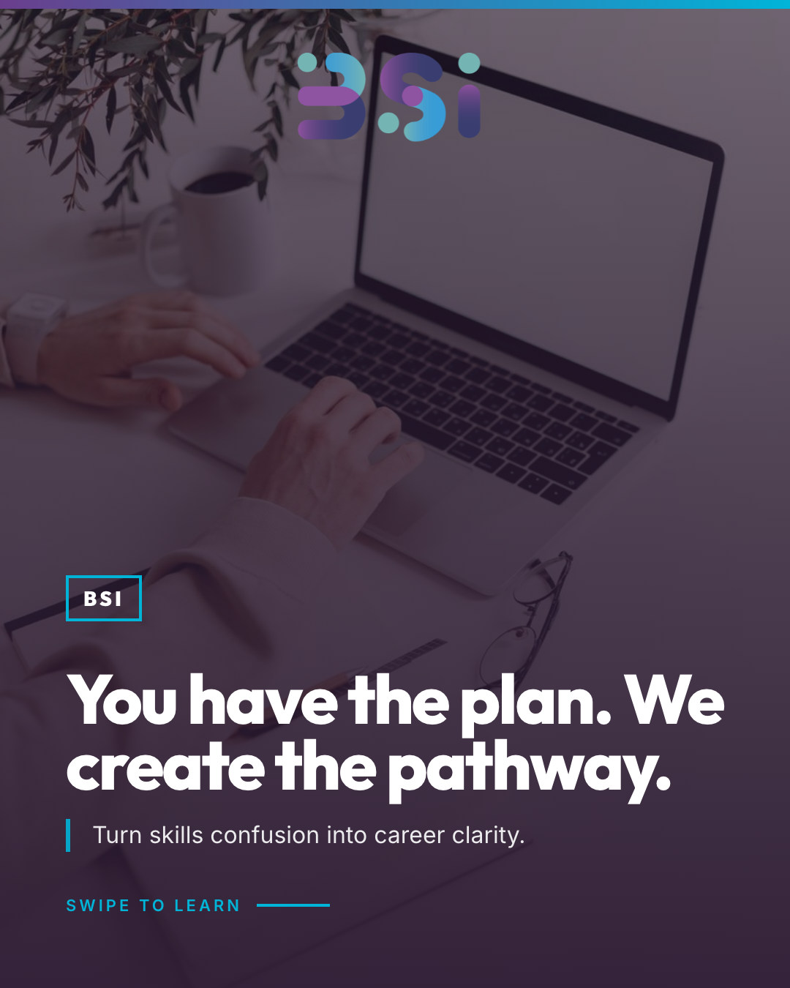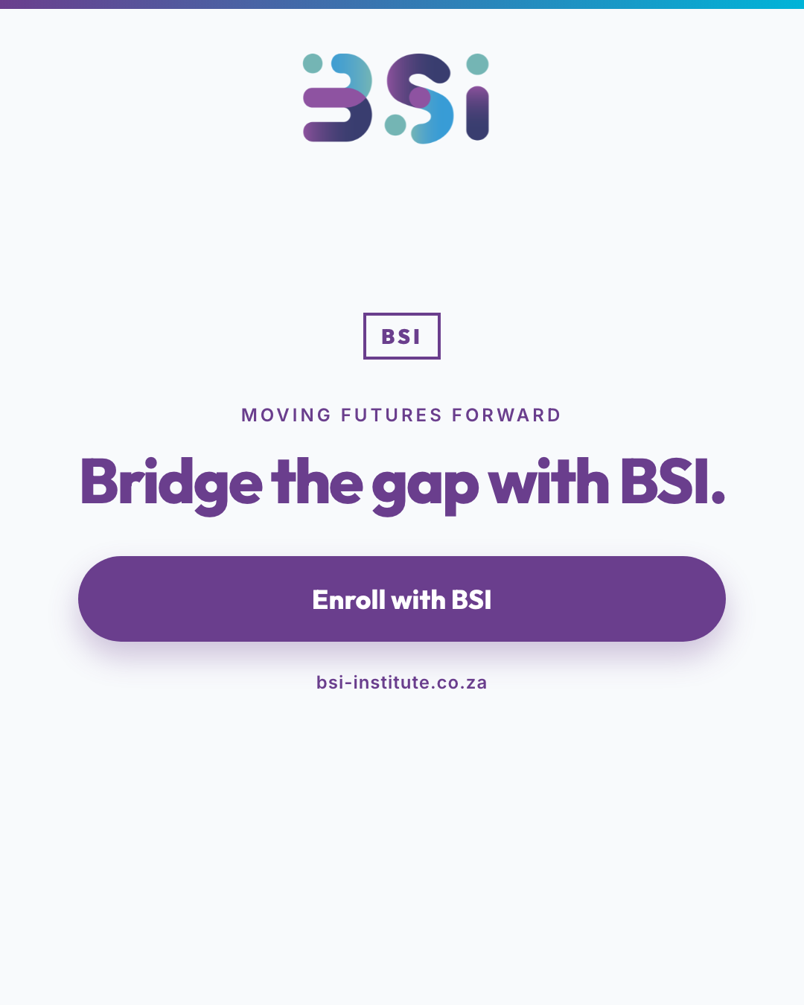
9 Aug | This Women's Day, we celebrate every woman moving her future forward.  You are rewriting the rules. Breaking through. Building the skills that matter.  Whether you're entering Banking, mastering Cybersecurity, or leading in Insurance—your growth is our mission.  BSI is proud to support women across South Africa with accredited, industry-aligned training that opens doors and closes gaps.  You are not alone in your journey. You are not behind. You are exactly where you need to be—ready for the next step.  Ready to move your future forward? Explore our learnerships and courses at bsi-institute.co.za  #BSI #HappyWomensDay #WomensDay2026 #SkillsDevelopment #CareerGrowth #SouthAfrica #WomenInBusiness #FutureReady #Learnerships #EmpowerWomen #MovingFuturesForward | 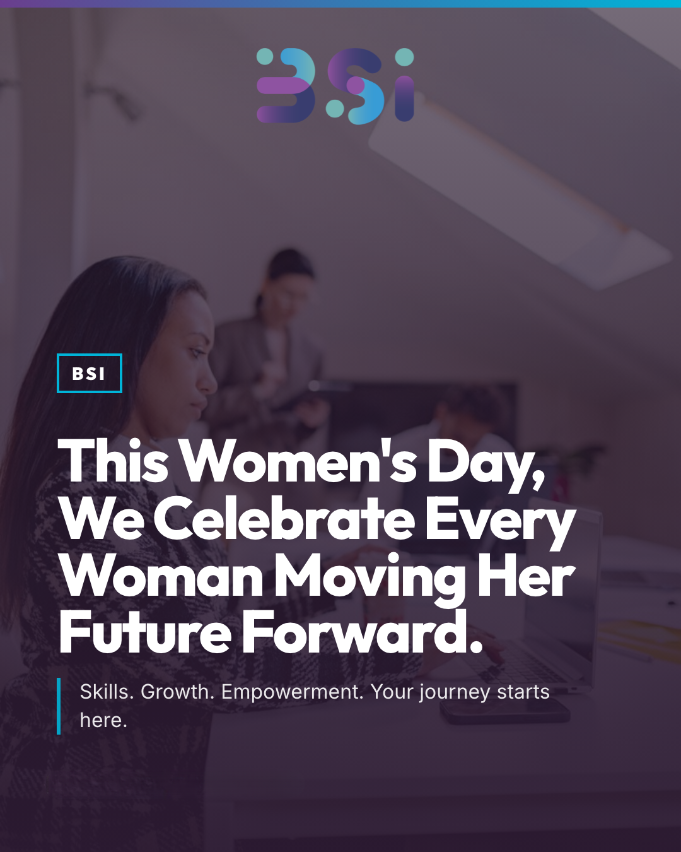
11 Aug | Most learnership failures happen before training even starts.  The difference between a transformative workforce development programme and a compliance headache? Four strategic decisions made upfront.  If you're planning a learner cohort, these decisions determine everything: programme alignment, learner success rates, workplace integration, and audit readiness.  BSI has guided hundreds of South African employers through successful learnership launches. We know what works—and what creates unnecessary risk.  Ready to move your workforce forward with confidence? Let's build your learnership strategy together.  Explore our corporate solutions at bsi-institute.co.za  #BSI #SkillsDevelopment #Learnerships #WorkplaceLearning #WorkforceDevelopment #HRStrategy #SouthAfrica #CorporateTraining #EmployeeTraining #BusinessGrowth #ComplianceReady | 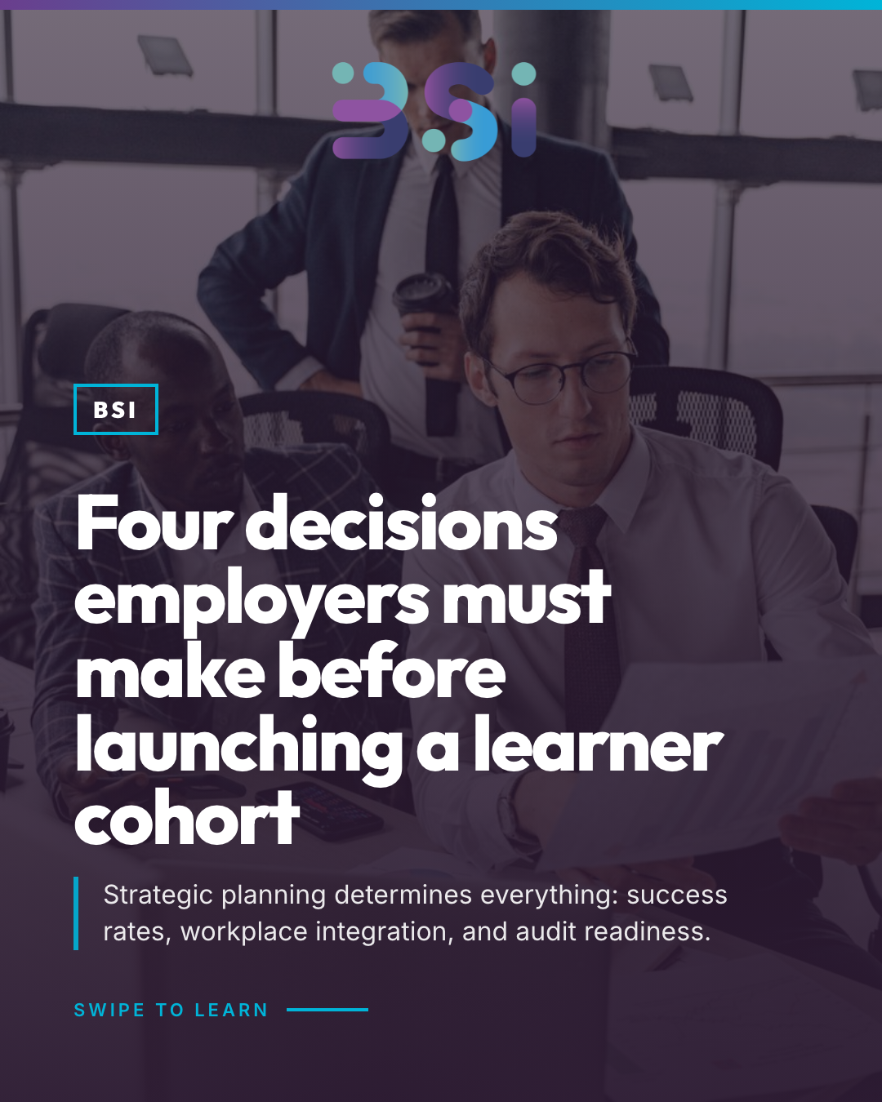  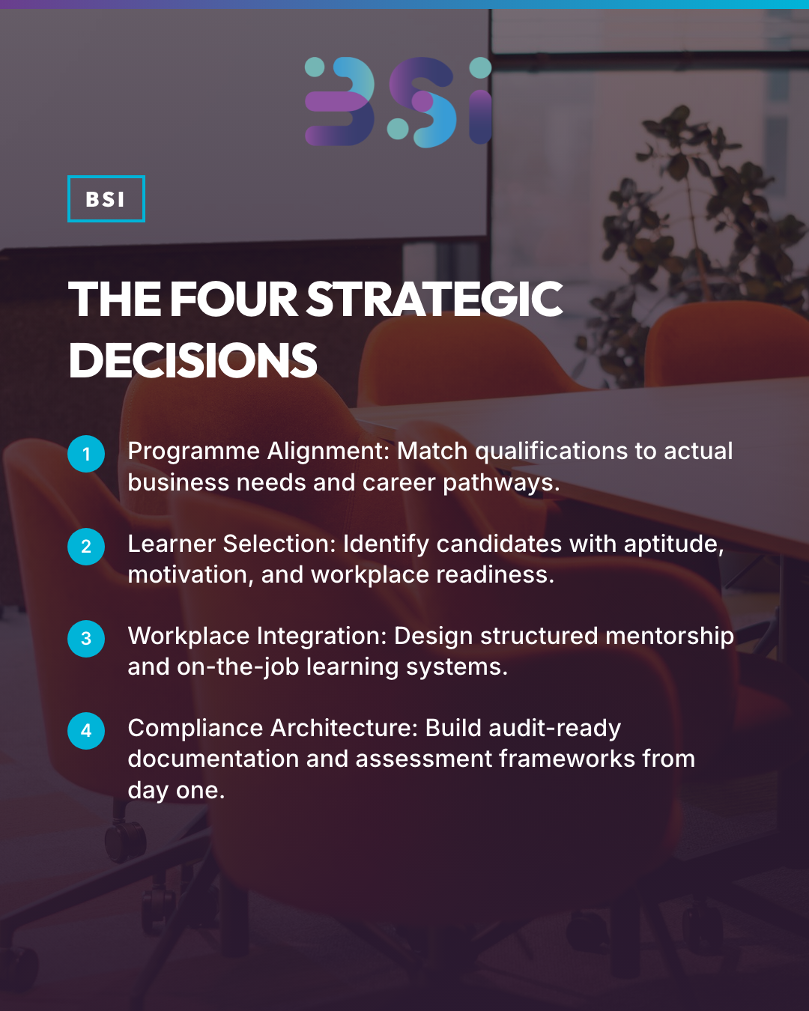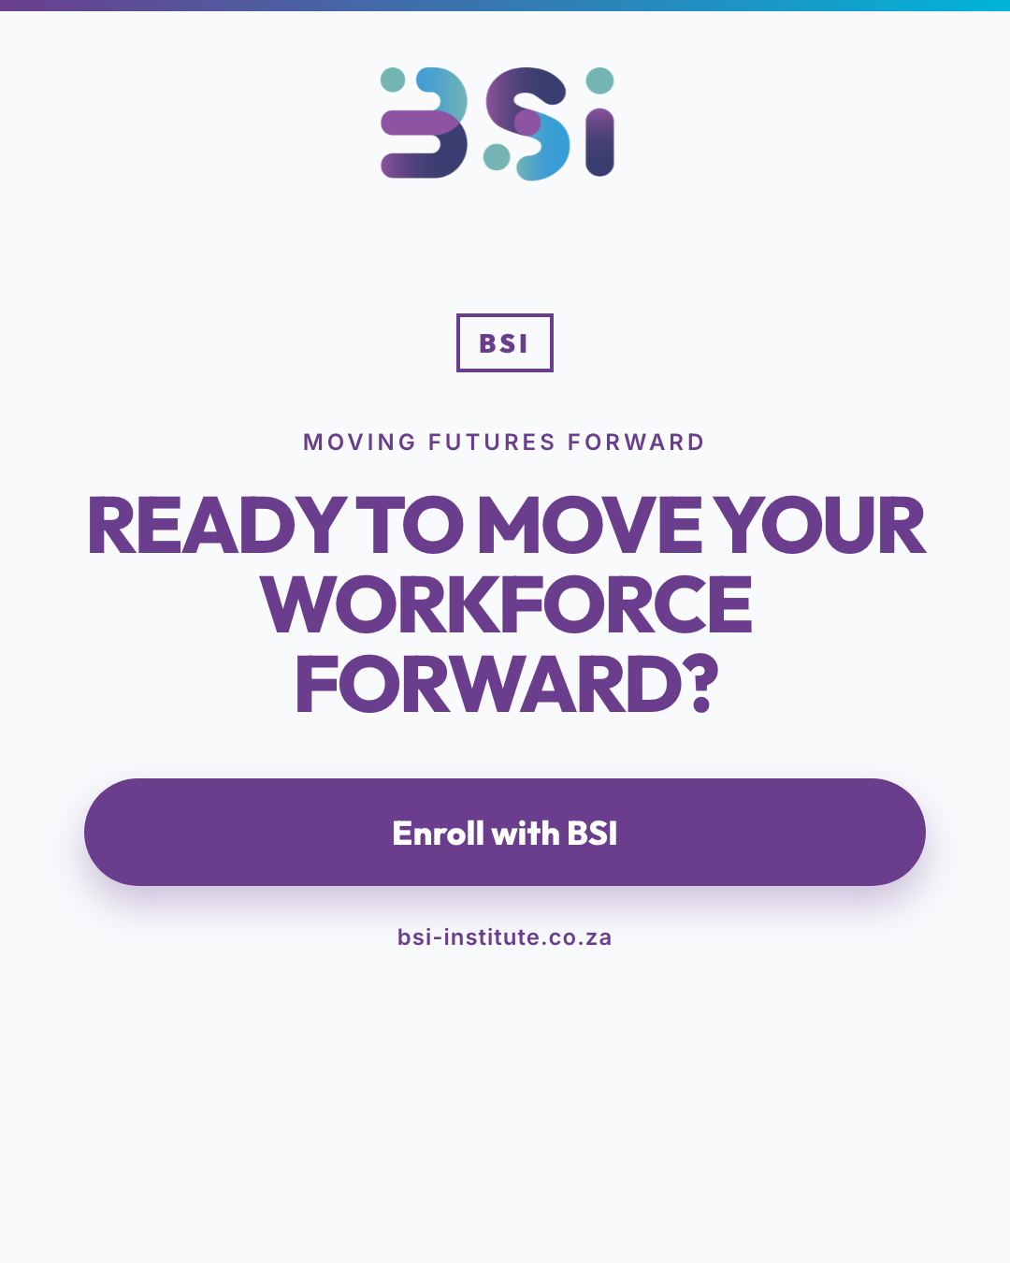
13 Aug | The financial services landscape is evolving faster than ever. But here's what most professionals miss: it's not about chasing every trend—it's about mastering the five convergence points that define the future of banking, insurance, and finance.  Technology. Compliance. Leadership. Customer capability. Data fluency.  These aren't just buzzwords. They're the exact skills employers are hiring for, promoting on, and building teams around right now.  The question isn't which qualification exists. It's which capability your career needs to strengthen today.  At BSI, we don't just offer courses. We map industry priorities to practical learning pathways—so you're always one step ahead.  Ready to move your future forward? Explore our accredited programmes at bsi-institute.co.za  #BSI #SkillsDevelopment #FinancialServices #CareerGrowth #SouthAfrica #Banking #Insurance #Learnerships #FutureReady #DigitalTransformation | 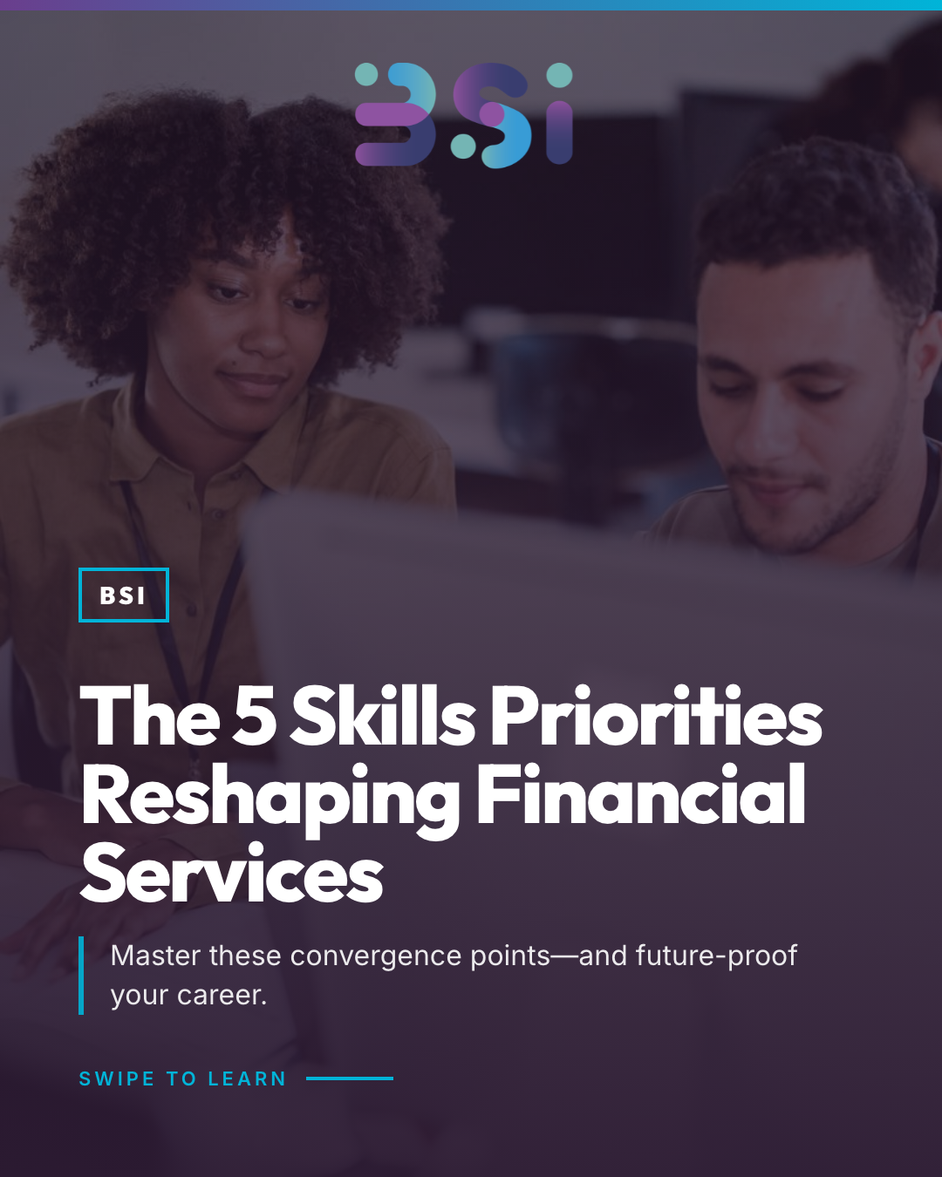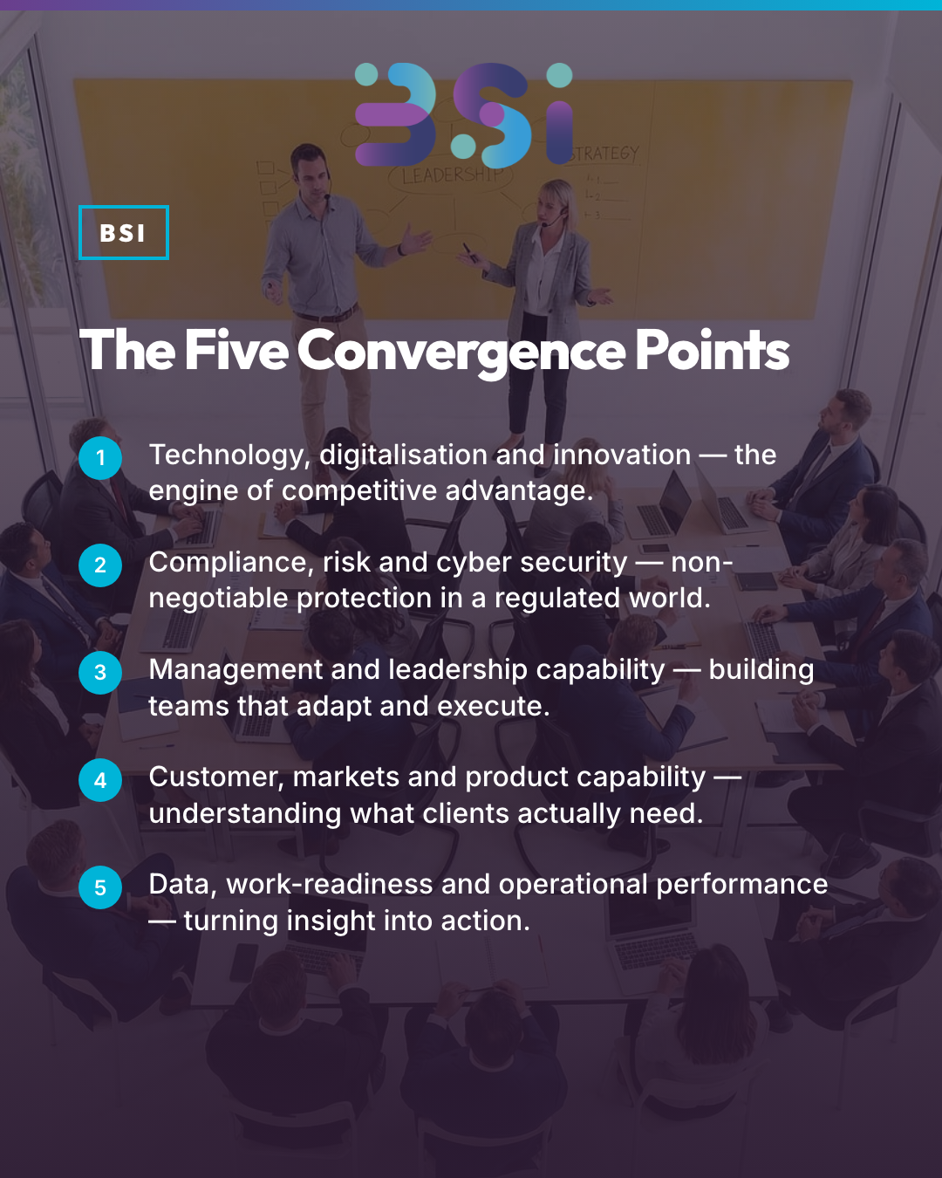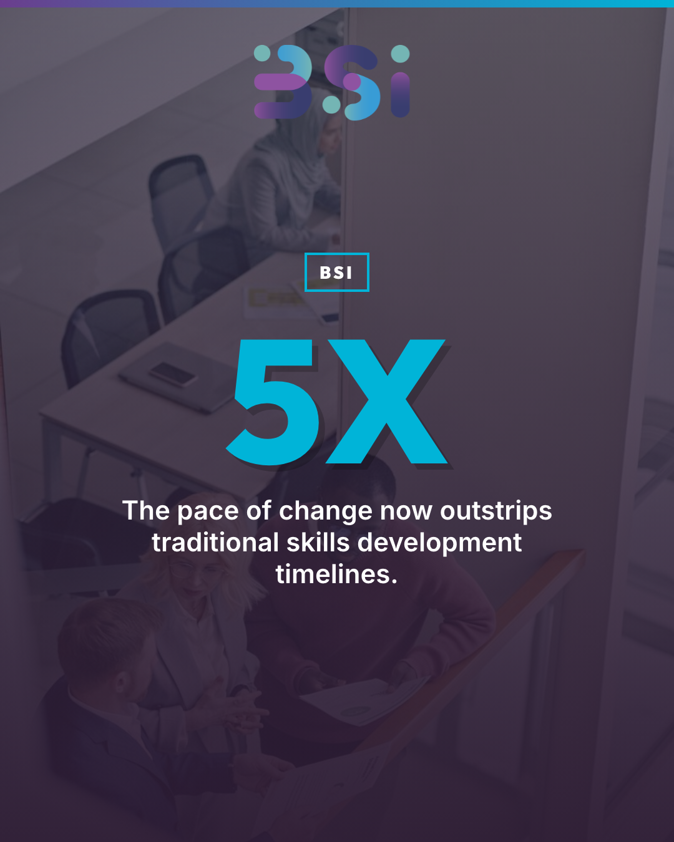  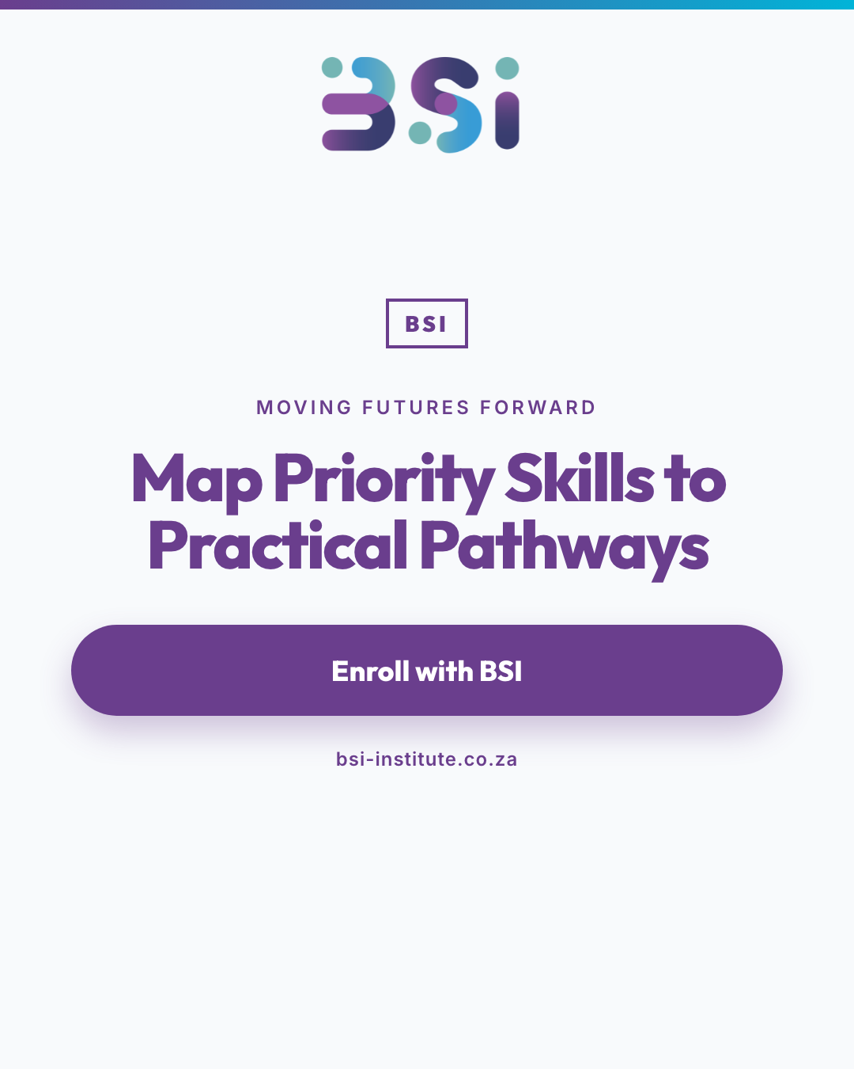
18 Aug | B-BBEE verification shouldn't feel like an audit nightmare.  The truth? Evidence isn't created during verification—it's created every single day of the learner journey.  ✓ Signed agreements before training begins  ✓ Demographic records aligned to compliance requirements  ✓ Assessment evidence tracked in real-time  ✓ Expenditure proof captured, not reconstructed  ✓ Progress milestones documented systematically  When training supports real transformation—not just compliance theatre—the evidence trail tells that story clearly.  BSI designs learnership programmes with verification-ready documentation built in. Because your B-BBEE scorecard should reflect the genuine skills development happening in your organisation.  Ready to move your future forward? Explore our corporate training solutions at bsi-institute.co.za  #BSI #SkillsDevelopment #BBBEE #CorporateTraining #SouthAfrica #Learnerships #HRLeadership #Transformation #ComplianceExcellence | 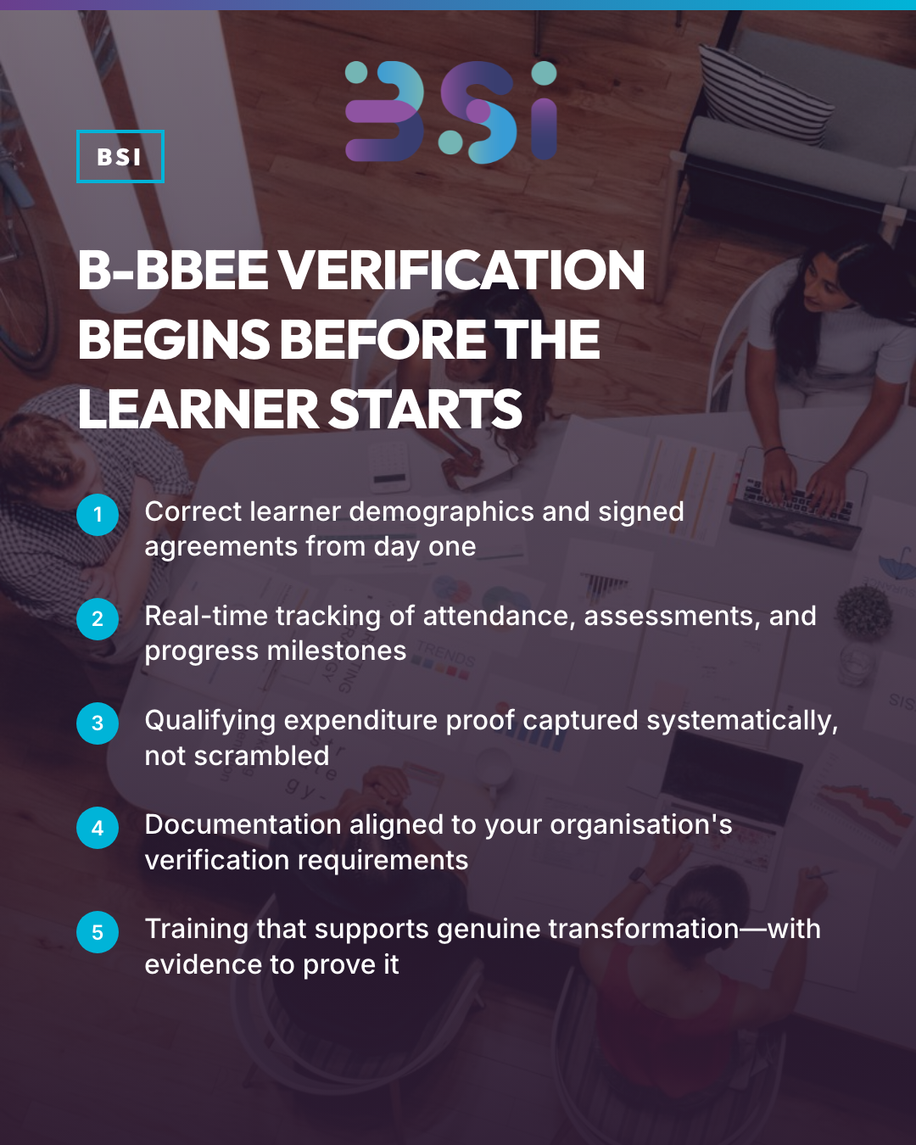
25 Aug | Which part of learner implementation is currently the biggest challenge for your organisation?  • Confirming programme availability  • Selecting the right learners  • Securing workplace support  • Managing evidence and reporting | POLL
28 AUg | ARTICLE  From Skills Plan to Learner Cohort: A Practical Action Guide for Financial Services Employers  SUGGESTED ARTICLE STRUCTURE  1. What has changed — and what employers must still decide  2. Moving from WSP/ATR priorities to a practical learner plan  3. Aligning training with business, transformation and B-BBEE Skills Development objectives  4. Planning for mandatory, PIVOTAL and discretionary grant considerations  5. Verifying programme, provider and learner readiness  6. Building workplace support and an evidence trail  7. The executive action checklist

