IT STANDARD OPERATING PROCEDURE
Installation of the Vision Portal on RHEL
Automated Deployment Using Bash Scripts
Red Hat Enterprise Linux 9.7 • FIPS + CIS / DISA-STIG Compliant
Document Title | Vision Portal Installation SOP (RHEL)
Source Repository | Signifi-IT / vision-allinone-rhel-shell_scripts
Target Platform | RHEL 9.7 (on-prem or public cloud)
Privilege Level | root (via sudo)
Document Version | 2.0
Classification | Internal — IT Operations

Table of Contents

1. Introduction
The Vision Portal is an all-in-one web application platform deployed on a single Red Hat Enterprise Linux (RHEL) host. A complete deployment brings together several components on the same server: a PostgreSQL 14 database, a PHP 8.2 application tier served by Apache HTTPD, an HAProxy edge that terminates TLS and routes traffic, and a PeerJS signalling service managed under PM2.
This Standard Operating Procedure (SOP) documents the supported, repeatable method for installing the Vision Portal using the automated Bash scripts maintained in the Signifi-IT vision-allinone-rhel-shell_scripts repository. The scripts are numbered and run in sequence; each performs a discrete phase of the build, logs its actions to a shared deployment log, and validates its results. A single answer file (answers.txt) supplies every environment-specific value, and three operator-supplied files (a TLS certificate, an SSH deploy key, and a database backup) are staged ahead of time.
Following this procedure end to end produces a consistent, security-hardened deployment and reduces the risk of manual error. Every command needed to complete the installation, along with the commands used to verify each phase, is included.

2. Audience
This document is intended for IT and infrastructure engineers responsible for provisioning and deploying the Vision Portal. Readers are expected to be comfortable with:
- Administering RHEL 9 systems from the command line, including dnf, systemctl, and SELinux concepts.
- Operating as the root user and using sudo to escalate privileges.
- Basic Git operations and SSH key handling.
- Core service concepts for PostgreSQL, Apache HTTPD/PHP-FPM, HAProxy, and Node.js/PM2.
It is also a useful reference for technical reviewers, security and compliance personnel verifying the build against the required baseline, and support staff who need to understand how the platform is assembled.

3. Scope
This SOP covers the complete installation and configuration of the Vision Portal on a single, fresh RHEL 9.7 server (on-premises or in a public cloud), from initial system preparation through to post-installation verification. It includes:
- System preparation, package installation, and the system upgrade / reboot.
- Configuration of the PostgreSQL repository, installation of PostgreSQL 14, and restoration of the application database from a backup.
- Deployment of the application, media, API, and mobile components, and PHP configuration.
- Configuration of Apache HTTPD, HAProxy with TLS, and the PeerJS service.
- Populating the answer file, staging the required files, and running all eight scripts in order, with verification at each step.
The following are out of scope for this document:
- Provisioning the underlying server, network, DNS, or firewall, and applying the FIPS + CIS / DISA-STIG baseline (these are prerequisites, assumed complete).
- Obtaining the TLS certificate, SSH deploy key, and database backup file (supplied by the operator).
- Application-level administration, day-2 operations, upgrades, backups, monitoring, and disaster recovery.
- Multi-server, high-availability, or horizontally scaled topologies — this procedure addresses the single-host all-in-one deployment only.

4. Architecture Overview
All components run on one RHEL host. HAProxy is the only service exposed to clients; it terminates TLS on port 443 and reverse-proxies to the backend services, which bind to localhost only. The diagram below shows the request flow.
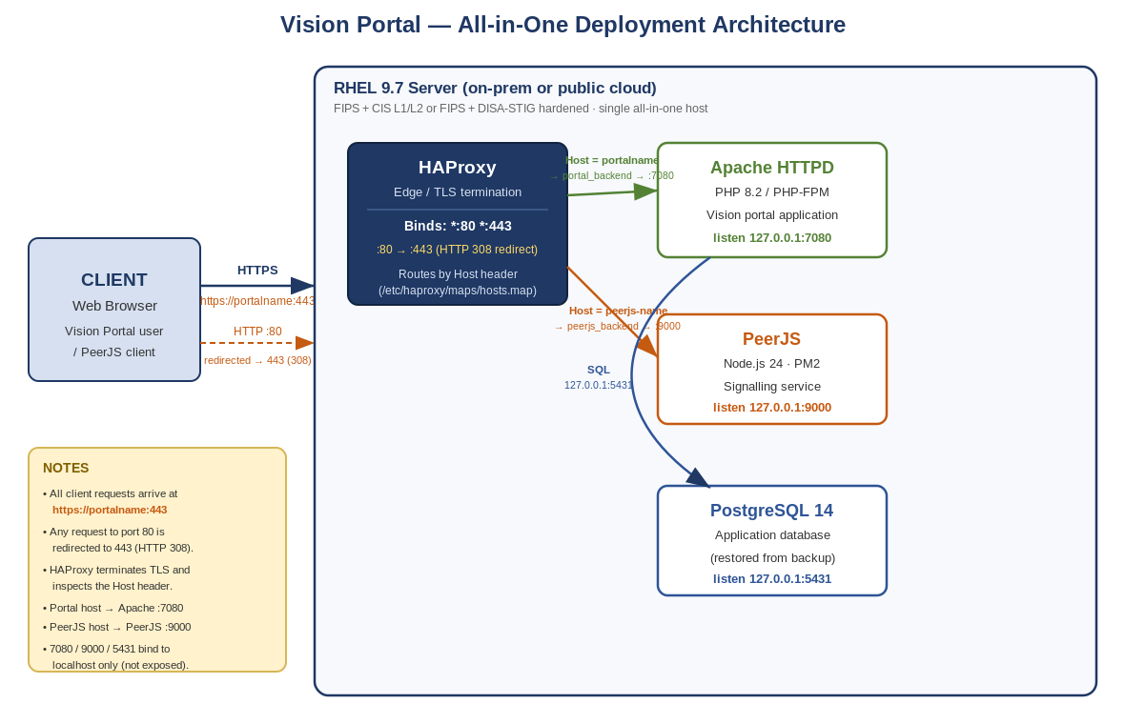
Request flow: A client always connects to https://portalname:443. Any request that arrives on port 80 is redirected to 443 with an HTTP 308. HAProxy binds *:80 and *:443, terminates TLS, and inspects the Host header to choose a backend: portal traffic is proxied to Apache HTTPD on 127.0.0.1:7080, and PeerJS traffic is proxied to the Node.js/PeerJS service on 127.0.0.1:9000. Apache (PHP-FPM) connects to PostgreSQL on 127.0.0.1:5431.
Service | Bind address | Role
HAProxy | *:80 and *:443 | TLS edge; 80→443 (308); host-based routing
Apache HTTPD / PHP-FPM | 127.0.0.1:7080 | Serves the Vision portal application
PeerJS (Node.js / PM2) | 127.0.0.1:9000 | Real-time signalling service
PostgreSQL 14 | 127.0.0.1:5431 | Application database

5. Prerequisites
The following prerequisites must be satisfied before beginning. Do not proceed until every item is confirmed.

5.1 Server and Operating System
Requirement | Details
RHEL Server | A Red Hat Enterprise Linux server — on-premises (physical or virtual) or an instance in a public cloud (AWS, Azure, GCP, OCI, etc.).
Operating System Version | Currently supported: RHEL 9.7  The version must be locked to RHEL 9.7 so that future dnf upgrade operations do not move the host to a newer minor release.
RHEL Subscription | Registered with an active Red Hat subscription attached to a pool that provides BaseOS, AppStream and CodeReady Builder content.
Security Baseline | Hardened to one of: FIPS + CIS Level I/II, or FIPS + DISA-STIG. FIPS mode enabled and the CIS or STIG profile applied before installation.
Privileges | An account with sudo rights able to escalate to root.
Network / Outbound Access | Outbound access to the destinations listed in Section 5.2 (Red Hat CDN, PGDG and Fedora/EPEL repositories, GitHub, Bitbucket, the npm registry and PM2).

5.2 Outbound Network Whitelist
On firewalled or proxied networks, whitelist every domain below before running the scripts. Unless noted, access is over HTTPS (TCP 443); time sync uses NTP (UDP 123); GitHub and Bitbucket cloning use HTTPS/SSH.
Domain | Purpose
pool.ntp.org | Public NTP service used to synchronize system time.
subscription.rhsm.redhat.com | Red Hat subscription management service for entitlement and licensing.
cert-api.access.redhat.com | Red Hat API used for certificate and system authentication services.
cert.console.redhat.com | Red Hat web console service for certificate and system identity management.
connect.cloud.redhat.com | Red Hat Insights / telemetry platform for system monitoring and analytics.
cdn.redhat.com | Red Hat content delivery network for package and update distribution.
download.postgresql.org | Official PostgreSQL repository for database software packages.
dl.fedoraproject.org | Fedora project download server for packages and updates.
mirrors.fedoraproject.org | Fedora mirror redirect service that selects nearby download mirrors.
ca.mirrors.cicku.me | Third-party Fedora mirror used to serve package downloads.
codecs.fedoraproject.org | Fedora repository providing multimedia codecs and related packages.
github.com | Git hosting platform from which this deployment repository is cloned.
bitbucket.org | Git-based source code hosting platform by Atlassian (application repositories).
version.pm2.io | PM2 service endpoint used for version checks and updates of the Node.js process manager.
registry.npmjs.org | Official npm registry for JavaScript / Node.js package downloads.
IMPORTANT — wildcard domains and DNS search configuration
Wildcard domain entries (e.g. *.domain.com) should be evaluated based on the system’s DNS search configuration defined in /etc/resolv.conf.
Any domain listed under the search directive (for example, search example.com) should be treated as a wildcard whitelist entry to ensure proper resolution of short hostnames within that domain.
If no search domain is configured, add a corresponding entry based on the system hostname or intended DNS domain to ensure consistent and reliable name-resolution behaviour.
Check the current search domains with:
grep -E '^(search|domain)' /etc/resolv.conf

5.3 Verify the Prerequisites
Confirm the RHEL release is 9.7:
cat /etc/redhat-release
# Expected: Red Hat Enterprise Linux release 9.7 (Plow)
Confirm the subscription status:
subscription-manager status
# Expected: Overall Status: Current / Registered
Confirm FIPS mode is enabled (both should report enabled / 1):
fips-mode-setup --check
cat /proc/sys/crypto/fips_enabled
Confirm (or set) the version lock so dnf stays on 9.7:
subscription-manager release --set=9.7
subscription-manager release --show

5.4 Install Git and Clone the Repository
This procedure is delivered as a Git repository that must be cloned to /tmp/scripts the first time. Escalate to root, install Git with dnf, then clone the repository and change into it.
Escalate to root:
sudo -i
whoami # Expected: root
Install Git (skip if already present):
dnf install -y git
git --version
Clone the repository into /tmp/scripts:
git clone https://github.com/Signifi-IT/vision-allinone-rhel-shell_scripts.git /tmp/scripts
Change into the scripts directory:
cd /tmp/scripts
ls -1 *.sh # confirm the eight numbered scripts are present

6. Configuration File — answers.txt
Every environment-specific value is supplied through answers.txt, which is sourced by each script. Populate the empty values and review the pre-filled ones before running any script. Paths default to ${SCRIPT_DIR}/files/project_files/, where ${SCRIPT_DIR} resolves to the scripts directory automatically.

6.1 Variable Reference
Variable | Description
LOCAL_TIMEZONE | System timezone applied by 10-system_prep.sh. A valid zoneinfo name, e.g. America/Toronto.
POSTGRES_ADMIN_PASSWORD | Password set for the PostgreSQL superuser (postgres).
DB_USER_AUTHENTICATION_HBA | Array of DB roles that receive a local scram-sha-256 rule in pg_hba.conf.
DB_NETWORK_AUTHENTICATION_HBA | Array of CIDR networks granted host scram-sha-256 access in pg_hba.conf.
APP_DB_USER | Application database role (owner of the application database).
APP_DB_PASSWORD | Password for APP_DB_USER.
APP_DB_NAME | Name of the application database created and into which the backup is restored.
BACKUP_FILE_PATH | Path to the PostgreSQL backup file. Defaults to ${SCRIPT_DIR}/files/project_files/<filename> — set <filename> to your dump.
BITBUCKET_KEY | Path to the SSH private key used to clone the application and PeerJS repositories from Bitbucket. Defaults to ${SCRIPT_DIR}/files/project_files/<filename>.
PORTAL_URL | Public URL / domain of the Vision portal. Drives the web root, Apache vhost, HAProxy backend and TLS host map.
APP_URL | Git (SSH) URL of the main Vision application repository. Default: git@bitbucket.org:teamsignifi/vision.git.
APP_BRANCH | Git branch of the main application to deploy (e.g. qa-15.0.0).
APP_MEDIA_URL | Git (SSH) URL of the media-assets repository.
APP_MEDIA_BRANCH | Git branch of the media-assets repository.
APP_API_URL | Git (SSH) URL of the application API repository.
APP_API_BRANCH | Git branch of the API repository.
APP_MOBILE_URL | Git (SSH) URL of the mobile-UI distribution repository.
APP_MOBILE_BRANCH | Git branch of the mobile-UI repository.
ALLOWED_SERVER_STATUS_IPS | Array of CIDR ranges permitted to reach the Apache /status and /server-status endpoints via HAProxy.
CERT_PATH | Path to the SSL/TLS certificate (PEM) used by HAProxy for both the portal and PeerJS. Defaults to ${SCRIPT_DIR}/files/project_files/<haproxy_cert>.pem.
HAPROXY_ALLOWED_STATS_IPS | Array of CIDR ranges permitted to reach the HAProxy stats endpoint /haproxy-stats.
PEERJS_PORTAL_URL | Public URL / domain of the PeerJS signalling service. Drives its web root, HAProxy backend and TLS host map.

6.2 Edit the Answer File
nano /tmp/scripts/answers.txt
IMPORTANT
Fill in every blank variable — passwords, timezone, portal URLs, database name/user, and the BACKUP_FILE_PATH, BITBUCKET_KEY and CERT_PATH filenames. A script aborts early if a variable it requires is empty or a referenced file is missing.

7. Required Files — files/project_files/
Three operator-supplied files must be staged before running the scripts. Place all three in the files/project_files/ directory inside the cloned repository and point the matching answers.txt variable at each. These files are not stored in Git (the directory ships with only a .gitkeep placeholder).
File | answers.txt variable | Purpose
TLS certificate (PEM) | CERT_PATH | Combined certificate + private key in PEM format used by HAProxy to terminate HTTPS for both the portal and PeerJS. Installed to /etc/haproxy/certs/.
SSH deploy key | BITBUCKET_KEY | Private SSH key used to clone the Vision application, media, API, mobile and PeerJS repositories from Bitbucket. The scripts set its permissions to 0400 automatically.
Database backup | BACKUP_FILE_PATH | PostgreSQL dump restored into the application database by 40-postgresql_setup.sh via pg_restore.

7.1 Stage the Files
Copy your three files into place (adjust the source paths to wherever you uploaded them):
cd /tmp/scripts
cp <source>/<haproxy_cert>.pem files/project_files/
cp <source>/<ssh_key> files/project_files/
cp <source>/<backup>.dump files/project_files/
Verify all three files are present and non-empty, and that answers.txt points at them:
ls -l /tmp/scripts/files/project_files/
grep -E '^(BACKUP_FILE_PATH|BITBUCKET_KEY|CERT_PATH)=' answers.txt

8. Deployment Overview
The installation is split into eight scripts, run strictly in order. Each logs to a shared deployment log and validates its results.
Script | Purpose
10-system_prep.sh | Cleans/rebuilds DNF metadata, installs base utilities, removes Vim, performs a full system upgrade, sets Nano as default editor and the timezone, then reboots the server.
20-postgresql_repo.sh | Disables the built-in PostgreSQL module and configures the official PostgreSQL (PGDG) repository.
30-app_stack.sh | Installs EPEL, enables CodeReady Builder, restricts to the required repos, installs PHP 8.2, PostgreSQL 14, Apache HTTPD and supporting packages; initialises PostgreSQL on port 5431 and sets SELinux booleans.
40-postgresql_setup.sh | Sets the postgres admin password, configures pg_hba.conf (scram-sha-256), creates the application role and database, and restores the database backup.
50-setup_application_files.sh | Clones the Vision application, media, API and mobile repositories from Bitbucket, deploys PHP configuration files and restarts PHP-FPM.
60-configure_apache_site.sh | Hardens Apache, sets the listener to 127.0.0.1:7080, renders the virtual host from a template and maps the SELinux HTTP port.
70-haproxy_setup.sh | Installs and configures HAProxy (2.8.14) and rsyslog, deploys the TLS certificate, renders front-end/back-end configs and starts HAProxy.
80-peerjs_setup.sh | Installs Node.js 24 and PM2, deploys the PeerJS server, installs its TLS certificate, wires it into HAProxy and persists the PM2 process.
All scripts append to /var/log/vision_deployment.log. Tail it in a second terminal to watch progress: tail -f /var/log/vision_deployment.log.

9. Installation Procedure
Complete Sections 5.4 (clone), 6 (answers.txt) and 7 (staged files) first. All steps run as root from within /tmp/scripts.

9.1 Make the Scripts Executable
cd /tmp/scripts
chmod +x *.sh

9.2 Run the Scripts in Sequence
Execute the scripts in numerical order. Do not start a script until the previous one has completed successfully.
NOTE — automatic reboot after the first script
After running 10-system_prep.sh, the system will reboot automatically (a reboot is scheduled one minute after it completes, to apply the full system upgrade).
Wait for the server to finish rebooting, reconnect over SSH, and escalate to root again before running any of the remaining scripts (20- through 80-).

Step 1 — System preparation (triggers reboot)
./10-system_prep.sh
Wait for the reboot, then reconnect and return to the scripts directory:
ssh <user>@<server>
sudo -i
uptime
cd /tmp/scripts

Step 2 — Configure the PostgreSQL repository
./20-postgresql_repo.sh
Verify: dnf repolist | grep -i pgdg

Step 3 — Install the application stack
./30-app_stack.sh
Verify PHP, the services and PostgreSQL on 5431:
php -v
systemctl is-enabled postgresql-14 httpd php-fpm
/usr/pgsql-14/bin/pg_isready -p 5431

Step 4 — Configure PostgreSQL and restore the database
./40-postgresql_setup.sh
Verify the database exists and the migrations query ran (logged):
sudo -u postgres /usr/pgsql-14/bin/psql -p 5431 -c "\l"
grep -i 'Migrations table' /var/log/vision_deployment.log

Step 5 — Deploy the application files
./50-setup_application_files.sh
Verify the web root is populated and PHP-FPM is running:
ls -l /var/www/<PORTAL_URL>
systemctl status php-fpm --no-pager

Step 6 — Configure the Apache site
./60-configure_apache_site.sh
Verify Apache config, listener on 7080 and the SELinux port:
apachectl configtest
ss -ltnp | grep 7080
semanage port -l | grep 7080

Step 7 — Set up HAProxy and TLS
./70-haproxy_setup.sh
Verify the HAProxy config validates and the service is active:
haproxy -c -f /etc/haproxy/haproxy.cfg -f /etc/haproxy/conf.d
systemctl status haproxy --no-pager
ls -l /etc/haproxy/certs/

Step 8 — Deploy PeerJS
./80-peerjs_setup.sh
Verify Node.js, the PM2 process and the reloaded HAProxy:
node -v
/usr/local/bin/pm2 list
systemctl status haproxy --no-pager

10. Post-Installation Verification
Once all eight scripts have completed, confirm the platform is healthy end-to-end.
- All core services active: systemctl is-active postgresql-14 httpd php-fpm haproxy
- PeerJS online under PM2: /usr/local/bin/pm2 status
- Backends listening on localhost: ss -ltnp | grep -E '5431|7080|9000'
- HAProxy edge listening on 80 and 443: ss -ltnp | grep -E ':80|:443'
- Review the deployment log for warnings/errors: grep -E '\[(WARN|ERROR)' /var/log/vision_deployment.log
- From a browser, confirm the portal loads over HTTPS and that http://<PORTAL_URL> redirects to https://<PORTAL_URL>. Also check the PeerJS host resolves through HAProxy.
End of Standard Operating Procedure

