Effect of CT Acquisition Parameters on Reconstruction Quality Using Digital Phantoms
Student: Caio Martini De Souza
Course: COSC 4372 – Fundamentals of Medical Imaging

Members of the Team
- Caio Martini De Souza – PSID 1856442 – Undergraduate – Computer Science

1. Introduction
Computed tomography (CT) relies on the acquisition of multiple X-ray projections around an object, followed by image reconstruction using inverse algorithms such as filtered backprojection. In practical systems, image quality strongly depends on acquisition parameters such as the number of projections and the angular coverage of the scan. Fewer projections or limited-angle acquisition can reduce imaging time and radiation dose, but may degrade reconstruction accuracy and introduce artifacts.
This project simulates the CT imaging pipeline using digital phantoms and evaluates reconstructed image quality objectively using several quantitative metrics. The work expands on material covered in class by implementing sinogram generation, reconstruction using MATLAB’s iradon, and image‐quality assessment methods that measure pixel accuracy, structural fidelity, gradient sharpness, and edge preservation.
The project aims are:
- Aim 1: Generate digital phantoms (simple geometric phantom and Modified Shepp–Logan phantom) to serve as ground-truth images for CT reconstruction.
- Aim 2: Simulate CT acquisition using varying numbers of projections and angular coverage values, producing sinograms for each parameter combination.
- Aim 3: Reconstruct images using filtered backprojection and compare reconstructions with their ground-truth phantoms.
- Aim 4: Quantitatively evaluate reconstruction quality using MSE, SSIM, Gradient Error, Gradient Entropy, and Laplacian‐based sharpness, and analyze how these metrics vary with acquisition parameters.
- Aim 5: Generate summary plots illustrating the effect of acquisition settings on reconstruction fidelity.

2. Methods

2.1 Phantom Generation
Two types of ground-truth phantoms were used:
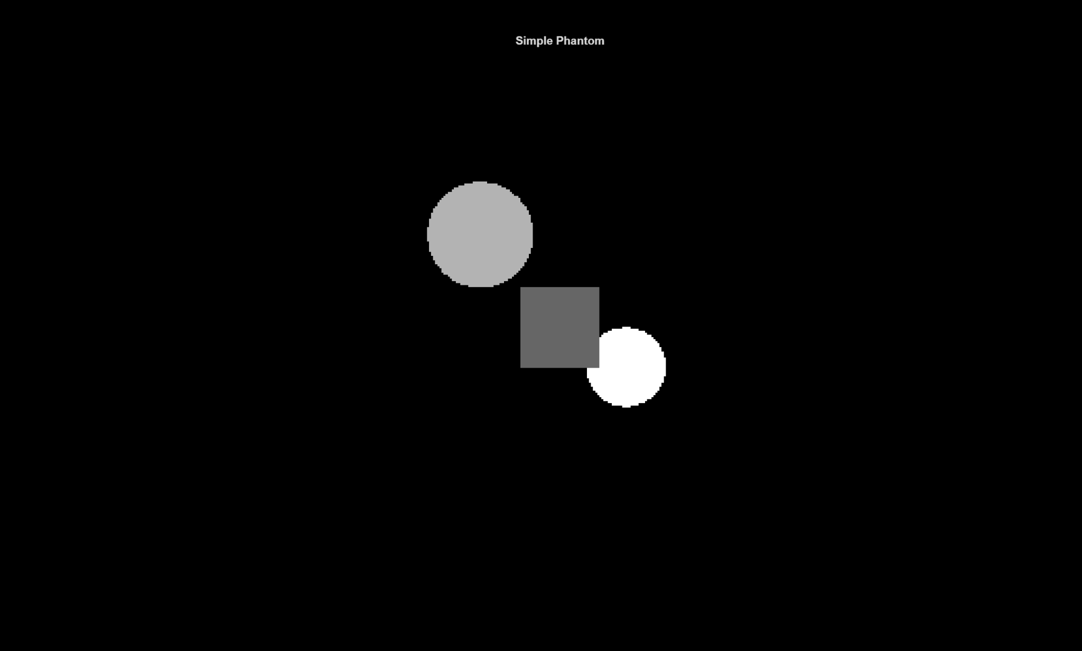
- Simple Phantom: A custom phantom made of two circular regions with different intensities and a rectangular region. This phantom provides clear edges and simple shapes for assessing how reconstruction quality degrades under limited sampling.
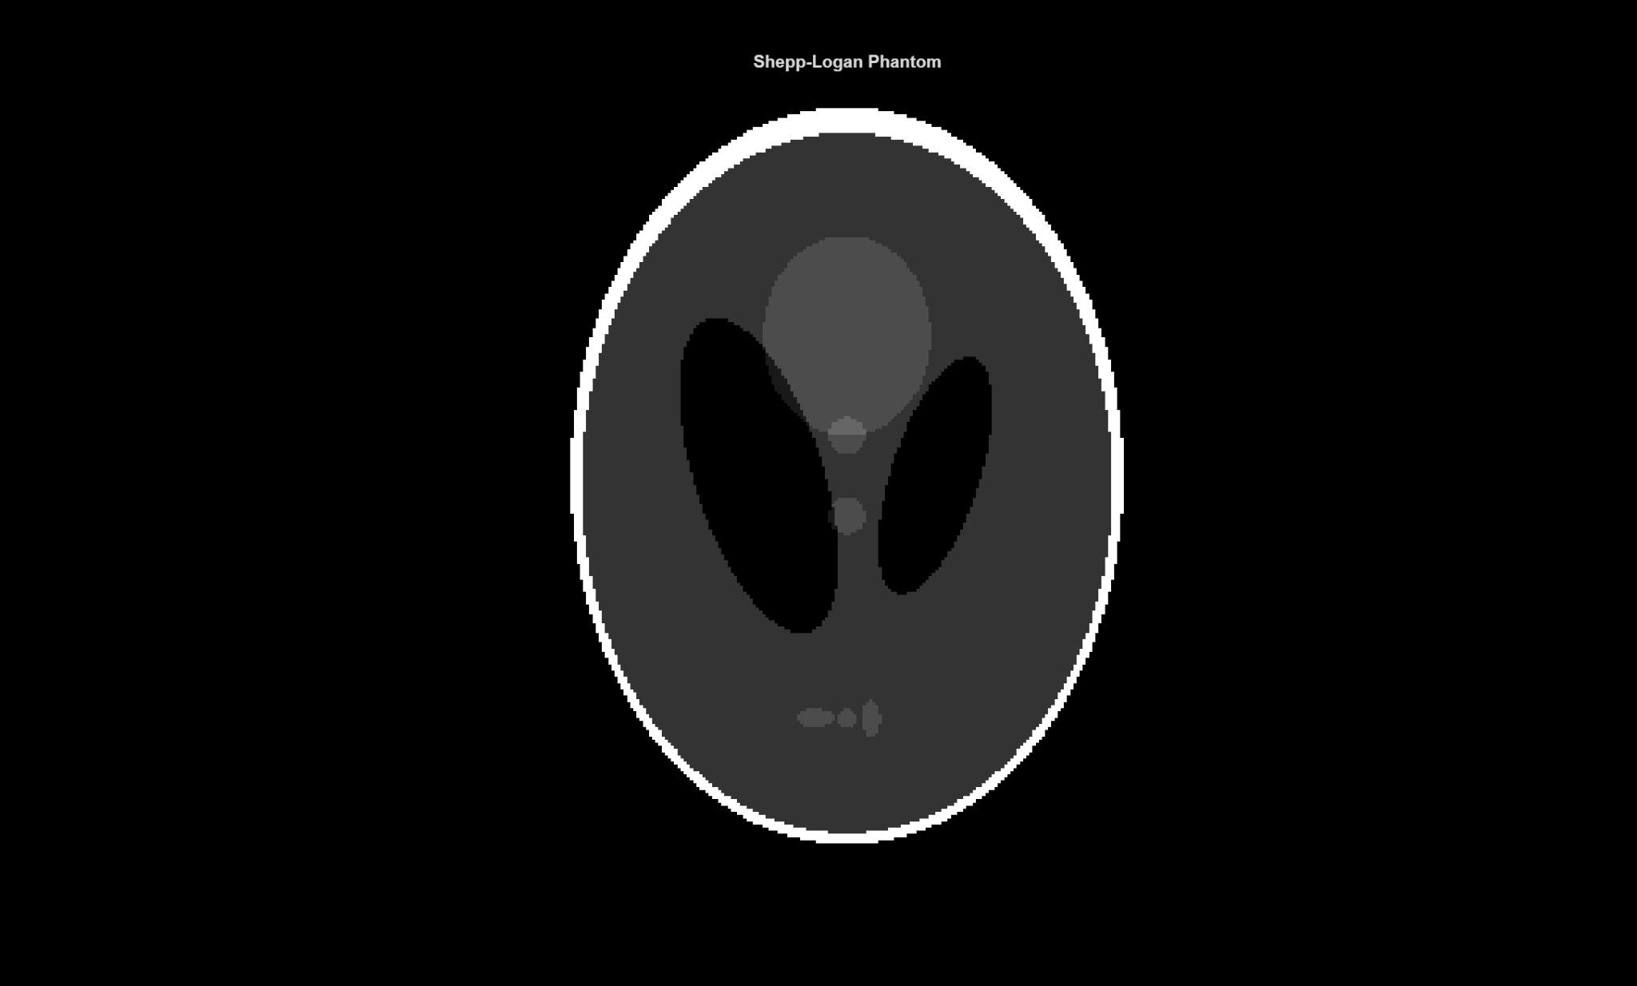
- Modified Shepp–Logan Phantom: MATLAB’s phantom("Modified Shepp-Logan"), representing a simplified anatomical head model commonly used in CT simulation studies.
This phantom generation procedure directly addresses Aim 1, which focuses on creating ground-truth images for use in all reconstruction experiments.
Both phantoms were generated at 256 × 256 resolution and stored for use in all experiments.

2.2 CT Acquisition Simulation
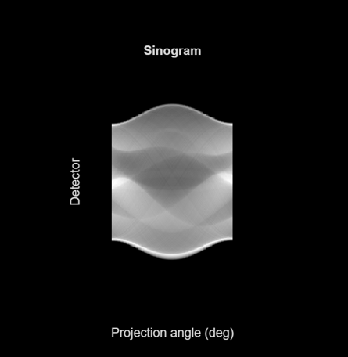
Parallel-beam projection data were generated using MATLAB’s radon function. For each phantom, sinograms were computed using the following acquisition parameters:
- Number of projections (nProj):
30, 60, 90, 180
- Maximum scan angle (θ<sub>max</sub>):
180°, 150°, 120°, 90°
Projection angles were uniformly distributed from 0 to θ<sub>max</sub>.
Reducing θ<sub>max</sub> simulates limited-angle CT, an important real-world challenge that leads to incomplete sampling and characteristic streak artifacts. This acquisition setup fulfills Aim 2, where the goal is to simulate CT projection data under varying numbers of projections and angular coverage.

2.3 Reconstruction
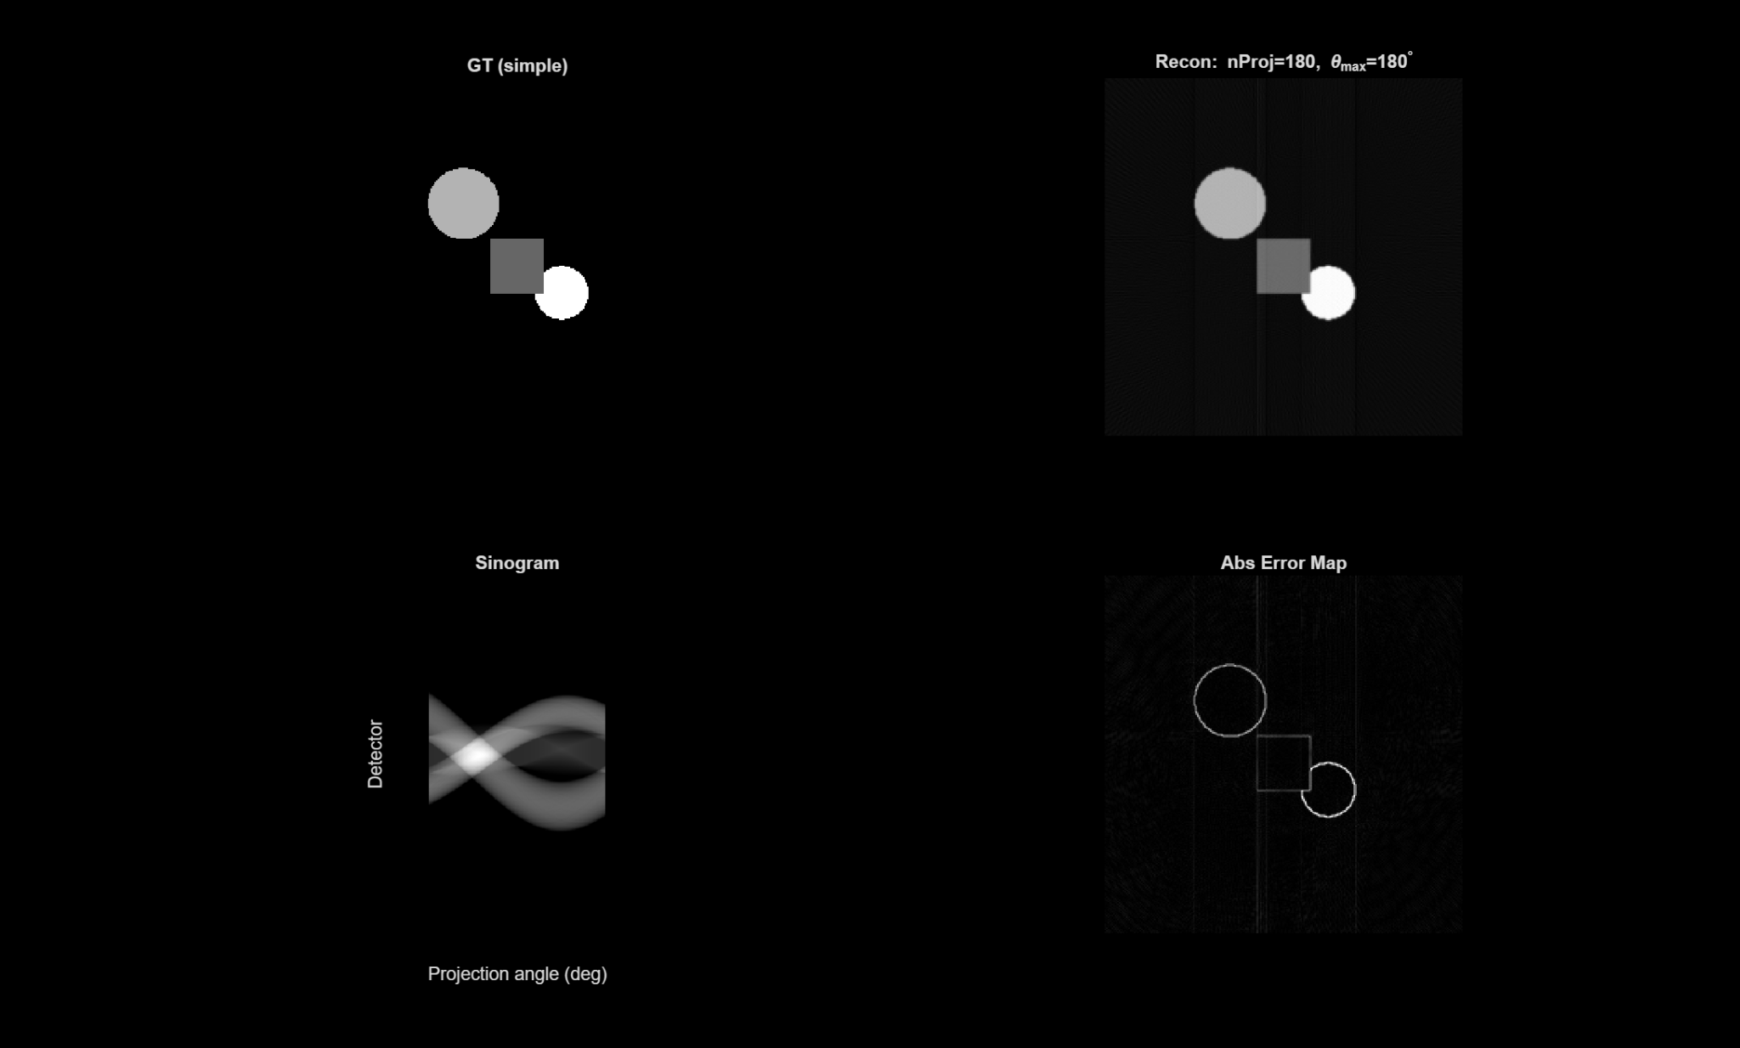
Reconstruction was performed using MATLAB’s iradon with the following settings:
- Filter: Ram-Lak
- Interpolation: Linear
- Output size: 256 × 256
- Scaling: Preserved as in MATLAB default FBP
This method approximates standard filtered backprojection used in clinical CT. The reconstruction step corresponds to Aim 3, since filtered backprojection is used to generate CT images that will be compared with the original phantoms.

2.4 Image Quality Metrics
Each reconstructed image was compared to its ground-truth phantom using five quantitative metrics:

1. Mean Squared Error (MSE)
Quantifies pixel-wise intensity differences. Lower MSE indicates more accurate reconstruction.

2. Structural Similarity Index (SSIM)
Measures similarity in luminance, contrast, and structural information. Higher SSIM indicates better structural preservation.

3. Gradient Error (GE)
Computed using gradient magnitude maps of both images. Lower GE indicates better edge and texture reproduction.

4. Gradient Entropy
Entropy of the gradient magnitude histogram. High entropy typically reflects richer or noisier edge content. The difference between ground-truth and reconstruction entropy indicates edge degradation.

5. Variance of Laplacian
A sharpness measure computed by applying a Laplacian filter and computing variance. Higher values correspond to sharper images; lower values correspond to blurring or oversmoothing.
All metrics were implemented in compute_metrics.m and applied across all 32 combinations of phantom type, nProj, and θ<sub>max</sub>.
These metrics were implemented to satisfy Aim 4, which requires quantitative evaluation of reconstruction quality under different acquisition parameters.

2.5 Implementation Overview
All code was written in MATLAB and organized into modular functions:
- generate_phantom.m – creates simple and Shepp–Logan phantoms
- acquire_sinogram.m – performs Radon transform
- reconstruct_ct.m – applies inverse Radon transform
- compute_metrics.m – computes all five quality metrics
- run_medim_project.m – runs all experiments and saves reconstructed images + CSV results
- analyze_results.m – generates summary plots for all metrics
All outputs (images, plots, and metrics_results.csv) were saved in a dedicated results/ directory.
Together, these implemented functions support all computational tasks required for Aim 5, which involves generating summary plots and analyzing trends across acquisition conditions.

3. Results and Discussion

3.1 Visual Comparison of Reconstructions

The visual comparisons presented in this section address Aim 3, which focuses on evaluating reconstruction quality relative to the ground-truth phantoms.
Representative reconstructions show clear trends:
- Low nProj (e.g., 30):
Images exhibit strong streaking artifacts and blurred boundaries.
- Increasing nProj (60 → 90 → 180):
Reconstruction quality improves noticeably.
Edges become sharper, noise decreases, and structures in both phantoms become more distinct.
- Limited-angle scans (θ<sub>max</sub> < 180°):
Even with many projections, the reconstructions are incomplete.
Missing angular views cause characteristic streaking and directional blurring.
The effect is especially visible in the Shepp phantom where elliptical structures are distorted.
These observations align with standard CT sampling theory.
3.2 Quantitative Metric Trends — Shepp Phantom

These quantitative results support Aim 4, which requires examining how reconstruction metrics vary with projection number and angular coverage.
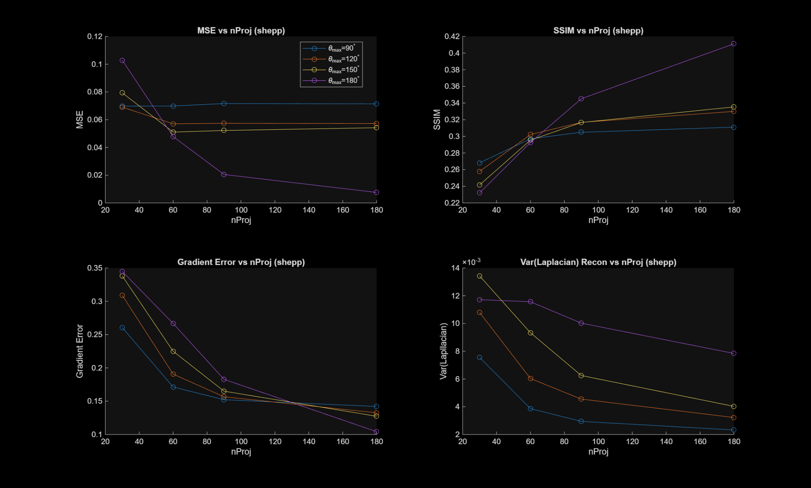

MSE
- MSE decreases consistently as the number of projections increases.
- Full-angle scans (180°) always achieve the lowest error.
- Limited-angle (90°) yields the highest error across all nProj.

SSIM
- SSIM increases with nProj, confirming improved structural fidelity.
- 180° scans produce the best SSIM values.
- SSIM curves flatten as nProj increases, indicating diminishing returns.

Gradient Error
- GE decreases steadily with more projections.
- Limited-angle scans show significantly higher GE due to missing structural information.

Variance of Laplacian
- Sharpness improves as nProj increases.
- Limited-angle scans show lower sharpness, consistent with blurring and distorted edges.
The Shepp phantom's complexity makes these degradations especially visible.

3.3 Quantitative Metric Trends — Simple Phantom

As with the Shepp phantom, this section further addresses Aim 4 by evaluating how sampling parameters affect reconstruction quality.
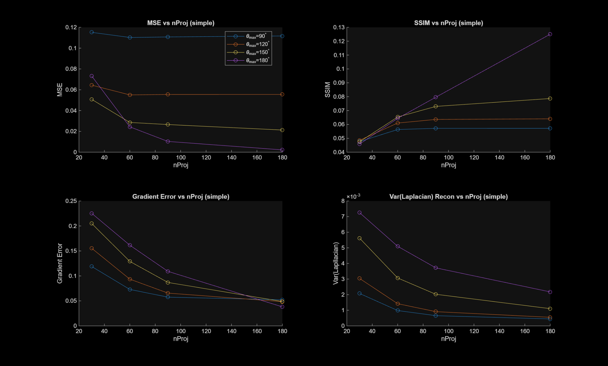
The simple phantom shows the same general trends:
- Higher nProj → lower MSE, lower GE, higher SSIM, higher sharpness
- Reduced θ<sub>max</sub> → worse quality on all metrics
Because the simple phantom contains fewer anatomical details, metric curves are smoother and less sensitive to subtle distortions, but the trends remain consistent.

3.4 Relationship Between Metrics and Visual Results

This integrated analysis contributes to Aim 5, where the goal is to interpret metric behavior in relation to visual artifact patterns.
- MSE reflects overall reconstruction accuracy but does not capture perceptual quality alone.
- SSIM aligns strongly with visual clarity of structures.
- Gradient Error and Gradient Entropy correlate well with visible edge blurring and streaking.
- Laplacian variance quantifies sharpness loss, matching human perception.
Using a combination of these metrics provides a robust, multi-dimensional evaluation of CT reconstruction quality.

4. Conclusions
- Increasing the number of projections significantly improves CT reconstruction accuracy and sharpness.
- Limited-angle CT acquisition degrades image quality, increasing MSE and GE, reducing SSIM, and reducing edge sharpness.
- The Modified Shepp–Logan phantom demonstrates stronger sensitivity to limited sampling due to its anatomical complexity.
- Gradient-based metrics provide valuable insights beyond pixel-level comparisons, confirming the need for multiple evaluation measures when assessing reconstruction quality.
- The experiment successfully demonstrates how acquisition constraints directly affect reconstruction fidelity in CT systems.

5. Code Appendix
Include all .m files in the order you used them:
- Generate_phantom.m
function P = generate_phantom(type, N)
% generate_phantom
% ---------------------------------------------
% Generates a digital phantom image.
%
% INPUTS:
% type : "simple" or "shepp"
% N : output image size (NxN)
%
% OUTPUT:
% P : generated phantom image
%
% The "simple" phantom is custom-built using circles and a rectangle.
% The "shepp" phantom uses MATLAB's Modified Shepp-Logan model.
if nargin < 1
type = "shepp";
end
if nargin < 2
N = 256;
end
switch lower(string(type))
case "simple"
P = zeros(N);
[x, y] = meshgrid(linspace(-1,1,N), linspace(-1,1,N));

% Two circular shapes
r1 = sqrt((x+0.3).^2 + (y+0.3).^2) <= 0.2;
r2 = sqrt((x-0.25).^2 + (y-0.2).^2) <= 0.15;
% Rectangular shape
rect = abs(x) <= 0.15 & y >= -0.1 & y <= 0.2;
% Assign intensities
P(r1) = 0.7;
P(r2) = 1.0;
P(rect)= 0.4;
case "shepp"
% MATLAB built-in phantom
P = phantom("Modified Shepp-Logan", N);
otherwise
error("Unknown phantom type.");
end
End

- Acquire_sinogram.m
function [sino, theta] = acquire_sinogram(P, nProj, thetaMax)
% acquire_sinogram
% ---------------------------------------------
% Computes the Radon transform (sinogram) of phantom P.
%
% INPUTS:
% P : ground truth phantom
% nProj : number of projection angles
% thetaMax : maximum angle in degrees (180, 150, 120, 90)
%
% OUTPUTS:
% sino : sinogram image
% theta : vector of projection angles
if nargin < 2
nProj = 180;
end
if nargin < 3
thetaMax = 180;
end
% Evenly spaced projection angles from 0 to thetaMax
theta = linspace(0, thetaMax, nProj);
% Perform Radon transform
sino = radon(P, theta);
end

- reconstruct_ct.m
function R = reconstruct_ct(sino, theta, N)
% reconstruct_ct
% ---------------------------------------------
% Performs filtered backprojection reconstruction
% using MATLAB's iradon function.
%
% INPUTS:
% sino : sinogram (Radon transform)
% theta : projection angles (degrees)
% N : reconstruction output size NxN
%
% OUTPUT:
% R : reconstructed CT image
if nargin < 3
N = 256;
end
% Filtered Backprojection (Ram-Lak filter)
R = iradon(sino, theta, "Ram-Lak", "linear", 1, N);
end

- compute_metrics.m
function metrics = compute_metrics(gt, recon)
% compute_metrics
% ---------------------------------------------------
% Computes multiple image quality metrics comparing
% the reconstructed image to the ground truth phantom.
%
% INPUTS:
% gt : ground truth image
% recon : reconstructed image
%
% OUTPUT:
% metrics : struct containing:
% mse
% ssim
% gradient_error
% grad_entropy_gt
% grad_entropy_recon
% grad_entropy_diff
% laplacian_var_gt
% laplacian_var_recon
% laplacian_var_diff
% Normalize images to [0,1]
gt = mat2gray(gt);
recon = mat2gray(recon);
% -------------------------------
% 1. MSE
% -------------------------------
mse_val = mean((gt(:) - recon(:)).^2);
% -------------------------------
% 2. SSIM
% -------------------------------
ssim_val = ssim(recon, gt);
% -------------------------------
% 3. Gradient Error
% -------------------------------
[mag_gt, mag_rec] = local_gradient_maps(gt, recon);
ge_val = sum(abs(mag_gt(:) - mag_rec(:))) / numel(gt);
% -------------------------------
% 4. Gradient Entropy
% -------------------------------
gEn_gt = local_grad_entropy(mag_gt);
gEn_rec = local_grad_entropy(mag_rec);
gEn_diff = abs(gEn_gt - gEn_rec);
% -------------------------------
% 5. Laplacian Variance (sharpness)
% -------------------------------
lap_gt = local_laplacian(gt);
lap_rec = local_laplacian(recon);
lap_var_gt = var(lap_gt(:));
lap_var_rec = var(lap_rec(:));
lap_var_diff = abs(lap_var_gt - lap_var_rec);
% Assemble metrics struct
metrics.mse = mse_val;
metrics.ssim = ssim_val;
metrics.gradient_error = ge_val;
metrics.grad_entropy_gt = gEn_gt;
metrics.grad_entropy_recon = gEn_rec;
metrics.grad_entropy_diff = gEn_diff;
metrics.laplacian_var_gt = lap_var_gt;
metrics.laplacian_var_recon = lap_var_rec;
metrics.laplacian_var_diff = lap_var_diff;
end
% ---------------------------------------------------
% Helper Functions
% ---------------------------------------------------
function [mag_gt, mag_rec] = local_gradient_maps(gt, recon)
% Computes gradient magnitudes for both images.
[gx_gt, gy_gt] = imgradientxy(gt);
[gx_rec, gy_rec] = imgradientxy(recon);
mag_gt = sqrt(gx_gt.^2 + gy_gt.^2);
mag_rec = sqrt(gx_rec.^2 + gy_rec.^2);
end
function val = local_grad_entropy(mag)
% Computes entropy of gradient magnitude histogram.
mag = mag(:);
nbins = 64;
[counts, ~] = histcounts(mag, nbins);
p = counts / sum(counts);
p = p(p > 0); % remove zeros for log computation
val = -sum(p .* log(p));
end
function lap = local_laplacian(I)
% Applies Laplacian filter for sharpness measurement.
k = [0 1 0; 1 -4 1; 0 1 0];
lap = imfilter(I, k, "replicate", "conv");
end

- run_medim_project.m
clear; close all; clc;
% Ensure results folder exists
if ~exist("results", "dir")
mkdir results
end
% Phantom sizes and parameter sweeps
N = 256;
phantomTypes = {"simple", "shepp"};
nProjList = [30 60 90 180];
thetaMaxList = [180 150 120 90];
% Total number of experiments
numComb = numel(phantomTypes) * numel(thetaMaxList) * numel(nProjList);
% Preallocate results struct using template
tmp = compute_metrics(zeros(N), zeros(N));
tmp.phantom_type = "";
tmp.nProj = 0;
tmp.thetaMax = 0;
results = repmat(tmp, numComb, 1);
idx = 1;
% ----------------------------------------------
% Run all phantom / acquisition combinations
% ----------------------------------------------
for p = 1:numel(phantomTypes)
% Generate ground truth
P = generate_phantom(phantomTypes{p}, N);

for t = 1:numel(thetaMaxList)
thetaMax = thetaMaxList(t);

for k = 1:numel(nProjList)
nProj = nProjList(k);

% Acquire projections
[sino, theta] = acquire_sinogram(P, nProj, thetaMax);
% Reconstruct
R = reconstruct_ct(sino, theta, N);
% Compute metrics
m = compute_metrics(P, R);
m.phantom_type = phantomTypes{p};
m.nProj = nProj;
m.thetaMax = thetaMax;
results(idx) = m;
idx = idx + 1;
% --------------------------------------
% Save image figure with 4 subplots
% --------------------------------------
f = figure;
subplot(2,2,1); imshow(P, []);
title(sprintf("GT (%s)", phantomTypes{p}));
subplot(2,2,2); imshow(R, []);
title(sprintf("Recon: nProj=%d, θ_{max}=%d°", nProj, thetaMax));
subplot(2,2,3);
imshow(sino, [], "XData", theta, "YData", 1:size(sino,1));
xlabel("Angle (deg)");
ylabel("Detector");
title("Sinogram");
subplot(2,2,4); imshow(abs(P-R), []);
title("Abs Error Map");
fname = sprintf("results_%s_theta%d_nProj%d.png", ...
phantomTypes{p}, thetaMax, nProj);
saveas(f, fullfile("results", fname));
close(f);
end
end
end
% Save results table
T = struct2table(results);
writetable(T, fullfile("results", "metrics_results.csv"));
disp(T);

- analyze_results.m
clear; close all; clc;
% Load table of all metric results
T = readtable(fullfile("results", "metrics_results.csv"));
phantoms = unique(T.phantom_type);
thetaVals = unique(T.thetaMax);
% ---------------------------------------------------
% Create metric plots for each phantom
% ---------------------------------------------------
for p = 1:numel(phantoms)
pt = phantoms{p};
mask_p = strcmp(T.phantom_type, pt);

figure;
legend_entries = cell(numel(thetaVals),1);

for t = 1:numel(thetaVals)
thetaMax = thetaVals(t);
mask = mask_p & T.thetaMax == thetaMax;
Tsub = T(mask, :);
% Sort rows by number of projections for clean plotting
[~, order] = sort(Tsub.nProj);
Tsub = Tsub(order, :);
% -----------------------------
% Plot MSE
% -----------------------------
subplot(2,2,1);
hold on;
plot(Tsub.nProj, Tsub.mse, "-o");
title(sprintf("MSE vs nProj (%s)", pt));
xlabel("nProj");
ylabel("MSE");
legend_entries{t} = sprintf("\\theta_{max}=%d°", thetaMax);
% -----------------------------
% Plot SSIM
% -----------------------------
subplot(2,2,2);
hold on;
plot(Tsub.nProj, Tsub.ssim, "-o");
title(sprintf("SSIM vs nProj (%s)", pt));
xlabel("nProj");
ylabel("SSIM");
% -----------------------------
% Plot Gradient Error
% -----------------------------
subplot(2,2,3);
hold on;
plot(Tsub.nProj, Tsub.gradient_error, "-o");
title(sprintf("Gradient Error vs nProj (%s)", pt));
xlabel("nProj");
ylabel("Gradient Error");
% -----------------------------
% Plot Laplacian Variance
% -----------------------------
subplot(2,2,4);
hold on;
plot(Tsub.nProj, Tsub.laplacian_var_recon, "-o");
title(sprintf("Var(Laplacian) vs nProj (%s)", pt));
xlabel("nProj");
ylabel("Var(Laplacian)");
end

subplot(2,2,1);
legend(legend_entries, "Location", "best");
% Save plot image
fname = sprintf("metrics_plots_%s.png", pt);
saveas(gcf, fullfile("results", fname));
end

- Save_phantoms.m
function save_phantoms()
% save_phantoms
% ----------------------------------------------------
% Generates and saves standalone phantom images for
% use in the Methods section of the project report.
%
% This script creates:
% - simple_phantom.png
% - shepp_phantom.png
%
% These are saved inside the "results" folder.
%
% No inputs.
% No outputs.
%
% REQUIREMENTS:
% - generate_phantom.m
% - MATLAB Image Processing Toolbox
clear; close all; clc;
% Image size for both phantoms
N = 256;
% ----------------------------------------------------
% Generate phantoms using our main phantom generator
% ----------------------------------------------------
P_simple = generate_phantom("simple", N);
P_shepp = generate_phantom("shepp", N);
% ----------------------------------------------------
% Ensure the results folder exists
% ----------------------------------------------------
if ~exist("results", "dir")
mkdir results
end
% ----------------------------------------------------
% Save Simple Phantom Image
% ----------------------------------------------------
figure;
imshow(P_simple, []);
title("Simple Phantom");
saveas(gcf, fullfile("results", "simple_phantom.png"));
close(gcf);
% ----------------------------------------------------
% Save Shepp–Logan Phantom Image
% ----------------------------------------------------
figure;
imshow(P_shepp, []);
title("Shepp-Logan Phantom");
saveas(gcf, fullfile("results", "shepp_phantom.png"));
close(gcf);
disp("Phantom images successfully saved to /results/");
end

