Image Processing Project Blog

Week 2

Sam Evans

# Contrast Stretching

Contrast stretching (normalisation) widens the range of intensity values of an image. This can be viewed in an image’s histogram which displays intensity values against occurrences. *“A dark or low-contrast image is considered to be comprising a weak signal (information) and noise (due to insufficient illumination).” [1].* I stretched the seven vehicle images and compared their original and new histograms against each other.

## Code

The code used to perform the contrast stretching works first by storing information about the images histogram in the variables COUNTS and X. COUNTS stores occurrences and X stores the intensity values. These variables are used to remove the small occurrences of minimum and maximum intensity values.

% The number of times a certain intensity value occurs in G is set as COUNTS, and the intensity value itself is set in X. The minimum and maximum intensity values are found, excluding intensity values that appear less than 100 times in the image. This is done to avoid small intensity value peaks from affecting the stretching. The contrast is then stretched using a simple linear transform.

**[**COUNTS**,** X**]** **=** imhist**(**G**);**

**for** i **=** 1**:**length**(**X**)**

**if** COUNTS**(**i**)** **>** 300

Gmin **=** X**(**i**);**

**break**

**end**

**end**

**for** i **=** length**(**X**):-**1**:**1

**if** COUNTS**(**i**)** **>** 300

Gmax **=** X**(**i**);**

**break**

**end**

**end**

Gstr **=** **(**G **-** Gmin**)** **/** **(**Gmax **-** Gmin**);**

## Results

Below are the results from contrast stretching a few of the vehicle images. The grayscale of the original image will be in the top left of the figure beside its histogram. The contrast stretched image will be in the bottom left of the figure beside it’s histogram.

### Vehicle 1

The first image displays very little change other than being slightly darker. It can be seen in the histogram that the intensity values have been stretched to include smaller values closer to black (0).

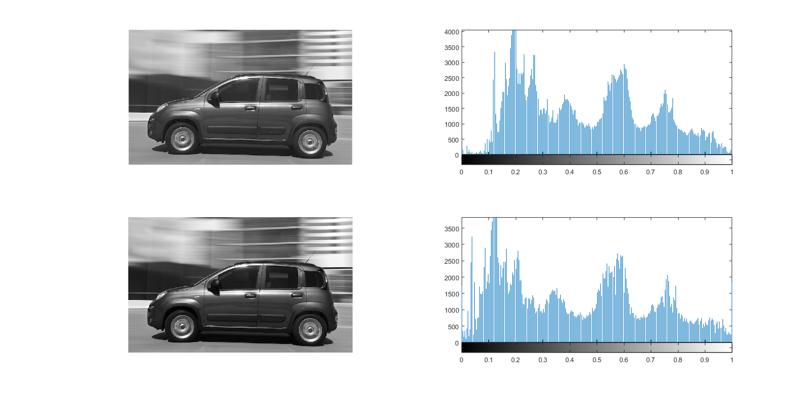

Vehicle 1 Histogram Comparison

## Vehicle 4

Similarly, the vehicle 4 image appears somewhat similar to vehicle 1 after being stretched. However, this time the picture is slightly brighter as higher intensity values are now more represented in the image.

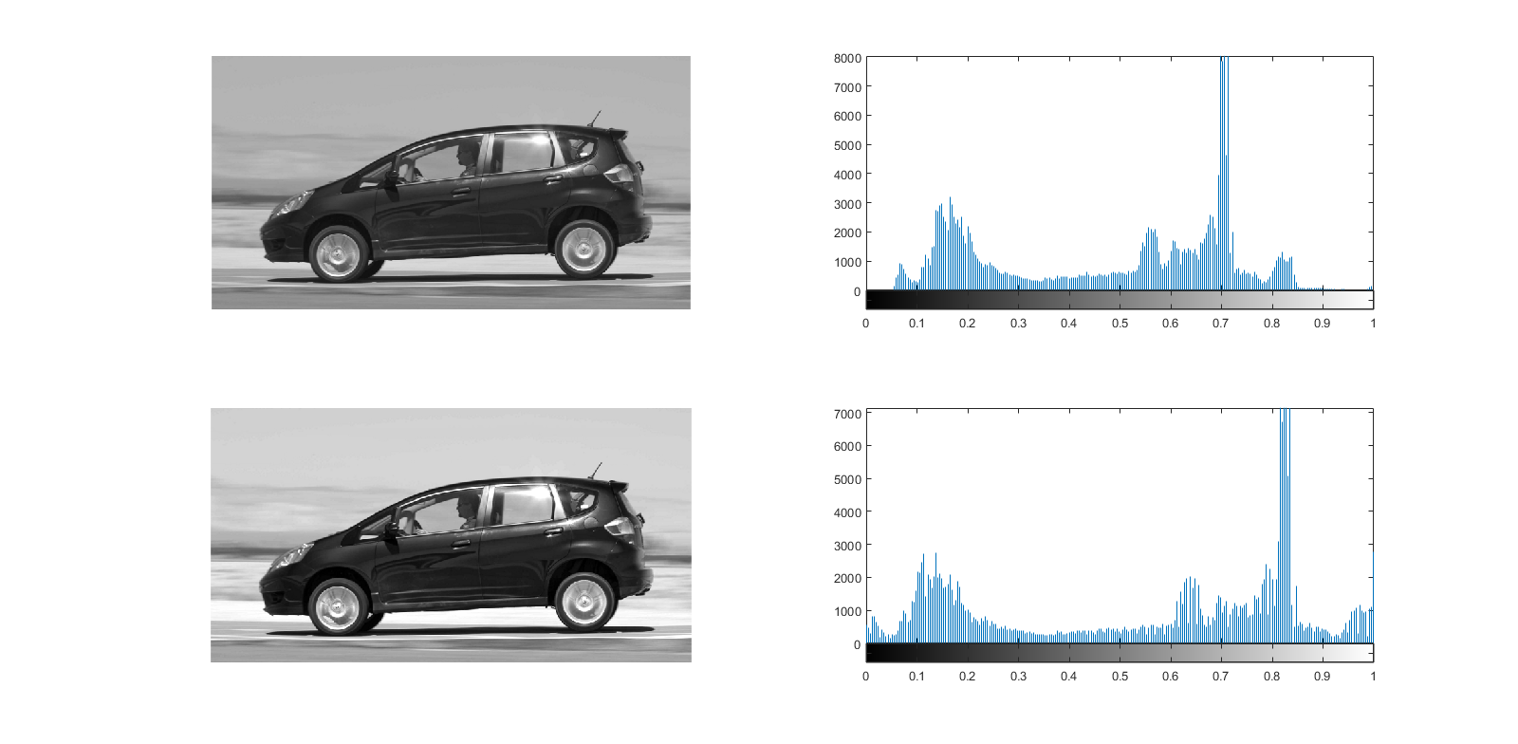

Vehicle 4 Histogram Comparison

## Other Vehicles

The other five vehicle images experienced very similar results to 1 and 4 or even less stretching at times.

# Conclusions

Overall it appears contrast stretching appears to have a small but positive effect on the images and would be worthwhile technique for the project.

# References

[1] Chouhan, Rajlaxmi, Rajib Kumar Jha, and Prabir Kumar Biswas. "Noise-Enhanced Contrast Stretching Of Dark Images In SVD-DWT Domain". 2013 Annual IEEE India Conference (INDICON) (2013): n. pag. Web. 13 Apr. 2017.