Image Processing Project Blog

Entry 3

Sam Evans

# Cleaning The Image

In order to obtain the height and width of the vehicle in each image it is necessary to clean up the image by removing the background. In initial testing I have used a number of image processing techniques to help with this. As an Example I will display the results on vehicle1.png.

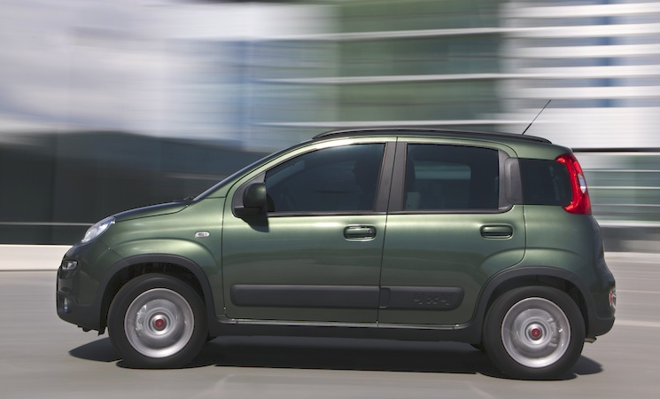

To start I **contract stretch** the greyscale image which as shown in a previous blog showed to improve the image quality slightly.

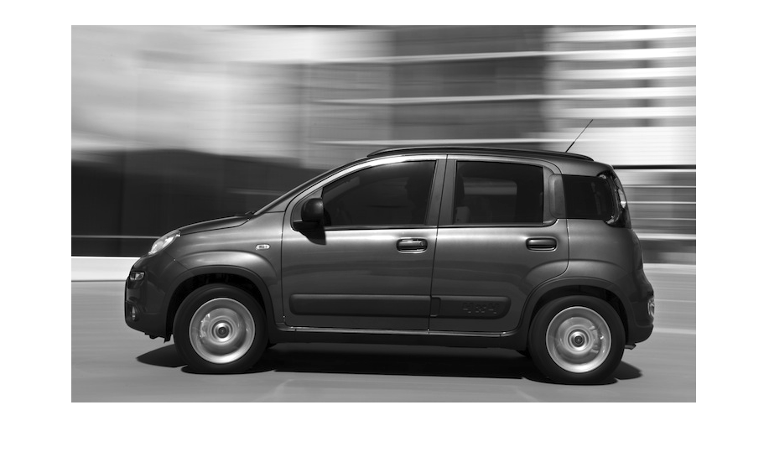

Next I **adaptive threshold** the image in order to remove the as much of the background as I can.

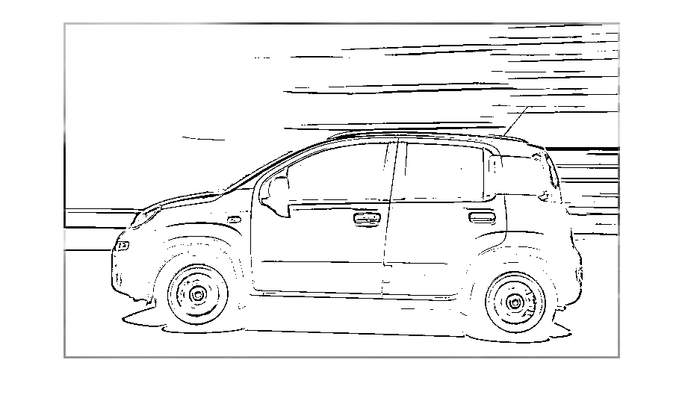

Following this I used **horizontal edge detection** in order to remove the active background. This removes much of the background but I do lose some information on the car here.

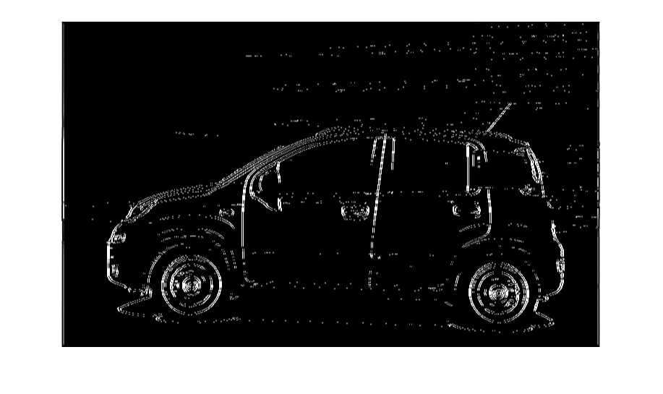

I then switched the black of the image to white and vice versa. I **opened** the areas with more than 25 pixels and **segment masked** the original colours back onto the image. Unfortunately some of the background remains which still needs to be removed.

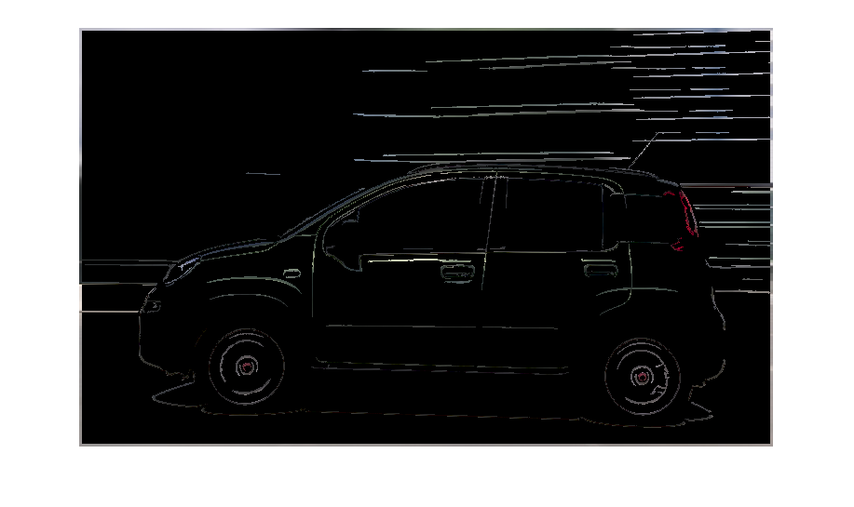

## Other Vehicle Image Results

### Vehicle2.png

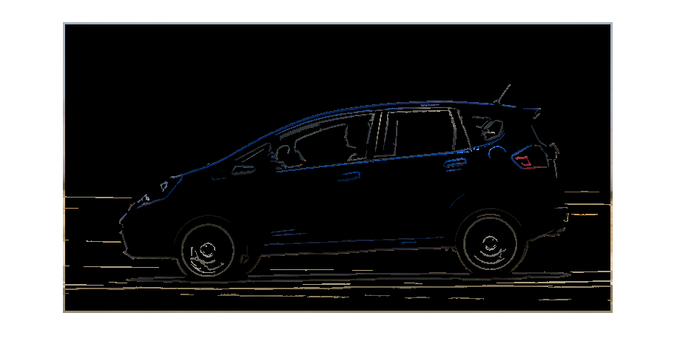

### Vehicle6.png



## Code

I **=** imread**(**'Vehicles1.png'**);**

I **=** im2double**(**I**);**

G **=** rgb2gray**(**I**);**

R **=** I**(:,:,**1**);**

G **=** I**(:,:,**2**);**

B **=** I**(:,:,**3**);**

%%%%%%%%%%%%%%%%%%%%%%%%%%%%%%% Filters %%%%%%%%%%%%%%%%%%%%%%%%%%%%%%%%%

% Initilise the filters: horizontal edge filter

Sx **=** **[**1 0 **-**1**;**

2 0 **-**2**;**

1 0 **-**1**]** **/** 4**;**

%%%%%%%%%%%%%%%%%%%%%%%%%%% Contrast Streching %%%%%%%%%%%%%%%%%%%%%%%%%%

% Contrast streching widens the range of intensity values of an image. The

% number of times a certain intensity value occurs in G, is set as COUNTS,

% and the intensity value itself is set in X. The minimum and maximum

% intesity values are found, excluding intesity values that appear less

% than 100 times in the image. This is done to avoid small intesity value

% peaks from affecting the streching. The contrast is then streched using a

% simple linear transform.

**[**COUNTS**,** X**]** **=** imhist**(**G**);**

**for** i **=** 1**:**length**(**X**)**

**if** COUNTS**(**i**)** **>** 300

Gmin **=** X**(**i**);**

**break**

**end**

**end**

**for** i **=** length**(**X**):-**1**:**1

**if** COUNTS**(**i**)** **>** 300

Gmax **=** X**(**i**);**

**break**

**end**

**end**

Gstr **=** **(**G **-** Gmin**)** **/** **(**Gmax **-** Gmin**);**

%%%%%%%%%%%%%%%%%%%%%%%% Adaptive Thresholding %%%%%%%%%%%%%%%%%%%%%%%%%%

% Form of segmentation that sets pixels to either a foreground or

% background value based on an intesity value threshold. Adaptive differs

% from global by setting unique thresholds for different sections of an

% image.

%

% A square(cookie) of 7x7 pixels is thresholded for every pixel. the height

% and width of the filtered image are used so as not to go over the edge of

% the image. If the pixel is above the mean intensity value of the cookie -

% C (in this case 15/225) then it is set to 1(White). If not, it is set to 0

% (Black).

**[**H**,** W**]** **=** size**(**Gstr**);**

Gthr **=** Gstr**;**

n **=** 7**;**

half **=** floor**(**n **/** 2**);**

**for** i **=** half **+** 1**:**H **-** half

**for** j **=** half **+** 1**:**W **-** half

Cookie **=** Gstr**(**i **-** half**:**i **+** half**,** j **-** half**:**j **+** half**);**

Gthr**(**i**,** j**)** **=** Gstr**(**i**,** j**)** **>** mean**(**Cookie**(:))** **-** 15 **/** 255**;**

**end**

**end**

%%%%%%%%%%%%%%%%%%%%%%%%%% Edge Detection %%%%%%%%%%%%%%%%%%%%%%%%%%%%%

% Edges are the sections of images with most change between pixels. The

% horizontal edges of the thresholded image are found.

edgex **=** conv2**(**Gthr**,** Sx**,** 'same'**);**

edgex **=** abs**(**edgex**);**

%%%%%%%%%%%%%%%%%%%%%%%%%%%% Morphology %%%%%%%%%%%%%%%%%%%%%%%%%%%%%%%

% Morphology is the process of re assembling parts of an image that

% should be a whole. Here the edge detection image has its polarity

% reversed. Areas that are made up of 25 pixels or more are opened.

ROI **=** **(**1**-**edgex**);**

ROI **=** bwareaopen**(**ROI**,** 25**);**

%%%%%%%%%%%%%%%%%%%%%%%%%%%%%% Output %%%%%%%%%%%%%%%%%%%%%%%%%%%%%%%%%

Output**(:,:,**1**)** **=** ROI **.\*** R**;**

Output**(:,:,**2**)** **=** ROI **.\*** G**;**

Output**(:,:,**3**)** **=** ROI **.\*** B**;**

figure**,**imshow**(**Output**)**

# Conclusions

The cleaning of the images is making steady progress but does still need more work to remove all of the background.