Image Processing Project Blog

Entry 4

Sam Evans

# YCbCr

*“YCbCr One of two primary color spaces used to represent digital component video (the other is RGB). The difference between YCbCr and RGB is that YCbCr represents color as brightness and two color difference signals, while RGB represents color as red, green and blue. In YCbCr, the Y is the brightness (luma), Cb is blue minus luma (B-Y) and Cr is red minus luma (R-Y).” [1].*

Having tested flesh detection using the YCbCr colour space I wanted to test whether or not this could be used to detect car paint. I started off by cropping a small section of the image Vehicle1.png, on the cars paint. I used this cropped image to check the Cb values against the Cr values.

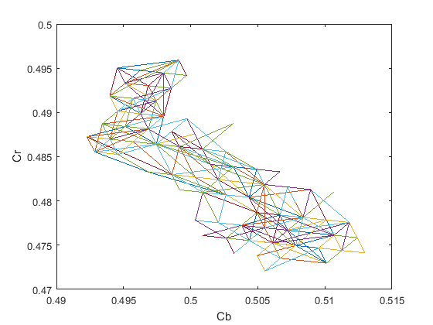

Figure : Vehicle 1 Paint Cb against Cr

From here I was able to define a region of interest (ROI) based on the YCbCr colour space:

ROI = (Cb > 125/255) & (Cb < 132/255) & (Cr > 119/255) & (Cr < 127/255);

# Results

Unfortunately, the defined range did not produce satisfactory results on the vehicle 1 image or any other vehicle images.

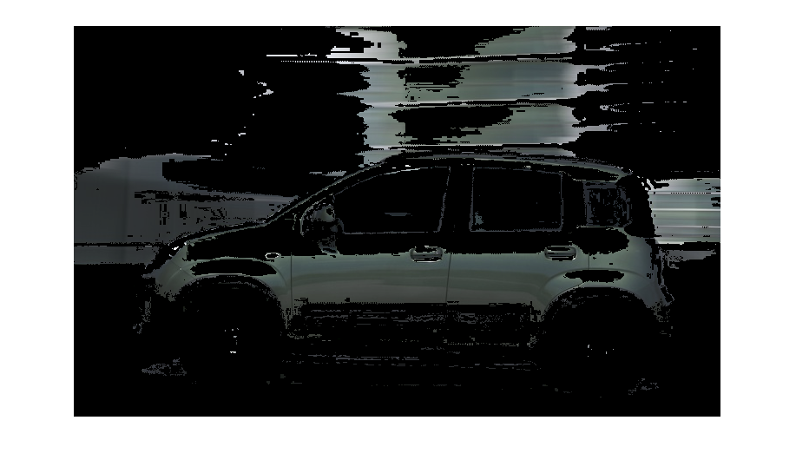

Figure : Vehicle 1 ROI masked with original colour

Viewing the plots for other vehicles paint it becomes clear that the car paint does not have a specific YCbCr range like flesh.

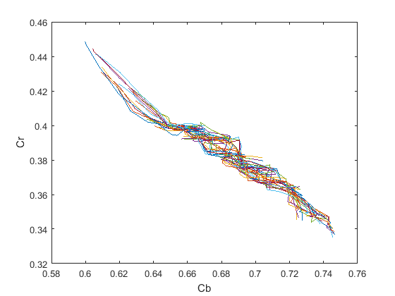

Figure : Vehicle 2 Paint Cb against Cr

## Code

I **=** imread**(**'Vehicles1.png'**);**

I **=** im2double**(**I**);**

R **=** I**(:,** **:,** 1**);**

G **=** I**(:,** **:,** 2**);**

B **=** I**(:,** **:,** 3**);**

YCbCr **=** rgb2ycbcr**(**I**);**

Y **=** YCbCr**(:,** **:,** 1**);**

Cb **=** YCbCr**(:,** **:,** 2**);**

Cr **=** YCbCr**(:,** **:,** 3**);**

% figure, plot(Cb,Cr), ylabel('Cr'), xlabel('Cb');

ROI **=** **(**Cb **>** 125**/**255**)** **&** **(**Cb **<** 132**/**255**)** **&** **(**Cr **>** 119**/**255**)** **&(**Cr **<** 127**/**255**);**

output **=** I**;**

output**(:,:,**1**)** **=** ROI**.\***R**;**

output**(:,:,**2**)** **=** ROI**.\***G**;**

output**(:,:,**3**)** **=** ROI**.\***B**;**

imshow**(**output**);**

# Conclusions

The YCbCr colour range will not help in identifying the cars.

# References

[1]"YCbCr Definition from PC Magazine Encyclopedia", Pcmag.com, 2017. [Online]. Available: http://www.pcmag.com/encyclopedia/term/55147/ycbcr. [Accessed: 21- Apr- 2017].