Cleaning
Maintenance
Repair
Martinique
Pool & Spa Services
Restoration

Keeping your pool or spa sparkling, safe, and clean


Full Service
Weekly or Bi-Weekly
- Brush and vacuum
- Empty filters
- Leaf & debris maintenance
- Water testing
- Basic chemistry
Chemical Service Only
- Chlorine levels
- pH balance
- Algae prevention
- Basic chemistry

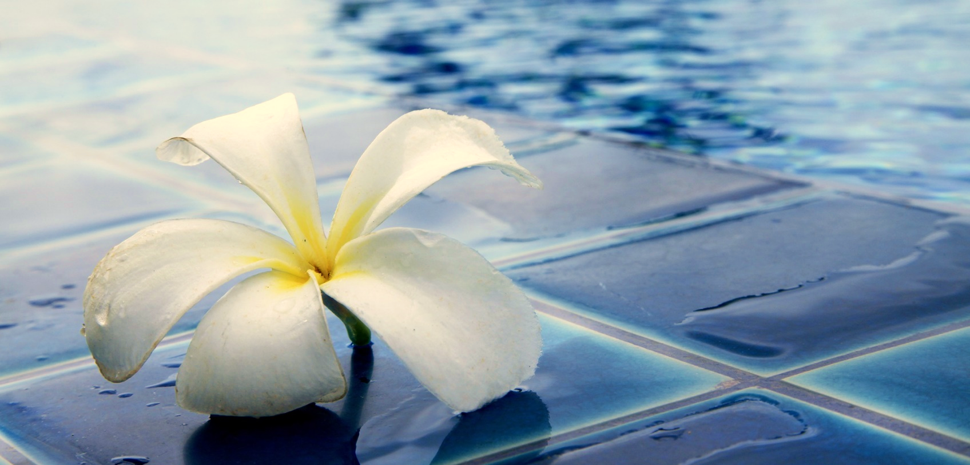

Martinique
Pool & Spa Services
Maintenance
Cleaning
Repair

Restoration

Keeping your pool or spa sparkling, safe, and clean

Salt Water Pool & Spa Maintenance
- Salinity monitoring
- pH balance
- Corrosion prevention
- Clean salt cells

- Alkalinity Levels
- Calcium Levels
- Stabilizer Levels
- Dissolved Solids
Monthly Testing



