

New Online Resident Portal
1000 Lake Sylvan Boulevard | Orlando, FL 32804 A Buena Vida Community

Spring Newsletter
Residents are raving about Buena Vida Online, the new web portal for residents of Lime Grove Apartments and other Buena Vida communities.
Buena Vida Online gives you access to community news, announcements, and other important information. You can also use the portal to:
- Pay your rent online
- Renew your lease
- Submit a maintenance request
- Reserve the clubhouse
Have you visited the portal yet? Don’t wait! Call our office today at 321.555.5463 to activate your account, and obtain your user name and password.
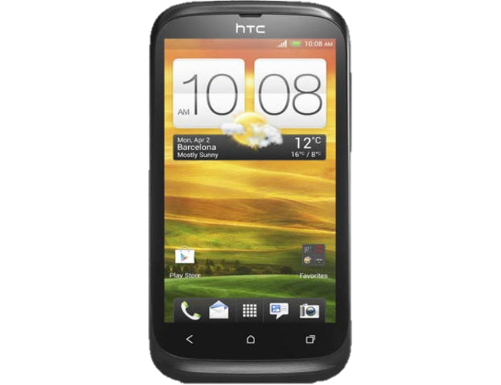
Important Contact Info

City of Orlando
Police Dept.: 321.555.1728
Animal Control: 321.555.8915
Water/Sewage: 321.555.6142
General: 321.555.7266
Leasing Office
Phone: 321.555.5463
Fax: 321.555.5464
Email: info@limegroveapts.com
Office Hours
Monday-Friday 9:00-6:00
Saturday 10:00-5:00
Sunday 1:00-5:00

Pool Reopening & Celebration
Spring Newsletter
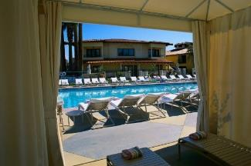Join us Saturday, April 7, to celebrate the grand reopening of our newly renovated pool!
Features include a resort-style pool deck, private cabanas, gourmet grilling area, and much more. We can’t wait for you to see the transformation!
The celebration will last from dawn ‘til dusk. (After that, it’s up to you!) Fruit, lemonade, slushies, and other cool treats will be served from 1:00-2:00 PM.
Memorial Day Barbecue

Mmmm! It’s that time of the year again! Time to gather up the kids and come on down to the pool for our annual Memorial Day Barbecue. This year, our Memorial Day buffet will be catered by Ralph’s Simmerin’ Barbecue and Slaw.
This year’s barbecue is scheduled on May 27th from 12:00 – 4:00. Come hungry!


Community Reminders
Spring Newsletter
- Recycling is collected every other Wednesday. For a full list of recyclable items please visit our community’s waste management website.
- Please remember to pick up after your pets! Pet waste is a contributor to the spread of infectious diseases and contaminated drinking water. Baggies are provided by our local Parks and Recreation chapter. If you notice an empty bag stand, please call 321.555.4867.
- Glass containers are prohibited in the pool area. Please remember all guests must have their guest pass visible at all times.
- Visitors are only allowed to park in visitor spots. Any car without a visible Lime Grove decal parked in a residential spot will be towed. Please remind your guests of this policy!
- The dog park hours are from sunrise to sunset. The gate to the park will be locked otherwise. Outside of the park, please make sure your pet is on a leash at all times.

Dog and Owner Meet & Greet
Bring your pooch to the dog park at 5:00pm on April 30th and meet some fellow dog lovers! Treats will be provided for both humans and our furry friends. There will also be a kiddie pool, lots of tennis balls, and a few rope tugs for the pups to enjoy. All dogs must be up-to-date on vaccines in order to attend. No aggressive dogs please.

