portfolio

Sigrid Laas-Hurt, Junior Software Tester

2024

Table of Contents

Project#1 Restaurant Food Ordering application 2

Project overview 2

My responsibilities include 2

Project#2 Company Collaboration Platform 3

Project overview 3

My responsibilities include 3

Project#3 CRM Platform 6

Project overview 6

My responsibilities include 6

Project#4 Registration Forms 9

Project overview 9

My responsibilities include 9

Project#5 Task Management Platform 10

Project overview 10

My responsibilities include 10

Project#6 Work Management Tool 11

Project overview 11

My responsibilities include 11

# Project#1 Restaurant Food Ordering application

Project overview

Our customer Bella Pizzeria has decided to build a food ordering application that will allow contactless ordering in the restaurant (replacing the physical menu). The app must provide a customer with an overview of all the food and drink available in the restaurant, accept orders, and securely store customer data to comply with GDPR and data privacy laws.

The main functionalities of this app are:

* Contactless ordering for customers to keep staff safe
* No download is required, just scan a QR code or enter a web address
* Browse the menu, and order food and drinks
* Simple product management
* Contact Tracing securely records customer data and meets privacy laws.

## My responsibilities include

1. Worked in an agile team and followed Scrum routines.
2. Acted as the coordinator for Spint#1.
3. Utilized various testing techniques such as functional testing, use case testing, checklist-based testing, and cross-browser testing.
4. Wrote test documentation in **Confluence**, including checklists for use cases and final report.
5. Reported bugs in **Jira**. Our team has found 35 issues.

**Example of the reported bug:**

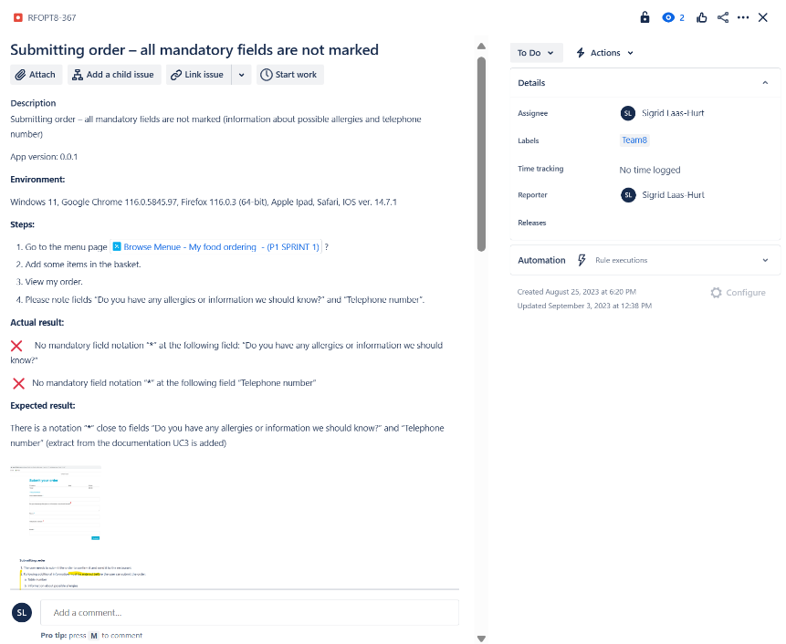

# Project#2 Company Collaboration Platform

## Project overview

The large energy company decided to build an application, that will increase employee productivity and internal communication. The company has more than 3000 employees, that are distributed between tens of departments and several offices. The pandemic highlighted the need for an up to date, cross-device solution for reaching the entire organization. In the increasingly hybrid world, employees need to be empowered to make decisions and communicate openly with peers.

The company decided to build an application that will allow employees to:

1. Have visibility over the company structure with an up to date organization chart
2. Build stronger connections with colleagues by having easy access to their interests, experience, skills and more
3. Be more productive by enabling them to quickly browse through facility and meeting room availability and office locations
4. Collaborate efficiently by creating custom contact lists for projects, events, social activities
5. Create and update their user status, such as sick leave, vacation, maternity leave

## My responsibilities include

1. Discovered existing functionalities and improved testing documentation
2. Developed new functionalities to the system that extended system capabilities
3. Worked in an agile team and followed Scrum routines.
4. Wrote test documentation in **Confluence**, including test cases and final report.
5. Utilized various testing techniques such as exploratory testing, functional testing, checklist-based testing, cross-browser testing, and regression testing.
6. Reported bugs in **Jira**. Our team has found 26 issues.
7. Tracked time in **Jira**.

**Example of the Test cases:**

**Example of the reported bug:**

**Example of the Final report:**

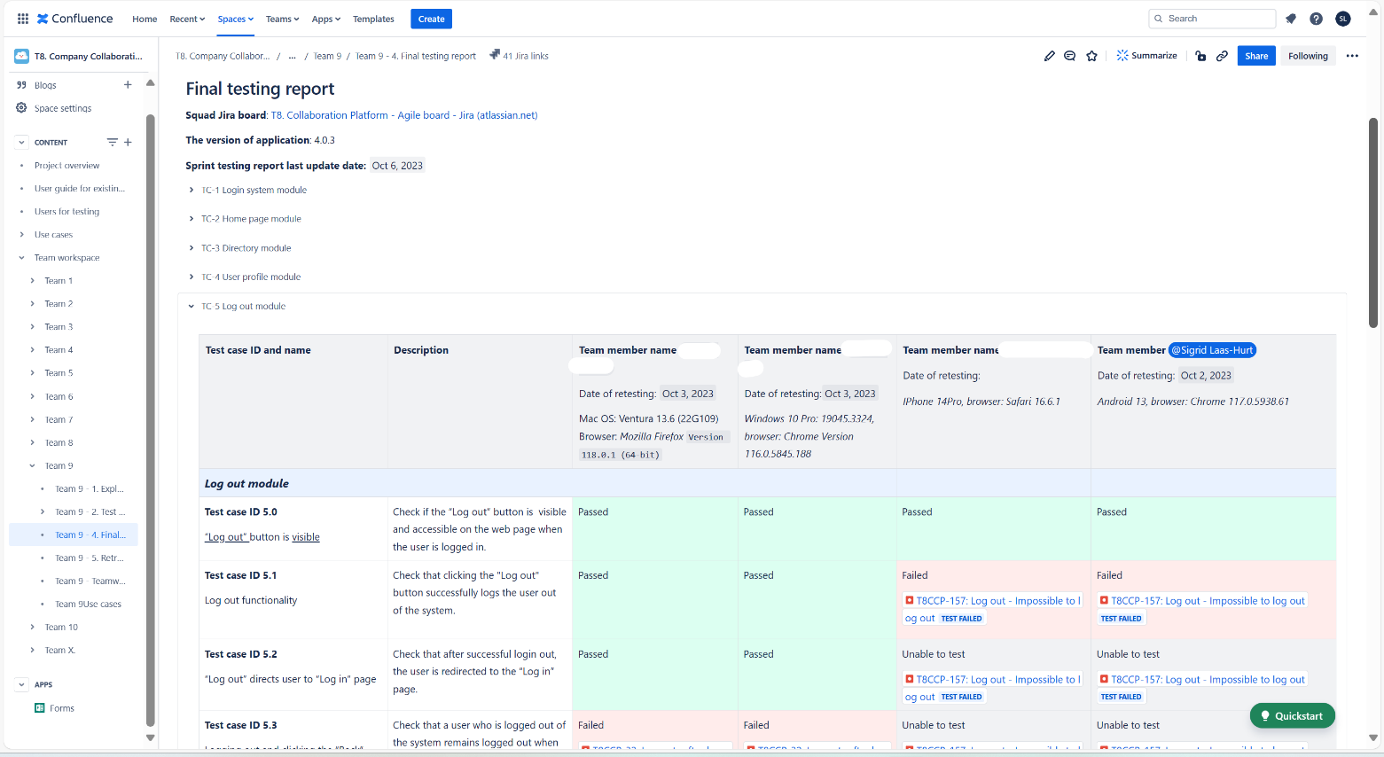

# Project#3 CRM Platform

## Project overview

Elevate Digital is a digital agency offering innovative marketing and web design solutions. They use custom strategies, eye-catching visuals, and data-driven optimization to make online experiences that are fun and increase the visibility of a company's brand.

Elevate Digital organizes its sales and project management with a simple CRM platform. There are 3 main business processes that are supported by the CRM:

* Collection of potential customers from different marketing channels and organising the marketing activities.
* Preparing offers, negotiating terms with potential customers and signing contracts.
* Managing projects with the signed contracts and tracking the progress of projects.

The marketing and sales teams at Elevate Digital currently use the CRM system on a daily basis. Because the number of manual tasks is continuously going up, our customer wants to start automating some parts of the processes and integrating them with other systems used in the company.

**The main goal of this project is to make an API that covers all of the main functions of the CRM platform.** The CRM platform lets our customers manage their work and different sales processes, like getting new customers, handling customer requests, making proposals, and closing them. The CRM platform is also used as a database of all customers and their data. The first step for this initiative is to build a comprehensive API for the CRM, that will allow for integrations and implementation automation procedures. All of the system's main tasks must be able to be done through the web services, which means that the API must allow this.

## My responsibilities include

1. Worked in an agile team and followed Scrum routines.
2. Acted as the coordinator for Spint#2.
3. Wrote test documentation in **Confluence**, including API testing test cases and final report.
4. Built a stable and well-tested API for the following functionalities of the CRM system:
   1. *Leads management (creation and management of the customer’s database);*
   2. *Invitation of new users;*
   3. Funnels management (creation and management of CRM funnels);
   4. *Deals management (creation and management of deals in different funnels.*
5. Utilized various testing techniques such as exploratory testing, API testing, browser testing, and end-to-end testing (example is in separate file Team 8 End-to-end test cases_Sigrid_LH).
6. Created **Postman** collections for testing of API.
7. Reported bugs in **Jira**. Our team has found 65 issues.
8. Tracked time in **Jira**

**Example of the Test cases:**

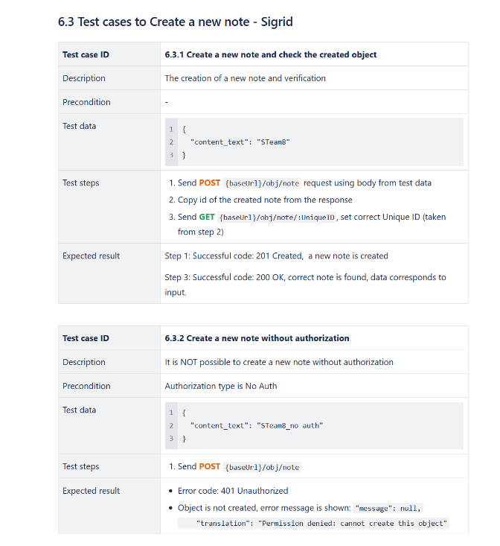 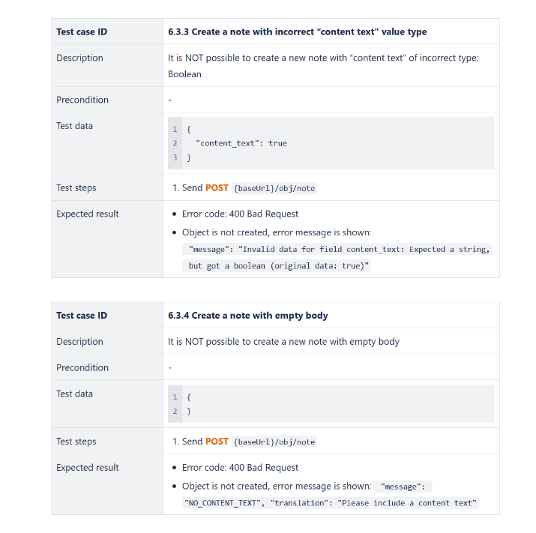

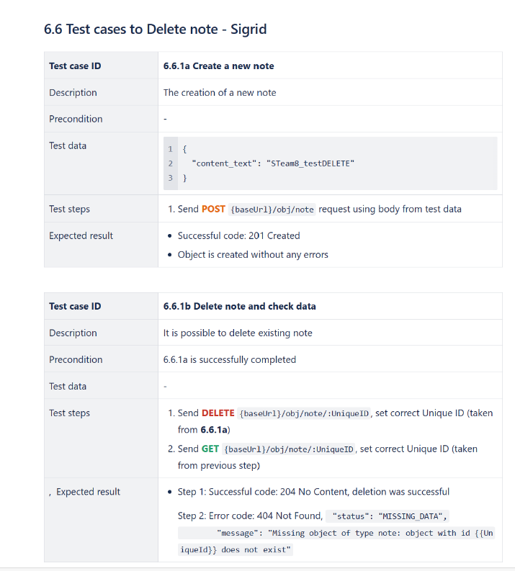

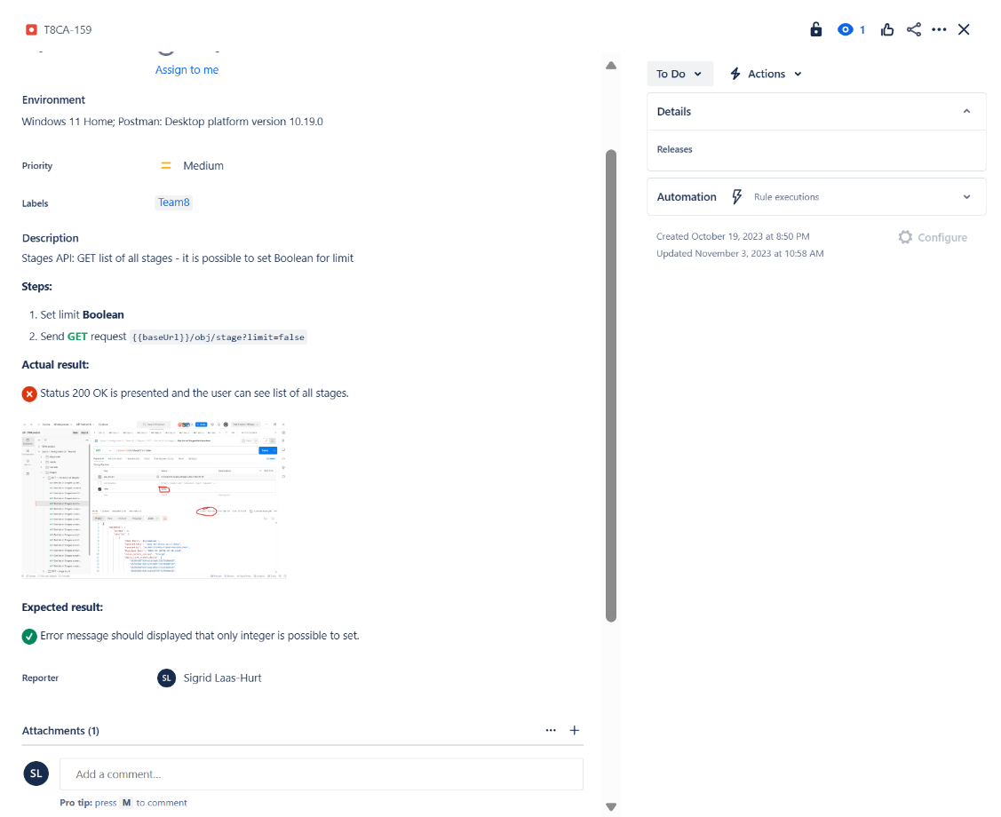**Example of the reported bug:**

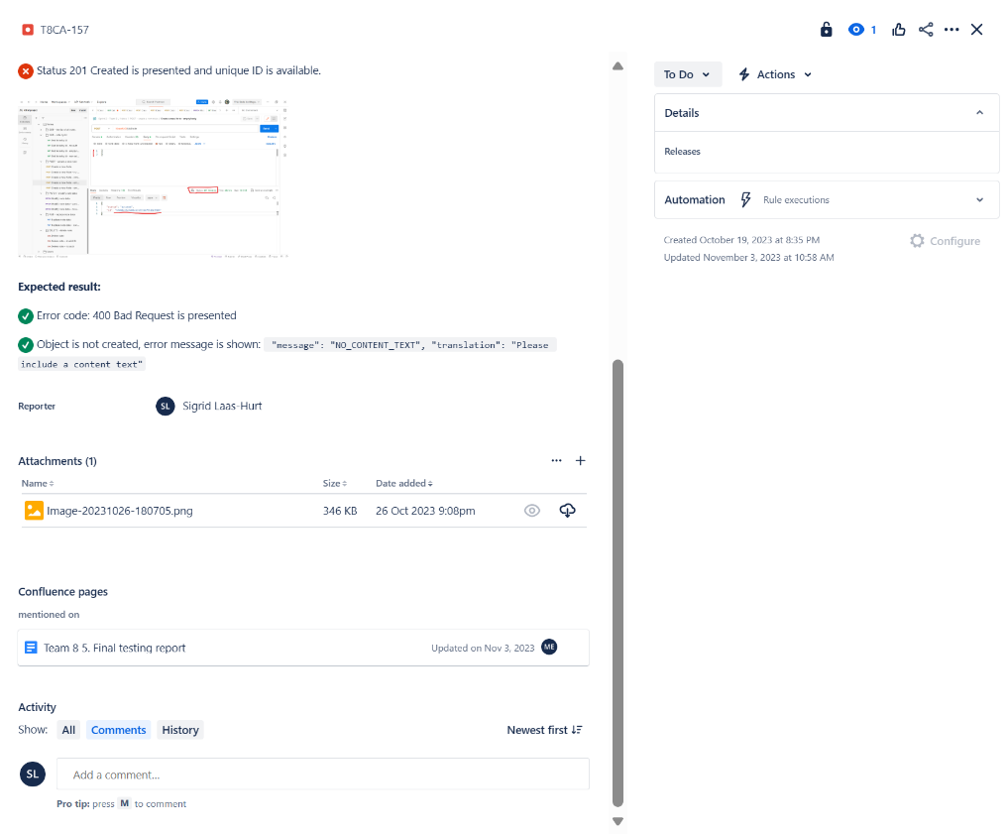

# Project#4 Registration Forms

## Project overview

We have a project with different registration forms (HTML, CSS, and JavaScript stack is used). Using those registration forms we will not only cover the basic functionality of Cypress but also make an introduction to the main parts of front-end architecture. Registration forms allow people to enter their data for registering them as users on the Web page.

The registration forms are partially covered by the automation tests, which ensure that forms are working and all workflows and elements on the forms are working, though some parts are not tested at all.   
Also, some parts of the automated tests for the second form intentionally contain some bugs, so automated tests are not working properly and need to be fixed.

## My responsibilities include

1. Worked individually.
2. Created UI automation tests using **Cypress**.
3. Modified the code using the **Visual Studio Code**
4. **Git** workflow. Code is committed to the **Github** repository
5. Tracked time in **Jira**.

**Example of the test:**

Add a new test when the phone number is not filled in: Add content to the empty test 'User cannot submit data when phone number is absent'

**Summary of results** is presented in file Project4_outcomes-Sigrid Laas-Hurt

**Github repository:** [Automation-Project-1/e2e at master · SigridLH/Automation-Project-1 (github.com)](https://github.com/SigridLH/Automation-Project-1/tree/master/e2e)

# Project#5 Task Management Platform

## Project overview

The goal of the project is to automate UI testing of the Jira Clone application. The Jira Clone is a lightweight ReactJS application that copies functionalities from the popular Jira task management system. The Jira Clone allows users to manage tasks for the project using a simple Kanban board. The goal of this project will be to cover as many functionalities as possible in the UI tests using the Cypress.

## My responsibilities include

1. Worked individually.
2. Created UI automation tests using **Cypress** for the following functionalities
   1. Creation, editing and deleting of tasks;
   2. Creation, editing and deleting of task comments;
   3. Time tracking functionality;
   4. Search functionality
3. Used the tool **Visual Studio Code**
4. Page Object Model approach
5. **Git** workflow. Code is committed to the **Github** repository
6. Tracked time in **Jira**.

**Summary of results** is presented in file Project5_outcomes-Sigrid Laas-Hurt

**Github repository:** [Automation-Project-2/cypress/e2e at master · SigridLH/Automation-Project-2 (github.com)](https://github.com/SigridLH/Automation-Project-2/tree/master/cypress/e2e)

# Project#6 Work Management Tool

## Project overview

The goal of the project is to automate API testing of the Jira Clone application.

## My responsibilities include

1. Worked individually.
2. Created Postman collections and wrote backend automation tests with **Postman** for the following functionalities
   1. Creating and updating tasks
   2. Deleting tasks
   3. Time tracking functionality – fir logging time and adding time estimation
   4. Creating, editing and deleting task comments
3. Tracked time in **Jira**.

**Example:**

