**DESIGNING A PLATFORM FOR NETWORK-RELATED EDUCATION**

# Software Architecture Document

Created by Sigurd Traberg Moth - [Simot18@student.sdu.dk](mailto:Simot18@student.sdu.dk)

Version number: 1.00

Color: #538135 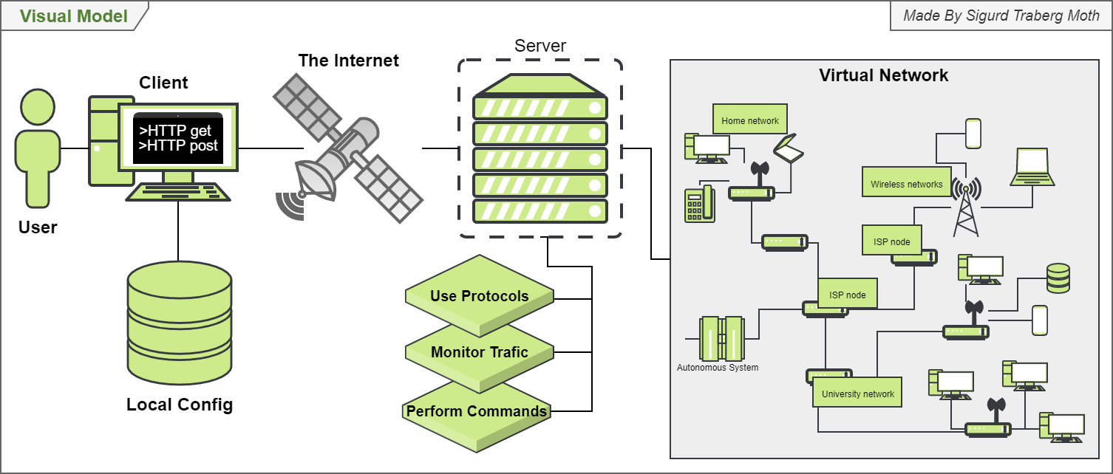

Contributors:

<Contribution> <Name> <Mail[Optional] >

# A. Document Structure

## A.1 Scope and Summary

The software architecture document (SAD) contains all the diagrams used to explain and understand the various design decisions as well as microservice architecture.

## A.2 How stakeholders can use the documentation

Stakeholders can use this document as a lookup tool to get a brief overview of systems or to get supporting documentation to the report and SRS.

## A.3 How the document is organized

Diagrams are developed in phases of Unified Process (UP). That is Requirements Analysis Design Implementation. The document is ordered by type of diagram and importance. System views Design diagrams Implementation (class) diagrams Sequence diagrams other diagrams.

Table of Contents

Software Architecture Document 1

A. Document Structure 2

A.1 Scope and Summary 2

A.2 How stakeholders can use the documentation 2

A.3 How the document is organized 2

System views 4

Domain model 4

Physical view of VIP 4

Overview 5

Design diagrams 6

3 layered architecture 6

Wrap and Expression 6

Overview of Monitor pattern 7

Http service 7

VipNode 8

Internal Network located on Session 8

Internal Network Application Layer 8

Implementation diagrams 9

Client 9

Expression and Wrap 10

Network Configuration 10

Use case diagrams 11

Common users 11

Teacher 12

Time, Student, Project, Developer 12

Sequence diagrams 13

Use case: sendData 13

Connecting to server 13

Other diagrams 14

Visual 14

Timeline 14

SRS design 15

Requirements to design 15

Agile workflow 15

Logo 1 16

Logo 2 16

Logo 3 16

Logo 4 16

Outdated diagrams 17

Logical view 17

# System views

## Domain model

Attempts to make the VIP understandable by using high-level explanations.

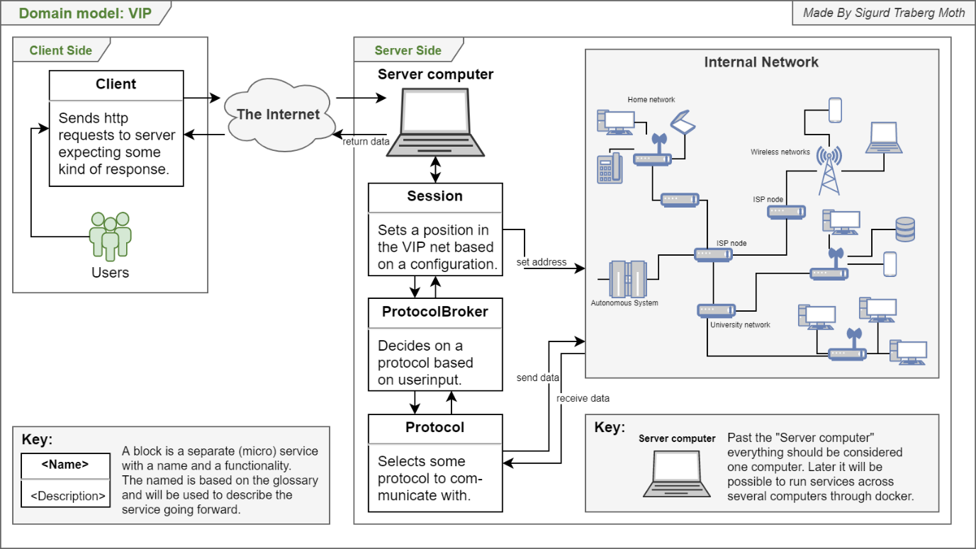

## Physical view of VIP

Details of how configurations, services, and classes are stored and hosted.

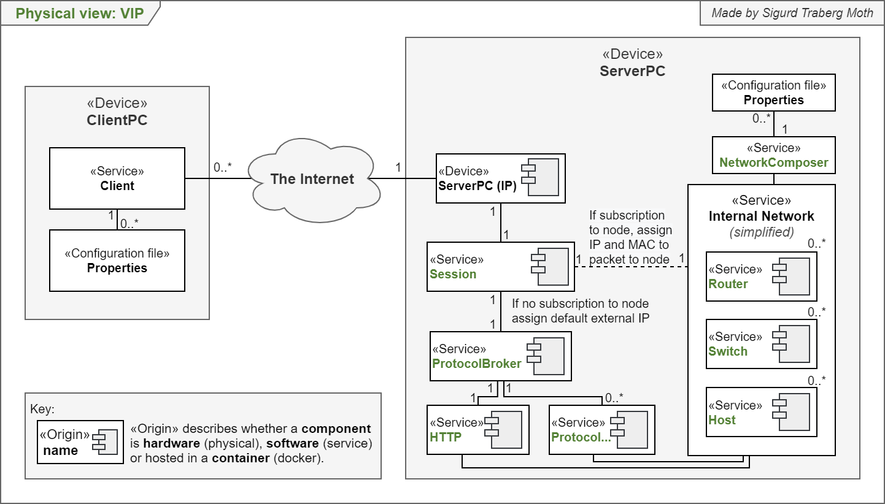

## Overview

A more detailed explanation of how the system functions including information on service and layer basis.

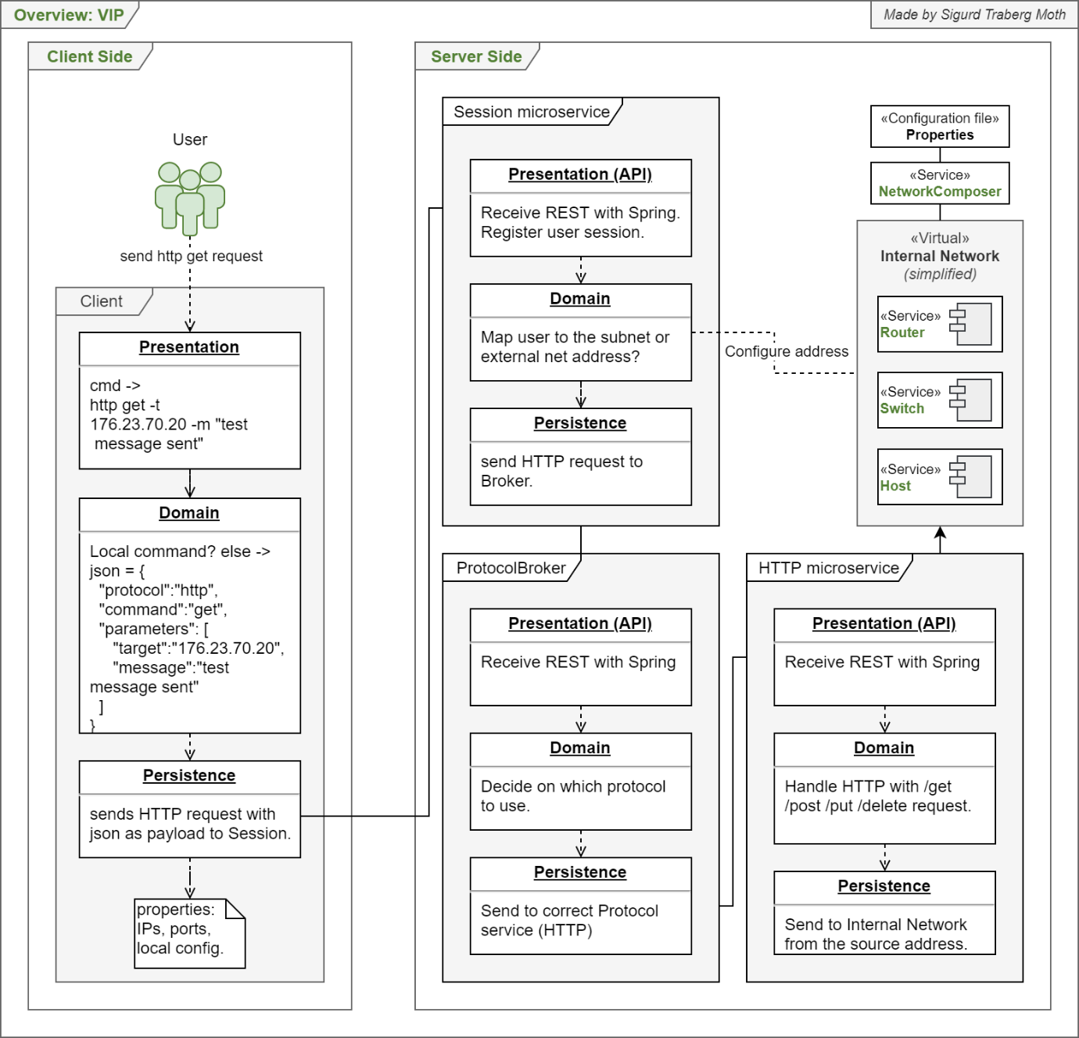

# Design diagrams

## 3 layered architecture

An illustration of the 3 layered architecture presentation, domain, and persistence and how interfaces act as middlemen between layers.

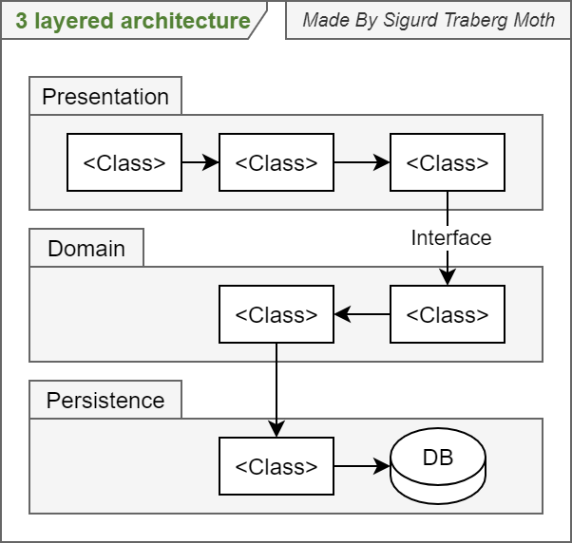

## Wrap and Expression

A diagram explaining the design of the Wrap object.

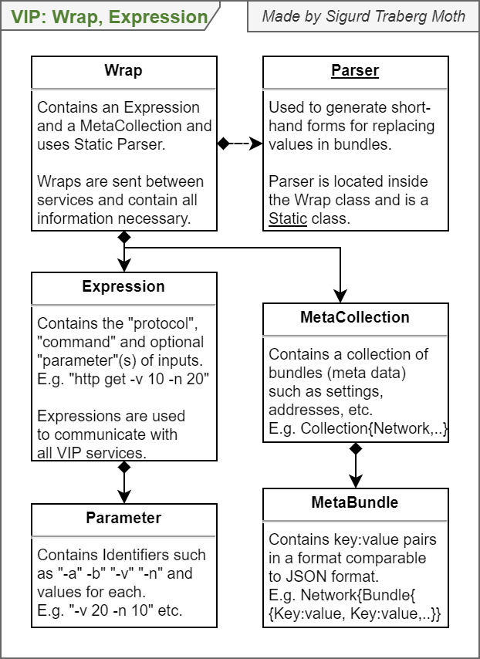

## Overview of Monitor pattern

A possible design of the monitor pattern.

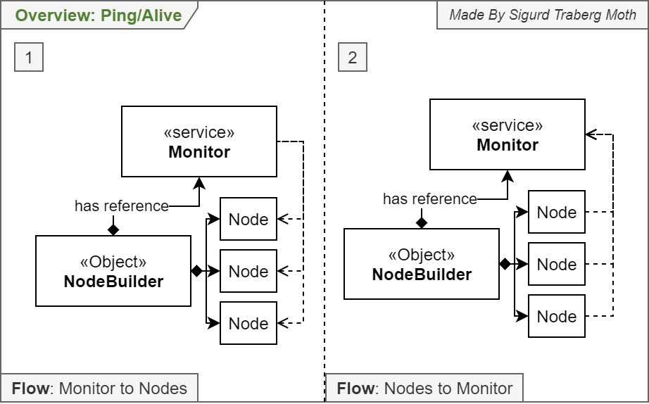

## HTTP service

A detailed explanation of the HTTP service design.

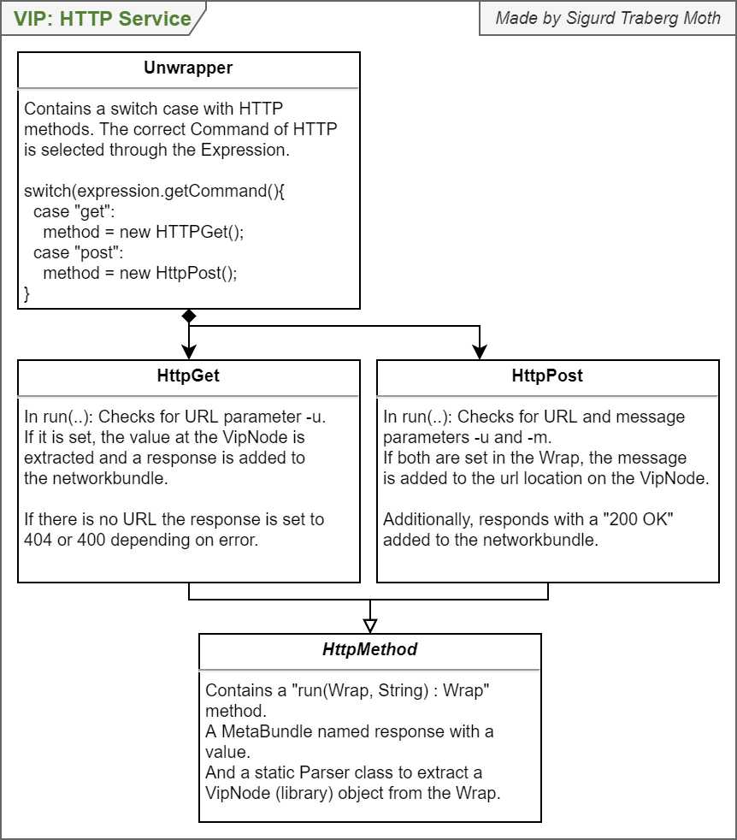

## VipNode

A detailed explanation of the VipNetwork and VipNode’s design and relationship with Session.

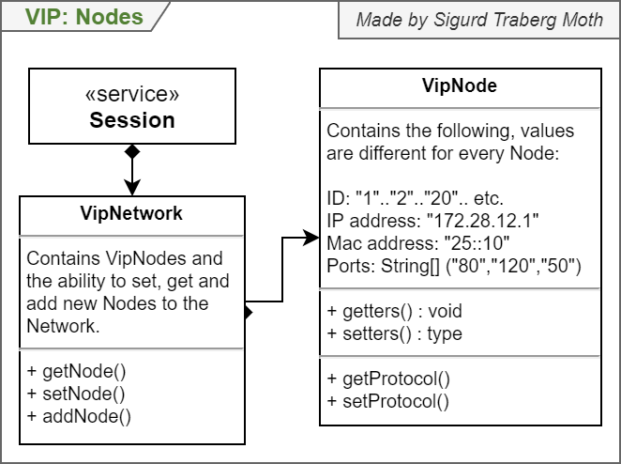

## Internal Network located on Session

Another illustration of the Internal Network that currently lives on the Session service.

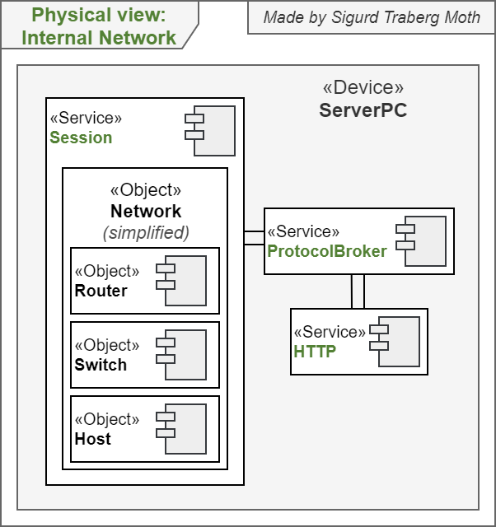

## Internal Network Application Layer

A potential design for the application layer when lower layers are also implemented.

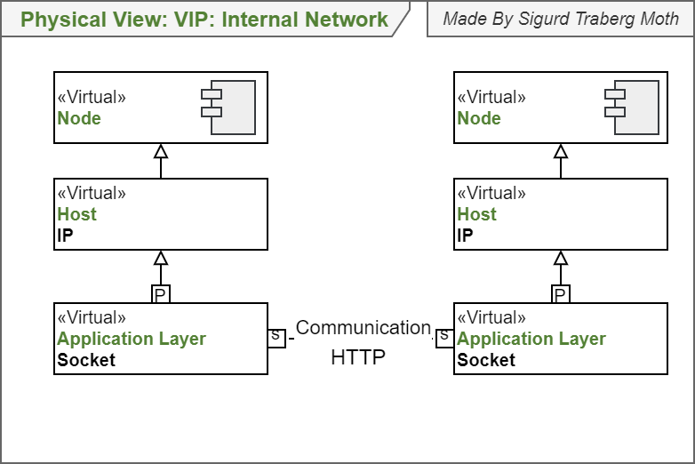

# Implementation diagrams

## Client

A full class diagram of the Client, some naming is outdated (Zoom in for details).

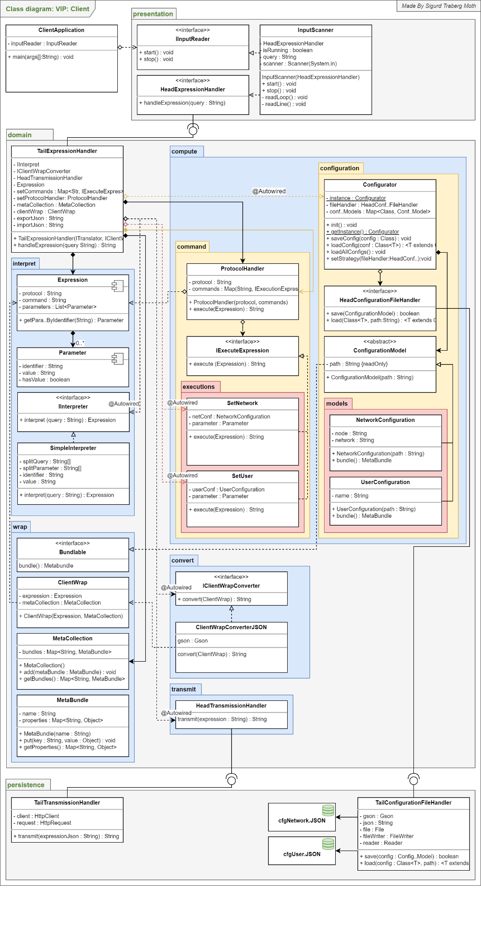

## Expression and Wrap

A class diagram explaining the Wrap in further detail.

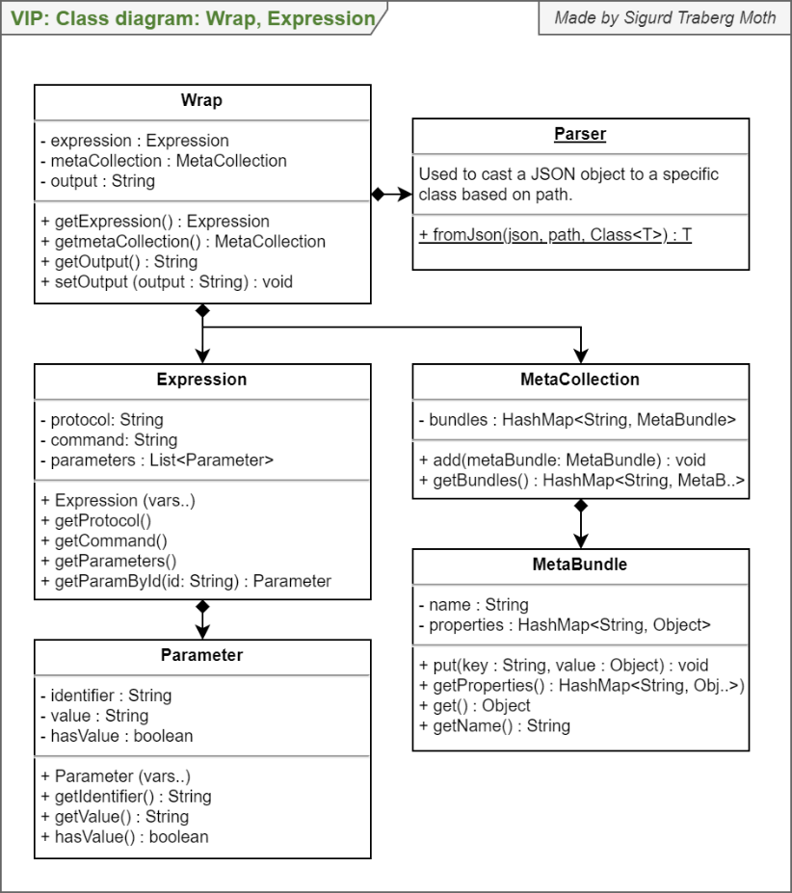

## Network Configuration

A mix of design and class diagram that illustrates the Configurator for a NetworkConfiguration.

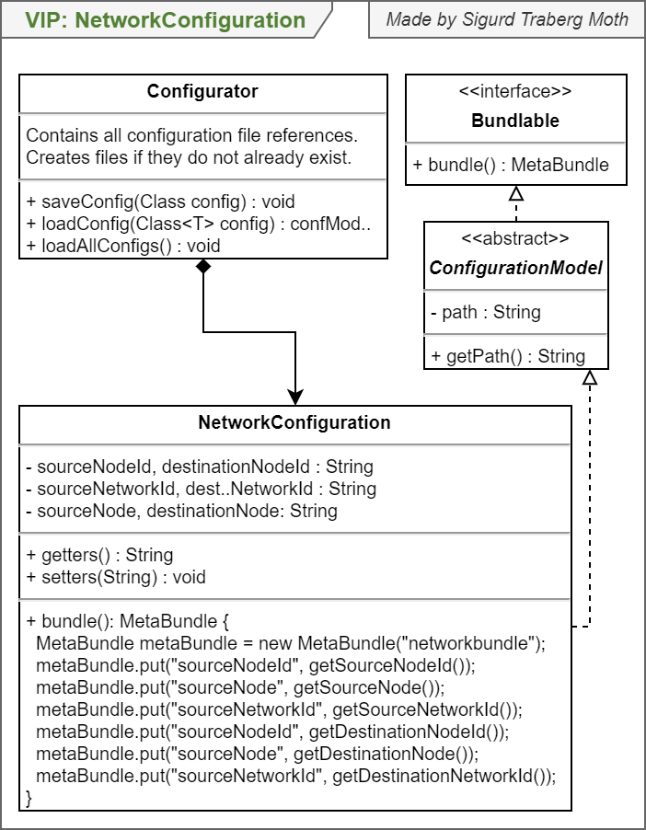

# Use case diagrams

## Common users

Discovered use cases for Common users with arrows to illustrate the area of interests and to group functionality.

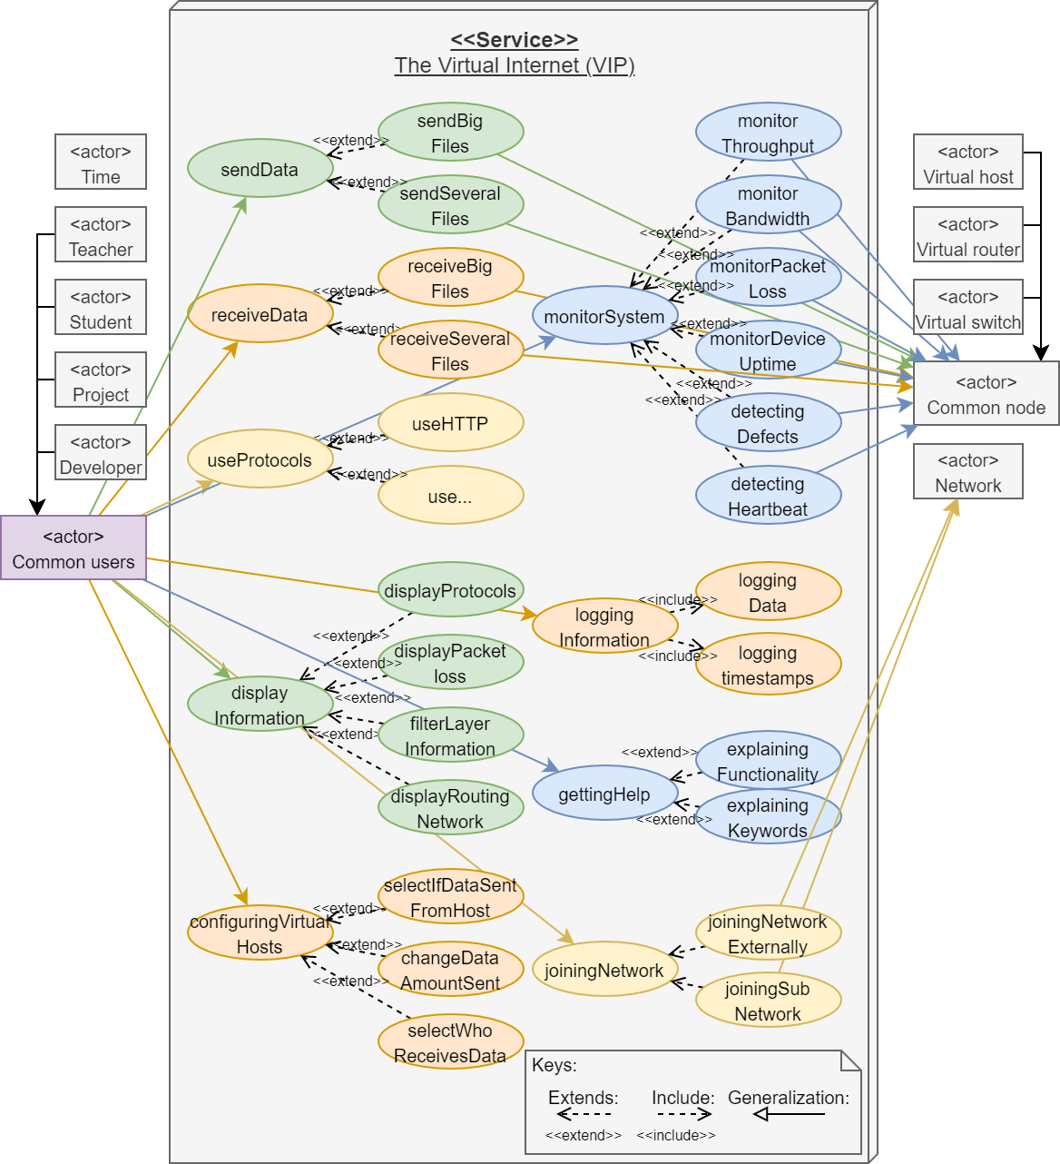

## Teacher

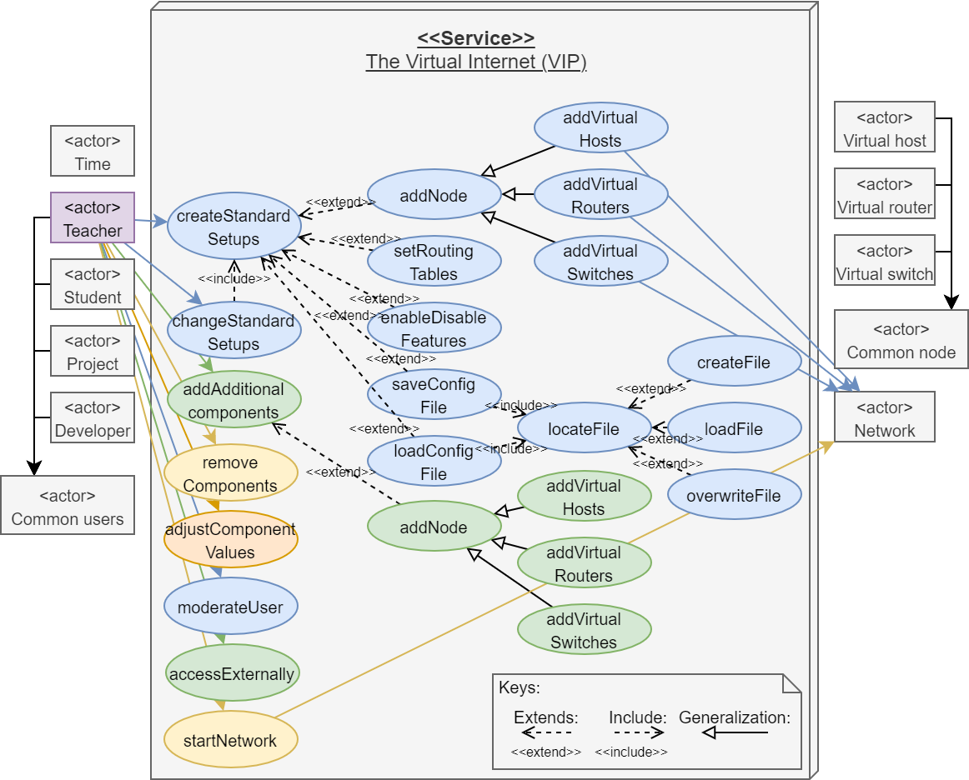

## Time, Student, Project, Developer

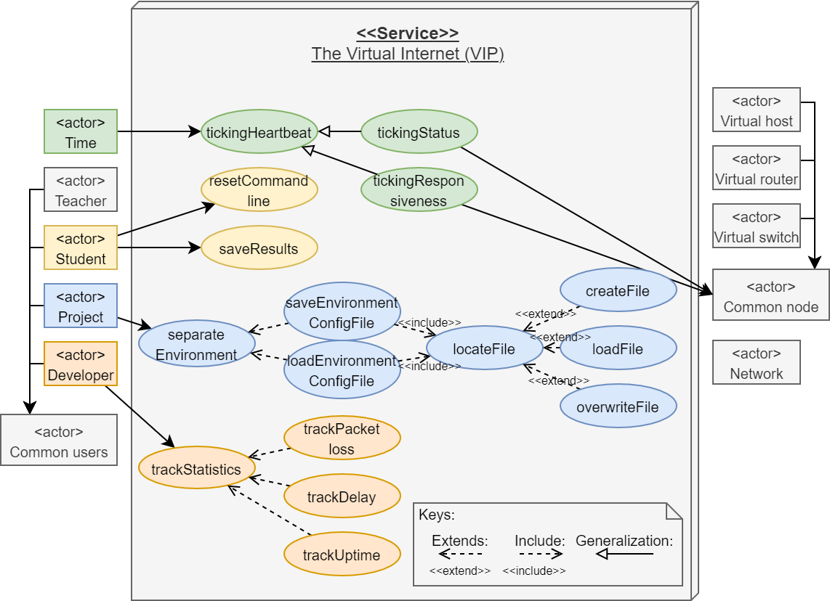

# Sequence diagrams

## Use case: sendData

A sequence diagram showing the flow of the use case for sending data through the VIP as a user.

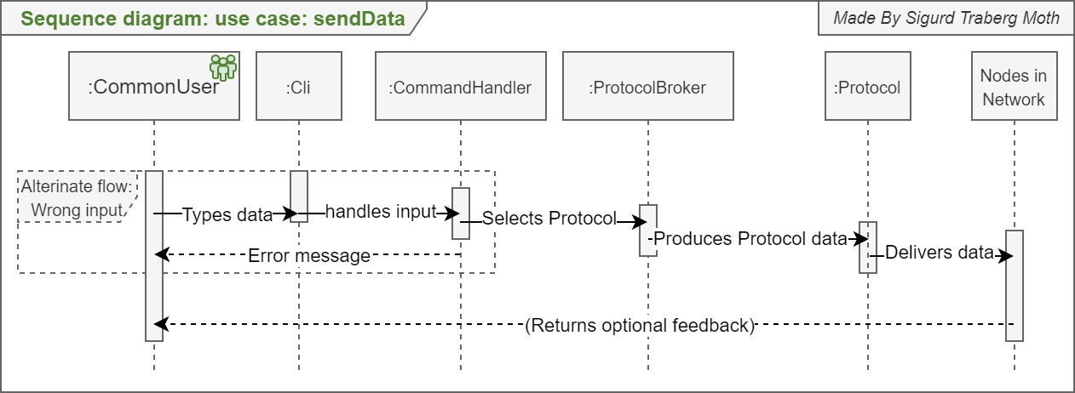

## Connecting to server

A sequence diagram illustrating the necessary flow when a client creates a new connection and overtakes a node.

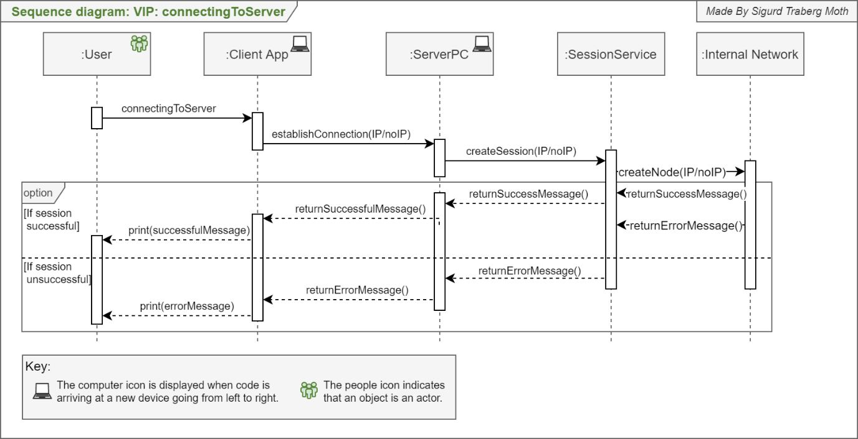

# Other diagrams

## Visual

A simple diagram is made to spark an interest in the reader.

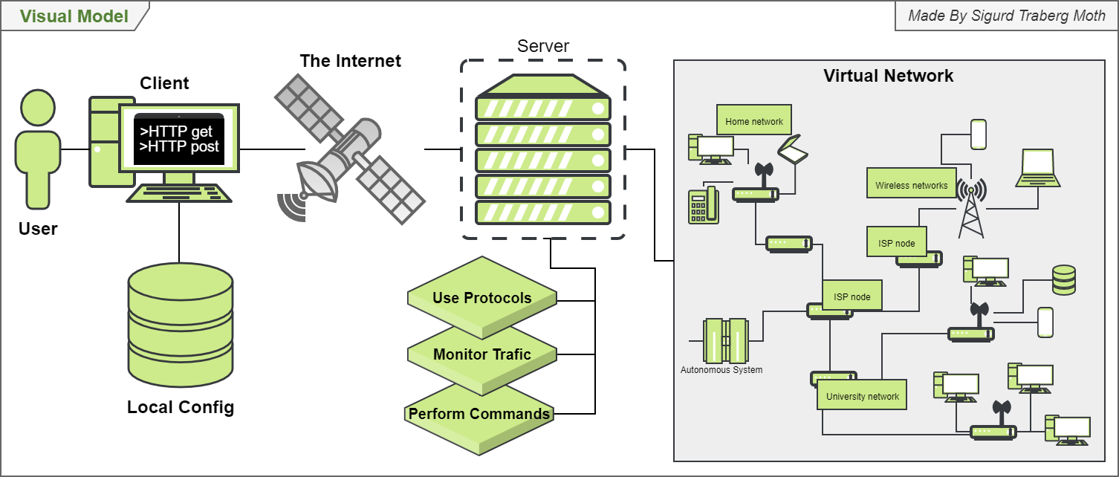

## Timeline

A milestones diagram pointing out expected goals as a part of the original Bachelor project.

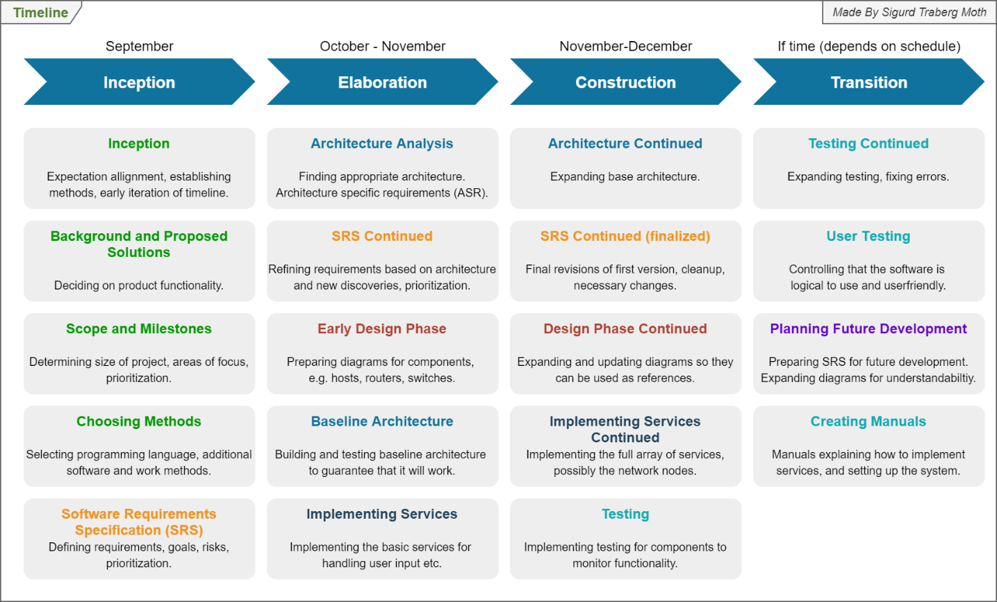

## SRS design

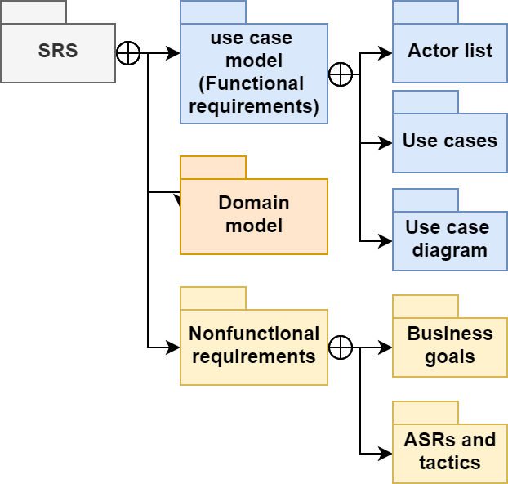

## Requirements to design

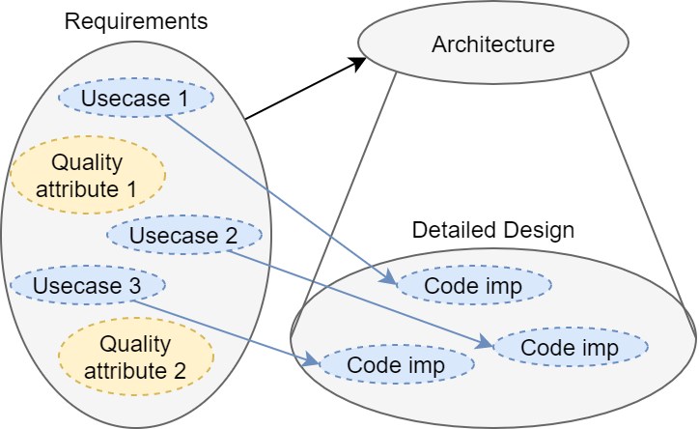

## Agile workflow

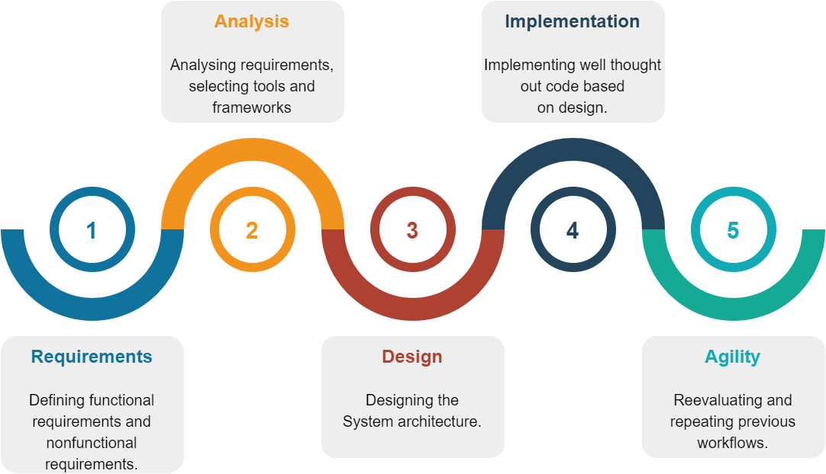

## Logo 1

The primary logo for the VIP. Other logos are optional for new features, currently only used as placeholders on GitLab to differentiate packages.



## Logo 2



## Logo 3



## Logo 4



# Outdated diagrams

## Logical view

The original diagram for the VIP design.

