1.1 Chemistry in Context

Learning Objectives
By the end of this section, you will be able to:
- Outline the historical development of chemistry
- Provide examples of the importance of chemistry in everyday life
- Describe the scientific method
- Differentiate among hypotheses, theories, and laws
- Provide examples illustrating macroscopic, microscopic, and symbolic domains
Throughout human history, people have tried to convert matter into more useful forms. Our Stone Age ancestors chipped pieces of flint into useful tools and carved wood into statues and toys. These endeavors involved changing the shape of a substance without changing the substance itself. But as our knowledge increased, humans began to change the composition of the substances as well—clay was converted into pottery, hides were cured to make garments, copper ores were transformed into copper tools and weapons, and grain was made into bread.
Humans began to practice chemistry when they learned to control fire and use it to cook, make pottery, and smelt metals. Subsequently, they began to separate and use specific components of matter. A variety of drugs such as aloe, myrrh, and opium were isolated from plants. Dyes, such as indigo and Tyrian purple, were extracted from plant and animal matter. Metals were combined to form alloys—for example, copper and tin were mixed together to make bronze—and more elaborate smelting techniques produced iron. Alkalis were extracted from ashes, and soaps were prepared by combining these alkalis with fats. Alcohol was produced by fermentation and purified by distillation.
Attempts to understand the behavior of matter extend back for more than 2500 years. As early as the sixth century BC, Greek philosophers discussed a system in which water was the basis of all things. You may have heard of the Greek postulate that matter consists of four elements: earth, air, fire, and water. Subsequently, an amalgamation of chemical technologies and philosophical speculations was spread from Egypt, China, and the eastern Mediterranean by alchemists, who endeavored to transform “base metals” such as lead into “noble metals” like gold, and to create elixirs to cure disease and extend life (Figure 1.2).
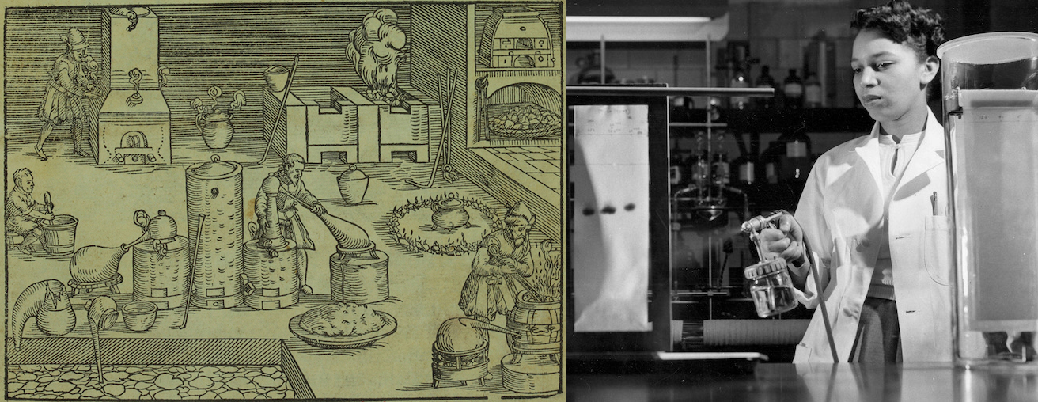
Figure 1.2 (a) This portrayal shows an alchemist’s workshop circa 1580. Although alchemy made some useful contributions to how to manipulate matter, it was not scientific by modern standards. (b) While the equipment used by Alma Levant Hayden in this 1952 picture might not seem as sleek as you might find in a lab today, her approach was highly methodical and carefully recorded. A department head at the FDA, Hayden is most famous for exposing an aggressively marketed anti-cancer drug as nothing more than an unhelpful solution of common substances. (credit a: Chemical Heritage Foundation; b: NIH History Office)
From alchemy came the historical progressions that led to modern chemistry: the isolation of drugs from natural sources, such as plants and animals. But while many of the substances extracted or processed from those natural sources were critical in the treatment of diseases, many were scarce. For example, progesterone, which is critical to women's health, became available as a medicine in 1935, but its animal sources produced extremely small quantities, limiting its availability and increasing its expense. Likewise, in the 1940s, cortisone came into use to treat arthritis and other disorders and injuries, but it took a 36-step process to synthesize. Chemist Percy Lavon Julian turned to a more plentiful source: soybeans. Previously, Julian had developed a lab to isolate soy protein, which was used in firefighting among other applications. He focused on using the soy sterols—substances mostly used in plant membranes—and was able to quickly produce progesterone and later testosterone and other hormones. He later developed a process to do the same for cortisone, and laid the groundwork for modern drug design. Since soybeans and similar plant sources were extremely plentiful, the drugs soon became widely available, saving many lives.

Chemistry: The Central Science
Chemistry is sometimes referred to as “the central science” due to its interconnectedness with a vast array of other STEM disciplines (STEM stands for areas of study in the science, technology, engineering, and math fields). Chemistry and the language of chemists play vital roles in biology, medicine, materials science, forensics, environmental science, and many other fields (Figure 1.3). The basic principles of physics are essential for understanding many aspects of chemistry, and there is extensive overlap between many subdisciplines within the two fields, such as chemical physics and nuclear chemistry. Mathematics, computer science, and information theory provide important tools that help us calculate, interpret, describe, and generally make sense of the chemical world. Biology and chemistry converge in biochemistry, which is crucial to understanding the many complex factors and processes that keep living organisms (such as us) alive. Chemical engineering, materials science, and nanotechnology combine chemical principles and empirical findings to produce useful substances, ranging from gasoline to fabrics to electronics. Agriculture, food science, veterinary science, and brewing and wine making help provide sustenance in the form of food and drink to the world’s population. Medicine, pharmacology, biotechnology, and botany identify and produce substances that help keep us healthy. Environmental science, geology, oceanography, and atmospheric science incorporate many chemical ideas to help us better understand and protect our physical world. Chemical ideas are used to help understand the universe in astronomy and cosmology.
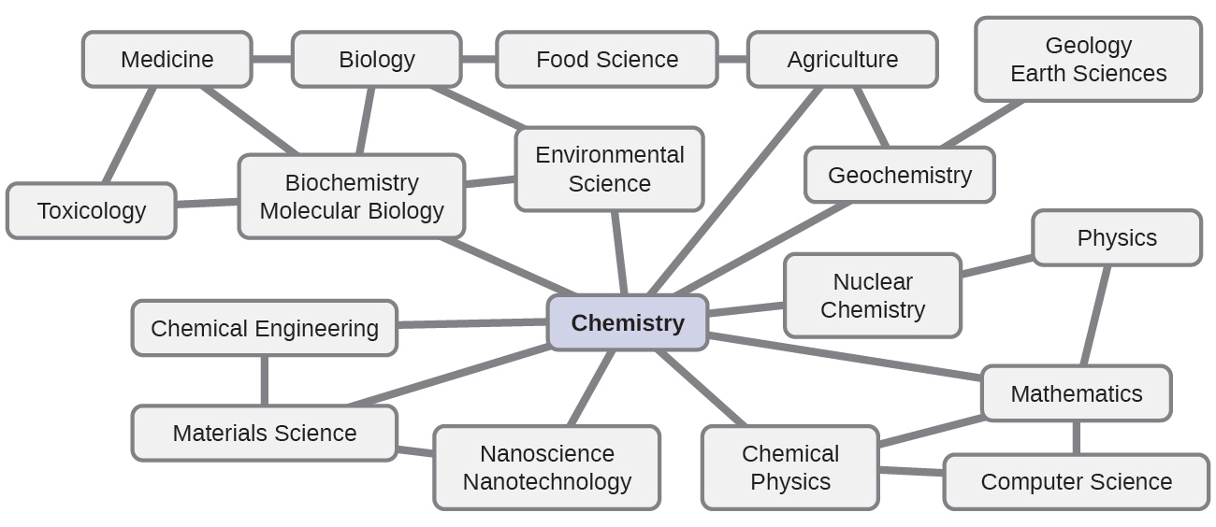
Figure 1.3 Knowledge of chemistry is central to understanding a wide range of scientific disciplines. This diagram shows just some of the interrelationships between chemistry and other fields.
What are some changes in matter that are essential to daily life? Digesting and assimilating food, synthesizing polymers that are used to make clothing, containers, cookware, and credit cards, and refining crude oil into gasoline and other products are just a few examples. As you proceed through this course, you will discover many different examples of changes in the composition and structure of matter, how to classify these changes and how they occurred, their causes, the changes in energy that accompany them, and the principles and laws involved. As you learn about these things, you will be learning chemistry, the study of the composition, properties, and interactions of matter. The practice of chemistry is not limited to chemistry books or laboratories: It happens whenever someone is involved in changes in matter or in conditions that may lead to such changes.

The Scientific Method
Chemistry is a science based on observation and experimentation. Doing chemistry involves attempting to answer questions and explain observations in terms of the laws and theories of chemistry, using procedures that are accepted by the scientific community. There is no single route to answering a question or explaining an observation, but there is an aspect common to every approach: Each uses knowledge based on experiments that can be reproduced to verify the results. Some routes involve a hypothesis, a tentative explanation of observations that acts as a guide for gathering and checking information. A hypothesis is tested by experimentation, calculation, and/or comparison with the experiments of others and then refined as needed.
Some hypotheses are attempts to explain the behavior that is summarized in laws. The laws of science summarize a vast number of experimental observations, and describe or predict some facet of the natural world. If such a hypothesis turns out to be capable of explaining a large body of experimental data, it can reach the status of a theory. Scientific theories are well-substantiated, comprehensive, testable explanations of particular aspects of nature. Theories are accepted because they provide satisfactory explanations, but they can be modified if new data become available. The path of discovery that leads from question and observation to law or hypothesis to theory, combined with experimental verification of the hypothesis and any necessary modification of the theory, is called the scientific method (Figure 1.4).
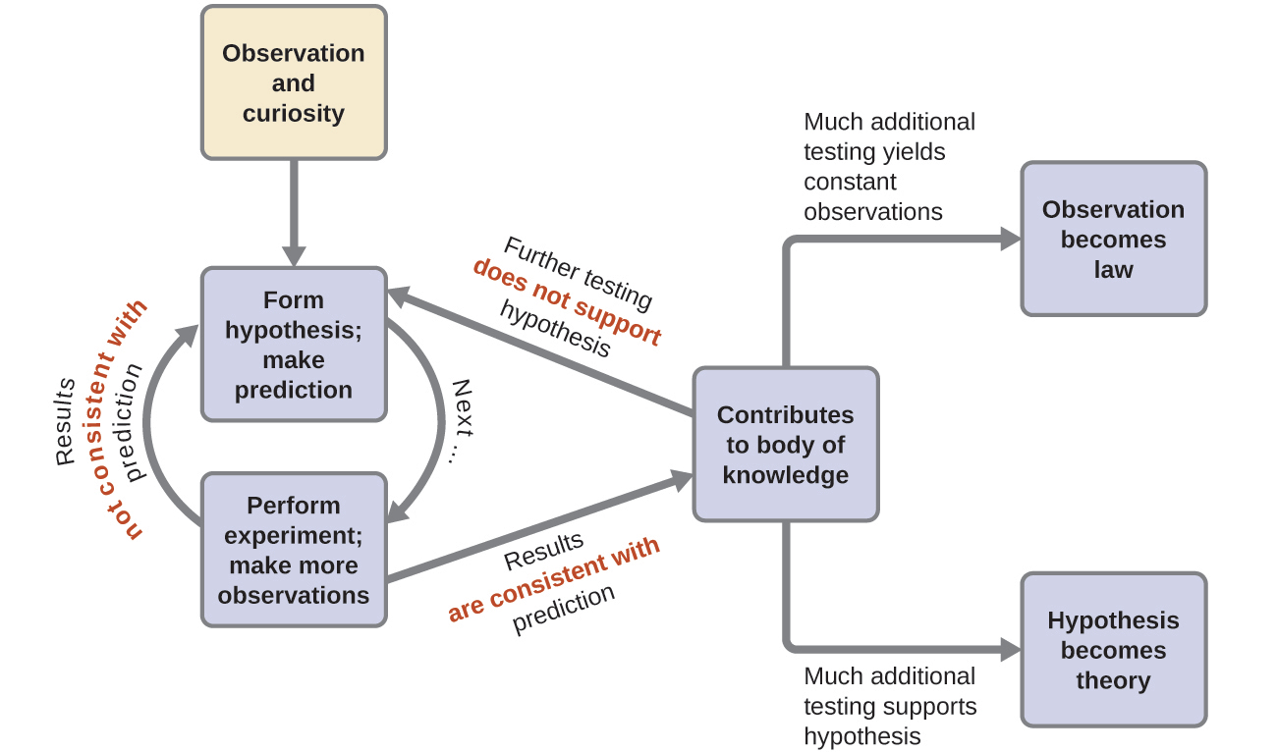
Figure 1.4 The scientific method follows a process similar to the one shown in this diagram. All the key components are shown, in roughly the right order. Scientific progress is seldom neat and clean: It requires open inquiry and the reworking of questions and ideas in response to findings.

The Domains of Chemistry
Chemists study and describe the behavior of matter and energy in three different domains: macroscopic, microscopic, and symbolic. These domains provide different ways of considering and describing chemical behavior.
Macro is a Greek word that means “large.” The macroscopic domain is familiar to us: It is the realm of everyday things that are large enough to be sensed directly by human sight or touch. In daily life, this includes the food you eat and the breeze you feel on your face. The macroscopic domain includes everyday and laboratory chemistry, where we observe and measure physical and chemical properties such as density, solubility, and flammability.
Micro comes from Greek and means “small.” The microscopic domain of chemistry is often visited in the imagination. Some aspects of the microscopic domain are visible through standard optical microscopes, for example, many biological cells. More sophisticated instruments are capable of imaging even smaller entities such as molecules and atoms (see Figure 1.5 (b)).
However, most of the subjects in the microscopic domain of chemistry are too small to be seen even with the most advanced microscopes and may only be pictured in the mind. Other components of the microscopic domain include ions and electrons, protons and neutrons, and chemical bonds, each of which is far too small to see.
The symbolic domain contains the specialized language used to represent components of the macroscopic and microscopic domains. Chemical symbols (such as those used in the periodic table), chemical formulas, and chemical equations are part of the symbolic domain, as are graphs, drawings, and calculations. These symbols play an important role in chemistry because they help interpret the behavior of the macroscopic domain in terms of the components of the microscopic domain. One of the challenges for students learning chemistry is recognizing that the same symbols can represent different things in the macroscopic and microscopic domains, and one of the features that makes chemistry fascinating is the use of a domain that must be imagined to explain behavior in a domain that can be observed.
A helpful way to understand the three domains is via the essential and ubiquitous substance of water. That water is a liquid at moderate temperatures, will freeze to form a solid at lower temperatures, and boil to form a gas at higher temperatures (Figure 1.5) are macroscopic observations. But some properties of water fall into the microscopic domain—what cannot be observed with the naked eye. The description of water as comprising two hydrogen atoms and one oxygen atom, and the explanation of freezing and boiling in terms of attractions between these molecules, is within the microscopic arena. The formula H₂O, which can describe water at either the macroscopic or microscopic levels, is an example of the symbolic domain. The abbreviations (g) for gas, (s) for solid, and (l) for liquid are also symbolic.
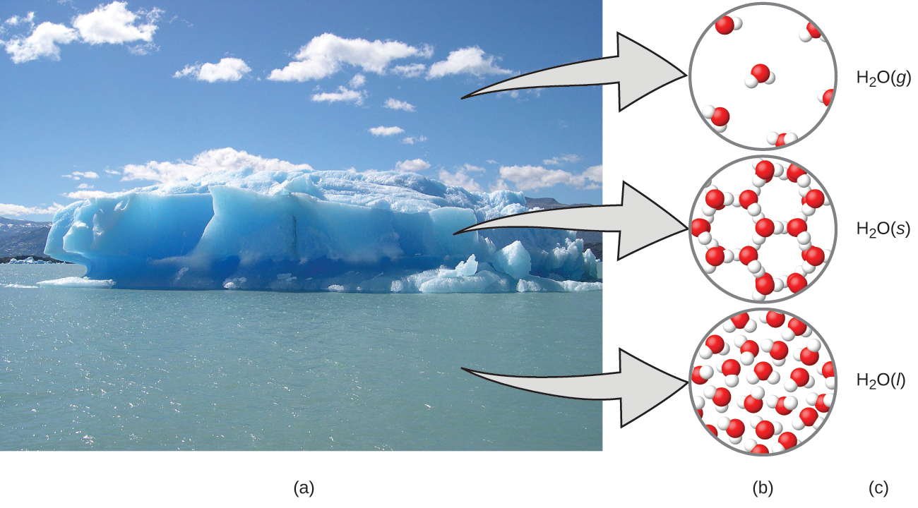
Figure 1.5 (a) Moisture in the air, icebergs, and the ocean represent water in the macroscopic domain. (b) At the molecular level (microscopic domain), gas molecules are far apart and disorganized, solid water molecules are close together and organized, and liquid molecules are close together and disorganized. (c) The formula H₂O symbolizes water, and (g), (s), and (l) symbolize its phases. Note that clouds are actually comprised of either very small liquid water droplets or solid water crystals; gaseous water in our atmosphere is not visible to the naked eye, although it may be sensed as humidity. (credit a: modification of work by “Gorkaazk”/Wikimedia Commons)

