1.3 Physical and Chemical Properties

Learning Objectives
By the end of this section, you will be able to:
- Identify properties of and changes in matter as physical or chemical
- Identify properties of matter as extensive or intensive
The characteristics that distinguish one substance from another are called properties. A physical property is a characteristic of matter that is not associated with a change in its chemical composition. Familiar examples of physical properties include density, color, hardness, melting and boiling points, and electrical conductivity. Some physical properties, such as density and color, may be observed without changing the physical state of the matter. Other physical properties, such as the melting temperature of iron or the freezing temperature of water, can only be observed as matter undergoes a physical change. A physical change is a change in the state or properties of matter without any accompanying change in the chemical identities of the substances contained in the matter. Physical changes are observed when wax melts, when sugar dissolves in coffee, and when steam condenses into liquid water (Figure 1.18). Other examples of physical changes include magnetizing and demagnetizing metals (as is done with common antitheft security tags) and grinding solids into powders (which can sometimes yield noticeable changes in color). In each of these examples, there is a change in the physical state, form, or properties of the substance, but no change in its chemical composition.
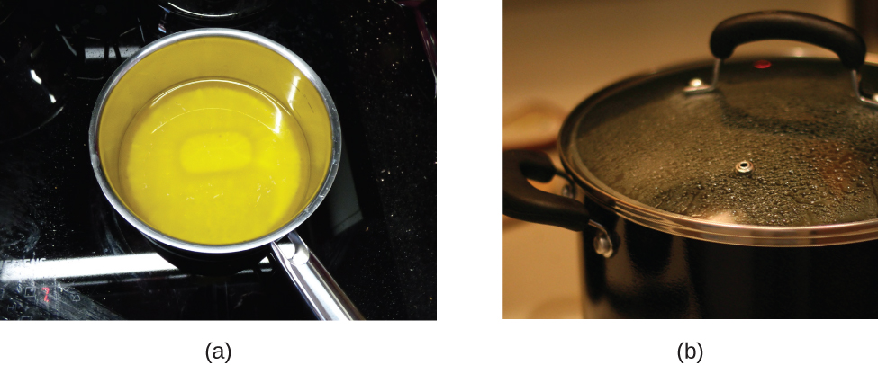
Figure 1.18 (a) Wax undergoes a physical change when solid wax is heated and forms liquid wax. (b) Steam condensing inside a cooking pot is a physical change, as water vapor is changed into liquid water. (credit a: modification of work by “95jb14”/Wikimedia Commons; credit b: modification of work by “mjneuby”/Flickr)
The ability to change from one type of matter into another (or the inability to change) is a chemical property. Examples of chemical properties include flammability, toxicity, acidity, and many other types of reactivity. Iron, for example, combines with oxygen in the presence of water to form rust; chromium does not oxidize (Figure 1.19). Nitroglycerin is very dangerous because it explodes easily; neon poses almost no hazard because it is very unreactive.
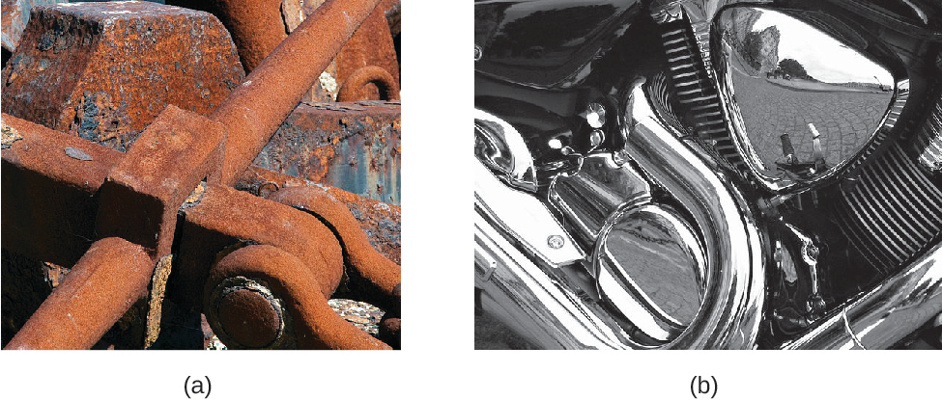
Figure 1.19 (a) One of the chemical properties of iron is that it rusts; (b) one of the chemical properties of chromium is that it does not. (credit a: modification of work by Tony Hisgett; credit b: modification of work by “Atoma”/Wikimedia Commons)
A chemical change always produces one or more types of matter that differ from the matter present before the change. The formation of rust is a chemical change because rust is a different kind of matter than the iron, oxygen, and water present before the rust formed. The explosion of nitroglycerin is a chemical change because the gases produced are very different kinds of matter from the original substance. Other examples of chemical changes include reactions that are performed in a lab (such as copper reacting with nitric acid), all forms of combustion (burning), and food being cooked, digested, or rotting (Figure 1.20).
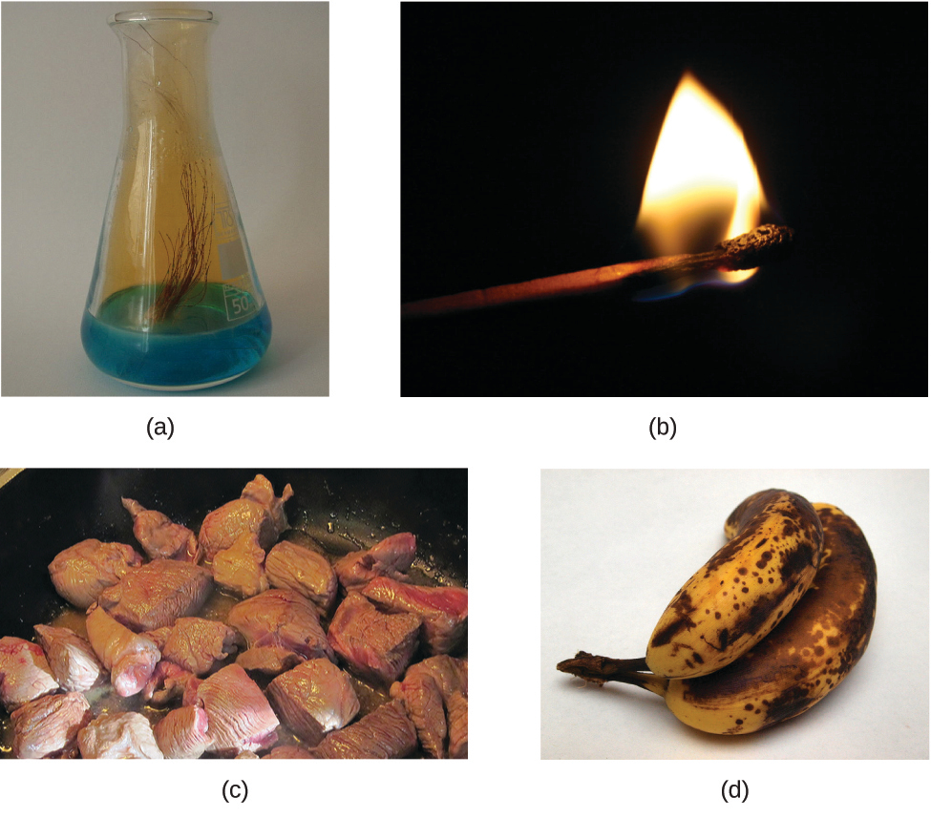
Figure 1.20 (a) Copper and nitric acid undergo a chemical change to form copper nitrate and brown, gaseous nitrogen dioxide. (b) During the combustion of a match, cellulose in the match and oxygen from the air undergo a chemical change to form carbon dioxide and water vapor. (c) Cooking red meat causes a number of chemical changes, including the oxidation of iron in myoglobin that results in the familiar red-to-brown color change. (d) A banana turning brown is a chemical change as new, darker (and less tasty) substances form. (credit b: modification of work by Jeff Turner; credit c: modification of work by Gloria Cabada-Leman; credit d: modification of work by Roberto Verzo)
Properties of matter fall into one of two categories. If the property depends on the amount of matter present, it is an extensive property. The mass and volume of a substance are examples of extensive properties; for instance, a gallon of milk has a larger mass than a cup of milk. The value of an extensive property is directly proportional to the amount of matter in question. If the property of a sample of matter does not depend on the amount of matter present, it is an intensive property. Temperature is an example of an intensive property. If the gallon and cup of milk are each at 20 °C (room temperature), when they are combined, the temperature remains at 20 °C. As another example, consider the distinct but related properties of heat and temperature. A drop of hot cooking oil spattered on your arm causes brief, minor discomfort, whereas a pot of hot oil yields severe burns. Both the drop and the pot of oil are at the same temperature (an intensive property), but the pot clearly contains much more heat (extensive property).

Chemistry in Everyday Life

Hazard Diamond
You may have seen the symbol shown in Figure 1.21 on containers of chemicals in a laboratory or workplace. Sometimes called a “fire diamond” or “hazard diamond,” this chemical hazard diamond provides valuable information that briefly summarizes the various dangers of which to be aware when working with a particular substance.
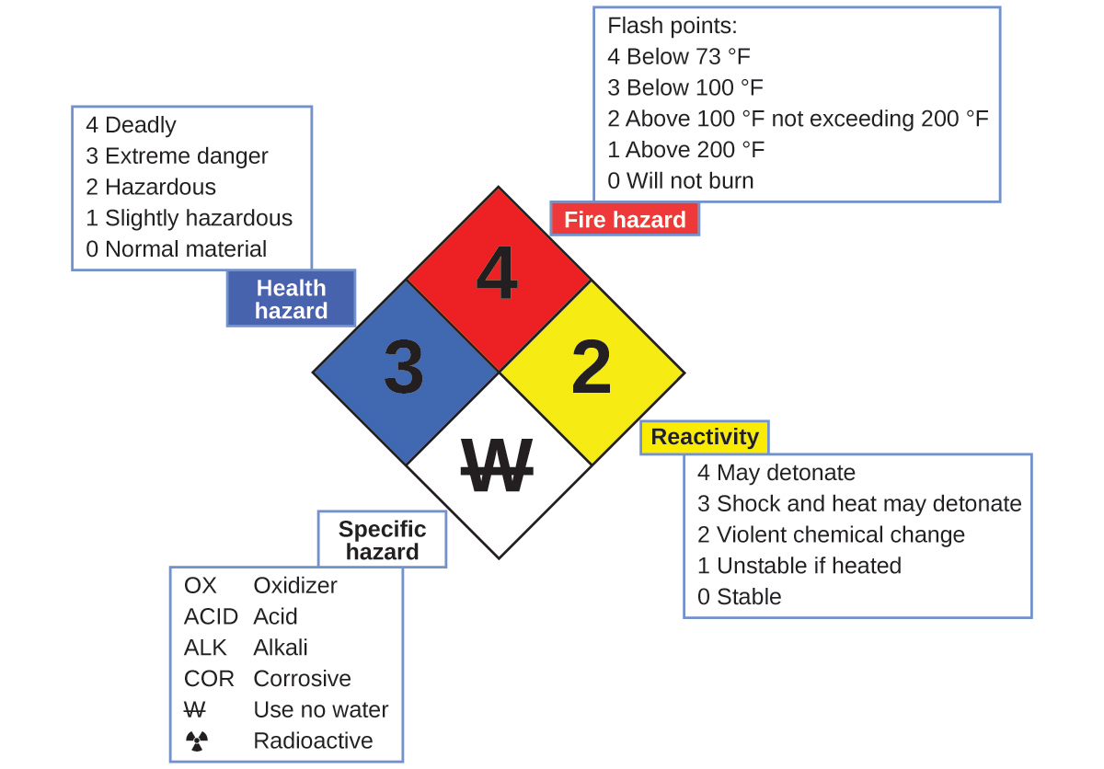
Figure 1.21 The National Fire Protection Agency (NFPA) hazard diamond summarizes the major hazards of a chemical substance.
The National Fire Protection Agency (NFPA) 704 Hazard Identification System was developed by NFPA to provide safety information about certain substances. The system details flammability, reactivity, health, and other hazards. Within the overall diamond symbol, the top (red) diamond specifies the level of fire hazard (temperature range for flash point). The blue (left) diamond indicates the level of health hazard. The yellow (right) diamond describes reactivity hazards, such as how readily the substance will undergo detonation or a violent chemical change. The white (bottom) diamond points out special hazards, such as if it is an oxidizer (which allows the substance to burn in the absence of air/oxygen), undergoes an unusual or dangerous reaction with water, is corrosive, acidic, alkaline, a biological hazard, radioactive, and so on. Each hazard is rated on a scale from 0 to 4, with 0 being no hazard and 4 being extremely hazardous.
While many elements differ dramatically in their chemical and physical properties, some elements have similar properties. For example, many elements conduct heat and electricity well, whereas others are poor conductors. These properties can be used to sort the elements into three classes: metals (elements that conduct well), nonmetals (elements that conduct poorly), and metalloids (elements that have intermediate conductivities).
The periodic table is a table of elements that places elements with similar properties close together (Figure 1.22). You will learn more about the periodic table as you continue your study of chemistry.
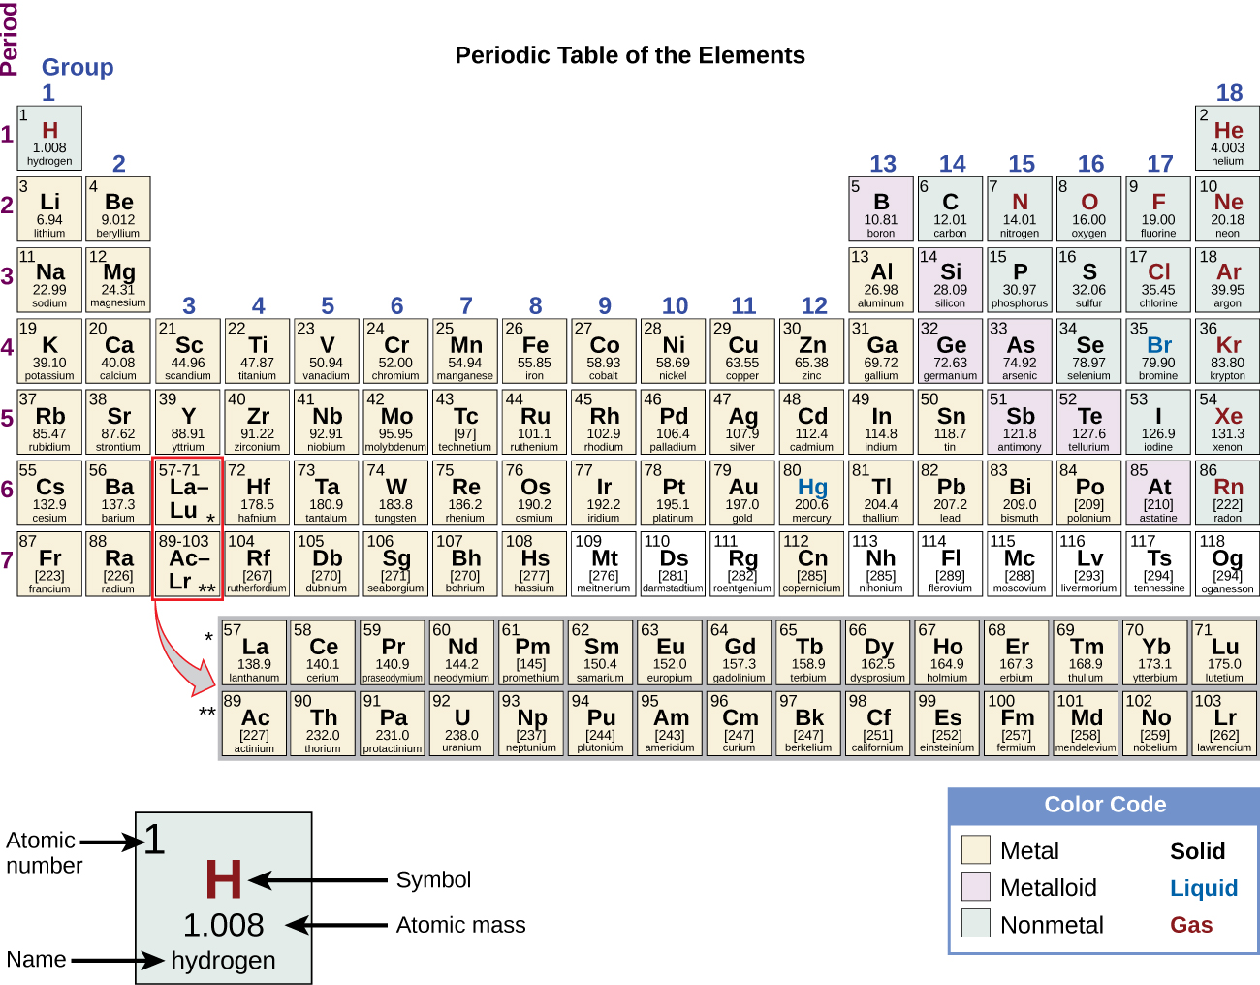
Figure 1.22 The periodic table shows how elements may be grouped according to certain similar properties. Note the background color denotes whether an element is a metal, metalloid, or nonmetal, whereas the element symbol color indicates whether it is a solid, liquid, or gas.

