1.4 Measurements

Learning Objectives
By the end of this section, you will be able to:
- Explain the process of measurement
- Identify the three basic parts of a quantity
- Describe the properties and units of length, mass, volume, density, temperature, and time
- Perform basic unit calculations and conversions in the metric and other unit systems
Measurements provide much of the information that informs the hypotheses, theories, and laws describing the behavior of matter and energy in both the macroscopic and microscopic domains of chemistry. Every measurement provides three kinds of information: the size or magnitude of the measurement (a number); a standard of comparison for the measurement (a unit); and an indication of the uncertainty of the measurement. While the number and unit are explicitly represented when a quantity is written, the uncertainty is an aspect of the measurement result that is more implicitly represented and will be discussed later.
The number in the measurement can be represented in different ways, including decimal form and scientific notation. (Scientific notation is also known as exponential notation; a review of this topic can be found in Appendix B.) For example, the maximum takeoff weight of a Boeing 777-200ER airliner is 298,000 kilograms, which can also be written as 2.98 $×$ 10⁵ kg. The mass of the average mosquito is about 0.0000025 kilograms, which can be written as 2.5 $×$ 10⁻⁶ kg.
Units, such as liters, pounds, and centimeters, are standards of comparison for measurements. A 2-liter bottle of a soft drink contains a volume of beverage that is twice that of the accepted volume of 1 liter. The meat used to prepare a 0.25-pound hamburger weighs one-fourth as much as the accepted weight of 1 pound. Without units, a number can be meaningless, confusing, or possibly life threatening. Suppose a doctor prescribes phenobarbital to control a patient’s seizures and states a dosage of “100” without specifying units. Not only will this be confusing to the medical professional giving the dose, but the consequences can be dire: 100 mg given three times per day can be effective as an anticonvulsant, but a single dose of 100 g is more than 10 times the lethal amount.
The measurement units for seven fundamental properties (“base units”) are listed in Table 1.2. The standards for these units are fixed by international agreement, and they are called the International System of Units or SI Units (from the French, Le Système International d’Unités). SI units have been used by the United States National Institute of Standards and Technology (NIST) since 1964. Units for other properties may be derived from these seven base units.
Base Units of the SI System
Property Measured | Name of Unit | Symbol of Unit
length | meter | m
mass | kilogram | kg
time | second | s
temperature | kelvin | K
electric current | ampere | A
amount of substance | mole | mol
luminous intensity | candela | cd
Table 1.2
Everyday measurement units are often defined as fractions or multiples of other units. Milk is commonly packaged in containers of 1 gallon (4 quarts), 1 quart (0.25 gallon), and one pint (0.5 quart). This same approach is used with SI units, but these fractions or multiples are always powers of 10. Fractional or multiple SI units are named using a prefix and the name of the base unit. For example, a length of 1000 meters is also called a kilometer because the prefix kilo means “one thousand,” which in scientific notation is 10³ (1 kilometer = 1000 m = 10³ m). The prefixes used and the powers to which 10 are raised are listed in Table 1.3.
Common Unit Prefixes
Prefix | Symbol | Factor | Example
femto | f | 10⁻¹⁵ | 1 femtosecond (fs) = 1 $×$ 10⁻¹⁵ s (0.000000000000001 s)
pico | p | 10⁻¹² | 1 picometer (pm) = 1 $×$ 10⁻¹² m (0.000000000001 m)
nano | n | 10⁻⁹ | 4 nanograms (ng) = 4 $×$ 10⁻⁹ g (0.000000004 g)
micro | µ | 10⁻⁶ | 1 microliter (μL) = 1 $×$ 10⁻⁶ L (0.000001 L)
milli | m | 10⁻³ | 2 millimoles (mmol) = 2 $×$ 10⁻³ mol (0.002 mol)
centi | c | 10⁻² | 7 centimeters (cm) = 7 $×$ 10⁻² m (0.07 m)
deci | d | 10⁻¹ | 1 deciliter (dL) = 1 $×$ 10⁻¹ L (0.1 L )
kilo | k | 10³ | 1 kilometer (km) = 1 $×$ 10³ m (1000 m)
mega | M | 10⁶ | 3 megahertz (MHz) = 3 $×$ 10⁶ Hz (3,000,000 Hz)
giga | G | 10⁹ | 8 gigayears (Gyr) = 8 $×$ 10⁹ yr (8,000,000,000 yr)
tera | T | 10¹² | 5 terawatts (TW) = 5 $×$ 10¹² W (5,000,000,000,000 W)
Table 1.3

Link to Learning
Need a refresher or more practice with scientific notation? Visit this site to go over the basics of scientific notation.

SI Base Units
The initial units of the metric system, which eventually evolved into the SI system, were established in France during the French Revolution. The original standards for the meter and the kilogram were adopted there in 1799 and eventually by other countries. This section introduces four of the SI base units commonly used in chemistry. Other SI units will be introduced in subsequent chapters.

Length
The standard unit of length in both the SI and original metric systems is the meter (m). A meter was originally specified as 1/10,000,000 of the distance from the North Pole to the equator. It is now defined as the distance light in a vacuum travels in 1/299,792,458 of a second. A meter is about 3 inches longer than a yard (Figure 1.23); one meter is about 39.37 inches or 1.094 yards. Longer distances are often reported in kilometers (1 km = 1000 m = 10³ m), whereas shorter distances can be reported in centimeters (1 cm = 0.01 m = 10⁻² m) or millimeters (1 mm = 0.001 m = 10⁻³ m).
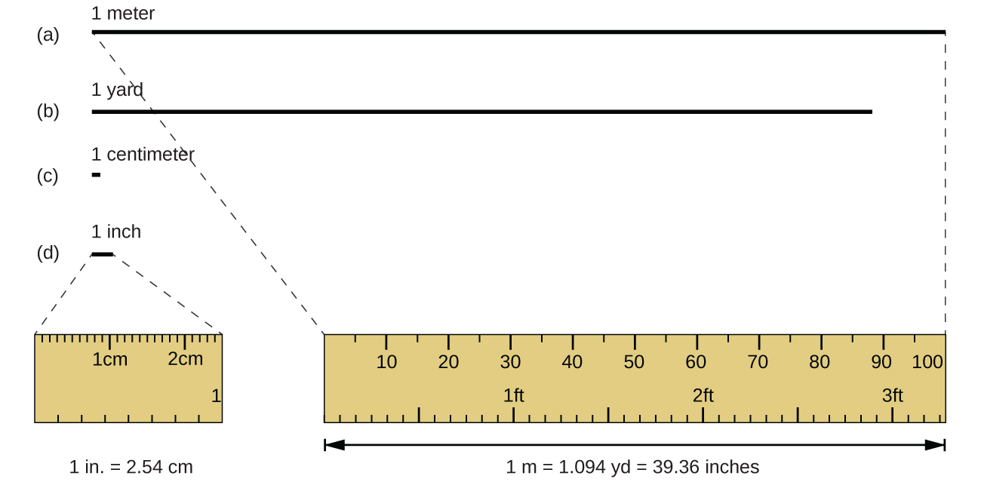
Figure 1.23 The relative lengths of 1 m, 1 yd, 1 cm, and 1 in. are shown (not actual size), as well as comparisons of 2.54 cm and 1 in., and of 1 m and 1.094 yd.

Mass
The standard unit of mass in the SI system is the kilogram (kg). The kilogram was previously defined by the International Union of Pure and Applied Chemistry (IUPAC) as the mass of a specific reference object. This object was originally one liter of pure water, and more recently it was a metal cylinder made from a platinum-iridium alloy with a height and diameter of 39 mm (Figure 1.24). In May 2019, this definition was changed to one that is based instead on precisely measured values of several fundamental physical constants.1. One kilogram is about 2.2 pounds. The gram (g) is exactly equal to 1/1000 of the mass of the kilogram (10⁻³ kg).
1
For details see https://www.nist.gov/pml/weights-and-measures/si-units-mass
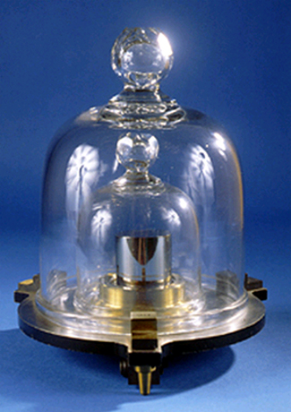
Figure 1.24 This replica prototype kilogram as previously defined is housed at the National Institute of Standards and Technology (NIST) in Maryland. (credit: National Institutes of Standards and Technology)

Temperature
Temperature is an intensive property. The SI unit of temperature is the kelvin (K). The IUPAC convention is to use kelvin (all lowercase) for the word, K (uppercase) for the unit symbol, and neither the word “degree” nor the degree symbol (°). The degree Celsius (°C) is also allowed in the SI system, with both the word “degree” and the degree symbol used for Celsius measurements. Celsius degrees are the same magnitude as those of kelvin, but the two scales place their zeros in different places. Water freezes at 273.15 K (0 °C) and boils at 373.15 K (100 °C), and normal human body temperature is approximately 310 K (37 °C). The conversion between these two units and the Fahrenheit scale will be discussed later in this chapter.

Time
The SI base unit of time is the second (s). Small and large time intervals can be expressed with the appropriate prefixes; for example, 3 microseconds = 0.000003 s = 3 $×$ 10⁻⁶ and 5 megaseconds = 5,000,000 s = 5 $×$ 10⁶ s. Alternatively, hours, days, and years can be used.

Derived SI Units
We can derive many units from the seven SI base units. For example, we can use the base unit of length to define a unit of volume, and the base units of mass and length to define a unit of density.

Volume
Volume is the measure of the amount of space occupied by an object. The standard SI unit of volume is defined by the base unit of length (Figure 1.25). The standard volume is a cubic meter (m³), a cube with an edge length of exactly one meter. To dispense a cubic meter of water, we could build a cubic box with edge lengths of exactly one meter. This box would hold a cubic meter of water or any other substance.
A more commonly used unit of volume is derived from the decimeter (0.1 m, or 10 cm). A cube with edge lengths of exactly one decimeter contains a volume of one cubic decimeter (dm³). A liter (L) is the more common name for the cubic decimeter. One liter is about 1.06 quarts.
A cubic centimeter (cm³) is the volume of a cube with an edge length of exactly one centimeter. The abbreviation cc (for cubic centimeter) is often used by health professionals. A cubic centimeter is equivalent to a milliliter (mL) and is 1/1000 of a liter.
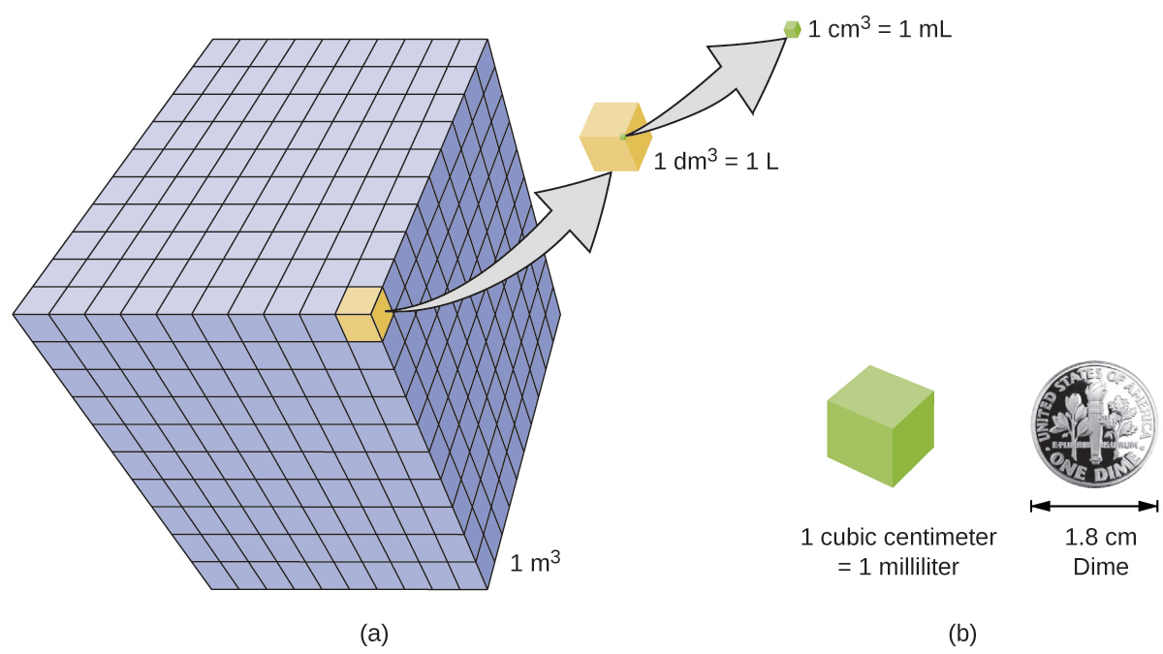
Figure 1.25 (a) The relative volumes are shown for cubes of 1 m³, 1 dm³ (1 L), and 1 cm³ (1 mL) (not to scale). (b) The diameter of a dime is compared relative to the edge length of a 1-cm³ (1-mL) cube.

Density
We use the mass and volume of a substance to determine its density. Thus, the units of density are defined by the base units of mass and length.
The density of a substance is the ratio of the mass of a sample of the substance to its volume. The SI unit for density is the kilogram per cubic meter (kg/m³). For many situations, however, this is an inconvenient unit, and we often use grams per cubic centimeter (g/cm³) for the densities of solids and liquids, and grams per liter (g/L) for gases. Although there are exceptions, most liquids and solids have densities that range from about 0.7 g/cm³ (the density of gasoline) to 19 g/cm³ (the density of gold). The density of air is about 1.2 g/L. Table 1.4 shows the densities of some common substances.
Densities of Common Substances
Solids | Liquids | Gases (at 25 °C and 1 atm)
ice (at 0 °C) 0.92 g/cm³ | water 1.0 g/cm³ | dry air 1.20 g/L
oak (wood) 0.60–0.90 g/cm³ | ethanol 0.79 g/cm³ | oxygen 1.31 g/L
iron 7.9 g/cm³ | acetone 0.79 g/cm³ | nitrogen 1.14 g/L
copper 9.0 g/cm³ | glycerin 1.26 g/cm³ | carbon dioxide 1.80 g/L
lead 11.3 g/cm³ | olive oil 0.92 g/cm³ | helium 0.16 g/L
silver 10.5 g/cm³ | gasoline 0.70–0.77 g/cm³ | neon 0.83 g/L
gold 19.3 g/cm³ | mercury 13.6 g/cm³ | radon 9.1 g/L
Table 1.4
While there are many ways to determine the density of an object, perhaps the most straightforward method involves separately finding the mass and volume of the object, and then dividing the mass of the sample by its volume. In the following example, the object's mass is measured using a scale, but its volume is calculated geometrically from length measurements.
$$\text{density}= \frac{\text{mass}}{\text{volume}}$$

Example 1.1

Calculation of Density
Gold—in bricks, bars, and coins—has been a form of currency for centuries. In order to swindle people into paying for a brick of gold without actually investing in a brick of gold, people have considered filling the centers of hollow gold bricks with lead to fool buyers into thinking that the entire brick is gold. It does not work: Lead is a dense substance, but its density is not as great as that of gold, 19.3 g/cm³. What is the density of lead if a cube of lead has an edge length of 2.00 cm and a mass of 90.7 g?

Solution
The density of a substance can be calculated by dividing its mass by its volume. The volume of a cube is calculated by cubing the edge length.
$$\text{volume of lead cube}=2.00 cm × 2.00 cm × 2.00 cm={\text{8.00 cm}}^{3}$$
$$\text{density}= \frac{\text{mass}}{\text{volume}} = \frac{\text{90.7 g}}{{\text{8.00 cm}}^{3}} = {\text{11.3 g/cm}}^{3}$$
(We will discuss the reason for rounding to the first decimal place in the next section.)

Check Your Learning
(a) To three decimal places, what is the volume of a cube (cm³) with an edge length of 0.843 cm?
(b) If the cube in part (a) is copper and has a mass of 5.34 g, what is the density of copper to two decimal places?

Answer:
(a) 0.599 cm³; (b) 8.91 g/cm³

Link to Learning
To learn more about the relationship between mass, volume, and density, use this interactive simulator to explore the density of different materials.

Example 1.2

Using Displacement of Water to Determine Density
This exercise uses a simulation to illustrate an alternative approach to the determination of density that involves measuring the object’s volume via displacement of water. Use the simulator to determine the densities iron and wood.

Solution
Click the “turn fluid into water” button in the simulator to adjust the density of liquid in the beaker to 1.00 g/mL. Remove the red block from the beaker and note the volume of water is 25.5 mL. Select the iron sample by clicking “iron” in the table of materials at the bottom of the screen, place the iron block on the balance pan, and observe its mass is 31.48 g. Transfer the iron block to the beaker and notice that it sinks, displacing a volume of water equal to its own volume and causing the water level to rise to 29.5 mL. The volume of the iron block is therefore:
$$v_{\text{iron}}=29.5 mL-25.5 mL=4.0 mL$$
The density of the iron is then calculated to be:
$$\text{density}= \frac{\text{mass}}{\text{volume}} = \frac{\text{31.48 g}}{4.0 mL} =\text{7.9 g/mL}$$
Remove the iron block from the beaker, change the block material to wood, and then repeat the mass and volume measurements. Unlike iron, the wood block does not sink in the water but instead floats on the water’s surface. To measure its volume, drag it beneath the water’s surface so that it is fully submerged.
$$\text{density}= \frac{\text{mass}}{\text{volume}} = \frac{\text{1.95 g}}{3.0 mL} =\text{0.65 g/mL}$$
Note: The sink versus float behavior illustrated in this example demonstrates the property of “buoyancy” (see end of chapter Exercise 1.42 and Exercise 1.43).

Check Your Learning
Following the water displacement approach, use the simulator to measure the density of the foam sample.

Answer:
0.230 g/mL

