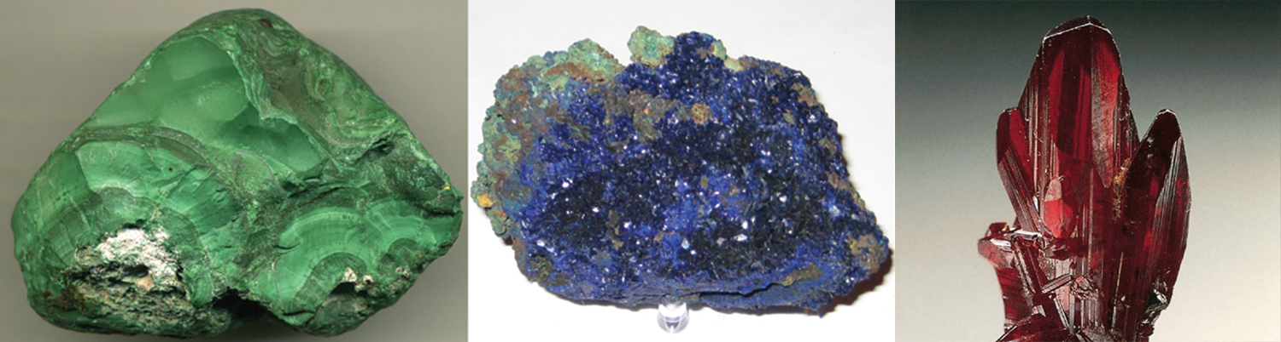
Figure 19.1 Transition metals often form vibrantly colored complexes. The minerals malachite (green), azurite (blue), and proustite (red) are some examples. (credit left: modification of work by James St. John; credit middle: modification of work by Stephanie Clifford; credit right: modification of work by Terry Wallace)

Chapter Outline
19.1 Occurrence, Preparation, and Properties of Transition Metals and Their Compounds
19.2 Coordination Chemistry of Transition Metals
19.3 Spectroscopic and Magnetic Properties of Coordination Compounds

Introduction
We have daily contact with many transition metals. Iron occurs everywhere—from the rings in your spiral notebook and the cutlery in your kitchen to automobiles, ships, buildings, and in the hemoglobin in your blood. Titanium is useful in the manufacture of lightweight, durable products such as bicycle frames, artificial hips, and jewelry. Chromium is useful as a protective plating on plumbing fixtures and automotive detailing.
In addition to being used in their pure elemental forms, many compounds containing transition metals have numerous other applications. Silver nitrate is used to create mirrors, zirconium silicate provides friction in automotive brakes, and many important cancer-fighting agents, like the drug cisplatin and related species, are platinum compounds.
The variety of properties exhibited by transition metals is due to their complex valence shells. Unlike most main group metals where one oxidation state is normally observed, the valence shell structure of transition metals means that they usually occur in several different stable oxidation states. In addition, electron transitions in these elements can correspond with absorption of photons in the visible electromagnetic spectrum, leading to colored compounds. Because of these behaviors, transition metals exhibit a rich and fascinating chemistry.

