Chapter 19
1.
(a) Sc: [Ar]4s²3d¹; (b) Ti: [Ar]4s²3d²; (c) Cr: [Ar]4s¹3d⁵; (d) Fe: [Ar]4s²3d⁶; (e) Ru: [Kr]5s²4d⁶
3.
(a) La: [Xe]6s²5d¹, La³⁺: [Xe]; (b) Sm: [Xe]6s²4f⁶, Sm³⁺: [Xe]4f⁵; (c) Lu: [Xe]6s²4f¹⁴5d¹, Lu³⁺: [Xe]4f¹⁴
5.
Al is used because it is the strongest reducing agent and the only option listed that can provide sufficient driving force to convert La(III) into La.
7.
Mo
9.
The CaSiO₃ slag is less dense than the molten iron, so it can easily be separated. Also, the floating slag layer creates a barrier that prevents the molten iron from exposure to O₂, which would oxidize the Fe back to Fe₂O₃.
11.
2.57%
13.
0.167 V
15.
E° = −0.6 V, E° is negative so this reduction is not spontaneous. E° = +1.1 V
17.
(a) $\text{Fe}\left(s\right)+2{\text{H}}_{3}{\text{O}}^{\text{+}}\left(aq\right)+{\text{SO}}_{4}​^{2−}\left(aq\right) → {\text{Fe}}^{2+}\left(aq\right)+{\text{SO}}_{4}​^{2−}\left(aq\right)+{\text{H}}_{2}\left(g\right)+2{\text{H}}_{2}\text{O}\left(l\right);$ (b) ${\text{FeCl}}_{3}\left(aq\right)+{\text{3Na}}^{\text{+}}\left(aq\right)+{\text{3OH}}^{\text{−}}\left(aq\right) →\text{Fe}{\left(\text{OH}\right)}_{3}\left(s\right)+{\text{3Na}}^{\text{+}}\left(aq\right)+{\text{3Cl}}^{\text{+}}\left(aq\right);$ (c) $\text{Mn}{\left(\text{OH}\right)}_{2}\left(s\right)+2{\text{H}}_{3}{\text{O}}^{\text{+}}\left(aq\right)+{\text{2Br}}^{\text{−}}\left(aq\right) → {\text{Mn}}^{2+}\left(aq\right)+{\text{2Br}}^{\text{−}}\left(aq\right)+4{\text{H}}_{2}\text{O}\left(l\right);$ (d) $\text{4Cr}\left(s\right)+3{\text{O}}_{2}\left(g\right) → 2{\text{Cr}}_{2}{\text{O}}_{3}\left(s\right);$ (e) ${\text{Mn}}_{2}{\text{O}}_{3}\left(s\right)+6{\text{H}}_{3}{\text{O}}^{\text{+}}\left(aq\right)+{\text{6Cl}}^{\text{−}}\left(aq\right) → 2{\text{MnCl}}_{3}\left(s\right)+9{\text{H}}_{2}\text{O}\left(l\right);$ (f) $\text{Ti}\left(s\right)+xs{\text{F}}_{2}\left(g\right) → {\text{TiF}}_{4}\left(g\right)$
19.
(a) ${\text{Cr}}_{2}{\left({\text{SO}}_{4}\right)}_{3}\left(aq\right)+\text{2Zn}\left(s\right)+{\text{2H}}_{3}{\text{O}}^{\text{+}}\left(aq\right) → {\text{2Zn}}^{2+}\left(aq\right)+{\text{H}}_{2}\left(g\right)+{\text{2H}}_{2}\text{O}\left(l\right)+{\text{2Cr}}^{2+}\left(aq\right)+{\text{3SO}}_{4}​^{2−}\left(aq\right);$ (b) ${\text{4TiCl}}_{3}\left(s\right)+{\text{CrO}}_{4}​^{2−}\left(aq\right)+{\text{8H}}^{\text{+}}\left(aq\right) → {\text{4Ti}}^{4+}\left(aq\right)+\text{Cr}\left(s\right)+{\text{4H}}_{2}\text{O}\left(l\right)+{\text{12Cl}}^{\text{−}}\left(aq\right);$ (c) In acid solution between pH 2 and pH 6, ${\text{CrO}}_{4}​^{2−}$ forms ${\text{HCrO}}_{4}​^{\text{−}},$ which is in equilibrium with dichromate ion. The reaction is ${\text{2HCrO}}_{4}​^{\text{−}}\left(aq\right) → {\text{Cr}}_{2}{\text{O}}_{7}​^{2−}\left(aq\right)+{\text{H}}_{2}\text{O}\left(l\right).$ At other acidic pHs, the reaction is ${\text{3Cr}}^{2+}\left(aq\right)+{\text{CrO}}_{4}​^{2−}\left(aq\right)+{\text{8H}}_{3}{\text{O}}^{\text{+}}\left(aq\right) → {\text{4Cr}}^{3+}\left(aq\right)+{\text{12H}}_{2}\text{O}\left(l\right);$ (d) ${\text{8CrO}}_{3}\left(s\right)+\text{9Mn}\left(s\right) \overset{\text{Δ}}{→} {\text{4Cr}}_{2}{\text{O}}_{3}\left(s\right)+{\text{3Mn}}_{3}{\text{O}}_{4}\left(s\right);$ (e) $\text{CrO}\left(s\right)+{\text{2H}}_{3}{\text{O}}^{\text{+}}\left(aq\right)+{\text{2NO}}_{3}​^{\text{−}}\left(aq\right) → {\text{Cr}}^{2+}\left(aq\right)+{\text{2NO}}_{3}​^{\text{−}}\left(aq\right)+{\text{3H}}_{2}\text{O}\left(l\right);$ (f) ${\text{CrCl}}_{3}\left(s\right)+\text{3NaOH}\left(aq\right) → \text{Cr}{\left(\text{OH}\right)}_{3}\left(s\right)+{\text{3Na}}^{\text{+}}\left(aq\right)+{\text{3Cl}}^{\text{−}}\left(aq\right)$
21.
(a) $\text{3Fe}\left(s\right)+{\text{4H}}_{2}\text{O}\left(g\right) → {\text{Fe}}_{3}{\text{O}}_{4}\left(s\right)+{\text{4H}}_{2}\left(g\right);$ (b) $\text{3NaOH}\left(aq\right)+\text{Fe}{\left({\text{NO}}_{3}\right)}_{3}\left(aq\right) \overset{ {\text{H}}_{2}\text{O} }{→} \text{Fe}{\left(\text{OH}\right)}_{3}\left(s\right)+{\text{3Na}}^{\text{+}}\left(aq\right)+3{\text{NO}}_{3}​^{\text{−}}\left(aq\right);$ (c) $\text{MnO}​^{4−}+5{\text{Fe}}^{\text{2+}}+8{\text{H}}^{\text{+}} → \text{Mn}​^{\text{2+}}+5{\text{Fe}}_{3}+4{\text{H}}_{2}\text{O};$ (d) $\text{Fe}\left(s\right)+{\text{2H}}_{3}{\text{O}}^{\text{+}}\left(aq\right)+{\text{SO}}_{4}​^{2−}\left(aq\right) → {\text{Fe}}^{2+}\left(aq\right)+{\text{SO}}_{4}​^{2−}\left(aq\right)+{\text{H}}_{2}\left(g\right)+{\text{2H}}_{2}\text{O}\left(l\right);$ (e) ${\text{4Fe}}^{2+}\left(aq\right)+{\text{O}}_{2}\left(g\right)+{\text{4HNO}}_{3}\left(aq\right) → {\text{4Fe}}^{3+}\left(aq\right)+{\text{2H}}_{2}\text{O}\left(l\right)+{\text{4NO}}_{3}​^{\text{−}}\left(aq\right);$ (f) ${\text{FeCO}}_{3}\left(s\right)+{\text{2HClO}}_{4}\left(aq\right) → \text{Fe}{\left({\text{ClO}}_{4}\right)}_{2}\left(aq\right)+{\text{H}}_{2}\text{O}\left(l\right)+{\text{CO}}_{2}\left(g\right);$ (g) $\text{3Fe}\left(s\right)+{\text{2O}}_{2}\left(g\right) \overset{ \text{Δ} }{→} {\text{Fe}}_{3}{\text{O}}_{4}\left(s\right)$
23.
As CN⁻ is added,
${\text{Ag}}^{\text{+}}\left(aq\right)+{\text{CN}}^{\text{−}}\left(aq\right) → \text{AgCN}\left(s\right)$
As more CN⁻ is added,
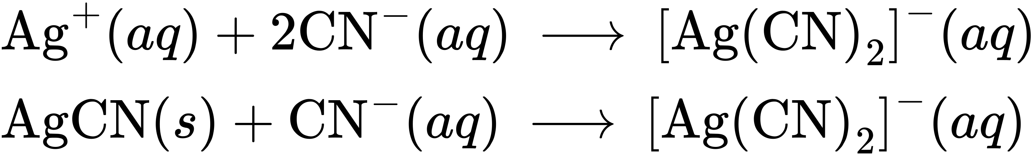
25.
(a) Sc³⁺; (b) Ti⁴⁺; (c) V⁵⁺; (d) Cr⁶⁺; (e) Mn⁴⁺; (f) Fe²⁺ and Fe³⁺; (g) Co²⁺ and Co³⁺; (h) Ni²⁺; (i) Cu⁺
27.
(a) 4, [Zn(OH)₄]²⁻; (b) 6, [Pd(CN)₆]²⁻; (c) 2, [AuCl₂]⁻; (d) 4, [Pt(NH₃)₂Cl₂]; (e) 6, K[Cr(NH₃)₂Cl₄]; (f) 6, [Co(NH₃)₆][Cr(CN)₆]; (g) 6, [Co(en)₂Br₂]NO₃
29.
(a) [Pt(H₂O)₂Br₂]:
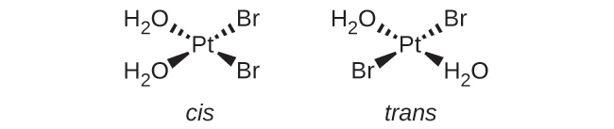
(b) [Pt(NH₃)(py)(Cl)(Br)]:
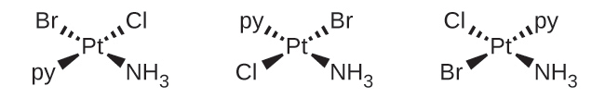
(c) [Zn(NH₃)₃Cl]⁺ :
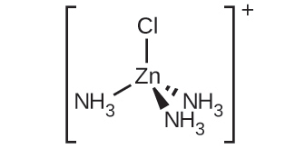
(d) [Pt(NH₃)₃Cl]⁺ :
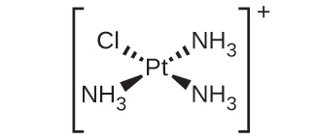
(e) [Ni(H₂O)₄Cl₂]:
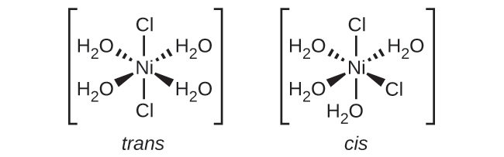
(f) [Co(C₂O₄)₂Cl₂]³⁻:
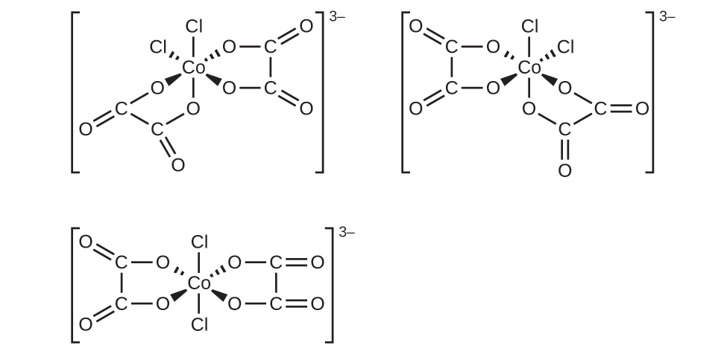
31.
(a) tricarbonatocobaltate(III) ion; (b) tetraaminecopper(II) ion; (c) tetraaminedibromocobalt(III) sulfate; (d) tetraamineplatinum(II) tetrachloroplatinate(II); (e) tris-(ethylenediamine)chromium(III) nitrate; (f) diaminedibromopalladium(II); (g) potassium pentachlorocuprate(II); (h) diaminedichlorozinc(II)
33.
(a) none; (b) none; (c) The two Cl ligands can be cis or trans. When they are cis, there will also be an optical isomer.
35.
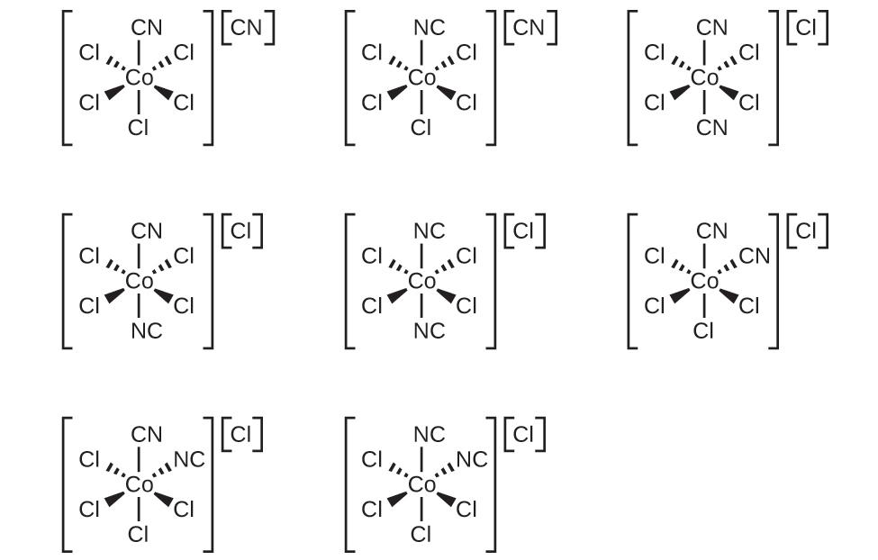
37.

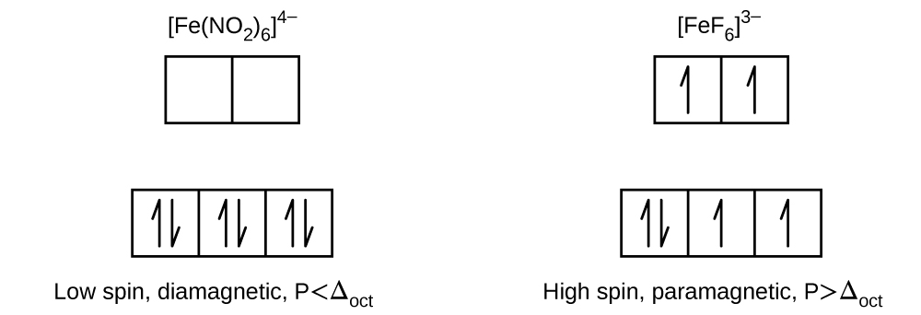
39.
[Co(H₂O)₆]Cl₂ with three unpaired electrons.
41.
(a) 4; (b) 2; (c) 1; (d) 5; (e) 0
43.
(a) [Fe(CN)₆]⁴⁻; (b) [Co(NH₃)₆]³⁺; (c) [Mn(CN)₆]⁴⁻
45.
The complex does not have any unpaired electrons. The complex does not have any geometric isomers, but the mirror image is nonsuperimposable, so it has an optical isomer.
47.
No. Au⁺ has a complete 5d sublevel.

