Appendix A The Periodic Table
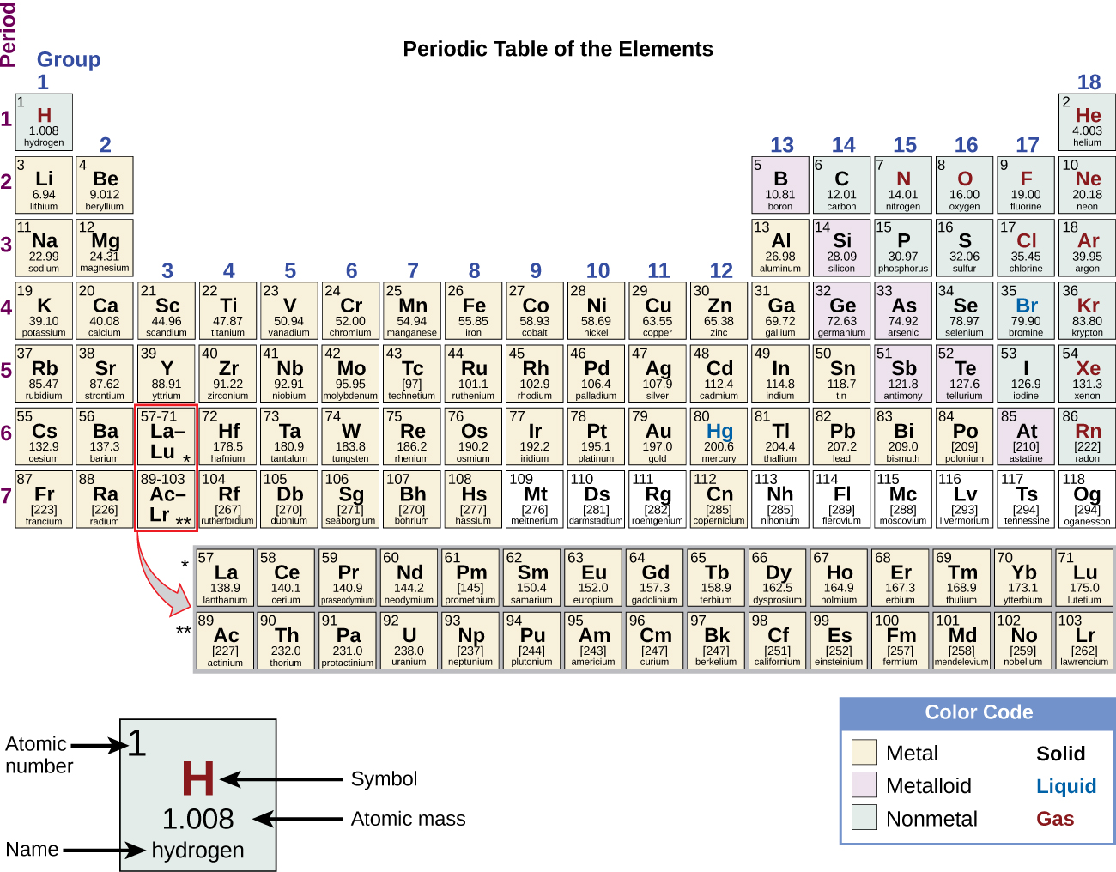
Figure A1

