3.2 Determining Empirical and Molecular Formulas

Learning Objectives
By the end of this section, you will be able to:
- Compute the percent composition of a compound
- Determine the empirical formula of a compound
- Determine the molecular formula of a compound
The previous section discussed the relationship between the bulk mass of a substance and the number of atoms or molecules it contains (moles). Given the chemical formula of the substance, one may determine the amount of the substance (moles) from its mass, and vice versa. But what if the chemical formula of a substance is unknown? In this section, these same principles will be applied to derive the chemical formulas of unknown substances from experimental mass measurements.

Percent Composition
The elemental makeup of a compound defines its chemical identity, and chemical formulas are the most succinct way of representing this elemental makeup. When a compound’s formula is unknown, measuring the mass of each of its constituent elements is often the first step in the process of determining the formula experimentally. The results of these measurements permit the calculation of the compound’s percent composition, defined as the percentage by mass of each element in the compound. For example, consider a gaseous compound composed solely of carbon and hydrogen. The percent composition of this compound could be represented as follows:
$\% \text{H}= \frac{\text{mass H}}{\text{mass compound}} × 100\%$
$\% \text{C}= \frac{\text{mass C}}{\text{mass compound}} × 100\%$
If analysis of a 10.0-g sample of this gas showed it to contain 2.5 g H and 7.5 g C, the percent composition would be calculated to be 25% H and 75% C:
$\% \text{H}= \frac{2.5 \text{g H}}{10.0 \text{g compound}} × 100\%=25\%$
$\% \text{C}= \frac{7.5 \text{g C}}{10.0 \text{g compound}} × 100\%=75\%$

Example 3.9

Calculation of Percent Composition
Analysis of a 12.04-g sample of a liquid compound composed of carbon, hydrogen, and nitrogen showed it to contain 7.34 g C, 1.85 g H, and 2.85 g N. What is the percent composition of this compound?

Solution
To calculate percent composition, divide the experimentally derived mass of each element by the overall mass of the compound, and then convert to a percentage:
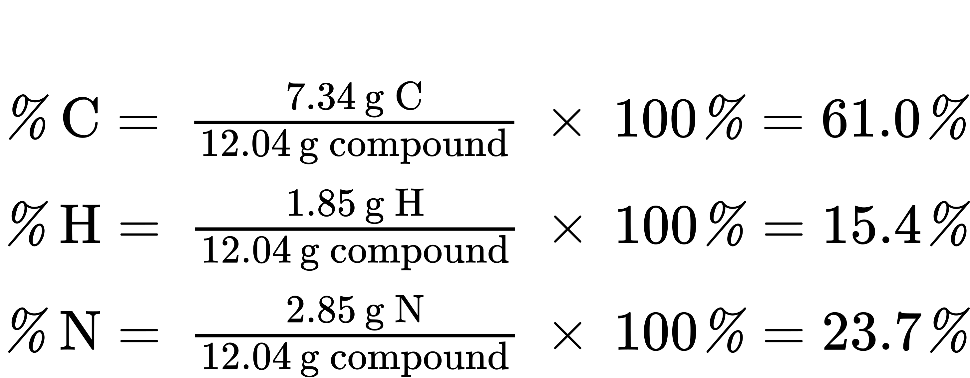
The analysis results indicate that the compound is 61.0% C, 15.4% H, and 23.7% N by mass.

Check Your Learning
A 24.81-g sample of a gaseous compound containing only carbon, oxygen, and chlorine is determined to contain 3.01 g C, 4.00 g O, and 17.81 g Cl. What is this compound’s percent composition?

Answer:
12.1% C, 16.1% O, 71.79% Cl

Determining Percent Composition from Molecular or Empirical Formulas
Percent composition is also useful for evaluating the relative abundance of a given element in different compounds of known formulas. As one example, consider the common nitrogen-containing fertilizers ammonia (NH₃), ammonium nitrate (NH₄NO₃), and urea (CH₄N₂O). The element nitrogen is the active ingredient for agricultural purposes, so the mass percentage of nitrogen in the compound is a practical and economic concern for consumers choosing among these fertilizers. For these sorts of applications, the percent composition of a compound is easily derived from its formula mass and the atomic masses of its constituent elements. A molecule of NH₃ contains one N atom weighing 14.01 amu and three H atoms weighing a total of (3 $×$ 1.008 amu) = 3.024 amu. The formula mass of ammonia is therefore (14.01 amu + 3.024 amu) = 17.03 amu, and its percent composition is:
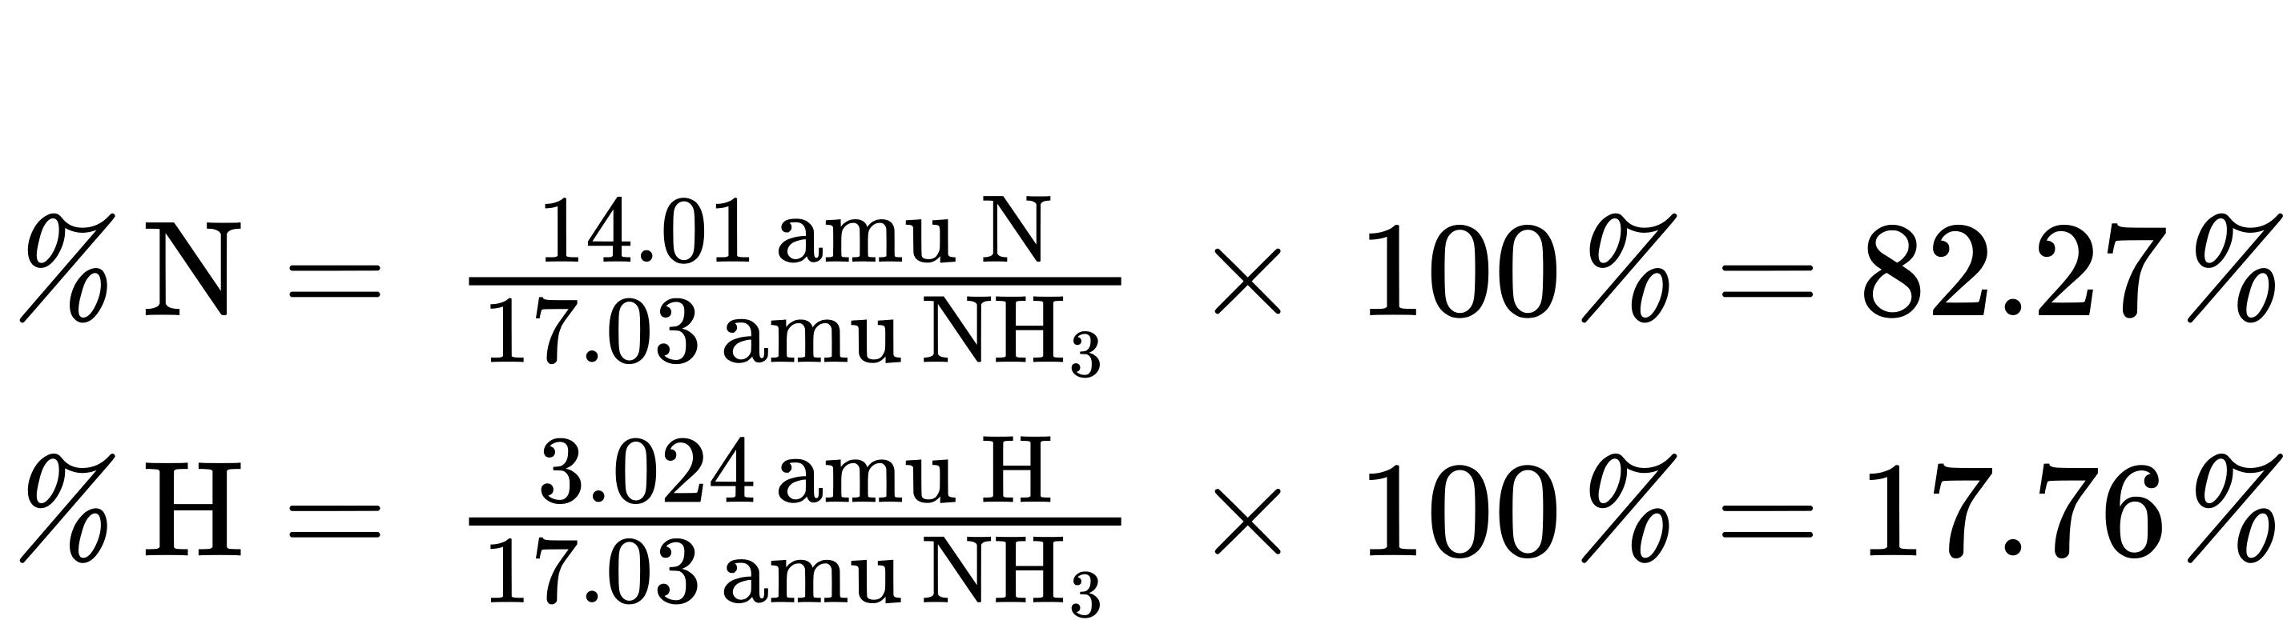
This same approach may be taken considering a pair of molecules, a dozen molecules, or a mole of molecules, etc. The latter amount is most convenient and would simply involve the use of molar masses instead of atomic and formula masses, as demonstrated Example 3.10. As long as the molecular or empirical formula of the compound in question is known, the percent composition may be derived from the atomic or molar masses of the compound's elements.

Example 3.10

Determining Percent Composition from a Molecular Formula
Aspirin is a compound with the molecular formula C₉H₈O₄. What is its percent composition?

Solution
To calculate the percent composition, the masses of C, H, and O in a known mass of C₉H₈O₄ are needed. It is convenient to consider 1 mol of C₉H₈O₄ and use its molar mass (180.159 g/mole, determined from the chemical formula) to calculate the percentages of each of its elements:
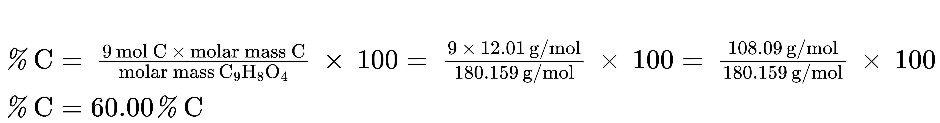
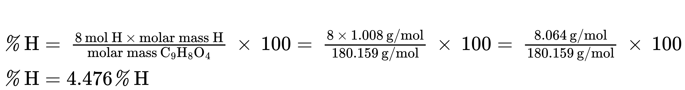
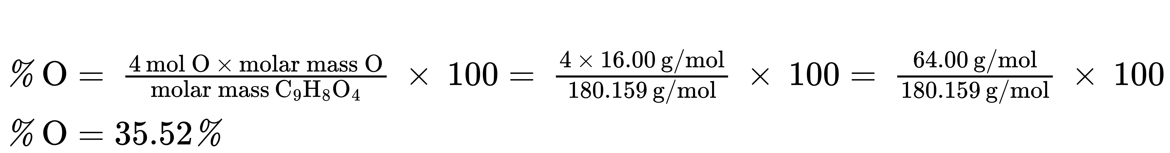
Note that these percentages sum to equal 100.00% when appropriately rounded.

Check Your Learning
To three significant digits, what is the mass percentage of iron in the compound Fe₂O₃?

Answer:
69.9% Fe

Determination of Empirical Formulas
As previously mentioned, the most common approach to determining a compound’s chemical formula is to first measure the masses of its constituent elements. However, keep in mind that chemical formulas represent the relative numbers, not masses, of atoms in the substance. Therefore, any experimentally derived data involving mass must be used to derive the corresponding numbers of atoms in the compound. This is accomplished using molar masses to convert the mass of each element to a number of moles. These molar amounts are used to compute whole-number ratios that can be used to derive the empirical formula of the substance. Consider a sample of compound determined to contain 1.71 g C and 0.287 g H. The corresponding numbers of atoms (in moles) are:
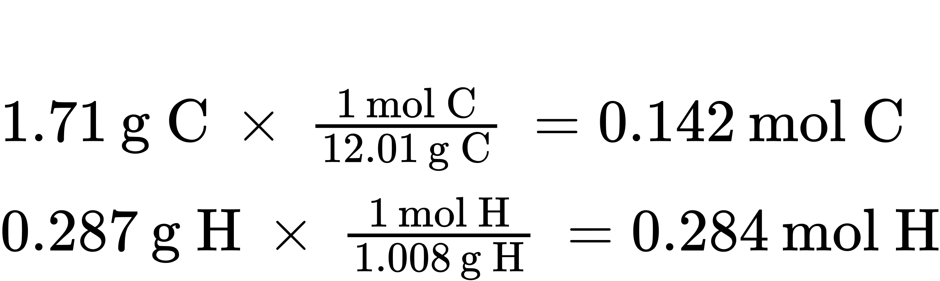
Thus, this compound may be represented by the formula C_{0.142}H_{0.284}. Per convention, formulas contain whole-number subscripts, which can be achieved by dividing each subscript by the smaller subscript:
${\text{C}}_{ \frac{0.142}{0.142} } {\text{H}}_{ \frac{0.284}{0.142} } \text{or} {\text{CH}}_{2}$
(Recall that subscripts of “1” are not written but rather assumed if no other number is present.)
The empirical formula for this compound is thus CH₂. This may or may not be the compound’s molecular formula as well; however, additional information is needed to make that determination (as discussed later in this section).
Consider as another example a sample of compound determined to contain 5.31 g Cl and 8.40 g O. Following the same approach yields a tentative empirical formula of:
${\text{Cl}}_{0.150}{\text{O}}_{0.525}={\text{Cl}}_{ \frac{0.150}{0.150} } {\text{O}}_{ \frac{0.525}{0.150} }={\text{ClO}}_{3.5}$
In this case, dividing by the smallest subscript still leaves us with a decimal subscript in the empirical formula. To convert this into a whole number, multiply each of the subscripts by two, retaining the same atom ratio and yielding Cl₂O₇ as the final empirical formula.
In summary, empirical formulas are derived from experimentally measured element masses by:
- Deriving the number of moles of each element from its mass
- Dividing each element’s molar amount by the smallest molar amount to yield subscripts for a tentative empirical formula
- Multiplying all coefficients by an integer, if necessary, to ensure that the smallest whole-number ratio of subscripts is obtained
Figure 3.11 outlines this procedure in flow chart fashion for a substance containing elements A and X.
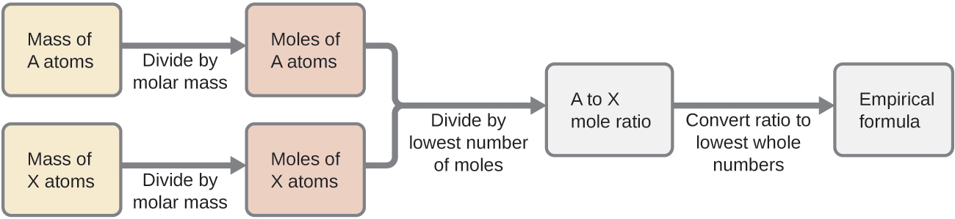
Figure 3.11 The empirical formula of a compound can be derived from the masses of all elements in the sample.

Example 3.11

Determining a Compound’s Empirical Formula from the Masses of Its Elements
A sample of the black mineral hematite (Figure 3.12), an oxide of iron found in many iron ores, contains 34.97 g of iron and 15.03 g of oxygen. What is the empirical formula of hematite?
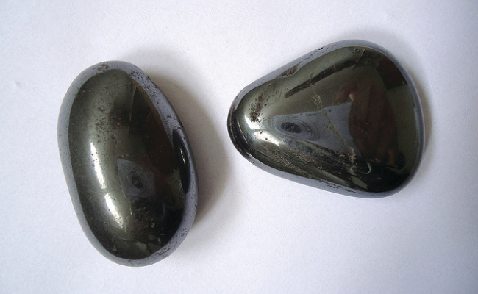
Figure 3.12 Hematite is an iron oxide that is used in jewelry. (credit: Mauro Cateb)

Solution
This problem provides the mass in grams of each element. Begin by finding the moles of each:
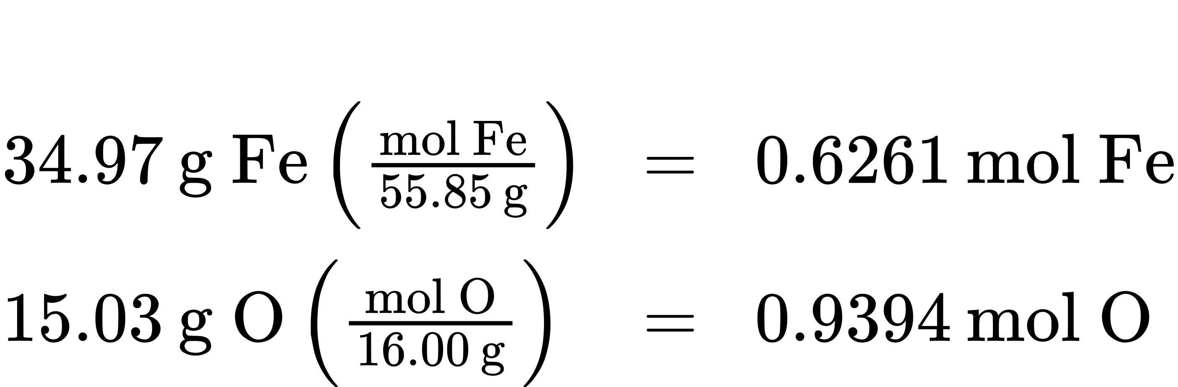
Next, derive the iron-to-oxygen molar ratio by dividing by the lesser number of moles:
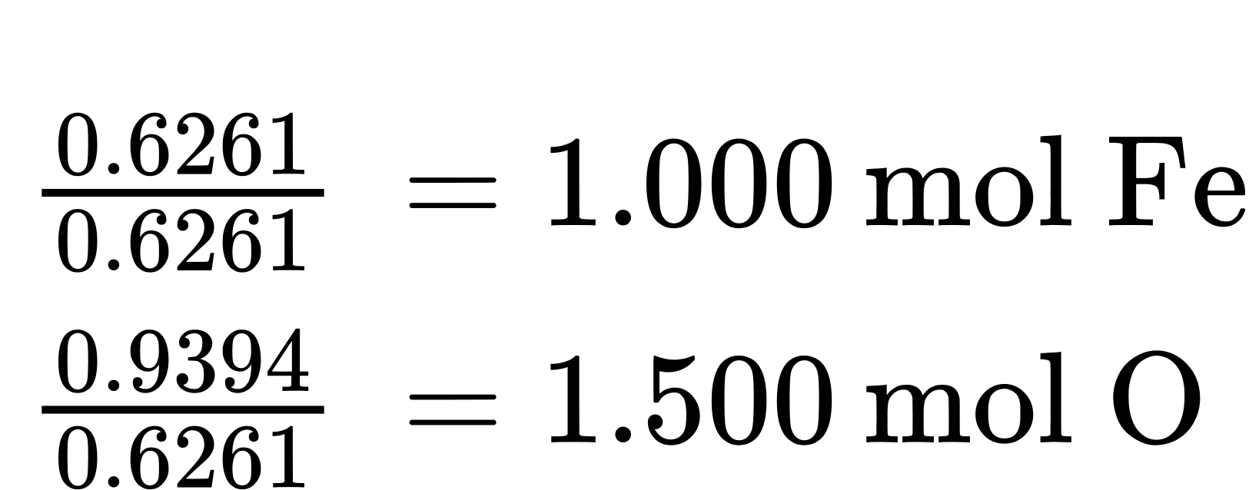
The ratio is 1.000 mol of iron to 1.500 mol of oxygen (Fe₁O_{1.5}). Finally, multiply the ratio by two to get the smallest possible whole number subscripts while still maintaining the correct iron-to-oxygen ratio:
$2\left({\text{Fe}}_{1}{\text{O}}_{1.5}\right) = {\text{Fe}}_{2}{\text{O}}_{3}$
The empirical formula is Fe₂O₃.

Check Your Learning
What is the empirical formula of a compound if a sample contains 0.130 g of nitrogen and 0.370 g of oxygen?

Answer:
N₂O₅

Link to Learning
For additional worked examples illustrating the derivation of empirical formulas, watch the brief video clip.

Deriving Empirical Formulas from Percent Composition
Finally, with regard to deriving empirical formulas, consider instances in which a compound’s percent composition is available rather than the absolute masses of the compound’s constituent elements. In such cases, the percent composition can be used to calculate the masses of elements present in any convenient mass of compound; these masses can then be used to derive the empirical formula in the usual fashion.

Example 3.12

Determining an Empirical Formula from Percent Composition
The bacterial fermentation of grain to produce ethanol forms a gas with a percent composition of 27.29% C and 72.71% O (Figure 3.13). What is the empirical formula for this gas?
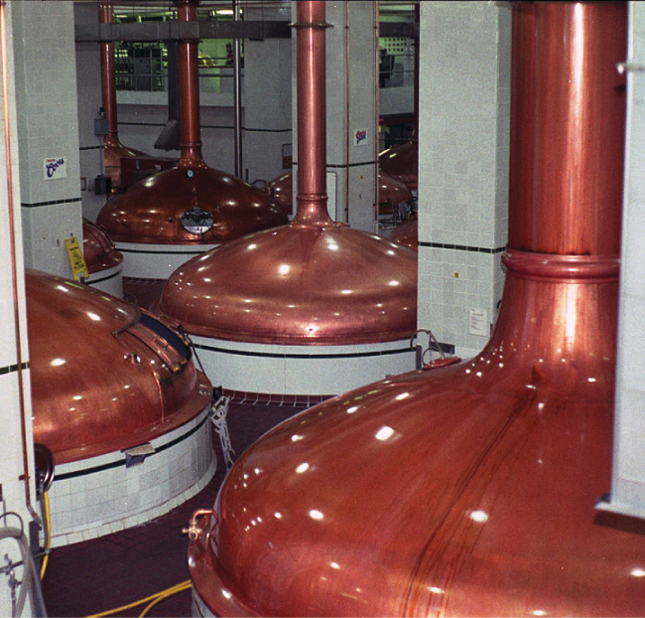
Figure 3.13 An oxide of carbon is removed from these fermentation tanks through the large copper pipes at the top. (credit: “Dual Freq”/Wikimedia Commons)

Solution
Since the scale for percentages is 100, it is most convenient to calculate the mass of elements present in a sample weighing 100 g. The calculation is “most convenient” because, per the definition for percent composition, the mass of a given element in grams is numerically equivalent to the element’s mass percentage. This numerical equivalence results from the definition of the “percentage” unit, whose name is derived from the Latin phrase per centum meaning “by the hundred.” Considering this definition, the mass percentages provided may be more conveniently expressed as fractions:
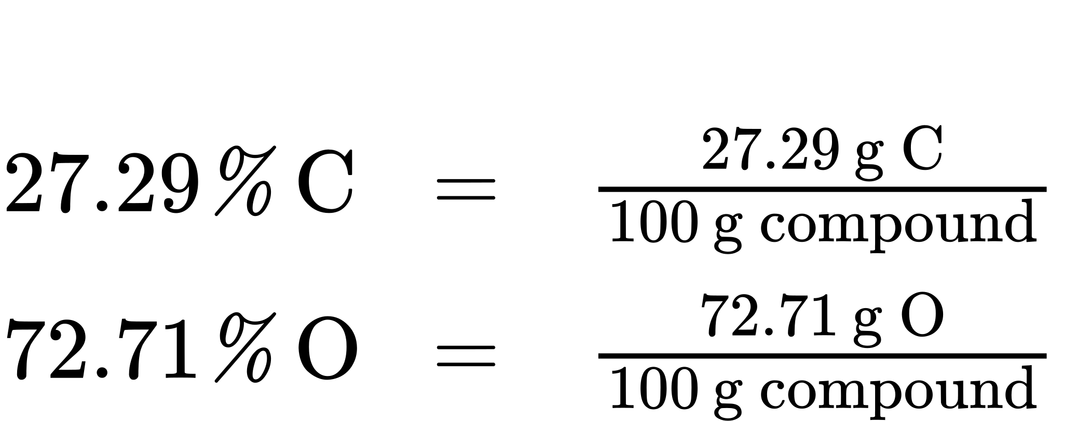
The molar amounts of carbon and oxygen in a 100-g sample are calculated by dividing each element’s mass by its molar mass:
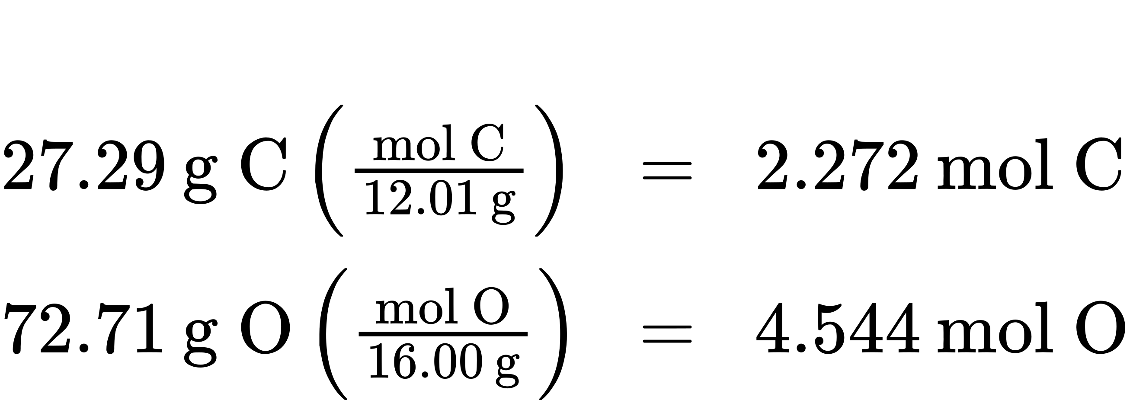
Coefficients for the tentative empirical formula are derived by dividing each molar amount by the lesser of the two:
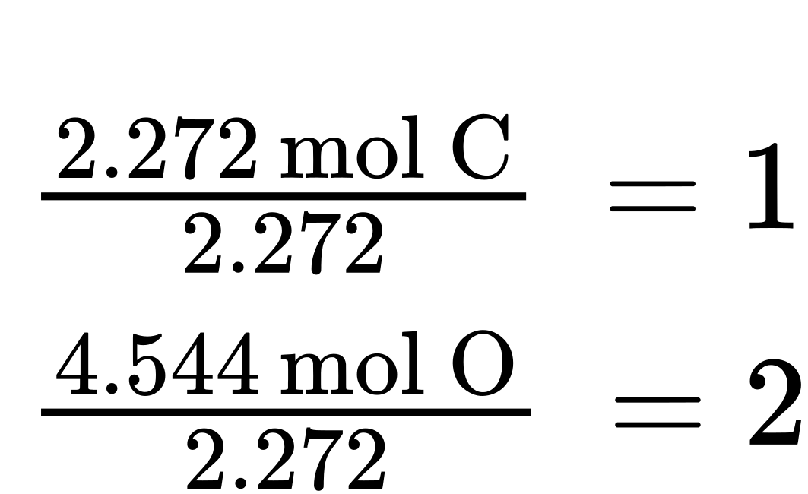
Since the resulting ratio is one carbon to two oxygen atoms, the empirical formula is CO₂.

Check Your Learning
What is the empirical formula of a compound containing 40.0% C, 6.71% H, and 53.28% O?

Answer:
CH₂O

Derivation of Molecular Formulas
Recall that empirical formulas are symbols representing the relative numbers of a compound’s elements. Determining the absolute numbers of atoms that compose a single molecule of a covalent compound requires knowledge of both its empirical formula and its molecular mass or molar mass. These quantities may be determined experimentally by various measurement techniques. Molecular mass, for example, is often derived from the mass spectrum of the compound (see discussion of this technique in the previous chapter on atoms and molecules). Molar mass can be measured by a number of experimental methods, many of which will be introduced in later chapters of this text.
Molecular formulas are derived by comparing the compound’s molecular or molar mass to its empirical formula mass. As the name suggests, an empirical formula mass is the sum of the average atomic masses of all the atoms represented in an empirical formula. If the molecular (or molar) mass of the substance is known, it may be divided by the empirical formula mass to yield the number of empirical formula units per molecule (n):
$\frac{\text{molecular or molar mass} \left(\text{amu or} \frac{\text{g}}{\text{mol}}\right)}{\text{empirical formula mass} \left(\text{amu or} \frac{\text{g}}{\text{mol}}\right)} =n \text{formula units/molecule}$
The molecular formula is then obtained by multiplying each subscript in the empirical formula by n, as shown by the generic empirical formula A_{x}B_{y}:
${\left({\text{A}}_{\text{x}}{\text{B}}_{\text{y}}\right)}_{\text{n}}={\text{A}}_{\text{nx}}{\text{B}}_{\text{ny}}$
For example, consider a covalent compound whose empirical formula is determined to be CH₂O. The empirical formula mass for this compound is approximately 30 amu (the sum of 12 amu for one C atom, 2 amu for two H atoms, and 16 amu for one O atom). If the compound’s molecular mass is determined to be 180 amu, this indicates that molecules of this compound contain six times the number of atoms represented in the empirical formula:
$\frac{180 \text{amu/molecule}}{30 \frac{\text{amu}}{\text{formula unit}} } =6 \text{formula units/molecule}$
Molecules of this compound are then represented by molecular formulas whose subscripts are six times greater than those in the empirical formula:
${\text{(CH}}_{\text{2}}{\text{O)}}_{\text{6}}={\text{C}}_{\text{6}}{\text{H}}_{\text{12}}{\text{O}}_{\text{6}}$
Note that this same approach may be used when the molar mass (g/mol) instead of the molecular mass (amu) is used. In this case, one mole of empirical formula units and molecules is considered, as opposed to single units and molecules.

Example 3.13

Determination of the Molecular Formula for Nicotine
Nicotine, an alkaloid in the nightshade family of plants that is mainly responsible for the addictive nature of cigarettes, contains 74.02% C, 8.710% H, and 17.27% N. If 40.57 g of nicotine contains 0.2500 mol nicotine, what is the molecular formula?

Solution
Determining the molecular formula from the provided data will require comparison of the compound’s empirical formula mass to its molar mass. As the first step, use the percent composition to derive the compound’s empirical formula. Assuming a convenient, a 100-g sample of nicotine yields the following molar amounts of its elements:
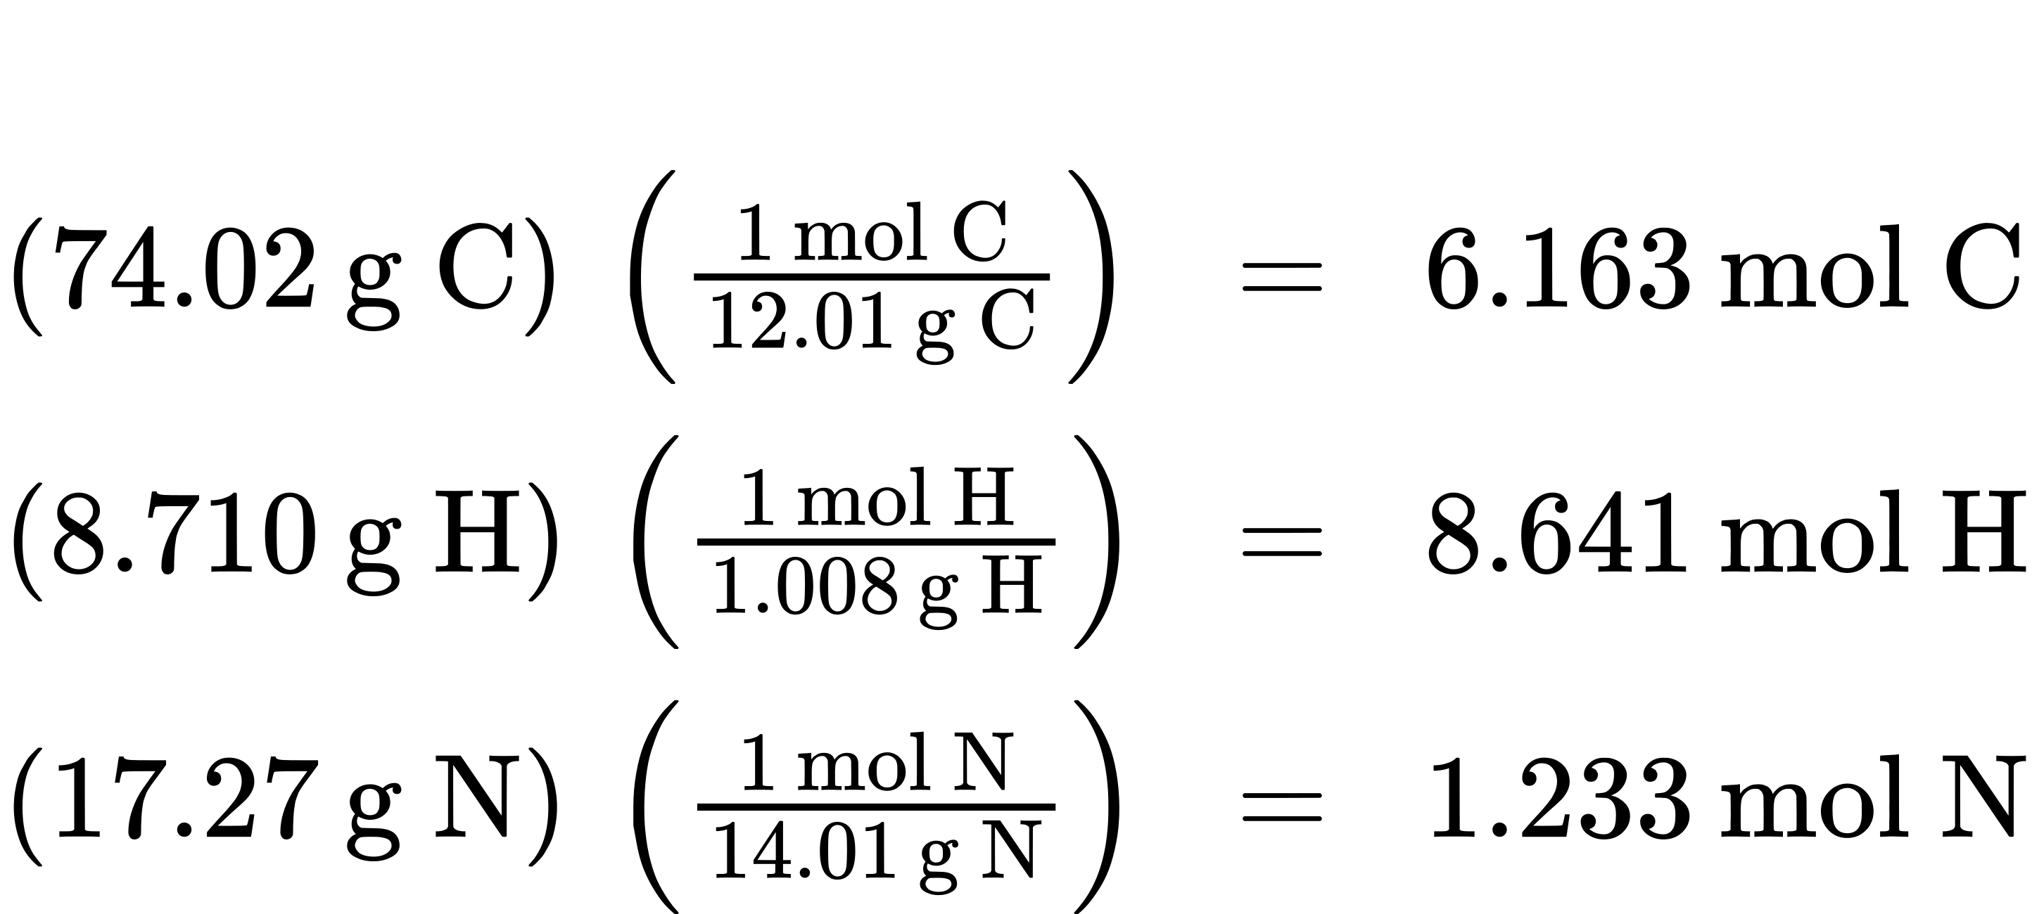
Next, calculate the molar ratios of these elements relative to the least abundant element, N.
$6.163 \text{mol} C/ 1.233 \text{mol} N=5$
$8.641 \text{mol} H/ 1.233 \text{mol} N=7$
$1.233 \text{mol} N/ 1.233 \text{mol} N=1$
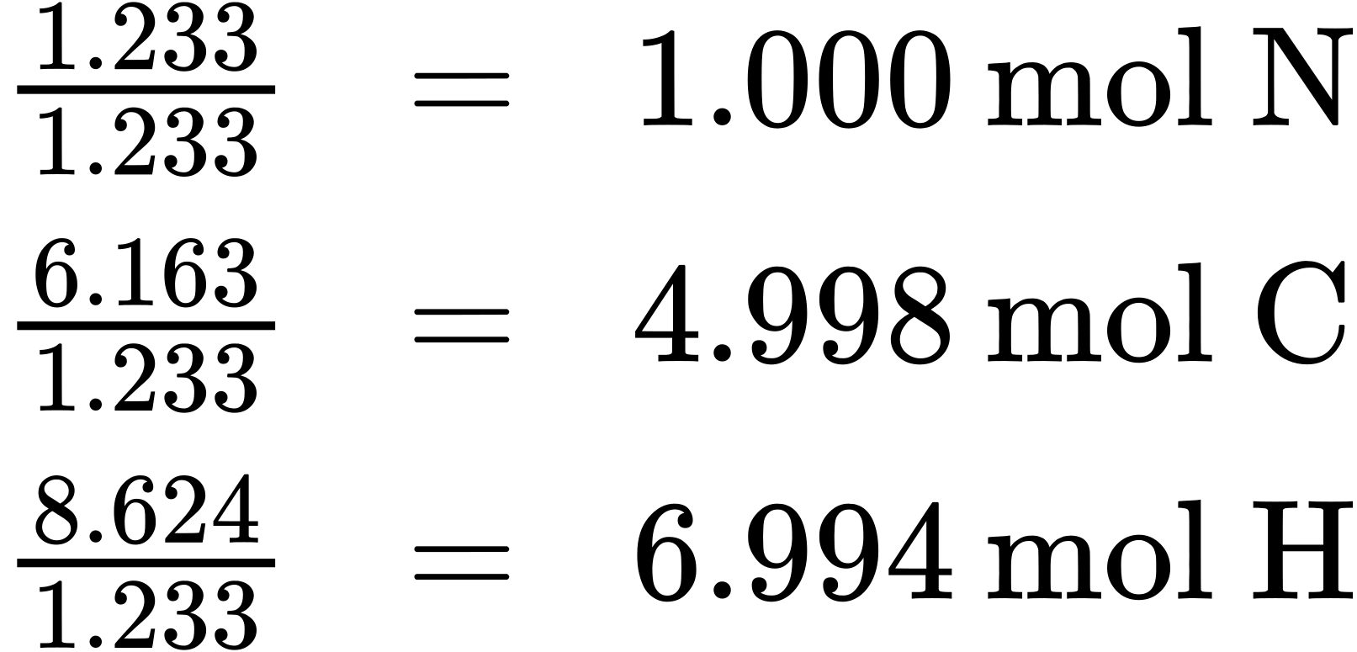
The C-to-N and H-to-N molar ratios are adequately close to whole numbers, and so the empirical formula is C₅H₇N. The empirical formula mass for this compound is therefore 81.13 amu/formula unit, or 81.13 g/mol formula unit.
Calculate the molar mass for nicotine from the given mass and molar amount of compound:
$\frac{40.57 \text{g nicotine}}{0.2500 \text{mol nicotine}} = \frac{162.3 \text{g}}{\text{mol}}$
Comparing the molar mass and empirical formula mass indicates that each nicotine molecule contains two formula units:
$\frac{162.3 \text{g/mol}}{81.13 \frac{\text{g}}{\text{formula unit}} } = 2 \text{formula units/molecule}$
Finally, derive the molecular formula for nicotine from the empirical formula by multiplying each subscript by two:
${\text{(C}}_{\text{5}}{\text{H}}_{\text{7}}{\text{N)}}_{\text{2}}={\text{C}}_{\text{10}}{\text{H}}_{\text{14}}{\text{N}}_{\text{2}}$

Check Your Learning
What is the molecular formula of a compound with a percent composition of 49.47% C, 5.201% H, 28.84% N, and 16.48% O, and a molecular mass of 194.2 amu?

Answer:
C₈H₁₀N₄O₂

