4.2 Classifying Chemical Reactions

Learning Objectives
By the end of this section, you will be able to:
- Define three common types of chemical reactions (precipitation, acid-base, and oxidation-reduction)
- Classify chemical reactions as one of these three types given appropriate descriptions or chemical equations
- Identify common acids and bases
- Predict the solubility of common inorganic compounds by using solubility rules
- Compute the oxidation states for elements in compounds
Humans interact with one another in various and complex ways, and we classify these interactions according to common patterns of behavior. When two humans exchange information, we say they are communicating. When they exchange blows with their fists or feet, we say they are fighting. Faced with a wide range of varied interactions between chemical substances, scientists have likewise found it convenient (or even necessary) to classify chemical interactions by identifying common patterns of reactivity. This module will provide an introduction to three of the most prevalent types of chemical reactions: precipitation, acid-base, and oxidation-reduction.

Precipitation Reactions and Solubility Rules
A precipitation reaction is one in which dissolved substances react to form one (or more) solid products. Many reactions of this type involve the exchange of ions between ionic compounds in aqueous solution and are sometimes referred to as double displacement, double replacement, or metathesis reactions. These reactions are common in nature and are responsible for the formation of coral reefs in ocean waters and kidney stones in animals. They are used widely in industry for production of a number of commodity and specialty chemicals. Precipitation reactions also play a central role in many chemical analysis techniques, including spot tests used to identify metal ions and gravimetric methods for determining the composition of matter (see the last module of this chapter).
The extent to which a substance may be dissolved in water, or any solvent, is quantitatively expressed as its solubility, defined as the maximum concentration of a substance that can be achieved under specified conditions. Substances with relatively large solubilities are said to be soluble. A substance will precipitate when solution conditions are such that its concentration exceeds its solubility. Substances with relatively low solubilities are said to be insoluble, and these are the substances that readily precipitate from solution. More information on these important concepts is provided in a later chapter on solutions. For purposes of predicting the identities of solids formed by precipitation reactions, one may simply refer to patterns of solubility that have been observed for many ionic compounds (Table 4.1).
Soluble Ionic Compounds | contain these ions | exceptions
Soluble Ionic Compounds | NH₄⁺  group I cations:  Li⁺  Na⁺  K⁺  Rb⁺  Cs⁺ | none
Soluble Ionic Compounds | Cl⁻  Br⁻  I⁻ | compounds with Ag⁺, Hg₂²⁺, and Pb²⁺
Soluble Ionic Compounds | F⁻ | compounds with group 2 metal cations, Pb²⁺, and Fe³⁺
Soluble Ionic Compounds | C₂H₃O₂⁻  HCO₃⁻  NO₃⁻  ClO₃⁻ | none
Soluble Ionic Compounds | SO₄²⁻ | compounds with Ag⁺, Ba²⁺, Ca²⁺, Hg₂²⁺, Pb²⁺ and Sr²⁺
Insoluble Ionic Compounds | contain these ions | exceptions
Insoluble Ionic Compounds | CO₃²⁻  CrO₄²⁻  PO₄³⁻  S²⁻ | compounds with group 1 cations and NH₄⁺
Insoluble Ionic Compounds | OH⁻ | compounds with group 1 cations and Ba²⁺
Table 4.1
A vivid example of precipitation is observed when solutions of potassium iodide and lead nitrate are mixed, resulting in the formation of solid lead iodide:
$2\text{KI}\left(aq\right)+\text{Pb}{\left({\text{NO}}_{3}\right)}_{2}\left(aq\right) → {\text{PbI}}_{2}\left(s\right)+2{\text{KNO}}_{3}\left(aq\right)$
This observation is consistent with the solubility guidelines: The only insoluble compound among all those involved is lead iodide, one of the exceptions to the general solubility of iodide salts.
The net ionic equation representing this reaction is:
${\text{Pb}}^{2+}\left(aq\right)+2{\text{I}}^{\text{−}}\left(aq\right) → {\text{PbI}}_{2}\left(s\right)$
Lead iodide is a bright yellow solid that was formerly used as an artist’s pigment known as iodine yellow (Figure 4.4). The properties of pure PbI₂ crystals make them useful for fabrication of X-ray and gamma ray detectors.
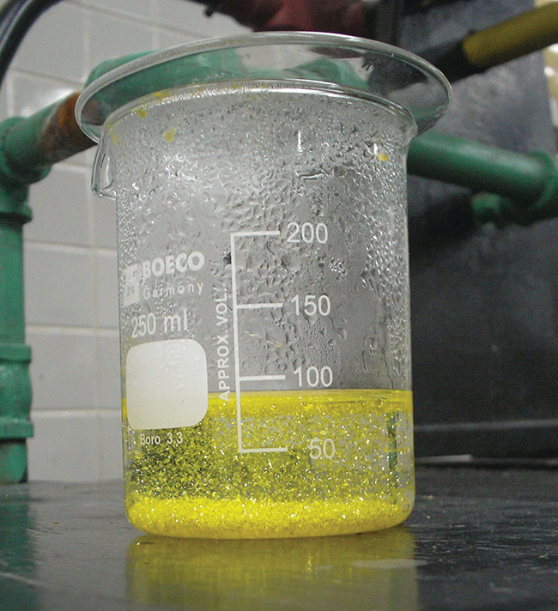
Figure 4.4 A precipitate of PbI₂ forms when solutions containing Pb²⁺ and I⁻ are mixed. (credit: Der Kreole/Wikimedia Commons)
The solubility guidelines in Table 4.1 may be used to predict whether a precipitation reaction will occur when solutions of soluble ionic compounds are mixed together. One merely needs to identify all the ions present in the solution and then consider if possible cation/anion pairing could result in an insoluble compound. For example, mixing solutions of silver nitrate and sodium chloride will yield a solution containing Ag⁺, ${\text{NO}}_{3}​^{−},$ Na⁺, and Cl⁻ ions. Aside from the two ionic compounds originally present in the solutions, AgNO₃ and NaCl, two additional ionic compounds may be derived from this collection of ions: NaNO₃ and AgCl. The solubility guidelines indicate all nitrate salts are soluble but that AgCl is one of insoluble. A precipitation reaction, therefore, is predicted to occur, as described by the following equations:

Example 4.3

Predicting Precipitation Reactions
Predict the result of mixing reasonably concentrated solutions of the following ionic compounds. If precipitation is expected, write a balanced net ionic equation for the reaction.
(a) potassium sulfate and barium nitrate
(b) lithium chloride and silver acetate
(c) lead nitrate and ammonium carbonate

Solution
(a) The two possible products for this combination are KNO₃ and BaSO₄. The solubility guidelines indicate BaSO₄ is insoluble, and so a precipitation reaction is expected. The net ionic equation for this reaction, derived in the manner detailed in the previous module, is
${\text{Ba}}^{2+}\left(aq\right)+{\text{SO}}_{4}^{2−}\left(aq\right) → {\text{BaSO}}_{4}\left(s\right)$
(b) The two possible products for this combination are LiC₂H₃O₂ and AgCl. The solubility guidelines indicate AgCl is insoluble, and so a precipitation reaction is expected. The net ionic equation for this reaction, derived in the manner detailed in the previous module, is
${\text{Ag}}^{\text{+}}\left(aq\right)+{\text{Cl}}^{\text{−}}\left(aq\right) → \text{AgCl}\left(s\right)$
(c) The two possible products for this combination are PbCO₃ and NH₄NO₃. The solubility guidelines indicate PbCO₃ is insoluble, and so a precipitation reaction is expected. The net ionic equation for this reaction, derived in the manner detailed in the previous module, is
${\text{Pb}}^{2+}\left(aq\right)+{\text{CO}}_{3}^{2−}\left(aq\right) → {\text{PbCO}}_{3}\left(s\right)$

Check Your Learning
Which solution could be used to precipitate the barium ion, Ba²⁺, in a water sample: sodium chloride, sodium hydroxide, or sodium sulfate? What is the formula for the expected precipitate?

Answer:
sodium sulfate, BaSO₄

Acid-Base Reactions
An acid-base reaction is one in which a hydrogen ion, H⁺, is transferred from one chemical species to another. Such reactions are of central importance to numerous natural and technological processes, ranging from the chemical transformations that take place within cells and the lakes and oceans, to the industrial-scale production of fertilizers, pharmaceuticals, and other substances essential to society. The subject of acid-base chemistry, therefore, is worthy of thorough discussion, and a full chapter is devoted to this topic later in the text.
For purposes of this brief introduction, we will consider only the more common types of acid-base reactions that take place in aqueous solutions. In this context, an acid is a substance that will dissolve in water to yield hydronium ions, H₃O⁺. As an example, consider the equation shown here:
$\text{HCl}\left(aq\right)+{\text{H}}_{2}\text{O}\left(l\right) → {\text{Cl}}^{\text{−}}\left(aq\right)+{\text{H}}_{3}{\text{O}}^{\text{+}}\left(aq\right)$
The process represented by this equation confirms that hydrogen chloride is an acid. When dissolved in water, H₃O⁺ ions are produced by a chemical reaction in which H⁺ ions are transferred from HCl molecules to H₂O molecules (Figure 4.5).
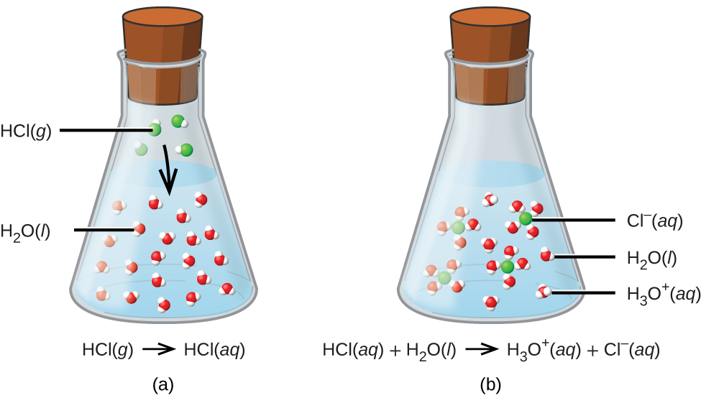
Figure 4.5 When hydrogen chloride gas dissolves in water, (a) it reacts as an acid, transferring protons to water molecules to yield (b) hydronium ions (and solvated chloride ions).
The nature of HCl is such that its reaction with water as just described is essentially 100% efficient: Virtually every HCl molecule that dissolves in water will undergo this reaction. Acids that completely react in this fashion are called strong acids, and HCl is one among just a handful of common acid compounds that are classified as strong (Table 4.2). A far greater number of compounds behave as weak acids and only partially react with water, leaving a large majority of dissolved molecules in their original form and generating a relatively small amount of hydronium ions. Weak acids are commonly encountered in nature, being the substances partly responsible for the tangy taste of citrus fruits, the stinging sensation of insect bites, and the unpleasant smells associated with body odor. A familiar example of a weak acid is acetic acid, the main ingredient in food vinegars:
${\text{CH}}_{3}{\text{CO}}_{2}\text{H}\left(aq\right)+{\text{H}}_{2}\text{O}\left(l\right)⇌{\text{CH}}_{3}{\text{CO}}_{2}​^{\text{−}}\left(aq\right)+{\text{H}}_{3}{\text{O}}^{\text{+}}\left(aq\right)$
When dissolved in water under typical conditions, only about 1% of acetic acid molecules are present in the ionized form, ${\text{CH}}_{3}{\text{CO}}_{2}​^{−}$ (Figure 4.6). (The use of a double-arrow in the equation above denotes the partial reaction aspect of this process, a concept addressed fully in the chapters on chemical equilibrium.)
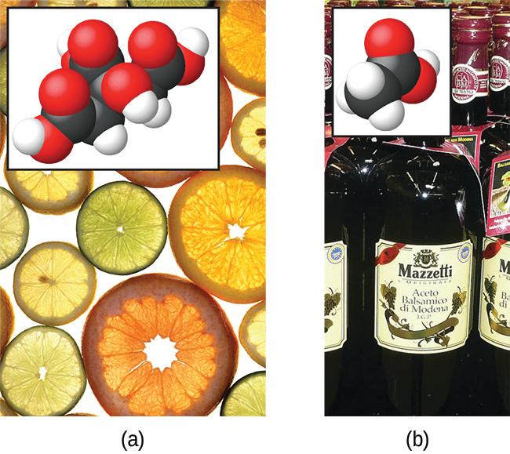
Figure 4.6 (a) Fruits such as oranges, lemons, and grapefruit contain the weak acid citric acid. (b) Vinegars contain the weak acid acetic acid. (credit a: modification of work by Scott Bauer; credit b: modification of work by Brücke-Osteuropa/Wikimedia Commons)
Common Strong Acids
Compound Formula | Name in Aqueous Solution
HBr | hydrobromic acid
HCl | hydrochloric acid
HI | hydroiodic acid
HNO₃ | nitric acid
HClO₄ | perchloric acid
H₂SO₄ | sulfuric acid
Table 4.2
A base is a substance that will dissolve in water to yield hydroxide ions, OH⁻. The most common bases are ionic compounds composed of alkali or alkaline earth metal cations (groups 1 and 2) combined with the hydroxide ion—for example, NaOH and Ca(OH)₂. Unlike the acid compounds discussed previously, these compounds do not react chemically with water; instead they dissolve and dissociate, releasing hydroxide ions directly into the solution. For example, KOH and Ba(OH)₂ dissolve in water and dissociate completely to produce cations (K⁺ and Ba²⁺, respectively) and hydroxide ions, OH⁻. These bases, along with other hydroxides that completely dissociate in water, are considered strong bases.
Consider as an example the dissolution of lye (sodium hydroxide) in water:
$\text{NaOH}\left(s\right) → {\text{Na}}^{\text{+}}\left(aq\right)+{\text{OH}}^{\text{−}}\left(aq\right)$
This equation confirms that sodium hydroxide is a base. When dissolved in water, NaOH dissociates to yield Na⁺ and OH⁻ ions. This is also true for any other ionic compound containing hydroxide ions. Since the dissociation process is essentially complete when ionic compounds dissolve in water under typical conditions, NaOH and other ionic hydroxides are all classified as strong bases.
Unlike ionic hydroxides, some compounds produce hydroxide ions when dissolved by chemically reacting with water molecules. In all cases, these compounds react only partially and so are classified as weak bases. These types of compounds are also abundant in nature and important commodities in various technologies. For example, global production of the weak base ammonia is typically well over 100 million metric tons annually, being widely used as an agricultural fertilizer, a raw material for chemical synthesis of other compounds, and an active ingredient in household cleaners (Figure 4.7). When dissolved in water, ammonia reacts partially to yield hydroxide ions, as shown here:
${\text{NH}}_{3}\left(aq\right)+{\text{H}}_{2}\text{O}\left(l\right)⇌{\text{NH}}_{4}​^{\text{+}}\left(aq\right)+{\text{OH}}^{\text{−}}\left(aq\right)$
This is, by definition, an acid-base reaction, in this case involving the transfer of H⁺ ions from water molecules to ammonia molecules. Under typical conditions, only about 1% of the dissolved ammonia is present as ${\text{NH}}_{4}​^{+}$ ions.
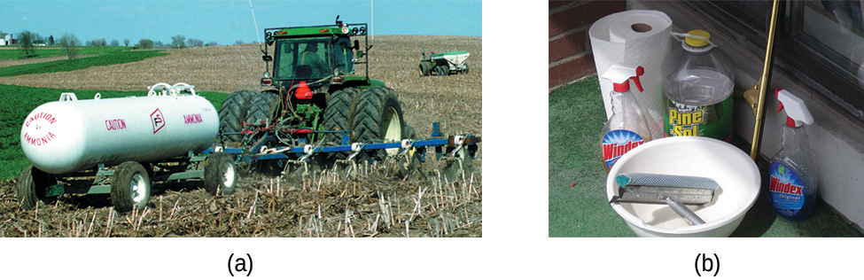
Figure 4.7 Ammonia is a weak base used in a variety of applications. (a) Pure ammonia is commonly applied as an agricultural fertilizer. (b) Dilute solutions of ammonia are effective household cleansers. (credit a: modification of work by National Resources Conservation Service; credit b: modification of work by pat00139)
A neutralization reaction is a specific type of acid-base reaction in which the reactants are an acid and a base (but not water), and the products are often a salt and water
$\text{acid}+\text{base} → \text{salt}+\text{water}$
To illustrate a neutralization reaction, consider what happens when a typical antacid such as milk of magnesia (an aqueous suspension of solid Mg(OH)₂) is ingested to ease symptoms associated with excess stomach acid (HCl):
$\text{Mg}{\text{(OH)}}_{2}\left(s\right)+2\text{HCl}\left(aq\right) → {\text{MgCl}}_{2}\left(aq\right)+2{\text{H}}_{2}\text{O}(l\text{).}$
Note that in addition to water, this reaction produces a salt, magnesium chloride.

Example 4.4

Writing Equations for Acid-Base Reactions
Write balanced chemical equations for the acid-base reactions described here:
(a) the weak acid hydrogen hypochlorite reacts with water
(b) a solution of barium hydroxide is neutralized with a solution of nitric acid

Solution
(a) The two reactants are provided, HOCl and H₂O. Since the substance is reported to be an acid, its reaction with water will involve the transfer of H⁺ from HOCl to H₂O to generate hydronium ions, H₃O⁺ and hypochlorite ions, OCl⁻.
$\text{HOCl}\left(aq\right)+{\text{H}}_{2}\text{O}\left(l\right)⇌{\text{OCl}}^{\text{−}}\left(aq\right)+{\text{H}}_{3}{\text{O}}^{\text{+}}\left(aq\right)$
A double-arrow is appropriate in this equation because it indicates the HOCl is a weak acid that has not reacted completely.
(b) The two reactants are provided, Ba(OH)₂ and HNO₃. Since this is a neutralization reaction, the two products will be water and a salt composed of the cation of the ionic hydroxide (Ba²⁺) and the anion generated when the acid transfers its hydrogen ion $\left({\text{NO}}_{3}​^{\text{−}}\right).$
$\text{Ba}{\text{(OH)}}_{2}\left(aq\right)+2{\text{HNO}}_{3}\left(aq\right) → \text{Ba}\left({\text{NO}}_{3}\right)​_{2}\left(aq\right)+2{\text{H}}_{2}\text{O}\left(l\right)$

Check Your Learning
Write the net ionic equation representing the neutralization of any strong acid with an ionic hydroxide. (Hint: Consider the ions produced when a strong acid is dissolved in water.)

Answer:
${\text{H}}_{3}{\text{O}}^{\text{+}}\left(aq\right)+{\text{OH}}^{\text{−}}\left(aq\right) → 2{\text{H}}_{2}\text{O}\left(l\right)$

Chemistry in Everyday Life

Stomach Antacids
Our stomachs contain a solution of roughly 0.03 M HCl, which helps us digest the food we eat. The burning sensation associated with heartburn is a result of the acid of the stomach leaking through the muscular valve at the top of the stomach into the lower reaches of the esophagus. The lining of the esophagus is not protected from the corrosive effects of stomach acid the way the lining of the stomach is, and the results can be very painful. When we have heartburn, it feels better if we reduce the excess acid in the esophagus by taking an antacid. As you may have guessed, antacids are bases. One of the most common antacids is calcium carbonate, CaCO₃. The reaction,
${\text{CaCO}}_{3}\left(s\right)+2\text{HCl}\left(aq\right) ⇌ {\text{CaCl}}_{2}\left(aq\right)+{\text{H}}_{2}\text{O}\left(l\right)+{\text{CO}}_{2}\left(g\right)$
not only neutralizes stomach acid, it also produces CO₂(g), which may result in a satisfying belch.
Milk of Magnesia is a suspension of the sparingly soluble base magnesium hydroxide, Mg(OH)₂. It works according to the reaction:
$\text{Mg}{\left(\text{OH}\right)}_{2}\left(s\right) ⇌ {\text{Mg}}^{2+}\left(aq\right)+2{\text{OH}}^{\text{−}}\left(aq\right)$
The hydroxide ions generated in this equilibrium then go on to react with the hydronium ions from the stomach acid, so that:
${\text{H}}_{3}{\text{O}}^{\text{+}}+{\text{OH}}^{\text{−}} ⇌ 2{\text{H}}_{2}\text{O}\left(l\right)$
This reaction does not produce carbon dioxide, but magnesium-containing antacids can have a laxative effect. Several antacids have aluminum hydroxide, Al(OH)₃, as an active ingredient. The aluminum hydroxide tends to cause constipation, and some antacids use aluminum hydroxide in concert with magnesium hydroxide to balance the side effects of the two substances.

Chemistry in Everyday Life

Culinary Aspects of Chemistry
Examples of acid-base chemistry are abundant in the culinary world. One example is the use of baking soda, or sodium bicarbonate in baking. NaHCO₃ is a base. When it reacts with an acid such as lemon juice, buttermilk, or sour cream in a batter, bubbles of carbon dioxide gas are formed from decomposition of the resulting carbonic acid, and the batter “rises.” Baking powder is a combination of sodium bicarbonate, and one or more acid salts that react when the two chemicals come in contact with water in the batter.
Many people like to put lemon juice or vinegar, both of which are acids, on cooked fish (Figure 4.8). It turns out that fish have volatile amines (bases) in their systems, which are neutralized by the acids to yield involatile ammonium salts. This reduces the odor of the fish, and also adds a “sour” taste that we seem to enjoy.
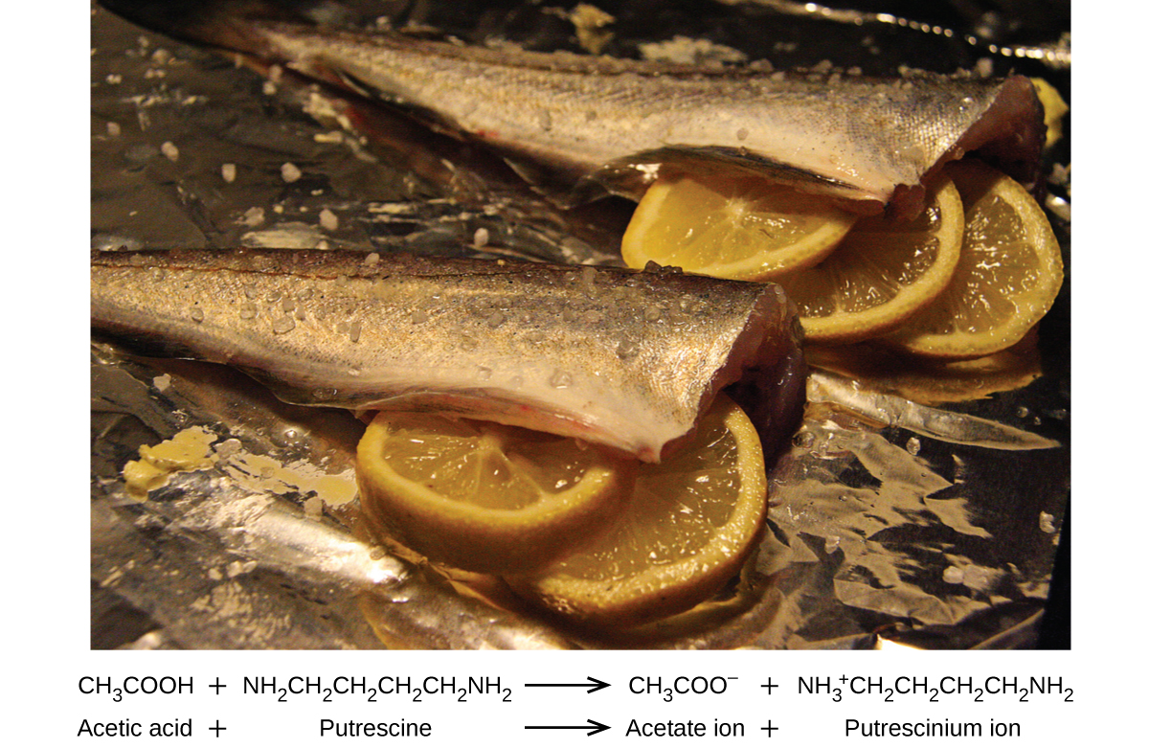
Figure 4.8 A neutralization reaction takes place between citric acid in lemons or acetic acid in vinegar, and the bases in the flesh of fish.
Pickling is a method used to preserve vegetables using a naturally produced acidic environment. The vegetable, such as a cucumber, is placed in a sealed jar submerged in a brine solution. The brine solution favors the growth of beneficial bacteria and suppresses the growth of harmful bacteria. The beneficial bacteria feed on starches in the cucumber and produce lactic acid as a waste product in a process called fermentation. The lactic acid eventually increases the acidity of the brine to a level that kills any harmful bacteria, which require a basic environment. Without the harmful bacteria consuming the cucumbers they are able to last much longer than if they were unprotected. A byproduct of the pickling process changes the flavor of the vegetables with the acid making them taste sour.

Link to Learning
Explore the microscopic view of strong and weak acids and bases.

Oxidation-Reduction Reactions
Earth’s atmosphere contains about 20% molecular oxygen, O₂, a chemically reactive gas that plays an essential role in the metabolism of aerobic organisms and in many environmental processes that shape the world. The term oxidation was originally used to describe chemical reactions involving O₂, but its meaning has evolved to refer to a broad and important reaction class known as oxidation-reduction (redox) reactions. A few examples of such reactions will be used to develop a clear picture of this classification.
Some redox reactions involve the transfer of electrons between reactant entities to yield ionic products, such as the reaction between sodium and chlorine to yield sodium chloride:
$\text{2Na}\left(s\right)+{\text{Cl}}_{2}\left(g\right) → 2\text{NaCl}\left(s\right)$
It is helpful to view the process with regard to each individual reactant, that is, to represent the fate of each reactant in the form of an equation called a half-reaction:
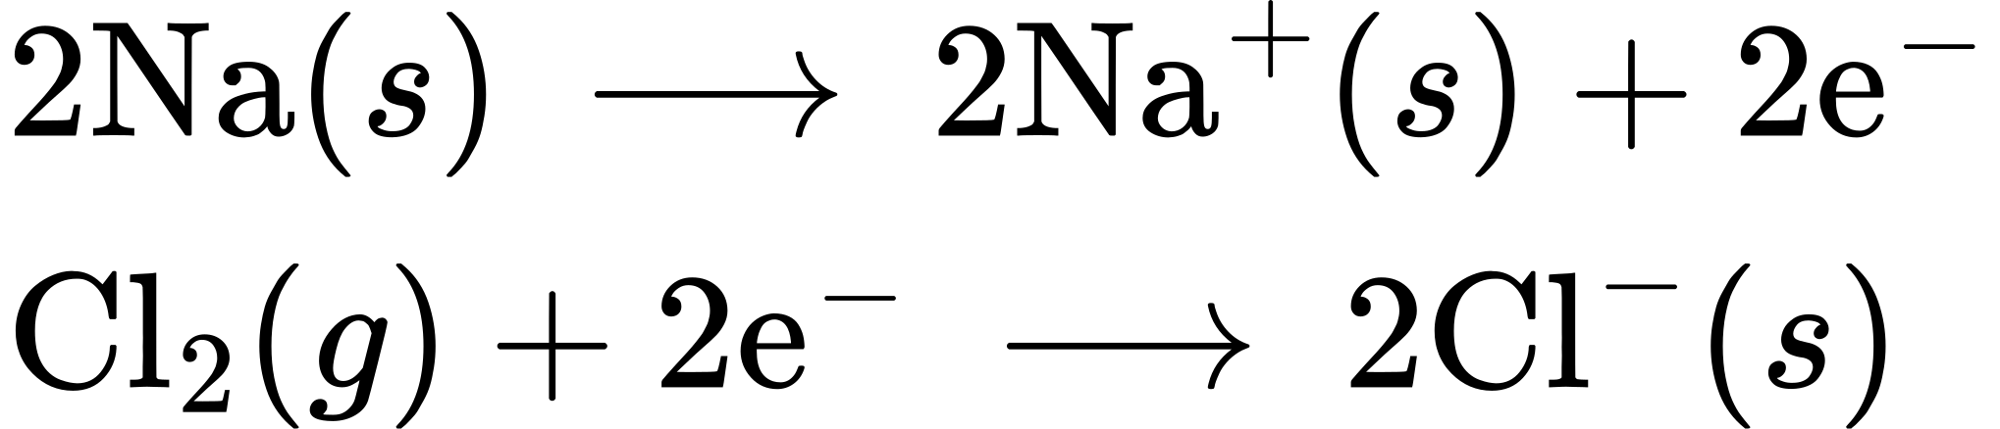
These equations show that Na atoms lose electrons while Cl atoms (in the Cl₂ molecule) gain electrons, the “s” subscripts for the resulting ions signifying they are present in the form of a solid ionic compound. For redox reactions of this sort, the loss and gain of electrons define the complementary processes that occur:
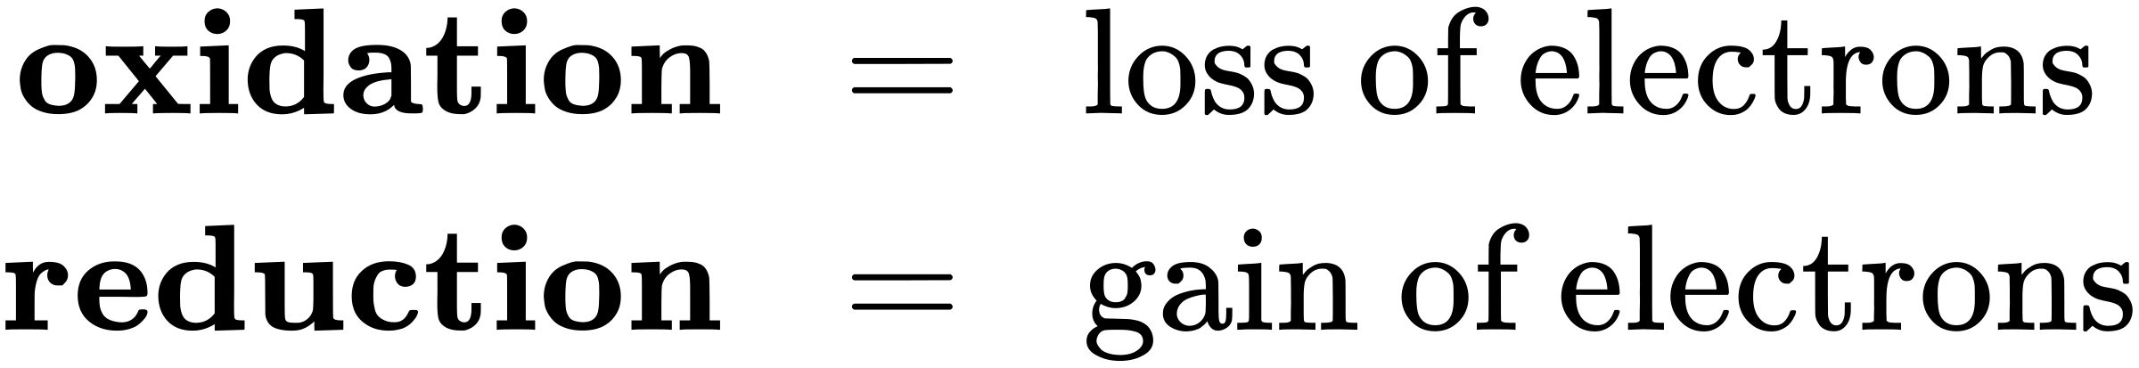
In this reaction, then, sodium is oxidized and chlorine undergoes reduction. Viewed from a more active perspective, sodium functions as a reducing agent (reductant), since it provides electrons to (or reduces) chlorine. Likewise, chlorine functions as an oxidizing agent (oxidant), as it effectively removes electrons from (oxidizes) sodium.
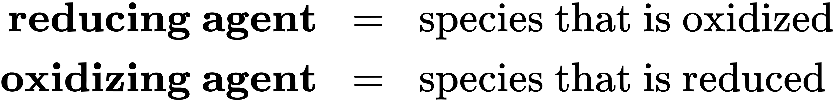
Some redox processes, however, do not involve the transfer of electrons. Consider, for example, a reaction similar to the one yielding NaCl:
${\text{H}}_{2}\left(g\right)+{\text{Cl}}_{2}\left(g\right) → 2\text{HCl}\left(g\right)$
The product of this reaction is a covalent compound, so transfer of electrons in the explicit sense is not involved. To clarify the similarity of this reaction to the previous one and permit an unambiguous definition of redox reactions, a property called oxidation number has been defined. The oxidation number (or oxidation state) of an element in a compound is the charge its atoms would possess if the compound were ionic. The following guidelines are used to assign oxidation numbers to each element in a molecule or ion.
- The oxidation number of an atom in an elemental substance is zero.
- The oxidation number of a monatomic ion is equal to the ion’s charge.
- Oxidation numbers for common nonmetals are usually assigned as follows:
  - Hydrogen: +1 when combined with nonmetals, −1 when combined with metals
  - Oxygen: −2 in most compounds, sometimes −1 (so-called peroxides, ${\text{O}}_{2}​^{\text{2−}}),$ very rarely $− \frac{1}{2}$ (so-called superoxides, ${\text{O}}_{2}​^{\text{−}}),$ positive values when combined with F (values vary)
  - Halogens: −1 for F always, −1 for other halogens except when combined with oxygen or other halogens (positive oxidation numbers in these cases, varying values)
- The sum of oxidation numbers for all atoms in a molecule or polyatomic ion equals the charge on the molecule or ion.
Note: The proper convention for reporting charge is to write the number first, followed by the sign (e.g., 2+), while oxidation number is written with the reversed sequence, sign followed by number (e.g., +2). This convention aims to emphasize the distinction between these two related properties.

Example 4.5

Assigning Oxidation Numbers
Follow the guidelines in this section of the text to assign oxidation numbers to all the elements in the following species:
(a) H₂S
(b) ${\text{SO}}_{3}​^{\text{2−}}$
(c) Na₂SO₄

Solution
(a) According to guideline 3, the oxidation number for H is +1.
Using this oxidation number and the compound’s formula, guideline 4 may then be used to calculate the oxidation number for sulfur:
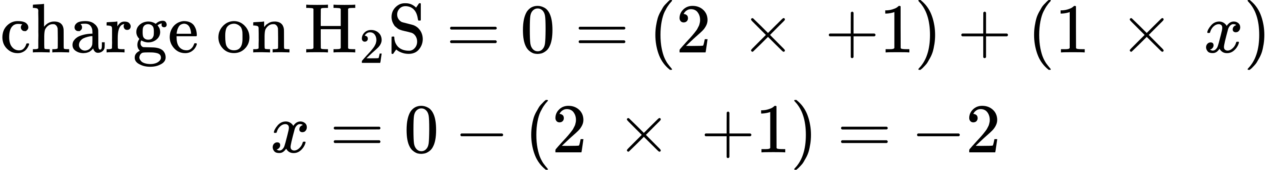
(b) Guideline 3 suggests the oxidation number for oxygen is −2.
Using this oxidation number and the ion’s formula, guideline 4 may then be used to calculate the oxidation number for sulfur:
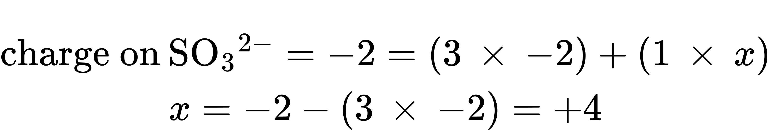
(c) For ionic compounds, it’s convenient to assign oxidation numbers for the cation and anion separately.
According to guideline 2, the oxidation number for sodium is +1.
Assuming the usual oxidation number for oxygen (−2 per guideline 3), the oxidation number for sulfur is calculated as directed by guideline 4:
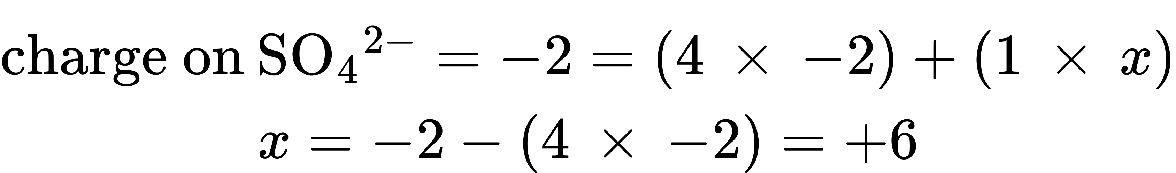

Check Your Learning
Assign oxidation states to the elements whose atoms are underlined in each of the following compounds or ions:
(a) KNO₃
(b) AlH₃
(c) $\underline{\text{N}}{\text{H}}_{4}​^{+}$
(d) ${\text{H}}_{2}\underline{\text{P}}{\text{O}}_{4}​^{−}$

Answer:
(a) N, +5; (b) Al, +3; (c) N, −3; (d) P, +5
Using the oxidation number concept, an all-inclusive definition of redox reaction has been established. Oxidation-reduction (redox) reactions are those in which one or more elements involved undergo a change in oxidation number. (While the vast majority of redox reactions involve changes in oxidation number for two or more elements, a few interesting exceptions to this rule do exist Example 4.6.) Definitions for the complementary processes of this reaction class are correspondingly revised as shown here:
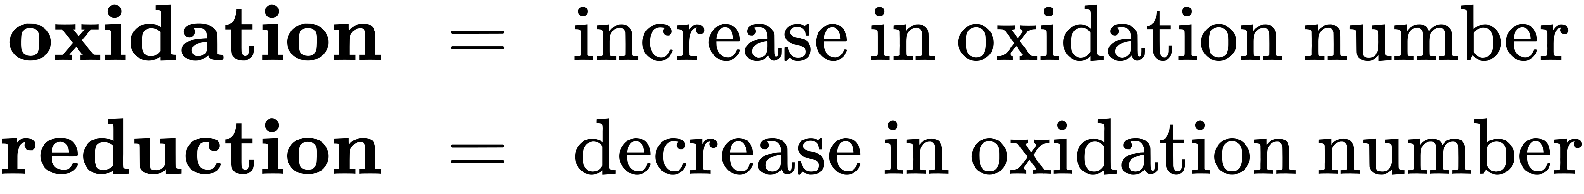
Returning to the reactions used to introduce this topic, they may now both be identified as redox processes. In the reaction between sodium and chlorine to yield sodium chloride, sodium is oxidized (its oxidation number increases from 0 in Na to +1 in NaCl) and chlorine is reduced (its oxidation number decreases from 0 in Cl₂ to −1 in NaCl). In the reaction between molecular hydrogen and chlorine, hydrogen is oxidized (its oxidation number increases from 0 in H₂ to +1 in HCl) and chlorine is reduced (its oxidation number decreases from 0 in Cl₂ to −1 in HCl).
Several subclasses of redox reactions are recognized, including combustion reactions in which the reductant (also called a fuel) and oxidant (often, but not necessarily, molecular oxygen) react vigorously and produce significant amounts of heat, and often light, in the form of a flame. Solid rocket-fuel reactions such as the one depicted in Figure 4.1 are combustion processes. A typical propellant reaction in which solid aluminum is oxidized by ammonium perchlorate is represented by this equation:
$10\text{Al}\left(s\right)+6{\text{NH}}_{4}{\text{ClO}}_{4}\left(s\right) → 4{\text{Al}}_{2}{\text{O}}_{3}\left(s\right)+2{\text{AlCl}}_{3}\left(s\right)+12{\text{H}}_{2}\text{O}\left(g\right)+3{\text{N}}_{2}\left(g\right)$

Link to Learning
Watch a brief video showing the test firing of a small-scale, prototype, hybrid rocket engine planned for use in the new Space Launch System being developed by NASA. The first engines firing at
3 s (green flame) use a liquid fuel/oxidant mixture, and the second, more powerful engines firing at 4 s (yellow flame) use a solid mixture.
Single-displacement (replacement) reactions are redox reactions in which an ion in solution is displaced (or replaced) via the oxidation of a metallic element. One common example of this type of reaction is the acid oxidation of certain metals:
$\text{Zn}\left(s\right)+2\text{HCl}\left(aq\right) → {\text{ZnCl}}_{2}\left(aq\right)+{\text{H}}_{2}\left(g\right)$
Metallic elements may also be oxidized by solutions of other metal salts; for example:
$\text{Cu}\left(s\right)+2{\text{AgNO}}_{3}\left(aq\right) → \text{Cu} {\left({\text{NO}}_{3}\right)}_{2}\left(aq\right)+2\text{Ag}\left(s\right)$
This reaction may be observed by placing copper wire in a solution containing a dissolved silver salt. Silver ions in solution are reduced to elemental silver at the surface of the copper wire, and the resulting Cu²⁺ ions dissolve in the solution to yield a characteristic blue color (Figure 4.9).
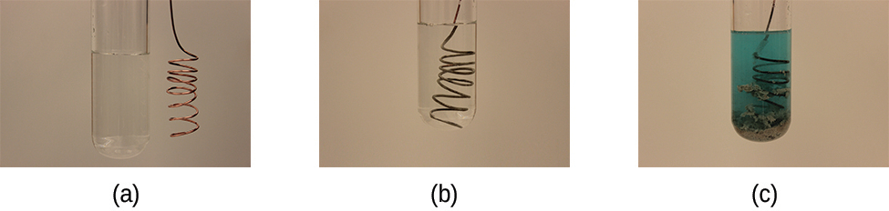
Figure 4.9 (a) A copper wire is shown next to a solution containing silver(I) ions. (b) Displacement of dissolved silver ions by copper ions results in (c) accumulation of gray-colored silver metal on the wire and development of a blue color in the solution, due to dissolved copper ions. (credit: modification of work by Mark Ott)

Example 4.6

Describing Redox Reactions
Identify which equations represent redox reactions, providing a name for the reaction if appropriate. For those reactions identified as redox, name the oxidant and reductant.
(a) ${\text{ZnCO}}_{3}\left(s\right) → \text{ZnO}\left(s\right)+{\text{CO}}_{2}\left(g\right)$
(b) $2\text{Ga}\left(l\right)+3{\text{Br}}_{2}\left(l\right) → 2{\text{GaBr}}_{3}\left(s\right)$
(c) $2{\text{H}}_{2}{\text{O}}_{2}\left(aq\right) → 2{\text{H}}_{2}\text{O}\left(l\right)+{\text{O}}_{2}\left(g\right)$
(d) ${\text{BaCl}}_{2}\left(aq\right)+{\text{K}}_{2}{\text{SO}}_{4}\left(aq\right) → {\text{BaSO}}_{4}\left(s\right)+2\text{KCl}\left(aq\right)$
(e) ${\text{C}}_{2}{\text{H}}_{4}\left(g\right)+3{\text{O}}_{2}\left(g\right) → 2{\text{CO}}_{2}\left(g\right)+2{\text{H}}_{2}\text{O}\left(l\right)$

Solution
Redox reactions are identified per definition if one or more elements undergo a change in oxidation number.
(a) This is not a redox reaction, since oxidation numbers remain unchanged for all elements.
(b) This is a redox reaction. Gallium is oxidized, its oxidation number increasing from 0 in Ga(l) to +3 in GaBr₃(s). The reducing agent is Ga(l). Bromine is reduced, its oxidation number decreasing from 0 in Br₂(l) to −1 in GaBr₃(s). The oxidizing agent is Br₂(l).
(c) This is a redox reaction. It is a particularly interesting process, as it involves the same element, oxygen, undergoing both oxidation and reduction (a so-called disproportionation reaction). Oxygen is oxidized, its oxidation number increasing from −1 in H₂O₂(aq) to 0 in O₂(g). Oxygen is also reduced, its oxidation number decreasing from −1 in H₂O₂(aq) to −2 in H₂O(l). For disproportionation reactions, the same substance functions as an oxidant and a reductant.
(d) This is not a redox reaction, since oxidation numbers remain unchanged for all elements.
(e) This is a redox reaction (combustion). Carbon is oxidized, its oxidation number increasing from −2 in C₂H₄(g) to +4 in CO₂(g). The reducing agent (fuel) is C₂H₄(g). Oxygen is reduced, its oxidation number decreasing from 0 in O₂(g) to −2 in H₂O(l). The oxidizing agent is O₂(g).

Check Your Learning
This equation describes the production of tin(II) chloride:
$\text{Sn}\left(s\right)+2\text{HCl}\left(g\right) → {\text{SnCl}}_{2}\left(s\right)+{\text{H}}_{2}\left(g\right)$
Is this a redox reaction? If so, provide a more specific name for the reaction if appropriate, and identify the oxidant and reductant.

Answer:
Yes, a single-replacement reaction. Sn(s)is the reductant, HCl(g) is the oxidant.

Balancing Redox Reactions via the Half-Reaction Method
Redox reactions that take place in aqueous media often involve water, hydronium ions, and hydroxide ions as reactants or products. Although these species are not oxidized or reduced, they do participate in chemical change in other ways (e.g., by providing the elements required to form oxyanions). Equations representing these reactions are sometimes very difficult to balance by inspection, so systematic approaches have been developed to assist in the process. One very useful approach is to use the method of half-reactions, which involves the following steps:
1. Write the two half-reactions representing the redox process.
2. Balance all elements except oxygen and hydrogen.
3. Balance oxygen atoms by adding H₂O molecules.
4. Balance hydrogen atoms by adding H⁺ ions.
5. Balance charge by adding electrons.
6. If necessary, multiply each half-reaction’s coefficients by the smallest possible integers to yield equal numbers of electrons in each.
7. Add the balanced half-reactions together and simplify by removing species that appear on both sides of the equation.
8. For reactions occurring in basic media (excess hydroxide ions), carry out these additional steps:
- Add OH⁻ ions to both sides of the equation in numbers equal to the number of H⁺ ions.
- On the side of the equation containing both H⁺ and OH⁻ ions, combine these ions to yield water molecules.
- Simplify the equation by removing any redundant water molecules.
9. Finally, check to see that both the number of atoms and the total charges1 are balanced.
1
The requirement of “charge balance” is just a specific type of “mass balance” in which the species in question are electrons. An equation must represent equal numbers of electrons on the reactant and product sides, and so both atoms and charges must be balanced.

Example 4.7

Balancing Redox Reactions in Acidic Solution
Write a balanced equation for the reaction between dichromate ion and iron(II) to yield iron(III) and chromium(III) in acidic solution.
${\text{Cr}}_{2}{\text{O}}_{7}​^{\text{2−}}+{\text{Fe}}^{\text{2+}} → {\text{Cr}}^{\text{3+}}+{\text{Fe}}^{\text{3+}}$

Solution
- Step 1.
- Write the two half-reactions.
- Each half-reaction will contain one reactant and one product with one element in common.
- ${\text{Fe}}^{\text{2+}} → {\text{Fe}}^{\text{3+}}$
- ${\text{Cr}}_{2}{\text{O}}_{7}​^{\text{2−}} → {\text{Cr}}^{\text{3+}}$
- Step 2.
- Balance all elements except oxygen and hydrogen. The iron half-reaction is already balanced, but the chromium half-reaction shows two Cr atoms on the left and one Cr atom on the right. Changing the coefficient on the right side of the equation to 2 achieves balance with regard to Cr atoms.
- ${\text{Fe}}^{\text{2+}} → {\text{Fe}}^{\text{3+}}$
- ${\text{Cr}}_{2}{\text{O}}_{7}​^{\text{2−}} → 2{\text{Cr}}^{\text{3+}}$
- Step 3.
- Balance oxygen atoms by adding H₂O molecules. The iron half-reaction does not contain O atoms. The chromium half-reaction shows seven O atoms on the left and none on the right, so seven water molecules are added to the right side.
- 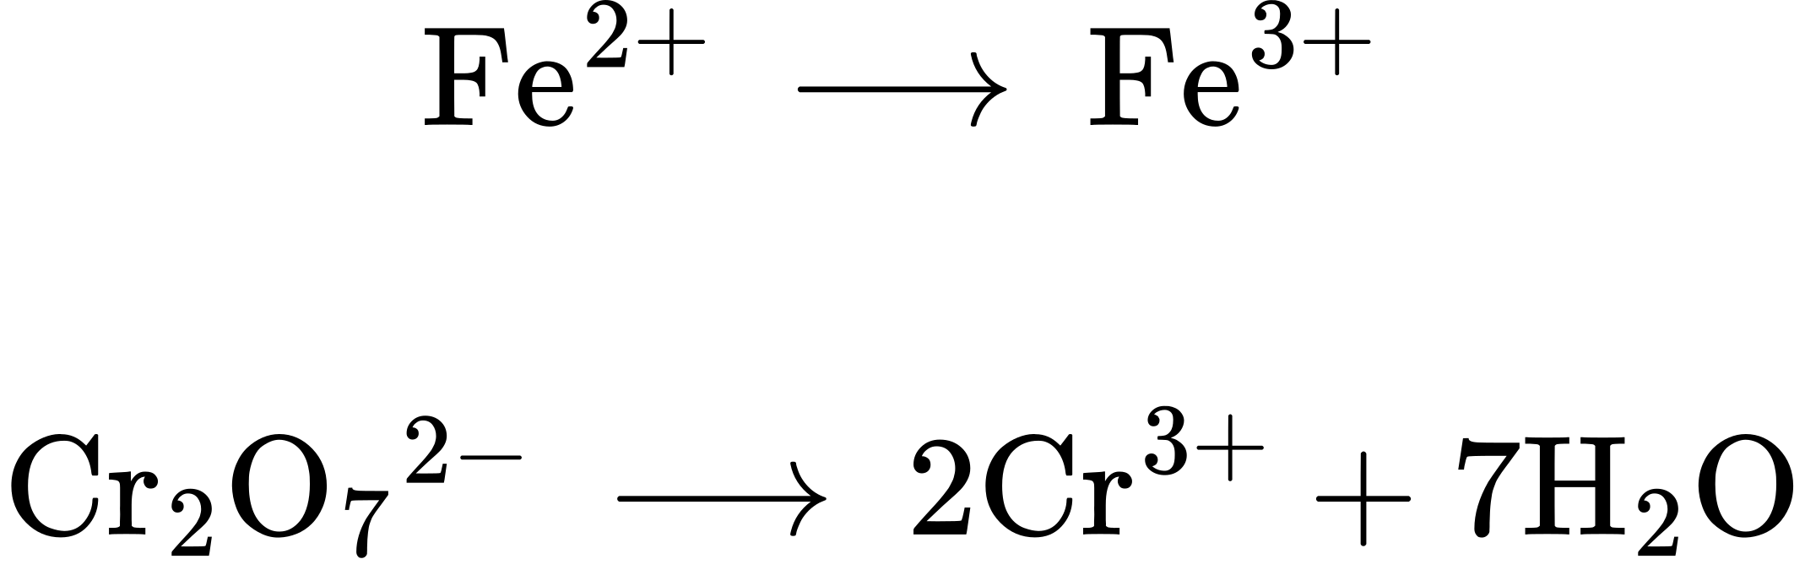
- Step 4.
- Balance hydrogen atoms by adding H⁺ions. The iron half-reaction does not contain H atoms. The chromium half-reaction shows 14 H atoms on the right and none on the left, so 14 hydrogen ions are added to the left side.
- ${\text{Fe}}^{\text{2+}} → {\text{Fe}}^{\text{3+}}$
- ${\text{Cr}}_{2}{\text{O}}_{7}​^{\text{2−}}+14{\text{H}}^{+} → 2{\text{Cr}}^{\text{3+}}+7{\text{H}}_{2}\text{O}$
- Step 5.
- Balance charge by adding electrons. The iron half-reaction shows a total charge of 2+ on the left side (1 Fe²⁺ ion) and 3+ on the right side (1 Fe³⁺ ion). Adding one electron to the right side brings that side’s total charge to (3+) + (1−) = 2+, and charge balance is achieved.
- The chromium half-reaction shows a total charge of (1 $×$ 2−) + (14 $×$ 1+) = 12+ on the left side ${(\text{1 Cr}}_{2}{\text{O}}_{7}​^{\text{2−}}$ ion and 14 H⁺ ions). The total charge on the right side is (2 $×$ 3+) = 6 + (2 Cr³⁺ ions). Adding six electrons to the left side will bring that side’s total charge to (12+ + 6−) = 6+, and charge balance is achieved.
- ${\text{Fe}}^{\text{2+}} → {\text{Fe}}^{\text{3+}}+{\text{e}}^{−}$
- ${\text{Cr}}_{2}{\text{O}}_{7}​^{\text{2−}}+14{\text{H}}^{+}+6{\text{e}}^{−} → 2{\text{Cr}}^{\text{3+}}+7{\text{H}}_{2}\text{O}$
- Step 6.
- Multiply the two half-reactions so the number of electrons in one reaction equals the number of electrons in the other reaction. To be consistent with mass conservation, and the idea that redox reactions involve the transfer (not creation or destruction) of electrons, the iron half-reaction’s coefficient must be multiplied by 6.
- ${\text{6Fe}}^{\text{2+}} → 6{\text{Fe}}^{\text{3+}}+6{\text{e}}^{−}$
- ${\text{Cr}}_{2}{\text{O}}_{7}​^{\text{2−}}+6{\text{e}}^{−}+14{\text{H}}^{+} → 2{\text{Cr}}^{\text{3+}}+7{\text{H}}_{2}\text{O}$
- Step 7.
- Add the balanced half-reactions and cancel species that appear on both sides of the equation.
- $6{\text{Fe}}^{\text{2+}}+{\text{Cr}}_{2}{\text{O}}_{7}​^{\text{2−}}+6{\text{e}}^{−}+14{\text{H}}^{+} → 6{\text{Fe}}^{\text{3+}}+6{\text{e}}^{−}+2{\text{Cr}}^{\text{3+}}+7{\text{H}}_{2}\text{O}$
- Only the six electrons are redundant species. Removing them from each side of the equation yields the simplified, balanced equation here:
- $6{\text{Fe}}^{\text{2+}}+{\text{Cr}}_{2}{\text{O}}_{7}​^{\text{2−}}+14{\text{H}}^{+} → 6{\text{Fe}}^{\text{3+}}+2{\text{Cr}}^{\text{3+}}+7{\text{H}}_{2}\text{O}$
A final check of atom and charge balance confirms the equation is balanced.
 | Reactants | Products
Fe | 6 | 6
Cr | 2 | 2
O | 7 | 7
H | 14 | 14
charge | 24+ | 24+

Check Your Learning
In basic solution, molecular chlorine, Cl₂, reacts with hydroxide ions, OH⁻, to yield chloride ions, Cl⁻. and chlorate ions, ClO₃⁻. HINT: This is a disproportionation reaction in which the element chlorine is both oxidized and reduced. Write a balanced equation for this reaction.

Answer:
$3{\text{Cl}}_{2}\left(aq\right)+6{\text{OH}}^{\text{−}}\left(aq\right) → 5{\text{Cl}}^{\text{−}}\left(aq\right)+{\text{ClO}}_{3}​^{\text{−}}\left(aq\right)+3{\text{H}}_{2}\text{O}\left(l\right)$

