4.4 Reaction Yields

Learning Objectives
By the end of this section, you will be able to:
- Explain the concepts of theoretical yield and limiting reactants/reagents.
- Derive the theoretical yield for a reaction under specified conditions.
- Calculate the percent yield for a reaction.
The relative amounts of reactants and products represented in a balanced chemical equation are often referred to as stoichiometric amounts. All the exercises of the preceding module involved stoichiometric amounts of reactants. For example, when calculating the amount of product generated from a given amount of reactant, it was assumed that any other reactants required were available in stoichiometric amounts (or greater). In this module, more realistic situations are considered, in which reactants are not present in stoichiometric amounts.

Limiting Reactant
Consider another food analogy, making grilled cheese sandwiches (Figure 4.13):
$\text{1 slice of cheese} + \text{2 slices of bread} → \text{1 sandwich}$
Stoichiometric amounts of sandwich ingredients for this recipe are bread and cheese slices in a 2:1 ratio. Provided with 28 slices of bread and 11 slices of cheese, one may prepare 11 sandwiches per the provided recipe, using all the provided cheese and having six slices of bread left over. In this scenario, the number of sandwiches prepared has been limited by the number of cheese slices, and the bread slices have been provided in excess.
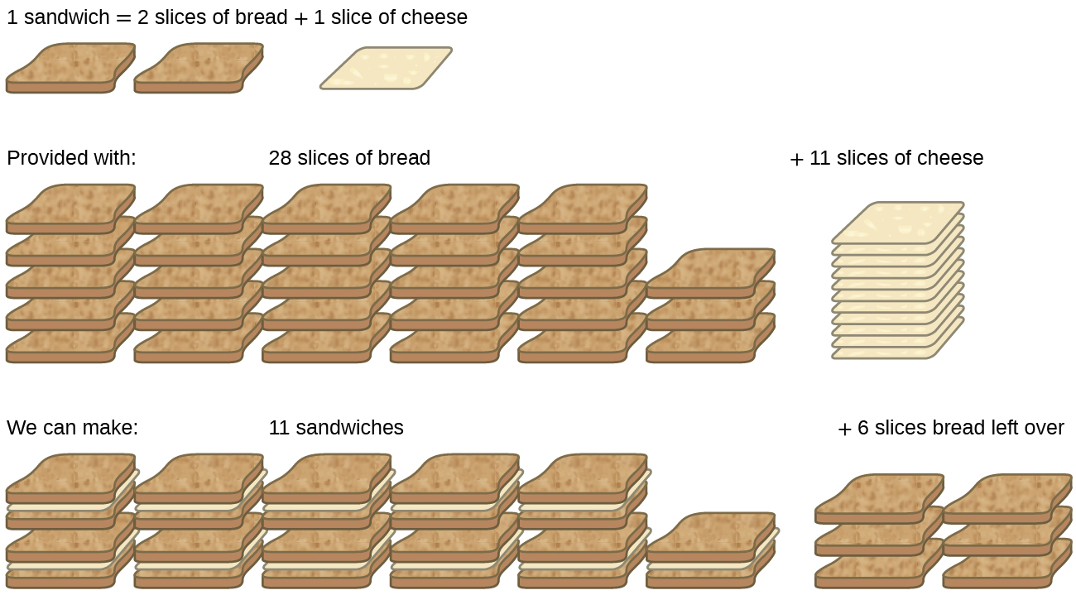
Figure 4.13 Sandwich making can illustrate the concepts of limiting and excess reactants.
Consider this concept now with regard to a chemical process, the reaction of hydrogen with chlorine to yield hydrogen chloride:
${\text{H}}_{2}\left(g\right)+{\text{Cl}}_{2}\left(g\right) → \text{2HCl}\left(g\right)$
The balanced equation shows the hydrogen and chlorine react in a 1:1 stoichiometric ratio. If these reactants are provided in any other amounts, one of the reactants will nearly always be entirely consumed, thus limiting the amount of product that may be generated. This substance is the limiting reactant, and the other substance is the excess reactant. Identifying the limiting and excess reactants for a given situation requires computing the molar amounts of each reactant provided and comparing them to the stoichiometric amounts represented in the balanced chemical equation. For example, imagine combining 3 moles of H₂ and 2 moles of Cl₂. This represents a 3:2 (or 1.5:1) ratio of hydrogen to chlorine present for reaction, which is greater than the stoichiometric ratio of 1:1. Hydrogen, therefore, is present in excess, and chlorine is the limiting reactant. Reaction of all the provided chlorine (2 mol) will consume 2 mol of the 3 mol of hydrogen provided, leaving 1 mol of hydrogen unreacted.
An alternative approach to identifying the limiting reactant involves comparing the amount of product expected for the complete reaction of each reactant. Each reactant amount is used to separately calculate the amount of product that would be formed per the reaction’s stoichiometry. The reactant yielding the lesser amount of product is the limiting reactant. For the example in the previous paragraph, complete reaction of the hydrogen would yield
$\text{mol HCl produced}=\text{3 mol} {\text{H}}_{2} × \frac{\text{2 mol HCl}}{\text{1 mol} {\text{H}}_{2}} =\text{6 mol HCl}$
Complete reaction of the provided chlorine would produce
$\text{mol HCl produced}=\text{2 mol} {\text{Cl}}_{2} × \frac{\text{2 mol HCl}}{\text{1 mol} {\text{Cl}}_{2}} =\text{4 mol HCl}$
The chlorine will be completely consumed once 4 moles of HCl have been produced. Since enough hydrogen was provided to yield 6 moles of HCl, there will be unreacted hydrogen remaining once this reaction is complete. Chlorine, therefore, is the limiting reactant and hydrogen is the excess reactant (Figure 4.14).
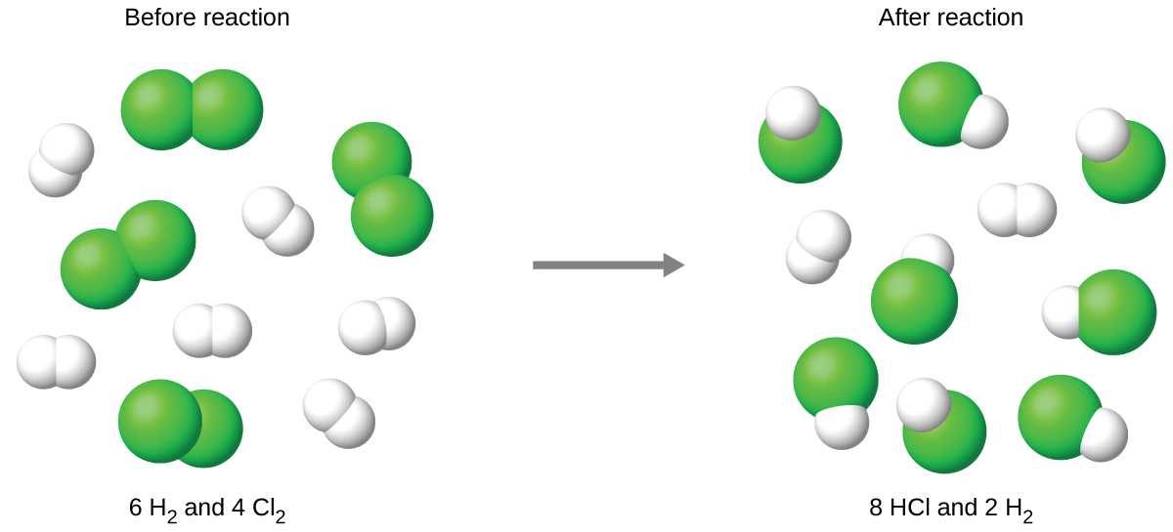
Figure 4.14 When H₂ and Cl₂ are combined in nonstoichiometric amounts, one of these reactants will limit the amount of HCl that can be produced. This illustration shows a reaction in which hydrogen is present in excess and chlorine is the limiting reactant.

Link to Learning
View this interactive simulation illustrating the concepts of limiting and excess reactants.

Example 4.12

Identifying the Limiting Reactant
Silicon nitride is a very hard, high-temperature-resistant ceramic used as a component of turbine blades in jet engines. It is prepared according to the following equation:
$\text{3Si}\left(s\right)+2{\text{N}}_{2}\left(g\right) → {\text{Si}}_{3}{\text{N}}_{4}\left(s\right)$
Which is the limiting reactant when 2.00 g of Si and 1.50 g of N₂ react?

Solution
Compute the provided molar amounts of reactants, and then compare these amounts to the balanced equation to identify the limiting reactant.
$\text{mol Si}=2.00 \text{g Si} × \frac{\text{1 mol Si}}{28.09 \text{g Si}} =\text{0.0712 mol Si}$
$\text{mol} {\text{N}}_{2}=1.50 \text{g} {\text{N}}_{2} × \frac{\text{1 mol} {\text{N}}_{2}}{28.02 \text{g} {\text{N}}_{2}} =\text{0.0535 mol} {\text{N}}_{2}$
The provided Si:N₂ molar ratio is:
$\frac{\text{0.0712 mol Si}}{\text{0.0535 mol} {\text{N}}_{2}} = \frac{\text{1.33 mol Si}}{\text{1 mol} {\text{N}}_{2}}$
The stoichiometric Si:N₂ ratio is:
$\frac{\text{3 mol Si}}{\text{2 mol} {\text{N}}_{2}} = \frac{\text{1.5 mol Si}}{\text{1 mol} {\text{N}}_{2}}$
Comparing these ratios shows that Si is provided in a less-than-stoichiometric amount, and so is the limiting reactant.
Alternatively, compute the amount of product expected for complete reaction of each of the provided reactants. The 0.0712 moles of silicon would yield
$\text{mol} {\text{Si}}_{3} {\text{N}}_{4} \text{produced}=\text{0.0712 mol Si} × \frac{1 \text{mol} {\text{Si}}_{3} {\text{N}}_{4}}{\text{3 mol Si}} =\text{0.0237 mol} {\text{Si}}_{3} {\text{N}}_{4}$
while the 0.0535 moles of nitrogen would produce
$\text{mol} {\text{Si}}_{3} {\text{N}}_{4} \text{produced}=\text{0.0535 mol} {\text{N}}_{2} × \frac{\text{1 mol} {\text{Si}}_{3} {\text{N}}_{4}}{\text{2 mol} {\text{N}}_{2}} =\text{0.0268 mol} {\text{Si}}_{3} {\text{N}}_{4}$
Since silicon yields the lesser amount of product, it is the limiting reactant.

Check Your Learning
Which is the limiting reactant when 5.00 g of H₂ and 10.0 g of O₂ react and form water?

Answer:
O₂

Percent Yield
The amount of product that may be produced by a reaction under specified conditions, as calculated per the stoichiometry of an appropriate balanced chemical equation, is called the theoretical yield of the reaction. In practice, the amount of product obtained is called the actual yield, and it is often less than the theoretical yield for a number of reasons. Some reactions are inherently inefficient, being accompanied by side reactions that generate other products. Others are, by nature, incomplete (consider the partial reactions of weak acids and bases discussed earlier in this chapter). Some products are difficult to collect without some loss, and so less than perfect recovery will reduce the actual yield. The extent to which a reaction’s theoretical yield is achieved is commonly expressed as its percent yield:
$\text{percent yield}= \frac{\text{actual yield}}{\text{theoretical yield}} × 100\%$
Actual and theoretical yields may be expressed as masses or molar amounts (or any other appropriate property; e.g., volume, if the product is a gas). As long as both yields are expressed using the same units, these units will cancel when percent yield is calculated.

Example 4.13

Calculation of Percent Yield
Upon reaction of 1.274 g of copper sulfate with excess zinc metal, 0.392 g copper metal was obtained according to the equation:
${\text{CuSO}}_{4}\left(aq\right)+\text{Zn}\left(s\right) → \text{Cu}\left(s\right)+{\text{ZnSO}}_{4}\left(aq\right)$
What is the percent yield?

Solution
The provided information identifies copper sulfate as the limiting reactant, and so the theoretical yield is found by the approach illustrated in the previous module, as shown here:
$1.274 \text{g} {\text{CuSO}}_{4} × \frac{1 \text{mol} {\text{CuSO}}_{4}}{159.62 \text{g} {\text{CuSO}}_{4}} × \frac{1 \text{mol Cu}}{1 \text{mol} {\text{CuSO}}_{4}} × \frac{63.55 \text{g Cu}}{1 \text{mol Cu}} =\text{0.5072 g Cu}$
Using this theoretical yield and the provided value for actual yield, the percent yield is calculated to be
$\text{percent yield}=\left(\frac{\text{actual yield}}{\text{theoretical yield}}\right) × 100$
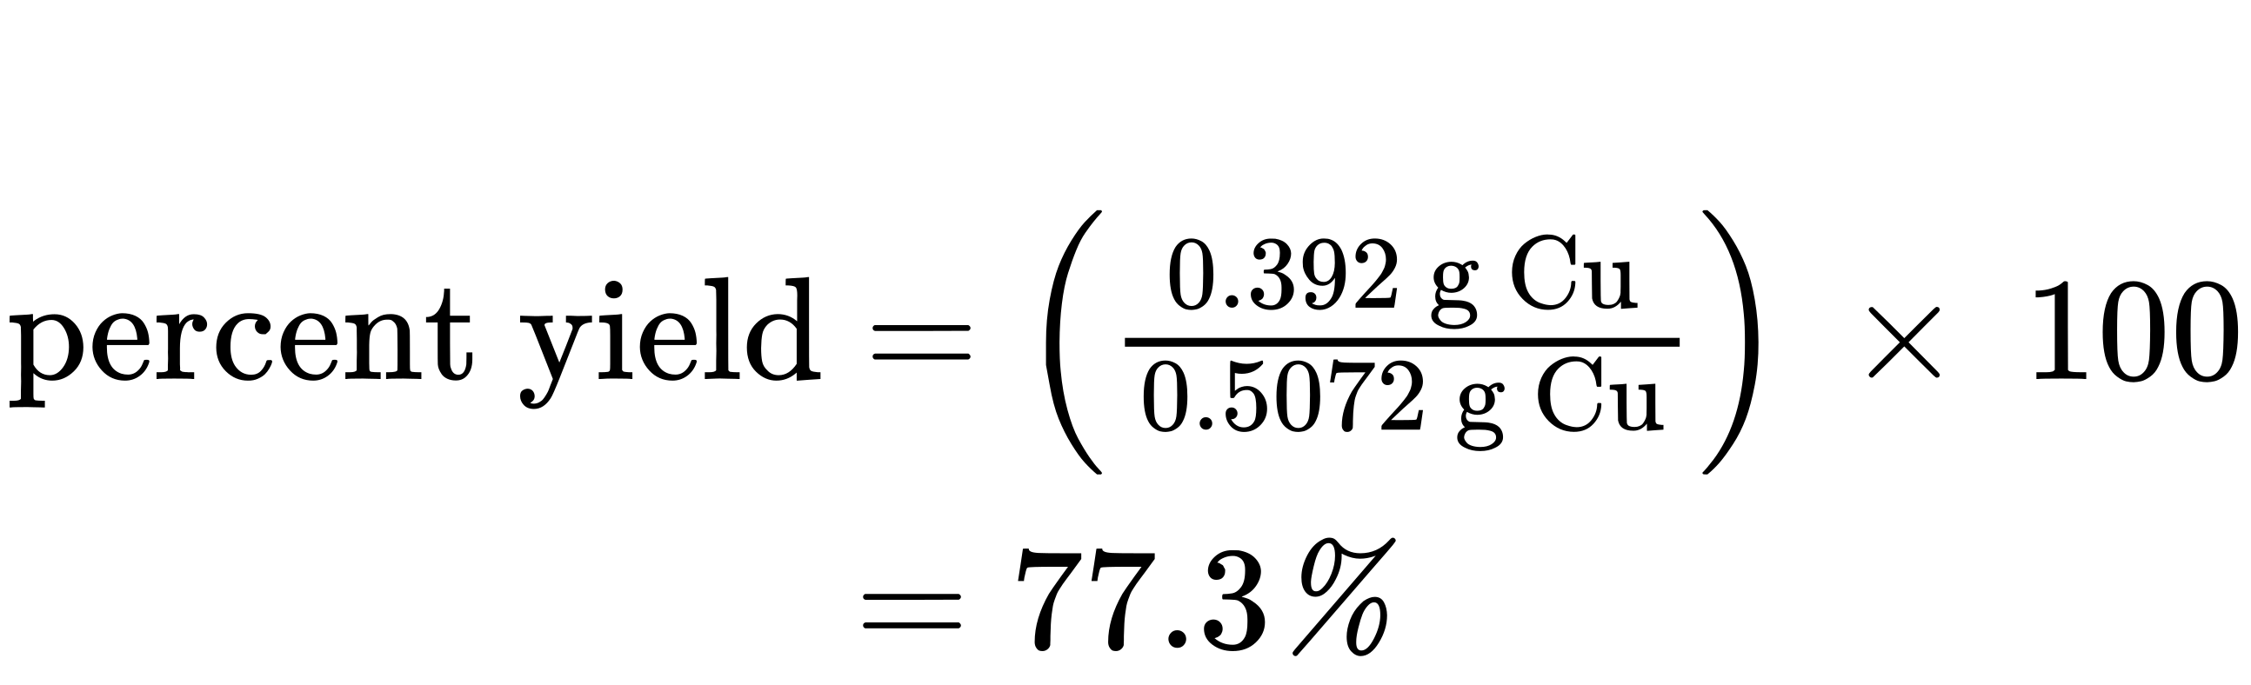

Check Your Learning
What is the percent yield of a reaction that produces 12.5 g of the gas Freon CF₂Cl₂ from 32.9 g of CCl₄ and excess HF?
${\text{CCl}}_{4}+2\text{HF} → {\text{CF}}_{2}{\text{Cl}}_{2}+2\text{HCl}$

Answer:
48.3%

How Sciences Interconnect

Green Chemistry and Atom Economy
The purposeful design of chemical products and processes that minimize the use of environmentally hazardous substances and the generation of waste is known as green chemistry. Green chemistry is a philosophical approach that is being applied to many areas of science and technology, and its practice is summarized by guidelines known as the “Twelve Principles of Green Chemistry” (see details at this website). One of the 12 principles is aimed specifically at maximizing the efficiency of processes for synthesizing chemical products. The atom economy of a process is a measure of this efficiency, defined as the percentage by mass of the final product of a synthesis relative to the masses of all the reactants used:
$\text{atom economy}= \frac{\text{mass of product}}{\text{mass of reactants}} × 100\%$
Though the definition of atom economy at first glance appears very similar to that for percent yield, be aware that this property represents a difference in the theoretical efficiencies of different chemical processes. The percent yield of a given chemical process, on the other hand, evaluates the efficiency of a process by comparing the yield of product actually obtained to the maximum yield predicted by stoichiometry.
The synthesis of the common nonprescription pain medication, ibuprofen, nicely illustrates the success of a green chemistry approach (Figure 4.15). First marketed in the early 1960s, ibuprofen was produced using a six-step synthesis that required 514 g of reactants to generate each mole (206 g) of ibuprofen, an atom economy of 40%. In the 1990s, an alternative process was developed by the BHC Company (now BASF Corporation) that requires only three steps and has an atom economy of ~80%, nearly twice that of the original process. The BHC process generates significantly less chemical waste; uses less-hazardous and recyclable materials; and provides significant cost-savings to the manufacturer (and, subsequently, the consumer). In recognition of the positive environmental impact of the BHC process, the company received the Environmental Protection Agency’s Greener Synthetic Pathways Award in 1997.
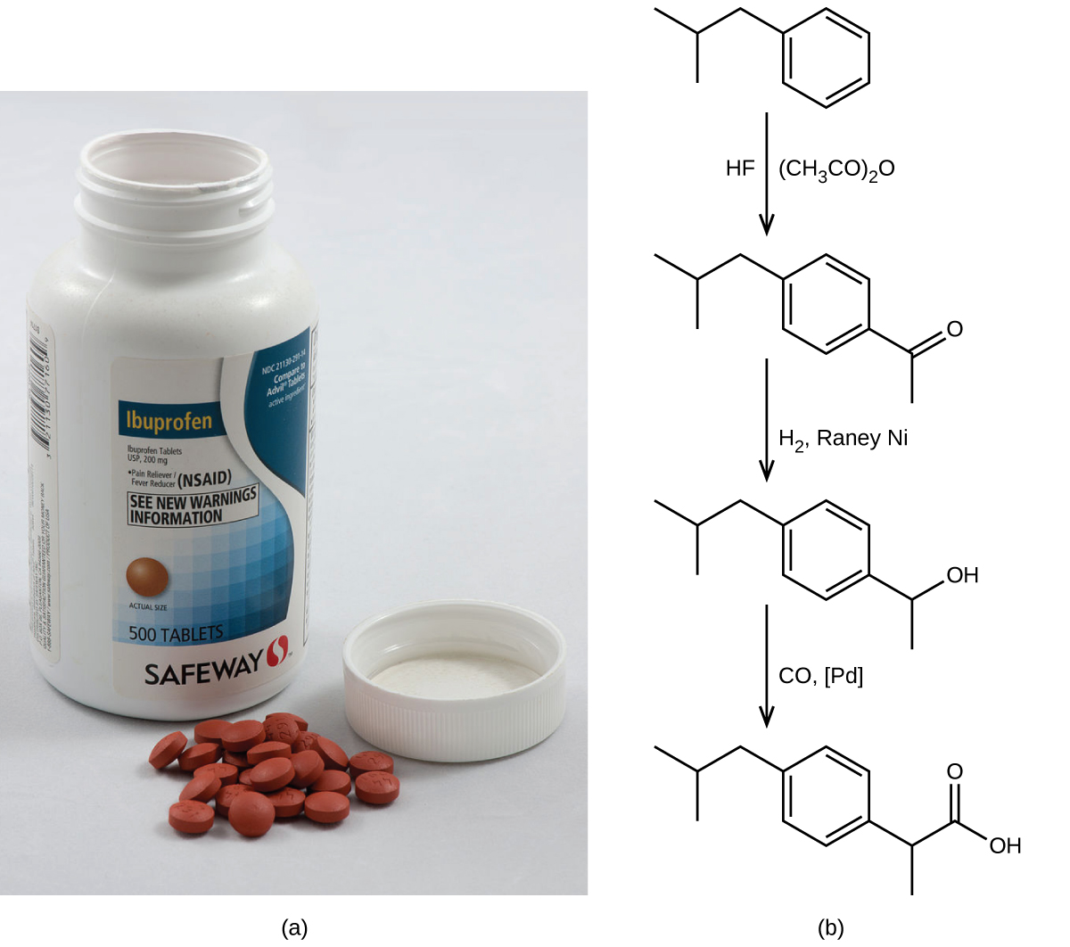
Figure 4.15 (a) Ibuprofen is a popular nonprescription pain medication commonly sold as 200 mg tablets. (b) The BHC process for synthesizing ibuprofen requires only three steps and exhibits an impressive atom economy. (credit a: modification of work by Derrick Coetzee)

