10.1 Intermolecular Forces

Learning Objectives
By the end of this section, you will be able to:
- Describe the types of intermolecular forces possible between atoms or molecules in condensed phases (dispersion forces, dipole-dipole attractions, and hydrogen bonding)
- Identify the types of intermolecular forces experienced by specific molecules based on their structures
- Explain the relation between the intermolecular forces present within a substance and the temperatures associated with changes in its physical state
As was the case for gaseous substances, the kinetic molecular theory may be used to explain the behavior of solids and liquids. In the following description, the term particle will be used to refer to an atom, molecule, or ion. Note that we will use the popular phrase “intermolecular attraction” to refer to attractive forces between the particles of a substance, regardless of whether these particles are molecules, atoms, or ions.
Consider these two aspects of the molecular-level environments in solid, liquid, and gaseous matter:
- Particles in a solid are tightly packed together and often arranged in a regular pattern; in a liquid, they are close together with no regular arrangement; in a gas, they are far apart with no regular arrangement.
- Particles in a solid vibrate about fixed positions and do not generally move in relation to one another; in a liquid, they move past each other but remain in essentially constant contact; in a gas, they move independently of one another except when they collide.
The differences in the properties of a solid, liquid, or gas reflect the strengths of the attractive forces between the atoms, molecules, or ions that make up each phase. The phase in which a substance exists depends on the relative extents of its intermolecular forces (IMFs) and the kinetic energies (KE) of its molecules. IMFs are the various forces of attraction that may exist between the atoms and molecules of a substance due to electrostatic phenomena, as will be detailed in this module. These forces serve to hold particles close together, whereas the particles’ KE provides the energy required to overcome the attractive forces and thus increase the distance between particles. Figure 10.2 illustrates how changes in physical state may be induced by changing the temperature, hence, the average KE, of a given substance.
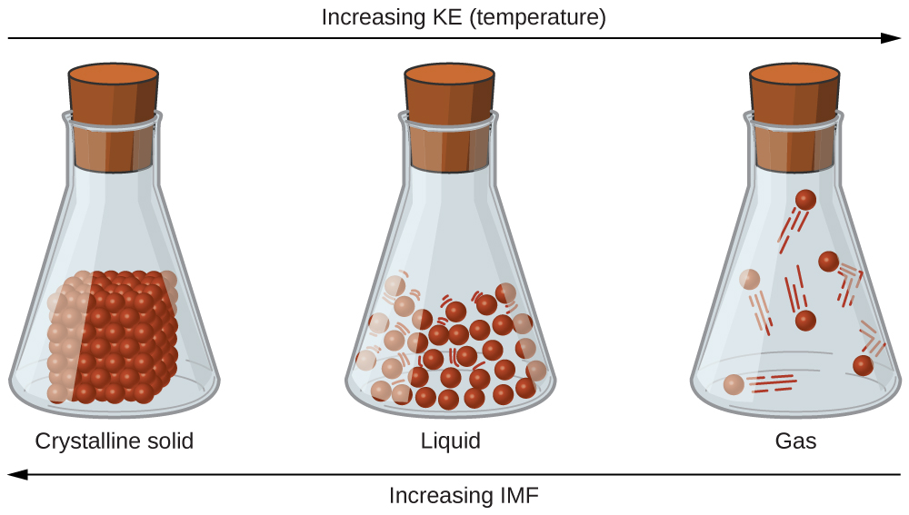
Figure 10.2 Transitions between solid, liquid, and gaseous states of a substance occur when conditions of temperature or pressure favor the associated changes in intermolecular forces. (Note: The space between particles in the gas phase is much greater than shown.)
As an example of the processes depicted in this figure, consider a sample of water. When gaseous water is cooled sufficiently, the attractions between H₂O molecules will be capable of holding them together when they come into contact with each other; the gas condenses, forming liquid H₂O. For example, liquid water forms on the outside of a cold glass as the water vapor in the air is cooled by the cold glass, as seen in Figure 10.3.
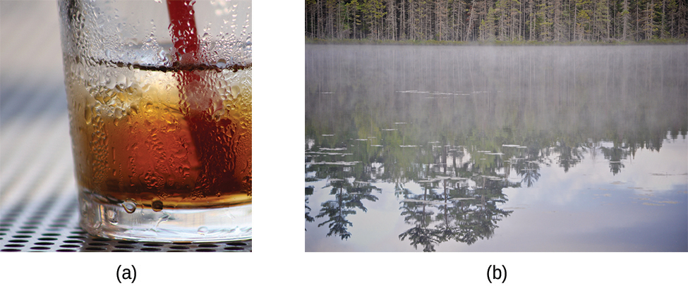
Figure 10.3 Condensation forms when water vapor in the air is cooled enough to form liquid water, such as (a) on the outside of a cold beverage glass or (b) in the form of fog. (credit a: modification of work by Jenny Downing; credit b: modification of work by Cory Zanker)
We can also liquefy many gases by compressing them, if the temperature is not too high. The increased pressure brings the molecules of a gas closer together, such that the attractions between the molecules become strong relative to their KE. Consequently, they form liquids. Butane, C₄H₁₀, is the fuel used in disposable lighters and is a gas at standard temperature and pressure. Inside the lighter’s fuel compartment, the butane is compressed to a pressure that results in its condensation to the liquid state, as shown in Figure 10.4.
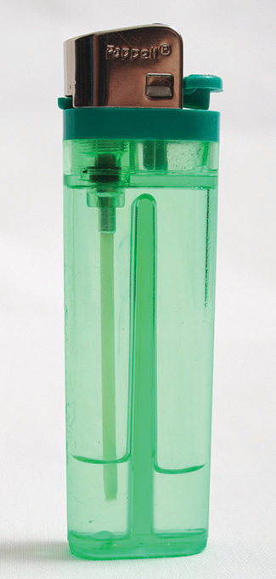
Figure 10.4 Gaseous butane is compressed within the storage compartment of a disposable lighter, resulting in its condensation to the liquid state. (credit: modification of work by “Sam-Cat”/Flickr)
Finally, if the temperature of a liquid becomes sufficiently low, or the pressure on the liquid becomes sufficiently high, the molecules of the liquid no longer have enough KE to overcome the IMF between them, and a solid forms. A more thorough discussion of these and other changes of state, or phase transitions, is provided in a later module of this chapter.

Link to Learning
Access this interactive simulation on states of matter, phase transitions, and intermolecular forces. This simulation is useful for visualizing concepts introduced throughout this chapter.

Forces between Molecules
Under appropriate conditions, the attractions between all gas molecules will cause them to form liquids or solids. This is due to intermolecular forces, not intramolecular forces. Intramolecular forces are those within the molecule that keep the molecule together, for example, the bonds between the atoms. Intermolecular forces are the attractions between molecules, which determine many of the physical properties of a substance. Figure 10.5 illustrates these different molecular forces. The strengths of these attractive forces vary widely, though usually the IMFs between small molecules are weak compared to the intramolecular forces that bond atoms together within a molecule. For example, to overcome the IMFs in one mole of liquid HCl and convert it into gaseous HCl requires only about 17 kilojoules. However, to break the covalent bonds between the hydrogen and chlorine atoms in one mole of HCl requires about 25 times more energy—430 kilojoules.
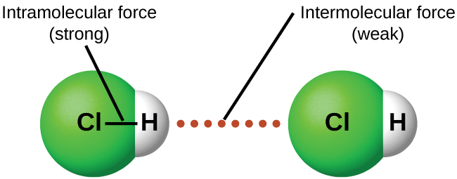
Figure 10.5 Intramolecular forces keep a molecule intact. Intermolecular forces hold multiple molecules together and determine many of a substance’s properties.
All of the attractive forces between neutral atoms and molecules are known as van der Waals forces, although they are usually referred to more informally as intermolecular attraction. We will consider the various types of IMFs in the next three sections of this module.

Dispersion Forces
One of the three van der Waals forces is present in all condensed phases, regardless of the nature of the atoms or molecules composing the substance. This attractive force is called the London dispersion force in honor of German-born American physicist Fritz London who, in 1928, first explained it. This force is often referred to as simply the dispersion force. Because the electrons of an atom or molecule are in constant motion (or, alternatively, the electron’s location is subject to quantum-mechanical variability), at any moment in time, an atom or molecule can develop a temporary, instantaneous dipole if its electrons are distributed asymmetrically. The presence of this dipole can, in turn, distort the electrons of a neighboring atom or molecule, producing an induced dipole. These two rapidly fluctuating, temporary dipoles thus result in a relatively weak electrostatic attraction between the species—a so-called dispersion force like that illustrated in Figure 10.6.
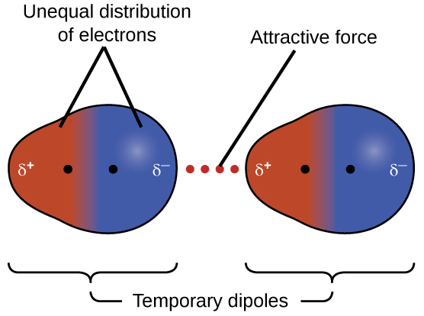
Figure 10.6 Dispersion forces result from the formation of temporary dipoles, as illustrated here for two nonpolar diatomic molecules.
Dispersion forces that develop between atoms in different molecules can attract the two molecules to each other. The forces are relatively weak, however, and become significant only when the molecules are very close. Larger and heavier atoms and molecules exhibit stronger dispersion forces than do smaller and lighter atoms and molecules. F₂ and Cl₂ are gases at room temperature (reflecting weaker attractive forces); Br₂ is a liquid, and I₂ is a solid (reflecting stronger attractive forces). Trends in observed melting and boiling points for the halogens clearly demonstrate this effect, as seen in Table 10.1.
Melting and Boiling Points of the Halogens
Halogen | Molar Mass | Atomic Radius | Melting Point | Boiling Point
fluorine, F₂ | 38 g/mol | 72 pm | 53 K | 85 K
chlorine, Cl₂ | 71 g/mol | 99 pm | 172 K | 238 K
bromine, Br₂ | 160 g/mol | 114 pm | 266 K | 332 K
iodine, I₂ | 254 g/mol | 133 pm | 387 K | 457 K
astatine, At₂ | 420 g/mol | 150 pm | 575 K | 610 K
Table 10.1
The increase in melting and boiling points with increasing atomic/molecular size may be rationalized by considering how the strength of dispersion forces is affected by the electronic structure of the atoms or molecules in the substance. In a larger atom, the valence electrons are, on average, farther from the nuclei than in a smaller atom. Thus, they are less tightly held and can more easily form the temporary dipoles that produce the attraction. The measure of how easy or difficult it is for another electrostatic charge (for example, a nearby ion or polar molecule) to distort a molecule’s charge distribution (its electron cloud) is known as polarizability. A molecule that has a charge cloud that is easily distorted is said to be very polarizable and will have large dispersion forces; one with a charge cloud that is difficult to distort is not very polarizable and will have small dispersion forces.

Example 10.1

London Forces and Their Effects
Order the following compounds of a group 14 element and hydrogen from lowest to highest boiling point: CH₄, SiH₄, GeH₄, and SnH₄. Explain your reasoning.

Solution
Applying the skills acquired in the chapter on chemical bonding and molecular geometry, all of these compounds are predicted to be nonpolar, so they may experience only dispersion forces: the smaller the molecule, the less polarizable and the weaker the dispersion forces; the larger the molecule, the larger the dispersion forces. The molar masses of CH₄, SiH₄, GeH₄, and SnH₄ are approximately 16 g/mol, 32 g/mol, 77 g/mol, and 123 g/mol, respectively. Therefore, CH₄ is expected to have the lowest boiling point and SnH₄ the highest boiling point. The ordering from lowest to highest boiling point is expected to be CH₄ < SiH₄ < GeH₄ < SnH₄.
A graph of the actual boiling points of these compounds versus the period of the group 14 element shows this prediction to be correct:
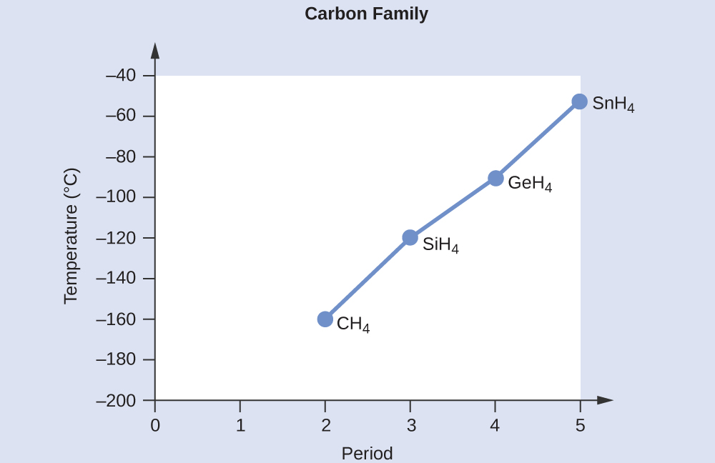

Check Your Learning
Order the following hydrocarbons from lowest to highest boiling point: C₂H₆, C₃H₈, and C₄H₁₀.

Answer:
C₂H₆ < C₃H₈ < C₄H₁₀. All of these compounds are nonpolar and only have London dispersion forces: the larger the molecule, the larger the dispersion forces and the higher the boiling point. The ordering from lowest to highest boiling point is therefore C₂H₆ < C₃H₈ < C₄H₁₀.
The shapes of molecules also affect the magnitudes of the dispersion forces between them. For example, boiling points for the isomers n-pentane, isopentane, and neopentane (shown in Figure 10.7) are 36 °C, 27 °C, and 9.5 °C, respectively. Even though these compounds are composed of molecules with the same chemical formula, C₅H₁₂, the difference in boiling points suggests that dispersion forces in the liquid phase are different, being greatest for n-pentane and least for neopentane. The elongated shape of n-pentane provides a greater surface area available for contact between molecules, resulting in correspondingly stronger dispersion forces. The more compact shape of isopentane offers a smaller surface area available for intermolecular contact and, therefore, weaker dispersion forces. Neopentane molecules are the most compact of the three, offering the least available surface area for intermolecular contact and, hence, the weakest dispersion forces. This behavior is analogous to the connections that may be formed between strips of VELCRO brand fasteners: the greater the area of the strip’s contact, the stronger the connection.
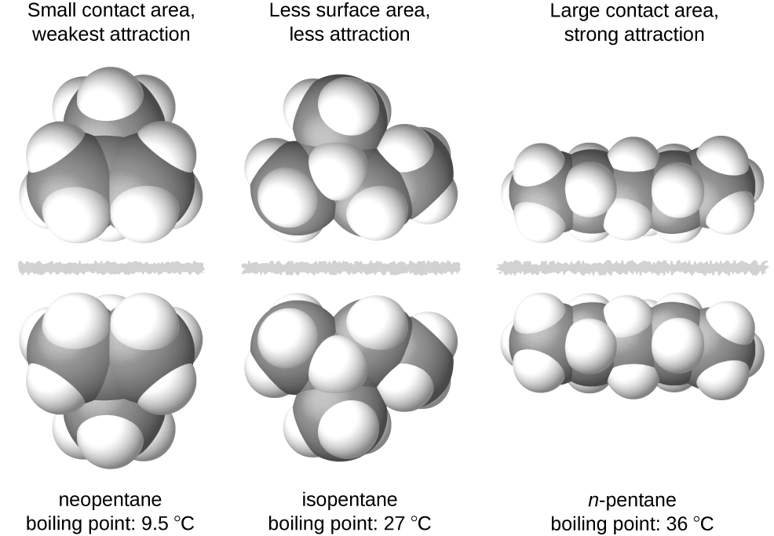
Figure 10.7 The strength of the dispersion forces increases with the contact area between molecules, as demonstrated by the boiling points of these pentane isomers.

Chemistry in Everyday Life

Geckos and Intermolecular Forces
Geckos have an amazing ability to adhere to most surfaces. They can quickly run up smooth walls and across ceilings that have no toe-holds, and they do this without having suction cups or a sticky substance on their toes. And while a gecko can lift its feet easily as it walks along a surface, if you attempt to pick it up, it sticks to the surface. How are geckos (as well as spiders and some other insects) able to do this? Although this phenomenon has been investigated for hundreds of years, scientists only recently uncovered the details of the process that allows geckos’ feet to behave this way.
Geckos’ toes are covered with hundreds of thousands of tiny hairs known as setae, with each seta, in turn, branching into hundreds of tiny, flat, triangular tips called spatulae. The huge numbers of spatulae on its setae provide a gecko, shown in Figure 10.8, with a large total surface area for sticking to a surface. In 2000, Kellar Autumn, who leads a multi-institutional gecko research team, found that geckos adhered equally well to both polar silicon dioxide and nonpolar gallium arsenide. This proved that geckos stick to surfaces because of dispersion forces—weak intermolecular attractions arising from temporary, synchronized charge distributions between adjacent molecules. Although dispersion forces are very weak, the total attraction over millions of spatulae is large enough to support many times the gecko’s weight.
In 2014, two scientists developed a model to explain how geckos can rapidly transition from “sticky” to “non-sticky.” Alex Greaney and Congcong Hu at Oregon State University described how geckos can achieve this by changing the angle between their spatulae and the surface. Geckos’ feet, which are normally nonsticky, become sticky when a small shear force is applied. By curling and uncurling their toes, geckos can alternate between sticking and unsticking from a surface, and thus easily move across it. Later research led by Alyssa Stark at University of Akron showed that geckos can maintain their hold on hydrophobic surfaces (similar to the leaves in their habitats) equally well whether the surfaces were wet or dry. Stark's experiment used a ribbon to gently pull the geckos until they slipped, so that the researchers could determine the geckos' ability to hold various surfaces under wet and dry conditions. Further investigations may eventually lead to the development of better adhesives and other applications.
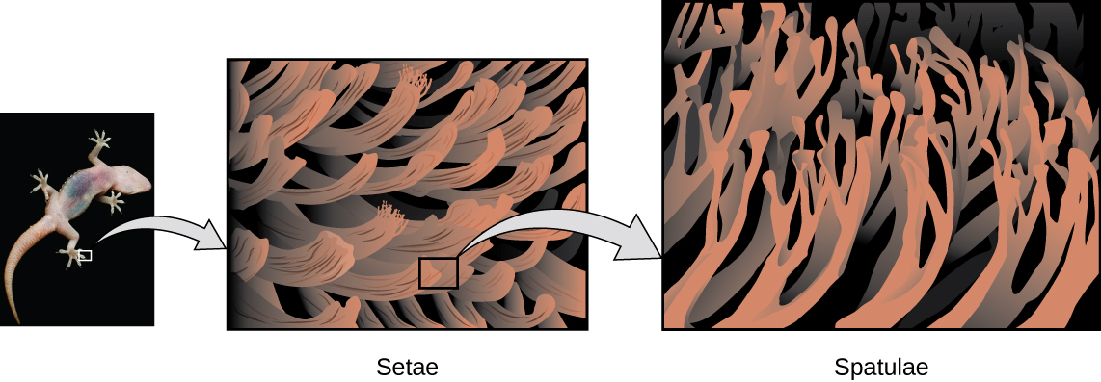
Figure 10.8 Geckos’ toes contain large numbers of tiny hairs (setae), which branch into many triangular tips (spatulae). Geckos adhere to surfaces because of van der Waals attractions between the surface and a gecko’s millions of spatulae. By changing how the spatulae contact the surface, geckos can turn their stickiness “on” and “off.” (credit photo: modification of work by “JC*+A!”/Flickr)

Link to Learning
Watch this video to learn more about Kellar Autumn’s research that determined that van der Waals forces are responsible for a gecko’s ability to cling and climb.

Dipole-Dipole Attractions
Recall from the chapter on chemical bonding and molecular geometry that polar molecules have a partial positive charge on one side and a partial negative charge on the other side of the molecule—a separation of charge called a dipole. Consider a polar molecule such as hydrogen chloride, HCl. In the HCl molecule, the more electronegative Cl atom bears the partial negative charge, whereas the less electronegative H atom bears the partial positive charge. An attractive force between HCl molecules results from the attraction between the positive end of one HCl molecule and the negative end of another. This attractive force is called a dipole-dipole attraction—the electrostatic force between the partially positive end of one polar molecule and the partially negative end of another, as illustrated in Figure 10.9.
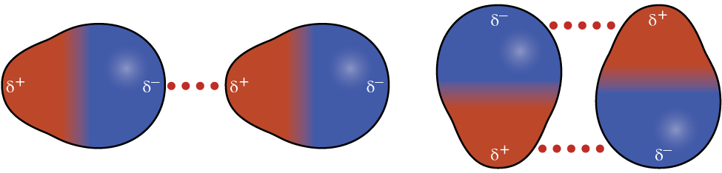
Figure 10.9 This image shows two arrangements of polar molecules, such as HCl, that allow an attraction between the partial negative end of one molecule and the partial positive end of another.
The effect of a dipole-dipole attraction is apparent when we compare the properties of HCl molecules to nonpolar F₂ molecules. Both HCl and F₂ consist of the same number of atoms and have approximately the same molecular mass. At a temperature of 150 K, molecules of both substances would have the same average KE. However, the dipole-dipole attractions between HCl molecules are sufficient to cause them to “stick together” to form a liquid, whereas the relatively weaker dispersion forces between nonpolar F₂ molecules are not, and so this substance is gaseous at this temperature. The higher normal boiling point of HCl (188 K) compared to F₂ (85 K) is a reflection of the greater strength of dipole-dipole attractions between HCl molecules, compared to the attractions between nonpolar F₂ molecules. We will often use values such as boiling or freezing points, or enthalpies of vaporization or fusion, as indicators of the relative strengths of IMFs of attraction present within different substances.

Example 10.2

Dipole-Dipole Forces and Their Effects
Predict which will have the higher boiling point: N₂ or CO. Explain your reasoning.

Solution
CO and N₂ are both diatomic molecules with masses of about 28 amu, so they experience similar London dispersion forces. Because CO is a polar molecule, it experiences dipole-dipole attractions. Because N₂ is nonpolar, its molecules cannot exhibit dipole-dipole attractions. The dipole-dipole attractions between CO molecules are comparably stronger than the dispersion forces between nonpolar N₂ molecules, so CO is expected to have the higher boiling point.

Check Your Learning
Predict which will have the higher boiling point: ICl or Br₂. Explain your reasoning.

Answer:
ICl. ICl and Br₂ have similar masses (~160 amu) and therefore experience similar London dispersion forces. ICl is polar and thus also exhibits dipole-dipole attractions; Br₂ is nonpolar and does not. The relatively stronger dipole-dipole attractions require more energy to overcome, so ICl will have the higher boiling point.

Hydrogen Bonding
Nitrosyl fluoride (ONF, molecular mass 49 amu) is a gas at room temperature. Water (H₂O, molecular mass 18 amu) is a liquid, even though it has a lower molecular mass. We clearly cannot attribute this difference between the two compounds to dispersion forces. Both molecules have about the same shape and ONF is the heavier and larger molecule. It is, therefore, expected to experience more significant dispersion forces. Additionally, we cannot attribute this difference in boiling points to differences in the dipole moments of the molecules. Both molecules are polar and exhibit comparable dipole moments. The large difference between the boiling points is due to a particularly strong dipole-dipole attraction that may occur when a molecule contains a hydrogen atom bonded to a fluorine, oxygen, or nitrogen atom (the three most electronegative elements). The very large difference in electronegativity between the H atom (2.1) and the atom to which it is bonded (4.0 for an F atom, 3.5 for an O atom, or 3.0 for a N atom), combined with the very small size of a H atom and the relatively small sizes of F, O, or N atoms, leads to highly concentrated partial charges with these atoms. Molecules with F-H, O-H, or N-H moieties are very strongly attracted to similar moieties in nearby molecules, a particularly strong type of dipole-dipole attraction called hydrogen bonding. Examples of hydrogen bonds include HF⋯HF, H₂O⋯HOH, and H₃N⋯HNH₂, in which the hydrogen bonds are denoted by dots. Figure 10.10 illustrates hydrogen bonding between water molecules.
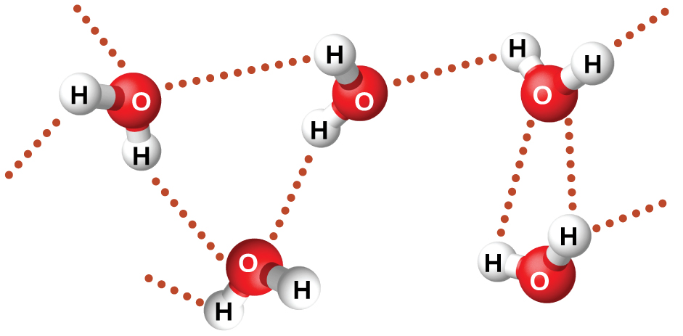
Figure 10.10 Water molecules participate in multiple hydrogen-bonding interactions with nearby water molecules.
Despite use of the word “bond,” keep in mind that hydrogen bonds are intermolecular attractive forces, not intramolecular attractive forces (covalent bonds). Hydrogen bonds are much weaker than covalent bonds, only about 5 to 10% as strong, but are generally much stronger than other dipole-dipole attractions and dispersion forces.
Hydrogen bonds have a pronounced effect on the properties of condensed phases (liquids and solids). For example, consider the trends in boiling points for the binary hydrides of group 15 (NH₃, PH₃, AsH₃, and SbH₃), group 16 hydrides (H₂O, H₂S, H₂Se, and H₂Te), and group 17 hydrides (HF, HCl, HBr, and HI). The boiling points of the heaviest three hydrides for each group are plotted in Figure 10.11. As we progress down any of these groups, the polarities of the molecules decrease slightly, whereas the sizes of the molecules increase substantially. The effect of increasingly stronger dispersion forces dominates that of increasingly weaker dipole-dipole attractions, and the boiling points are observed to increase steadily.
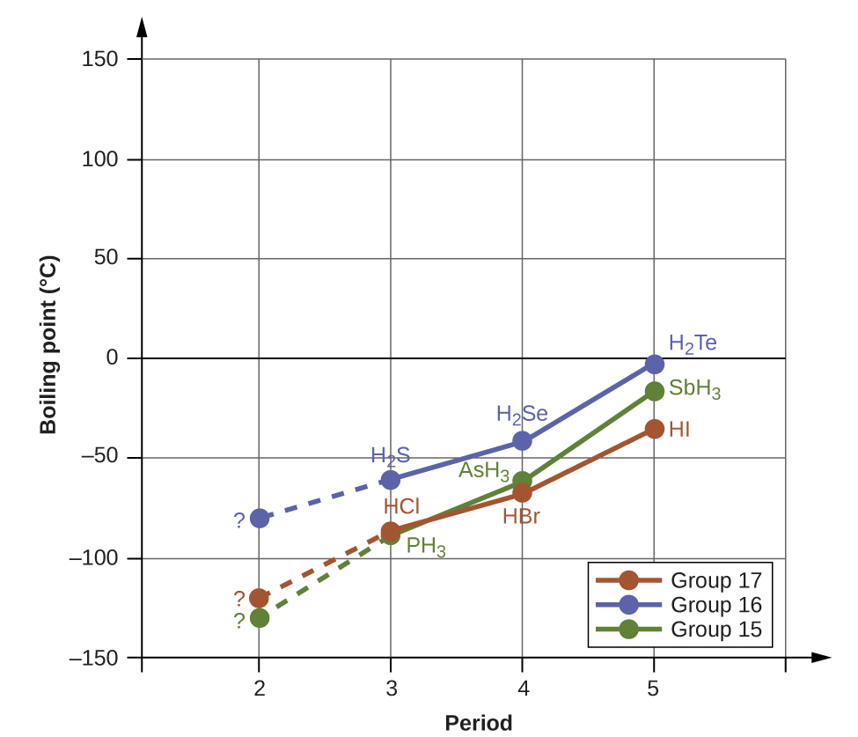
Figure 10.11 For the group 15, 16, and 17 hydrides, the boiling points for each class of compounds increase with increasing molecular mass for elements in periods 3, 4, and 5.
If we use this trend to predict the boiling points for the lightest hydride for each group, we would expect NH₃ to boil at about −120 °C, H₂O to boil at about −80 °C, and HF to boil at about −110 °C. However, when we measure the boiling points for these compounds, we find that they are dramatically higher than the trends would predict, as shown in Figure 10.12. The stark contrast between our naïve predictions and reality provides compelling evidence for the strength of hydrogen bonding.
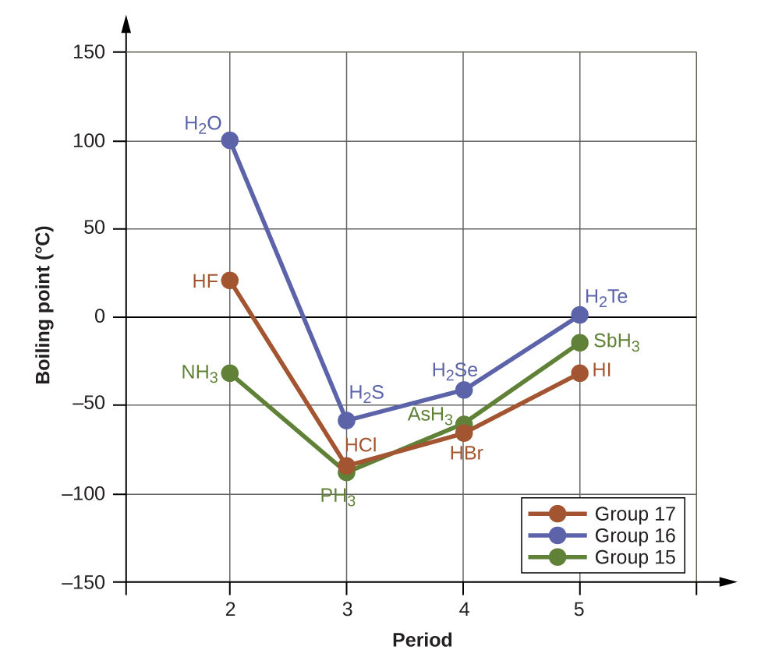
Figure 10.12 In comparison to periods 3−5, the binary hydrides of period 2 elements in groups 17, 16 and 15 (F, O and N, respectively) exhibit anomalously high boiling points due to hydrogen bonding.

Example 10.3

Effect of Hydrogen Bonding on Boiling Points
Consider the compounds dimethylether (CH₃OCH₃), ethanol (CH₃CH₂OH), and propane (CH₃CH₂CH₃). Their boiling points, not necessarily in order, are −42.1 °C, −24.8 °C, and 78.4 °C. Match each compound with its boiling point. Explain your reasoning.

Solution
The VSEPR-predicted shapes of CH₃OCH₃, CH₃CH₂OH, and CH₃CH₂CH₃ are similar, as are their molar masses (46 g/mol, 46 g/mol, and 44 g/mol, respectively), so they will exhibit similar dispersion forces. Since CH₃CH₂CH₃ is nonpolar, it may exhibit only dispersion forces. Because CH₃OCH₃ is polar, it will also experience dipole-dipole attractions. Finally, CH₃CH₂OH has an −OH group, and so it will experience the uniquely strong dipole-dipole attraction known as hydrogen bonding. So the ordering in terms of strength of IMFs, and thus boiling points, is CH₃CH₂CH₃ < CH₃OCH₃ < CH₃CH₂OH. The boiling point of propane is −42.1 °C, the boiling point of dimethylether is −24.8 °C, and the boiling point of ethanol is 78.5 °C.

Check Your Learning
Ethane (CH₃CH₃) has a melting point of −183 °C and a boiling point of −89 °C. Predict the melting and boiling points for methylamine (CH₃NH₂). Explain your reasoning.

Answer:
The melting point and boiling point for methylamine are predicted to be significantly greater than those of ethane. CH₃CH₃ and CH₃NH₂ are similar in size and mass, but methylamine possesses an −NH group and therefore may exhibit hydrogen bonding. This greatly increases its IMFs, and therefore its melting and boiling points. It is difficult to predict values, but the known values are a melting point of −93 °C and a boiling point of −6 °C.

How Sciences Interconnect

Hydrogen Bonding and DNA
Deoxyribonucleic acid (DNA) is found in every living organism and contains the genetic information that determines the organism’s characteristics, provides the blueprint for making the proteins necessary for life, and serves as a template to pass this information on to the organism’s offspring. A DNA molecule consists of two (anti-)parallel chains of repeating nucleotides, which form its well-known double helical structure, as shown in Figure 10.13.
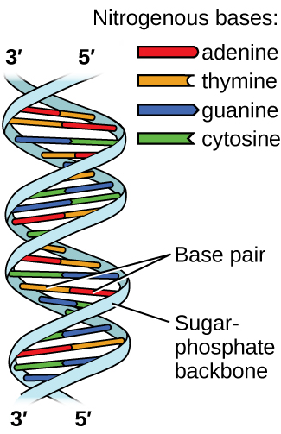
Figure 10.13 Two separate DNA molecules form a double-stranded helix in which the molecules are held together via hydrogen bonding. (credit: modification of work by Jerome Walker, Dennis Myts)
Each nucleotide contains a (deoxyribose) sugar bound to a phosphate group on one side, and one of four nitrogenous bases on the other. Two of the bases, cytosine (C) and thymine (T), are single-ringed structures known as pyrimidines. The other two, adenine (A) and guanine (G), are double-ringed structures called purines. These bases form complementary base pairs consisting of one purine and one pyrimidine, with adenine pairing with thymine, and cytosine with guanine. Each base pair is held together by hydrogen bonding. A and T share two hydrogen bonds, C and G share three, and both pairings have a similar shape and structure Figure 10.14.
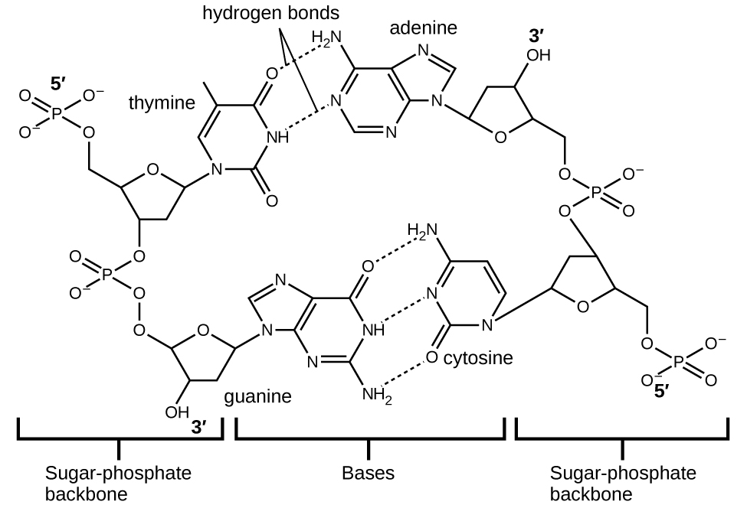
Figure 10.14 The geometries of the base molecules result in maximum hydrogen bonding between adenine and thymine (AT) and between guanine and cytosine (GC), so-called “complementary base pairs.”
The cumulative effect of millions of hydrogen bonds effectively holds the two strands of DNA together. Importantly, the two strands of DNA can relatively easily “unzip” down the middle since hydrogen bonds are relatively weak compared to the covalent bonds that hold the atoms of the individual DNA molecules together. This allows both strands to function as a template for replication.

