11.5 Colloids

Learning Objectives
By the end of this section, you will be able to:
- Describe the composition and properties of colloidal dispersions
- List and explain several technological applications of colloids
As a child, you may have made suspensions such as mixtures of mud and water, flour and water, or a suspension of solid pigments in water, known as tempera paint. These suspensions are heterogeneous mixtures composed of relatively large particles that are visible (or that can be seen with a magnifying glass). They are cloudy, and the suspended particles settle out after mixing. On the other hand, a solution is a homogeneous mixture in which no settling occurs and in which the dissolved species are molecules or ions. Solutions exhibit completely different behavior from suspensions. A solution may be colored, but it is transparent, the molecules or ions are invisible, and they do not settle out on standing. Another class of mixtures called colloids (or colloidal dispersions) exhibit properties intermediate between those of suspensions and solutions (Figure 11.29). The particles in a colloid are larger than most simple molecules; however, colloidal particles are small enough that they do not settle out upon standing.
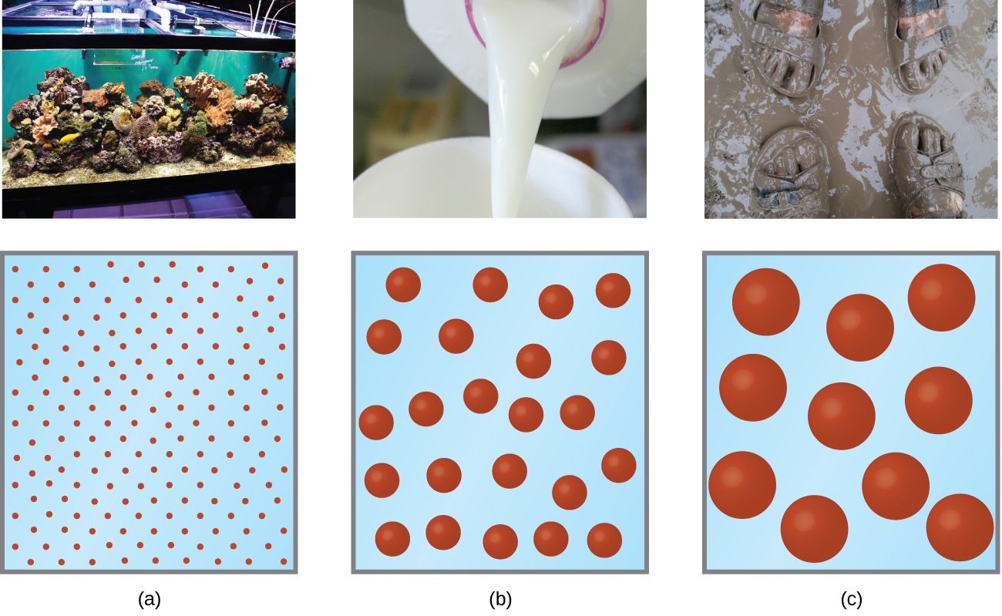
Figure 11.29 (a) A solution is a homogeneous mixture that appears clear, such as the saltwater in this aquarium. (b) In a colloid, such as milk, the particles are much larger but remain dispersed and do not settle. (c) A suspension, such as mud, is a heterogeneous mixture of suspended particles that appears cloudy and in which the particles can settle. (credit a photo: modification of work by Adam Wimsatt; credit b photo: modification of work by Melissa Wiese; credit c photo: modification of work by Peter Burgess)
The particles in a colloid are large enough to scatter light, a phenomenon called the Tyndall effect. This can make colloidal mixtures appear cloudy or opaque, such as the searchlight beams shown in Figure 11.30. Clouds are colloidal mixtures. They are composed of water droplets that are much larger than molecules, but that are small enough that they do not settle out.

Figure 11.30 The paths of searchlight beams are made visible when light is scattered by colloidal-size particles in the air (fog, smoke, etc.). (credit: “Bahman”/Wikimedia Commons)
The term “colloid”—from the Greek words kolla, meaning “glue,” and eidos, meaning “like”—was first used in 1861 by Thomas Graham to classify mixtures such as starch in water and gelatin. Many colloidal particles are aggregates of hundreds or thousands of molecules, but others (such as proteins and polymer molecules) consist of a single extremely large molecule. The protein and synthetic polymer molecules that form colloids may have molecular masses ranging from a few thousand to many million atomic mass units.
Analogous to the identification of solution components as “solute” and “solvent,” the components of a colloid are likewise classified according to their relative amounts. The particulate component typically present in a relatively minor amount is called the dispersed phase and the substance or solution throughout which the particulate is dispersed is called the dispersion medium. Colloids may involve virtually any combination of physical states (gas in liquid, liquid in solid, solid in gas, etc.), as illustrated by the examples of colloidal systems given in Table 11.4.
Examples of Colloidal Systems
Dispersed Phase | Dispersion Medium | Common Examples | Name
solid | gas | smoke, dust | —
solid | liquid | starch in water, some inks, paints, milk of magnesia | sol
solid | solid | some colored gems, some alloys | —
liquid | gas | clouds, fogs, mists, sprays | aerosol
liquid | liquid | milk, mayonnaise, butter | emulsion
liquid | solid | jellies, gels, pearl, opal (H₂O in SiO₂) | gel
gas | liquid | foams, whipped cream, beaten egg whites | foam
gas | solid | pumice, floating soaps | —
Table 11.4

Preparation of Colloidal Systems
Colloids are prepared by producing particles of colloidal dimensions and distributing these particles throughout a dispersion medium. Particles of colloidal size are formed by two methods:
- Dispersion methods: breaking down larger particles. For example, paint pigments are produced by dispersing large particles by grinding in special mills.
- Condensation methods: growth from smaller units, such as molecules or ions. For example, clouds form when water molecules condense and form very small droplets.
A few solid substances, when brought into contact with water, disperse spontaneously and form colloidal systems. Gelatin, glue, starch, and dehydrated milk powder behave in this manner. The particles are already of colloidal size; the water simply disperses them. Powdered milk particles of colloidal size are produced by dehydrating milk spray. Some atomizers produce colloidal dispersions of a liquid in air.
An emulsion may be prepared by shaking together or blending two immiscible liquids. This breaks one liquid into droplets of colloidal size, which then disperse throughout the other liquid. Oil spills in the ocean may be difficult to clean up, partly because wave action can cause the oil and water to form an emulsion. In many emulsions, however, the dispersed phase tends to coalesce, form large drops, and separate. Therefore, emulsions are usually stabilized by an emulsifying agent, a substance that inhibits the coalescence of the dispersed liquid. For example, a little soap will stabilize an emulsion of kerosene in water. Milk is an emulsion of butterfat in water, with the protein casein serving as the emulsifying agent. Mayonnaise is an emulsion of oil in vinegar, with egg yolk components as the emulsifying agents.
Condensation methods form colloidal particles by aggregation of molecules or ions. If the particles grow beyond the colloidal size range, drops or precipitates form, and no colloidal system results. Clouds form when water molecules aggregate and form colloid-sized particles. If these water particles coalesce to form adequately large water drops of liquid water or crystals of solid water, they settle from the sky as rain, sleet, or snow. Many condensation methods involve chemical reactions. A red colloidal suspension of iron(III) hydroxide may be prepared by mixing a concentrated solution of iron(III) chloride with hot water:
${\text{Fe}}^{\text{3+}}\left(aq\right)+3{\text{Cl}}^{\text{−}}\left(aq\right)+6{\text{H}}_{2}\text{O}\left(l\right) → \text{Fe}{\left(\text{OH}\right)}_{3}(s)+{\text{H}}_{3}{\text{O}}^{\text{+}}\left(aq\right)+3{\text{Cl}}^{\text{−}}(aq).$
A colloidal gold sol results from the reduction of a very dilute solution of gold(III) chloride by a reducing agent such as formaldehyde, tin(II) chloride, or iron(II) sulfate:
${\text{Au}}^{\text{3+}}+3{\text{e}}^{\text{−}} → \text{Au}$
Some gold sols prepared in 1857 are still intact (the particles have not coalesced and settled), illustrating the long-term stability of many colloids.

Soaps and Detergents
Pioneers made soap by boiling fats with a strongly basic solution made by leaching potassium carbonate, K₂CO₃, from wood ashes with hot water. Animal fats contain polyesters of fatty acids (long-chain carboxylic acids). When animal fats are treated with a base like potassium carbonate or sodium hydroxide, glycerol and salts of fatty acids such as palmitic, oleic, and stearic acid are formed. The salts of fatty acids are called soaps. The sodium salt of stearic acid, sodium stearate, has the formula C₁₇H₃₅CO₂Na and contains an uncharged nonpolar hydrocarbon chain, the C₁₇H₃₅— unit, and an ionic carboxylate group, the —${\text{CO}}_{2}​^{\text{−}}$ unit (Figure 11.31).
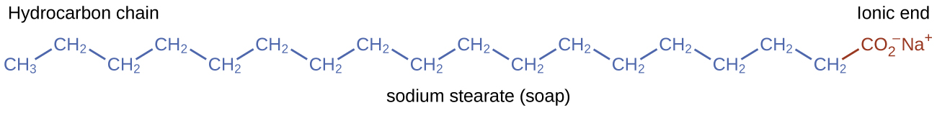
Figure 11.31 Soaps contain a nonpolar hydrocarbon end (blue) and an ionic end (red). The ionic end is a carboxylate group. The length of the hydrocarbon end can vary from soap to soap.
Detergents (soap substitutes) also contain nonpolar hydrocarbon chains, such as C₁₂H₂₅—, and an ionic group, such as a sulfate—${\text{OSO}}_{3}​^{\text{−}},$ or a sulfonate—${\text{SO}}_{3}​^{\text{−}}$ (Figure 11.32). Soaps form insoluble calcium and magnesium compounds in hard water; detergents form water-soluble products—a definite advantage for detergents.
Figure 11.32 Detergents contain a nonpolar hydrocarbon end (blue) and an ionic end (red). The ionic end can be either a sulfate or a sulfonate. The length of the hydrocarbon end can vary from detergent to detergent.
The cleaning action of soaps and detergents can be explained in terms of the structures of the molecules involved. The hydrocarbon (nonpolar) end of a soap or detergent molecule dissolves in, or is attracted to, nonpolar substances such as oil, grease, or dirt particles. The ionic end is attracted by water (polar), illustrated in Figure 11.33. As a result, the soap or detergent molecules become oriented at the interface between the dirt particles and the water so they act as a kind of bridge between two different kinds of matter, nonpolar and polar. Molecules such as this are termed amphiphilic since they have both a hydrophobic (“water-fearing”) part and a hydrophilic (“water-loving”) part. As a consequence, dirt particles become suspended as colloidal particles and are readily washed away.
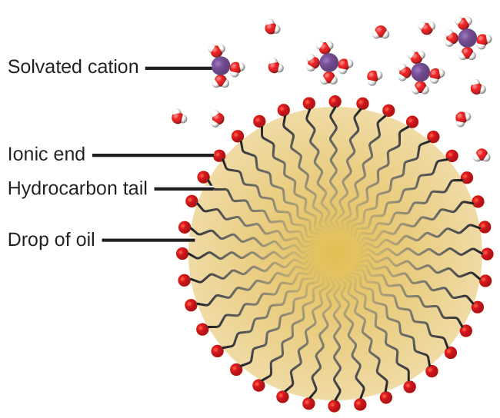
Figure 11.33 This diagrammatic cross section of an emulsified drop of oil in water shows how soap or detergent acts as an emulsifier.

Chemistry in Everyday Life

Deepwater Horizon Oil Spill
The blowout of the Deepwater Horizon oil drilling rig on April 20, 2010, in the Gulf of Mexico near Mississippi began the largest marine oil spill in the history of the petroleum industry. In the 87 days following the blowout, an estimated 4.9 million barrels (210 million gallons) of oil flowed from the ruptured well 5000 feet below the water’s surface. The well was finally declared sealed on September 19, 2010.
Crude oil is immiscible with and less dense than water, so the spilled oil rose to the surface of the water. Floating booms, skimmer ships, and controlled burns were used to remove oil from the water’s surface in an attempt to protect beaches and wetlands along the Gulf coast. In addition to removal of the oil, attempts were also made to lessen its environmental impact by rendering it “soluble” (in the loose sense of the term) and thus allowing it to be diluted to hopefully less harmful levels by the vast volume of ocean water. This approach used 1.84 million gallons of the oil dispersant Corexit 9527, most of which was injected underwater at the site of the leak, with small amounts being sprayed on top of the spill. Corexit 9527 contains 2-butoxyethanol (C₆H₁₄O₂), an amphiphilic molecule whose polar and nonpolar ends are useful for emulsifying oil into small droplets, increasing the surface area of the oil and making it more available to marine bacteria for digestion (Figure 11.34). While this approach avoids many of the immediate hazards that bulk oil poses to marine and coastal ecosystems, it introduces the possibility of long-term effects resulting from the introduction of the complex and potential toxic components of petroleum into the ocean’s food chain. A number of organizations are involved in monitoring the extended impact of this oil spill, including the National Oceanic and Atmospheric Administration (visit this website for additional details).
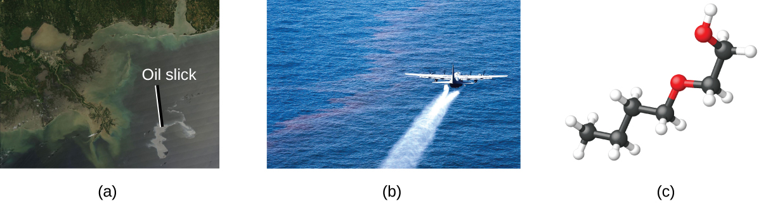
Figure 11.34 (a) This NASA satellite image shows the oil slick from the Deepwater Horizon spill. (b) A US Air Force plane sprays Corexit, a dispersant. (c) The molecular structure of 2-butoxyethanol is shown. (credit a: modification of work by “NASA, FT2, demis.nl”/Wikimedia Commons; credit b: modification of work by “NASA/MODIS Rapid Response Team”/Wikimedia Commons)

Electrical Properties of Colloidal Particles
Dispersed colloidal particles are often electrically charged. A colloidal particle of iron(III) hydroxide, for example, does not contain enough hydroxide ions to compensate exactly for the positive charges on the iron(III) ions. Thus, each individual colloidal particle bears a positive charge, and the colloidal dispersion consists of charged colloidal particles and some free hydroxide ions, which keep the dispersion electrically neutral. Most metal hydroxide colloids have positive charges, whereas most metals and metal sulfides form negatively charged dispersions. All colloidal particles in any one system have charges of the same sign. This helps keep them dispersed because particles containing like charges repel each other.
The charged nature of some colloidal particles may be exploited to remove them from a variety of mixtures. For example, the particles comprising smoke are often colloidally dispersed and electrically charged. Frederick Cottrell, an American chemist, developed a process to remove these particles. The charged particles are attracted to highly charged electrodes, where they are neutralized and deposited as dust (Figure 11.36). This is one of the important methods used to clean up the smoke from a variety of industrial processes. The process is also important in the recovery of valuable products from the smoke and flue dust of smelters, furnaces, and kilns. There are also similar electrostatic air filters designed for home use to improve indoor air quality.

Portrait of a Chemist

Frederick Gardner Cottrell
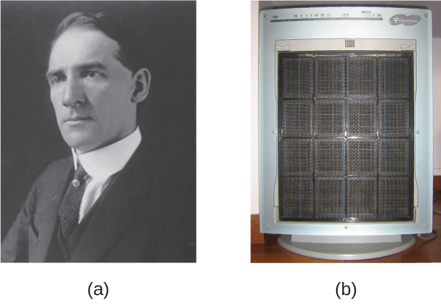
Figure 11.35 (a) Frederick Cottrell developed (b) the electrostatic precipitator, a device designed to curb air pollution by removing colloidal particles from air. (credit b: modification of work by “SpLot”/Wikimedia Commons)
Born in Oakland, CA, in 1877, Frederick Cottrell devoured textbooks as if they were novels and graduated from high school at the age of 16. He then entered the University of California (UC), Berkeley, completing a Bachelor’s degree in three years. He saved money from his $1200 annual salary as a chemistry teacher at Oakland High School to fund his studies in chemistry in Berlin with Nobel prize winner Jacobus Henricus van’t Hoff, and in Leipzig with Wilhelm Ostwald, another Nobel awardee. After earning his PhD in physical chemistry, he returned to the United States to teach at UC Berkeley. He also consulted for the DuPont Company, where he developed the electrostatic precipitator, a device designed to curb air pollution by removing colloidal particles from air. Cottrell used the proceeds from his invention to fund a nonprofit research corporation to finance scientific research.
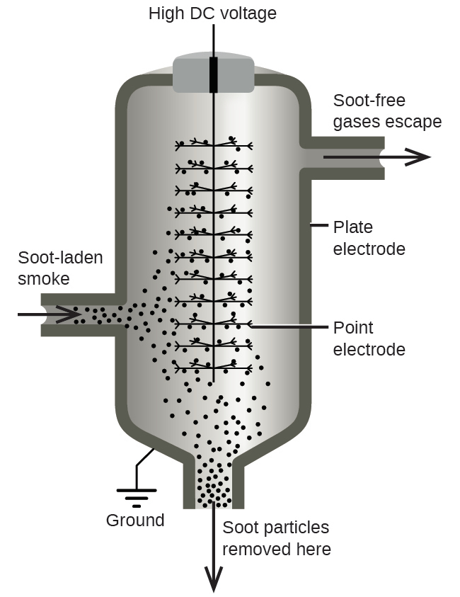
Figure 11.36 In a Cottrell precipitator, positively and negatively charged particles are attracted to highly charged electrodes, where they are neutralized and deposited as dust.

Gels
Gelatin desserts, such as Jell-O, are a type of colloid (Figure 11.37). Gelatin sets on cooling because the hot aqueous mixture of gelatin coagulates as it cools, yielding an extremely viscous body known as a gel. A gel is a colloidal dispersion of a liquid phase throughout a solid phase. It appears that the fibers of the dispersing medium form a complex three-dimensional network, the interstices being filled with the liquid medium or a dilute solution of the dispersing medium.
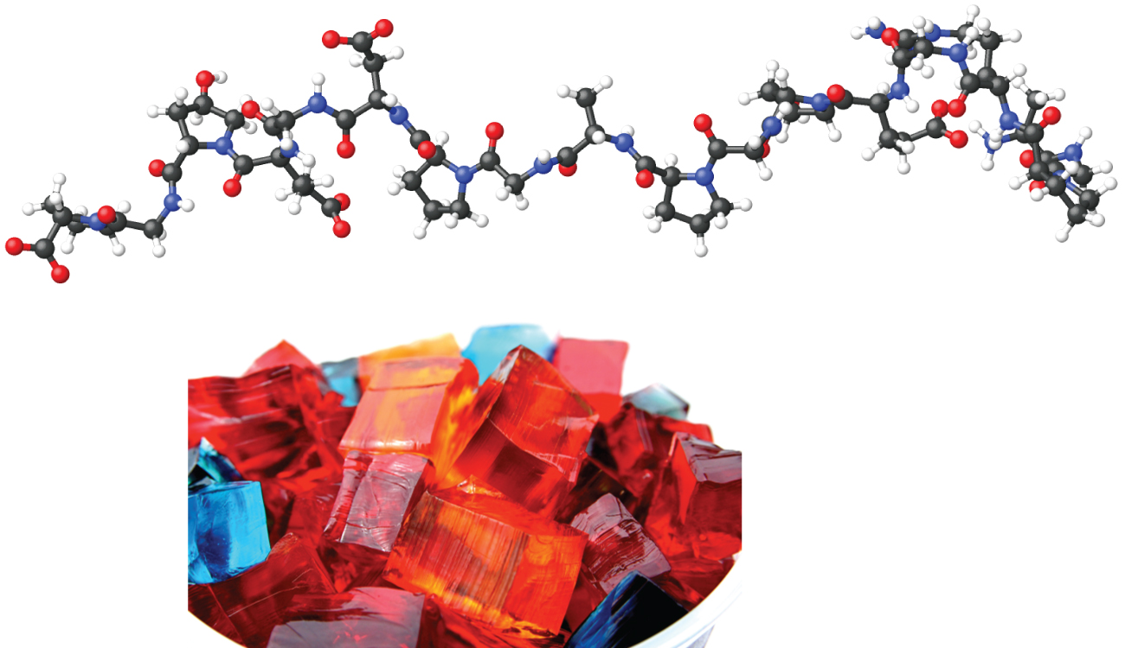
Figure 11.37 Gelatin desserts are colloids in which an aqueous solution of sweeteners and flavors is dispersed throughout a medium of solid proteins. (credit photo: modification of work by Steven Depolo)
Pectin, a carbohydrate from fruit juices, is a gel-forming substance important in jelly making. Silica gel, a colloidal dispersion of hydrated silicon dioxide, is formed when dilute hydrochloric acid is added to a dilute solution of sodium silicate. Canned Heat is a flammable gel made by mixing alcohol and a saturated aqueous solution of calcium acetate.

