12.2 Factors Affecting Reaction Rates

Learning Objectives
By the end of this section, you will be able to:
- Describe the effects of chemical nature, physical state, temperature, concentration, and catalysis on reaction rates
The rates at which reactants are consumed and products are formed during chemical reactions vary greatly. Five factors typically affecting the rates of chemical reactions will be explored in this section: the chemical nature of the reacting substances, the state of subdivision (one large lump versus many small particles) of the reactants, the temperature of the reactants, the concentration of the reactants, and the presence of a catalyst.

The Chemical Nature of the Reacting Substances
The rate of a reaction depends on the nature of the participating substances. Reactions that appear similar may have different rates under the same conditions, depending on the identity of the reactants. For example, when small pieces of the metals iron and sodium are exposed to air, the sodium reacts completely with air overnight, whereas the iron is barely affected. The active metals calcium and sodium both react with water to form hydrogen gas and a base. Yet calcium reacts at a moderate rate, whereas sodium reacts so rapidly that the reaction is almost explosive.

The Physical States of the Reactants
A chemical reaction between two or more substances requires intimate contact between the reactants. When reactants are in different physical states, or phases (solid, liquid, gaseous, dissolved), the reaction takes place only at the interface between the phases. Consider the heterogeneous reaction between a solid phase and either a liquid or gaseous phase. Compared with the reaction rate for large solid particles, the rate for smaller particles will be greater because the surface area in contact with the other reactant phase is greater. For example, large pieces of iron react more slowly with acids than they do with finely divided iron powder (Figure 12.6). Large pieces of wood smolder, smaller pieces burn rapidly, and saw dust burns explosively.
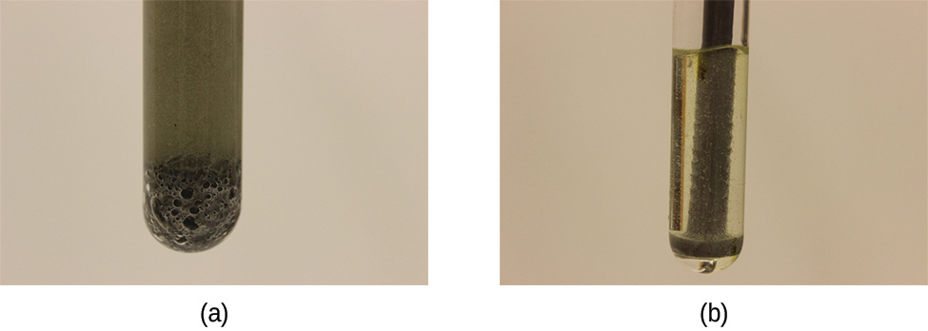
Figure 12.6 (a) Iron powder reacts rapidly with dilute hydrochloric acid and produces bubbles of hydrogen gas: Fe(s) + HCl(aq) $→$ 2FeCl₂(aq) + 3H₂(g). (b) An iron nail reacts more slowly because the surface area exposed to the acid is much less.

Link to Learning
Watch this video to see the reaction of cesium with water in slow motion and a discussion of how the state of reactants and particle size affect reaction rates.

Temperature of the Reactants
Chemical reactions typically occur faster at higher temperatures. Food can spoil quickly when left on the kitchen counter. However, the lower temperature inside of a refrigerator slows that process so that the same food remains fresh for days. Gas burners, hot plates, and ovens are often used in the laboratory to increase the speed of reactions that proceed slowly at ordinary temperatures. For many chemical processes, reaction rates are approximately doubled when the temperature is raised by 10 °C.

Concentrations of the Reactants
The rates of many reactions depend on the concentrations of the reactants. Rates usually increase when the concentration of one or more of the reactants increases. For example, calcium carbonate (CaCO₃) deteriorates as a result of its reaction with the pollutant sulfur dioxide. The rate of this reaction depends on the amount of sulfur dioxide in the air (Figure 12.7). An acidic oxide, sulfur dioxide combines with water vapor in the air to produce sulfurous acid in the following reaction:
${\text{SO}}_{\text{2}}\left(g\right)+{\text{H}}_{2}\text{O(}g) → {\text{H}}_{2}{\text{SO}}_{\text{3}}\left(aq\right)$
Calcium carbonate reacts with sulfurous acid as follows:
${\text{CaCO}}_{\text{3}}\left(s\right)+{\text{H}}_{2}{\text{SO}}_{\text{3}}\left(aq\right) → {\text{CaSO}}_{\text{3}}\left(aq\right)+{\text{CO}}_{\text{2}}\left(g\right)+{\text{H}}_{2}\text{O(}l)$
In a polluted atmosphere where the concentration of sulfur dioxide is high, calcium carbonate deteriorates more rapidly than in less polluted air. Similarly, phosphorus burns much more rapidly in an atmosphere of pure oxygen than in air, which is only about 20% oxygen.
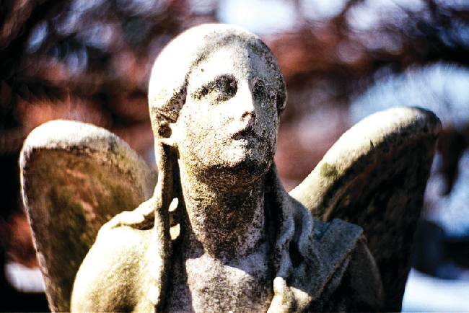
Figure 12.7 Statues made from carbonate compounds such as limestone and marble typically weather slowly over time due to the actions of water, and thermal expansion and contraction. However, pollutants like sulfur dioxide can accelerate weathering. As the concentration of air pollutants increases, deterioration of limestone occurs more rapidly. (credit: James P Fisher III)

Link to Learning
Phosphorus burns rapidly in air, but it will burn even more rapidly if the concentration of oxygen is higher. Watch this video to see an example.

The Presence of a Catalyst
Relatively dilute aqueous solutions of hydrogen peroxide, H₂O₂, are commonly used as topical antiseptics. Hydrogen peroxide decomposes to yield water and oxygen gas according to the equation:
$2{\text{H}}_{2}{\text{O}}_{2}\left(\text{aq}\right) → 2{\text{H}}_{2}\text{O}\left(l\right)+{\text{O}}_{2}\left(\text{g}\right)$
Under typical conditions, this decomposition occurs very slowly. When dilute H₂O₂(aq) is poured onto an open wound, however, the reaction occurs rapidly and the solution foams because of the vigorous production of oxygen gas. This dramatic difference is caused by the presence of substances within the wound’s exposed tissues that accelerate the decomposition process. Substances that function to increase the rate of a reaction are called catalysts, a topic treated in greater detail later in this chapter.

Link to Learning
Chemical reactions occur when molecules collide with each other and undergo a chemical transformation. Before physically performing a reaction in a laboratory, scientists can use molecular modeling simulations to predict how the parameters discussed earlier will influence the rate of a reaction. Use the PhET Reactions & Rates interactive to explore how temperature, concentration, and the nature of the reactants affect reaction rates.

