15.2 Lewis Acids and Bases

Learning Objectives
By the end of this section, you will be able to:
- Explain the Lewis model of acid-base chemistry
- Write equations for the formation of adducts and complex ions
- Perform equilibrium calculations involving formation constants
In 1923, G. N. Lewis proposed a generalized definition of acid-base behavior in which acids and bases are identified by their ability to accept or to donate a pair of electrons and form a coordinate covalent bond.
A coordinate covalent bond (or dative bond) occurs when one of the atoms in the bond provides both bonding electrons. For example, a coordinate covalent bond occurs when a water molecule combines with a hydrogen ion to form a hydronium ion. A coordinate covalent bond also results when an ammonia molecule combines with a hydrogen ion to form an ammonium ion. Both of these equations are shown here.
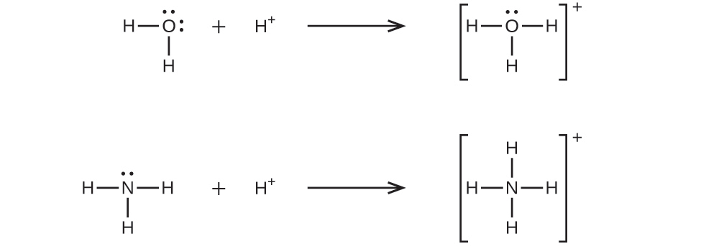
Reactions involving the formation of coordinate covalent bonds are classified as Lewis acid-base chemistry. The species donating the electron pair that compose the bond is a Lewis base, the species accepting the electron pair is a Lewis acid, and the product of the reaction is a Lewis acid-base adduct. As the two examples above illustrate, Brønsted-Lowry acid-base reactions represent a subcategory of Lewis acid reactions, specifically, those in which the acid species is H⁺. A few examples involving other Lewis acids and bases are described below.
The boron atom in boron trifluoride, BF₃, has only six electrons in its valence shell. Being short of the preferred octet, BF₃ is a very good Lewis acid and reacts with many Lewis bases; a fluoride ion is the Lewis base in this reaction, donating one of its lone pairs:
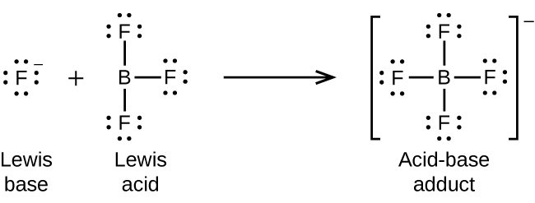
In the following reaction, each of two ammonia molecules, Lewis bases, donates a pair of electrons to a silver ion, the Lewis acid:
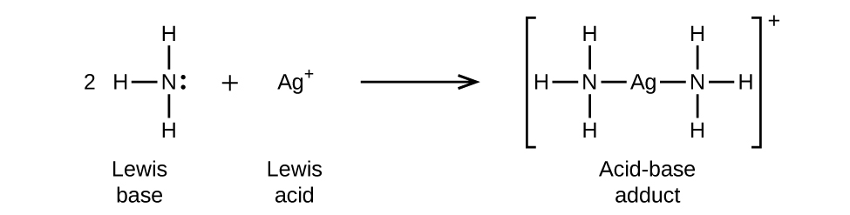
Nonmetal oxides act as Lewis acids and react with oxide ions, Lewis bases, to form oxyanions:
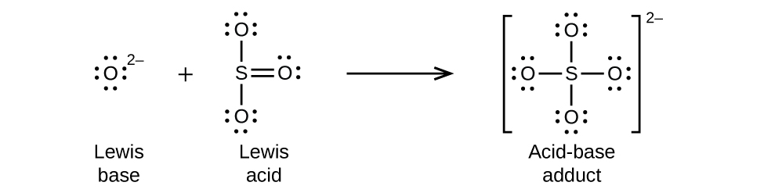
Many Lewis acid-base reactions are displacement reactions in which one Lewis base displaces another Lewis base from an acid-base adduct, or in which one Lewis acid displaces another Lewis acid:
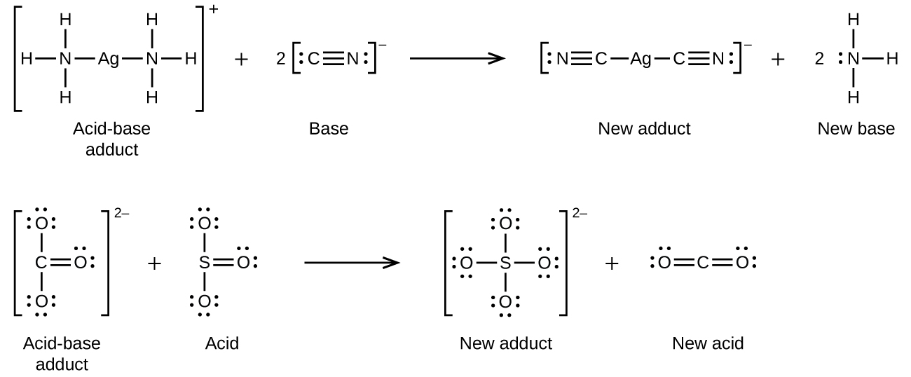
Another type of Lewis acid-base chemistry involves the formation of a complex ion (or a coordination complex) comprising a central atom, typically a transition metal cation, surrounded by ions or molecules called ligands. These ligands can be neutral molecules like H₂O or NH₃, or ions such as CN– or OH–. Often, the ligands act as Lewis bases, donating a pair of electrons to the central atom. These types of Lewis acid-base reactions are examples of a broad subdiscipline called coordination chemistry—the topic of another chapter in this text.
The equilibrium constant for the reaction of a metal ion with one or more ligands to form a coordination complex is called a formation constant (K_{f}) (sometimes called a stability constant). For example, the complex ion $\text{Cu}{\left(\text{CN}\right)}_{2}​^{\text{−}}$
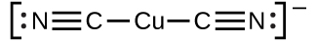
is produced by the reaction
${\text{Cu}}^{\text{+}}\left(aq\right)+2{\text{CN}}^{\text{−}}\left(aq\right)⇌\text{Cu}{\left(\text{CN}\right)}_{2}​^{\text{−}}\left(aq\right)$
The formation constant for this reaction is
$K_{\text{f}}=\frac{[\text{Cu}{\left(\text{CN}\right)}_{2}​^{\text{−}}]}{[{\text{Cu}}^{+}]{[{\text{CN}}^{\text{−}}]}^{2}}$
Alternatively, the reverse reaction (decomposition of the complex ion) can be considered, in which case the equilibrium constant is a dissociation constant (K_{d}). Per the relation between equilibrium constants for reciprocal reactions described, the dissociation constant is the mathematical inverse of the formation constant, K_{d} = K_{f}^{–1}. A tabulation of formation constants is provided in Appendix K.
As an example of dissolution by complex ion formation, let us consider what happens when we add aqueous ammonia to a mixture of silver chloride and water. Silver chloride dissolves slightly in water, giving a small concentration of Ag⁺ ([Ag⁺] = 1.3 $×$ 10^{–5} M):
$\text{AgCl}\left(s\right)⇌{\text{Ag}}^{\text{+}}\left(aq\right)+{\text{Cl}}^{\text{−}}\left(aq\right)$
However, if NH₃ is present in the water, the complex ion, $\text{Ag}{\left({\text{NH}}_{3}\right)}_{2}​^{+},$ can form according to the equation:
${\text{Ag}}^{\text{+}}\left(aq\right)+2{\text{NH}}_{3}\left(aq\right)⇌\text{Ag}{\left({\text{NH}}_{3}\right)}_{2}​^{\text{+}}\left(aq\right)$
with
$K_{\text{f}}=\frac{[\text{Ag}{\left({\text{NH}}_{3}\right)}_{2}​^{+}]}{[{\text{Ag}}^{+}]{[{\text{NH}}_{3}]}^{2}} =1.7 × {10}^{7}$
The large size of this formation constant indicates that most of the free silver ions produced by the dissolution of AgCl combine with NH ₃ to form $\text{Ag}{\left({\text{NH}}_{3}\right)}_{2}​^{+}.$ As a consequence, the concentration of silver ions, [Ag ⁺ ], is reduced, and the reaction quotient for the dissolution of silver chloride, [Ag ⁺ ][Cl – ], falls below the solubility product of AgCl:
$Q = [{\text{Ag}}^{+}]\left[{\text{Cl}}^{\text{−}}\right] < K_{\text{sp}}$
More silver chloride then dissolves. If the concentration of ammonia is great enough, all of the silver chloride dissolves.

Example 15.14

Dissociation of a Complex Ion
Calculate the concentration of the silver ion in a solution that initially is 0.10 M with respect to $\text{Ag}{\left({\text{NH}}_{3}\right)}_{2}​^{+}.$

Solution
Applying the standard ICE approach to this reaction yields the following: 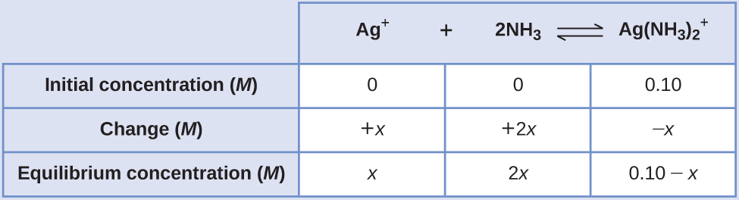
Substituting these equilibrium concentration terms into the K_{f} expression gives
$K_{\text{f}}=\frac{[\text{Ag}{\left({\text{NH}}_{3}\right)}_{2}​^{+}]}{[{\text{Ag}}^{+}]{[{\text{NH}}_{3}]}^{2}}$
$1.7 × {10}^{7} \text{=} \frac{0.10−x}{\left(x\right){\left(2x\right)}^{2}}$
The very large equilibrium constant means the amount of the complex ion that will dissociate, x, will be very small. Assuming x << 0.1 permits simplifying the above equation:
$1.7 × {10}^{7}=\frac{0.10}{\left(x\right){\left(2x\right)}^{2}}$
$x^{3}=\frac{0.10}{4\left(1.7 × {10}^{7}\right)} =1.5 × {10}^{−9}$
$x = \sqrt[3]{1.5 × {10}^{−9}} = 1.1 × {10}^{−3}$
Because only 1.1% of the $\text{Ag}{\left({\text{NH}}_{3}\right)}_{2}​^{+}$ dissociates into Ag⁺ and NH₃, the assumption that x is small is justified.
Using this value of x and the relations in the above ICE table allows calculation of all species’ equilibrium concentrations:
$[{\text{Ag}}^{+}] = 0+x=1.1 × {10}^{−3} M$
$[{\text{NH}}_{3}]=0+2x=2.2 × {10}^{−3} M$
$[\text{Ag}{\left({\text{NH}}_{3}\right)}_{2}​^{+}]=0.10−x=0.10−0.0011=0.099$
The concentration of free silver ion in the solution is 0.0011 M.

Check Your Learning
Calculate the silver ion concentration, [Ag⁺], of a solution prepared by dissolving 1.00 g of AgNO₃ and 10.0 g of KCN in sufficient water to make 1.00 L of solution. (Hint: Because K_{f} is very large, the silver/cyanide complex ion (see Appendix K), assume the reaction goes to completion and then calculate the [Ag⁺] produced by dissociation of the complex.)

Answer:
2.9 $×$ 10^{–22} M

