18.10 Occurrence, Preparation, and Properties of Sulfur

Learning Objectives
By the end of this section, you will be able to:
- Describe the properties, preparation, and uses of sulfur
Sulfur exists in nature as elemental deposits as well as sulfides of iron, zinc, lead, and copper, and sulfates of sodium, calcium, barium, and magnesium. Hydrogen sulfide is often a component of natural gas and occurs in many volcanic gases, like those shown in Figure 18.58. Sulfur is a constituent of many proteins and is essential for life.
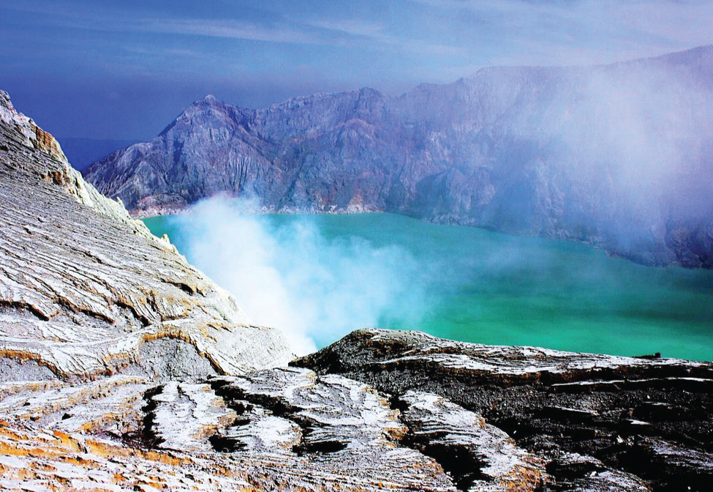
Figure 18.58 Volcanic gases contain hydrogen sulfide. (credit: Daniel Julie/Wikimedia Commons)
The Frasch process, illustrated in Figure 18.59, is important in the mining of free sulfur from enormous underground deposits in Texas and Louisiana. Superheated water (170 °C and 10 atm pressure) is forced down the outermost of three concentric pipes to the underground deposit. The hot water melts the sulfur. The innermost pipe conducts compressed air into the liquid sulfur. The air forces the liquid sulfur, mixed with air, to flow up through the outlet pipe. Transferring the mixture to large settling vats allows the solid sulfur to separate upon cooling. This sulfur is 99.5% to 99.9% pure and requires no purification for most uses.
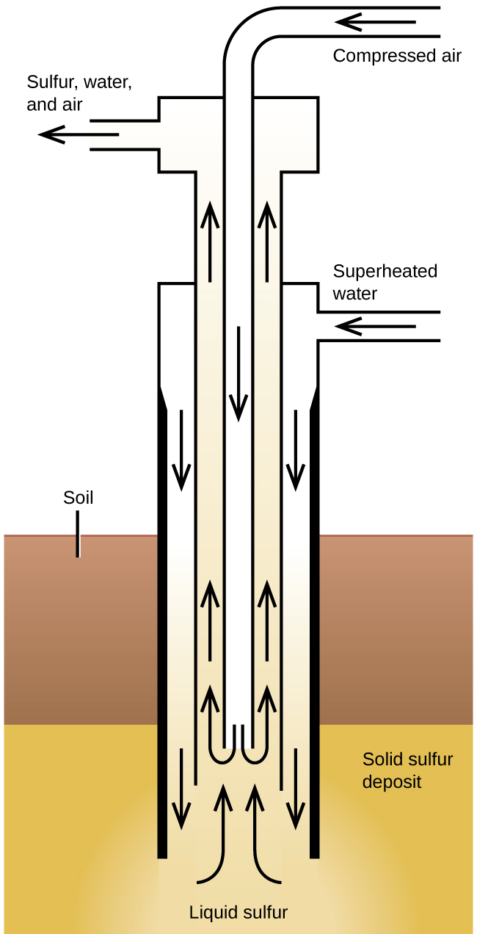
Figure 18.59 The Frasch process is used to mine sulfur from underground deposits.
Larger amounts of sulfur also come from hydrogen sulfide recovered during the purification of natural gas.
Sulfur exists in several allotropic forms. The stable form at room temperature contains eight-membered rings, and so the true formula is S₈. However, chemists commonly use S to simplify the coefficients in chemical equations; we will follow this practice in this book.
Like oxygen, which is also a member of group 16, sulfur exhibits a distinctly nonmetallic behavior. It oxidizes metals, giving a variety of binary sulfides in which sulfur exhibits a negative oxidation state (2−). Elemental sulfur oxidizes less electronegative nonmetals, and more electronegative nonmetals, such as oxygen and the halogens, will oxidize it. Other strong oxidizing agents also oxidize sulfur. For example, concentrated nitric acid oxidizes sulfur to the sulfate ion, with the concurrent formation of nitrogen(IV) oxide:
$\text{S}\left(s\right)+6{\text{HNO}}_{3}\left(aq\right) → 2{\text{H}}_{3}{\text{O}}^{\text{+}}\left(aq\right)+{\text{SO}}_{4} ^{2−}\left(aq\right)+6{\text{NO}}_{2}\left(g\right)$
The chemistry of sulfur with an oxidation state of 2− is similar to that of oxygen. Unlike oxygen, however, sulfur forms many compounds in which it exhibits positive oxidation states.

