18.7 Occurrence, Preparation, and Properties of Nitrogen

Learning Objectives
By the end of this section, you will be able to:
- Describe the properties, preparation, and uses of nitrogen
Most pure nitrogen comes from the fractional distillation of liquid air. The atmosphere consists of 78% nitrogen by volume. This means there are more than 20 million tons of nitrogen over every square mile of the earth’s surface. Nitrogen is a component of proteins and of the genetic material (DNA/RNA) of all plants and animals.
Under ordinary conditions, nitrogen is a colorless, odorless, and tasteless gas. It boils at 77 K and freezes at 63 K. Liquid nitrogen is a useful coolant because it is inexpensive and has a low boiling point. Nitrogen is very unreactive because of the very strong triple bond between the nitrogen atoms. The only common reactions at room temperature occur with lithium to form Li₃N, with certain transition metal complexes, and with hydrogen or oxygen in nitrogen-fixing bacteria. The general lack of reactivity of nitrogen makes the remarkable ability of some bacteria to synthesize nitrogen compounds using atmospheric nitrogen gas as the source one of the most exciting chemical events on our planet. This process is one type of nitrogen fixation. In this case, nitrogen fixation is the process where organisms convert atmospheric nitrogen into biologically useful chemicals. Nitrogen fixation also occurs when lightning passes through air, causing molecular nitrogen to react with oxygen to form nitrogen oxides, which are then carried down to the soil.

Chemistry in Everyday Life

Nitrogen Fixation
All living organisms require nitrogen compounds for survival. Unfortunately, most of these organisms cannot absorb nitrogen from its most abundant source—the atmosphere. Atmospheric nitrogen consists of N₂ molecules, which are very unreactive due to the strong nitrogen-nitrogen triple bond. However, a few organisms can overcome this problem through a process known as nitrogen fixation, illustrated in Figure 18.32.
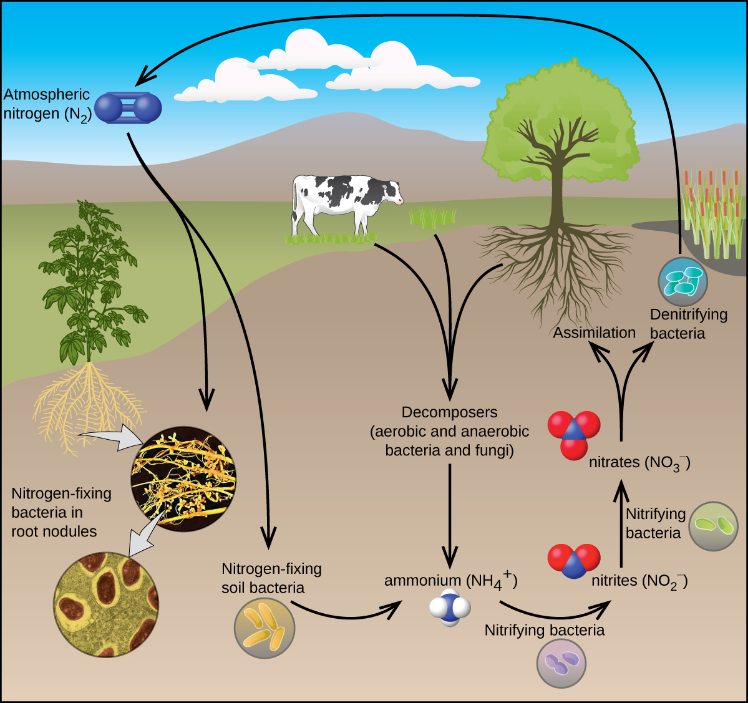
Figure 18.32 All living organisms require nitrogen. A few microorganisms are able to process atmospheric nitrogen using nitrogen fixation. (credit “roots”: modification of work by the United States Department of Agriculture; credit “root nodules”: modification of work by Louisa Howard)
Nitrogen fixation is the process where organisms convert atmospheric nitrogen into biologically useful chemicals. To date, the only known kind of biological organisms capable of nitrogen fixation are microorganisms. These organisms employ enzymes called nitrogenases, which contain iron and molybdenum. Many of these microorganisms live in a symbiotic relationship with plants, with the best-known example being the presence of rhizobia in the root nodules of legumes.
Large volumes of atmospheric nitrogen are necessary for making ammonia—the principal starting material used for preparation of large quantities of other nitrogen-containing compounds. Most other uses for elemental nitrogen depend on its inactivity. It is helpful when a chemical process requires an inert atmosphere. Canned foods and luncheon meats cannot oxidize in a pure nitrogen atmosphere, so they retain a better flavor and color, and spoil less rapidly, when sealed in nitrogen instead of air. This technology allows fresh produce to be available year-round, regardless of growing season.
There are compounds with nitrogen in all of its oxidation states from 3− to 5+. Much of the chemistry of nitrogen involves oxidation-reduction reactions. Some active metals (such as alkali metals and alkaline earth metals) can reduce nitrogen to form metal nitrides. In the remainder of this section, we will examine nitrogen-oxygen chemistry.
There are well-characterized nitrogen oxides in which nitrogen exhibits each of its positive oxidation numbers from 1+ to 5+. When ammonium nitrate is carefully heated, nitrous oxide (dinitrogen oxide) and water vapor form. Stronger heating generates nitrogen gas, oxygen gas, and water vapor. No one should ever attempt this reaction—it can be very explosive. In 1947, there was a major ammonium nitrate explosion in Texas City, Texas, and, in 2013, there was another major explosion in West, Texas. In the last 100 years, there were nearly 30 similar disasters worldwide, resulting in the loss of numerous lives. In this oxidation-reduction reaction, the nitrogen in the nitrate ion oxidizes the nitrogen in the ammonium ion. Nitrous oxide, shown in Figure 18.33, is a colorless gas possessing a mild, pleasing odor and a sweet taste. It finds application as an anesthetic for minor operations, especially in dentistry, under the name “laughing gas.”
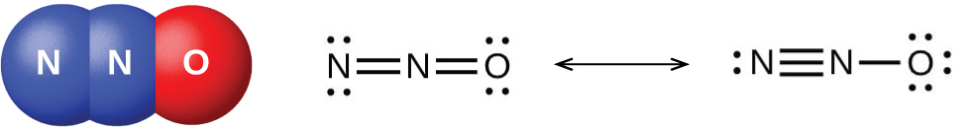
Figure 18.33 Nitrous oxide, N₂O, is an anesthetic that has these molecular (left) and resonance (right) structures.
Low yields of nitric oxide, NO, form when heating nitrogen and oxygen together. NO also forms when lightning passes through air during thunderstorms. Burning ammonia is the commercial method of preparing nitric oxide. In the laboratory, the reduction of nitric acid is the best method for preparing nitric oxide. When copper reacts with dilute nitric acid, nitric oxide is the principal reduction product:
$\text{3Cu}\left(s\right)+{\text{8HNO}}_{3}\left(aq\right) → \text{2NO}\left(g\right)+\text{3Cu}{\left({\text{NO}}_{3}\right)}_{2}\left(aq\right)+{\text{4H}}_{2}\text{O}\left(l\right)$
Gaseous nitric oxide is the most thermally stable of the nitrogen oxides and is the simplest known thermally stable molecule with an unpaired electron. It is one of the air pollutants generated by internal combustion engines, resulting from the reaction of atmospheric nitrogen and oxygen during the combustion process.
At room temperature, nitric oxide is a colorless gas consisting of diatomic molecules. As is often the case with molecules that contain an unpaired electron, two molecules combine to form a dimer by pairing their unpaired electrons to form a bond. Liquid and solid NO both contain N₂O₂ dimers, like that shown in Figure 18.34. Most substances with unpaired electrons exhibit color by absorbing visible light; however, NO is colorless because the absorption of light is not in the visible region of the spectrum.
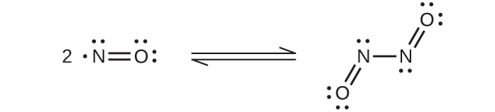
Figure 18.34 This shows the equilibrium between NO and N₂O₂. The molecule, N₂O₂, absorbs light.
Cooling a mixture of equal parts nitric oxide and nitrogen dioxide to −21 °C produces dinitrogen trioxide, a blue liquid consisting of N₂O₃ molecules (shown in Figure 18.35). Dinitrogen trioxide exists only in the liquid and solid states. When heated, it reverts to a mixture of NO and NO₂.
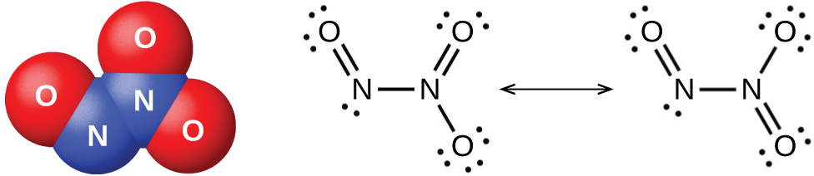
Figure 18.35 Dinitrogen trioxide, N₂O₃, only exists in liquid or solid states and has these molecular (left) and resonance (right) structures.
It is possible to prepare nitrogen dioxide in the laboratory by heating the nitrate of a heavy metal, or by the reduction of concentrated nitric acid with copper metal, as shown in Figure 18.36. Commercially, it is possible to prepare nitrogen dioxide by oxidizing nitric oxide with air.
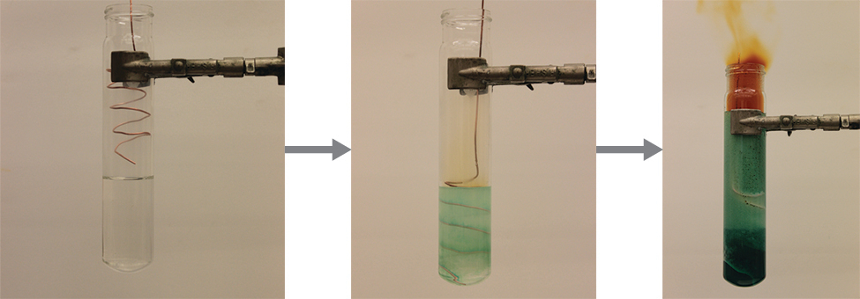
Figure 18.36 The reaction of copper metal with concentrated HNO₃ produces a solution of Cu(NO₃)₂ and brown fumes of NO₂. (credit: modification of work by Mark Ott)
The nitrogen dioxide molecule (illustrated in Figure 18.37) contains an unpaired electron, which is responsible for its color and paramagnetism. It is also responsible for the dimerization of NO₂. At low pressures or at high temperatures, nitrogen dioxide has a deep brown color that is due to the presence of the NO₂ molecule. At low temperatures, the color almost entirely disappears as dinitrogen tetraoxide, N₂O₄, forms. At room temperature, an equilibrium exists:
${\text{2NO}}_{2}\left(g\right) ⇌ {\text{N}}_{2}{\text{O}}_{4}\left(g\right) K_{P}=6.86$
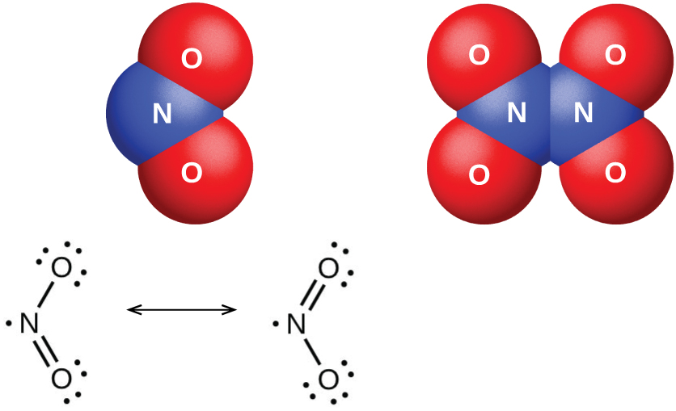
Figure 18.37 The molecular and resonance structures for nitrogen dioxide (NO₂, left) and dinitrogen tetraoxide (N₂O₄, right) are shown.
Dinitrogen pentaoxide, N₂O₅ (illustrated in Figure 18.38), is a white solid that is formed by the dehydration of nitric acid by phosphorus(V) oxide (tetraphosphorus decoxide):
${\text{P}}_{4}{\text{O}}_{10}\left(s\right)+{\text{4HNO}}_{3}\left(l\right) → {\text{4HPO}}_{3}\left(s\right)+{\text{2N}}_{2}{\text{O}}_{5}\left(s\right)$
It is unstable above room temperature, decomposing to N₂O₄ and O₂.
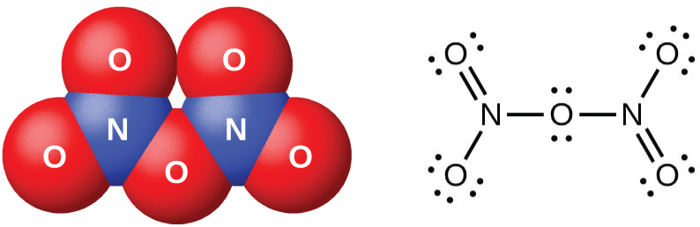
Figure 18.38 This image shows the molecular structure and one resonance structure of a molecule of dinitrogen pentaoxide, N₂O_{5.}
The oxides of nitrogen(III), nitrogen(IV), and nitrogen(V) react with water and form nitrogen-containing oxyacids. Nitrogen(III) oxide, N₂O₃, is the anhydride of nitrous acid; HNO₂ forms when N₂O₃ reacts with water. There are no stable oxyacids containing nitrogen with an oxidation state of 4+; therefore, nitrogen(IV) oxide, NO₂, disproportionates in one of two ways when it reacts with water. In cold water, a mixture of HNO₂ and HNO₃ forms. At higher temperatures, HNO₃ and NO will form. Nitrogen(V) oxide, N₂O₅, is the anhydride of nitric acid; HNO₃ is produced when N₂O₅ reacts with water:
${\text{N}}_{2}{\text{O}}_{5}\left(s\right)+{\text{H}}_{2}\text{O}\left(l\right) → {\text{2HNO}}_{3}\left(aq\right)$
The nitrogen oxides exhibit extensive oxidation-reduction behavior. Nitrous oxide resembles oxygen in its behavior when heated with combustible substances. N₂O is a strong oxidizing agent that decomposes when heated to form nitrogen and oxygen. Because one-third of the gas liberated is oxygen, nitrous oxide supports combustion better than air (one-fifth oxygen). A glowing splinter bursts into flame when thrust into a bottle of this gas. Nitric oxide acts both as an oxidizing agent and as a reducing agent. For example:
$\text{oxidizing agent:} {\text{P}}_{4}\left(s\right)+\text{6NO}\left(g\right) → {\text{P}}_{4}{\text{O}}_{6}\left(s\right)+{\text{3N}}_{2}\left(g\right)$
$\text{reducing agent:} {\text{Cl}}_{2}\left(g\right)+\text{2NO}\left(g\right) → \text{2ClNO}\left(g\right)$
Nitrogen dioxide (or dinitrogen tetraoxide) is a good oxidizing agent. For example:
${\text{NO}}_{2}\left(g\right)+\text{CO}\left(g\right) → \text{NO}\left(g\right)+{\text{CO}}_{2}\left(g\right)$
${\text{NO}}_{2}\left(g\right)+\text{2HCl}\left(aq\right) → \text{NO}\left(g\right)+{\text{Cl}}_{2}\left(g\right)+{\text{H}}_{2}\text{O}\left(l\right)$

