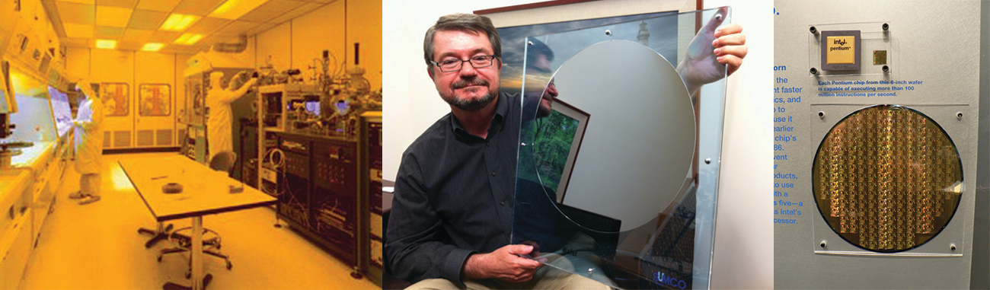
Figure 18.1 Purity is extremely important when preparing silicon wafers. Technicians in a cleanroom prepare silicon without impurities (left). The CEO of VLSI Research, Don Hutcheson, shows off a pure silicon wafer (center). A silicon wafer covered in Pentium chips is an enlarged version of the silicon wafers found in many electronics used today (right). (credit middle: modification of work by “Intel Free Press”/Flickr; credit right: modification of work by Naotake Murayama)

Chapter Outline
18.1 Periodicity
18.2 Occurrence and Preparation of the Representative Metals
18.3 Structure and General Properties of the Metalloids
18.4 Structure and General Properties of the Nonmetals
18.5 Occurrence, Preparation, and Compounds of Hydrogen
18.6 Occurrence, Preparation, and Properties of Carbonates
18.7 Occurrence, Preparation, and Properties of Nitrogen
18.8 Occurrence, Preparation, and Properties of Phosphorus
18.9 Occurrence, Preparation, and Compounds of Oxygen
18.10 Occurrence, Preparation, and Properties of Sulfur
18.11 Occurrence, Preparation, and Properties of Halogens
18.12 Occurrence, Preparation, and Properties of the Noble Gases

Introduction
The development of the periodic table in the mid-1800s came from observations that there was a periodic relationship between the properties of the elements. Chemists, who have an understanding of the variations of these properties, have been able to use this knowledge to solve a wide variety of technical challenges. For example, silicon and other semiconductors form the backbone of modern electronics because of our ability to fine-tune the electrical properties of these materials. This chapter explores important properties of representative metals, metalloids, and nonmetals in the periodic table.

