21.5 Uses of Radioisotopes

Learning Objectives
By the end of this section, you will be able to:
- List common applications of radioactive isotopes
Radioactive isotopes have the same chemical properties as stable isotopes of the same element, but they emit radiation, which can be detected. If we replace one (or more) atom(s) with radioisotope(s) in a compound, we can track them by monitoring their radioactive emissions. This type of compound is called a radioactive tracer (or radioactive label). Radioisotopes are used to follow the paths of biochemical reactions or to determine how a substance is distributed within an organism. Radioactive tracers are also used in many medical applications, including both diagnosis and treatment. They are used to measure engine wear, analyze the geological formation around oil wells, and much more.
Radioimmunossays (RIA), for example, rely on radioisotopes to detect the presence and/or concentration of certain antigens. Developed by Rosalyn Sussman Yalow and Solomon Berson in the 1950s, the technique is known for extreme sensitivity, meaning that it can detect and measure very small quantities of a substance. Prior to its discovery, most similar detection relied on large enough quantities to produce visible outcomes. RIA revolutionized and expanded entire fields of study, most notably endocrinology, and is commonly used in narcotics detection, blood bank screening, early cancer screening, hormone measurement, and allergy diagnosis. Based on her significant contribution to medicine, Yalow received a Nobel Prize, making her the second woman to be awarded the prize for medicine.
Radioisotopes have revolutionized medical practice (see Appendix M), where they are used extensively. Over 10 million nuclear medicine procedures and more than 100 million nuclear medicine tests are performed annually in the United States. Four typical examples of radioactive tracers used in medicine are technetium-99 $\left(​_{43}^{99}\text{Tc}\right)$, thallium-201 $\left(​_{ 81}^{201}\text{Tl}\right)$, iodine-131 $\left(​_{ 53}^{131}\text{I}\right)$, and sodium-24 $\left(​_{11}^{24}\text{Na}\right)$ . Damaged tissues in the heart, liver, and lungs absorb certain compounds of technetium-99 preferentially. After it is injected, the location of the technetium compound, and hence the damaged tissue, can be determined by detecting the γ rays emitted by the Tc-99 isotope. Thallium-201 (Figure 21.24) becomes concentrated in healthy heart tissue, so the two isotopes, Tc-99 and Tl-201, are used together to study heart tissue. Iodine-131 concentrates in the thyroid gland, the liver, and some parts of the brain. It can therefore be used to monitor goiter and treat thyroid conditions, such as Grave’s disease, as well as liver and brain tumors. Salt solutions containing compounds of sodium-24 are injected into the bloodstream to help locate obstructions to the flow of blood.
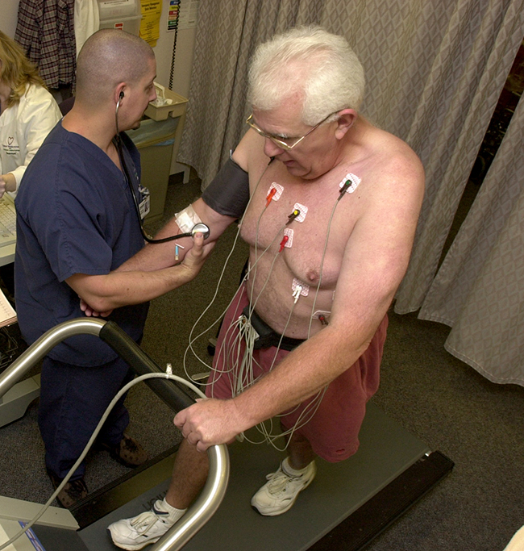
Figure 21.24 Administering thallium-201 to a patient and subsequently performing a stress test offer medical professionals an opportunity to visually analyze heart function and blood flow. (credit: modification of work by “Blue0ctane”/Wikimedia Commons)
Radioisotopes used in medicine typically have short half-lives—for example, the ubiquitous Tc-99m has a half-life of 6.01 hours. This makes Tc-99m essentially impossible to store and prohibitively expensive to transport, so it is made on-site instead. Hospitals and other medical facilities use Mo-99 (which is primarily extracted from U-235 fission products) to generate Tc-99. Mo-99 undergoes β decay with a half-life of 66 hours, and the Tc-99 is then chemically extracted (Figure 21.25). The parent nuclide Mo-99 is part of a molybdate ion, ${\text{MoO}}_{4}​^{2−};$ when it decays, it forms the pertechnetate ion, ${\text{TcO}}_{4}​^{\text{−}}.$ These two water-soluble ions are separated by column chromatography, with the higher charge molybdate ion adsorbing onto the alumina in the column, and the lower charge pertechnetate ion passing through the column in the solution. A few micrograms of Mo-99 can produce enough Tc-99 to perform as many as 10,000 tests.
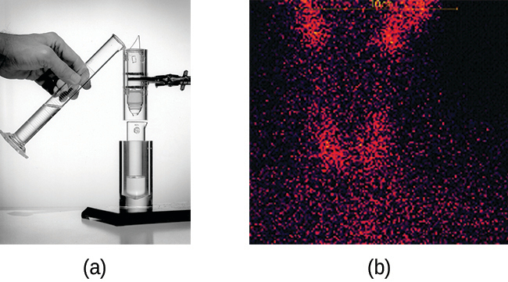
Figure 21.25 (a) The first Tc-99m generator (circa 1958) is used to separate Tc-99 from Mo-99. The ${\text{MoO}}_{4}​^{2−}$ is retained by the matrix in the column, whereas the ${\text{TcO}}_{4}​^{\text{−}}$ passes through and is collected. (b) Tc-99 was used in this scan of the neck of a patient with Grave’s disease. The scan shows the location of high concentrations of Tc-99. (credit a: modification of work by the Department of Energy; credit b: modification of work by “MBq”/Wikimedia Commons)
Radioisotopes can also be used, typically in higher doses than as a tracer, as treatment. Radiation therapy is the use of high-energy radiation to damage the DNA of cancer cells, which kills them or keeps them from dividing (Figure 21.26). A cancer patient may receive external beam radiation therapy delivered by a machine outside the body, or internal radiation therapy (brachytherapy) from a radioactive substance that has been introduced into the body. Note that chemotherapy is similar to internal radiation therapy in that the cancer treatment is injected into the body, but differs in that chemotherapy uses chemical rather than radioactive substances to kill the cancer cells.
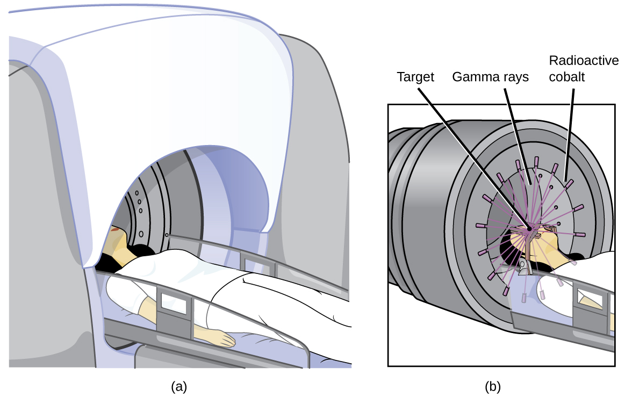
Figure 21.26 The cartoon in (a) shows a cobalt-60 machine used in the treatment of cancer. The diagram in (b) shows how the gantry of the Co-60 machine swings through an arc, focusing radiation on the targeted region (tumor) and minimizing the amount of radiation that passes through nearby regions.
Cobalt-60 is a synthetic radioisotope produced by the neutron activation of Co-59, which then undergoes β decay to form Ni-60, along with the emission of γ radiation. The overall process is:
$​_{27}^{59}\text{Co}+​_{0}^{1}\text{n} → ​_{27}^{60}\text{Co} → ​_{28}^{60}\text{Ni}+​_{−1}^{0}\text{β}+2​_{0}^{0}\text{γ}$
The overall decay scheme for this is shown graphically in Figure 21.27.
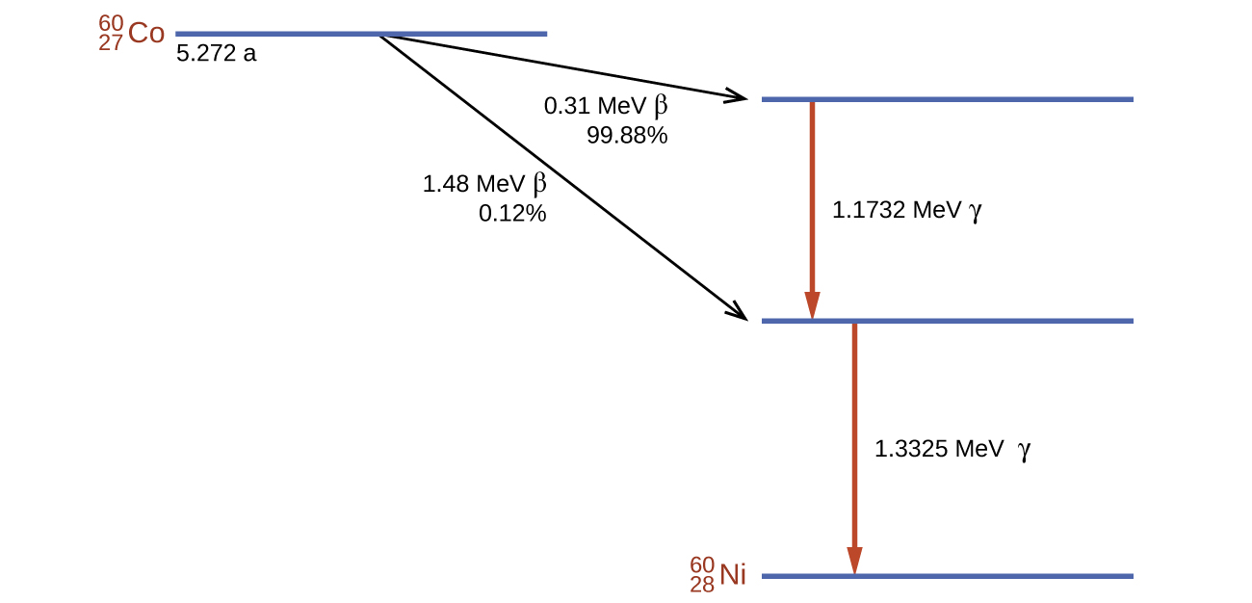
Figure 21.27 Co-60 undergoes a series of radioactive decays. The γ emissions are used for radiation therapy.
Radioisotopes are used in diverse ways to study the mechanisms of chemical reactions in plants and animals. These include labeling fertilizers in studies of nutrient uptake by plants and crop growth, investigations of digestive and milk-producing processes in cows, and studies on the growth and metabolism of animals and plants.
For example, the radioisotope C-14 was used to elucidate the details of how photosynthesis occurs. The overall reaction is:
${\text{6CO}}_{2}\left(g\right)+{\text{6H}}_{2}\text{O}\left(l\right) → {\text{C}}_{6}{\text{H}}_{12}{\text{O}}_{6}\left(s\right)+{\text{6O}}_{2}\left(g\right),$
but the process is much more complex, proceeding through a series of steps in which various organic compounds are produced. In studies of the pathway of this reaction, plants were exposed to CO₂ containing a high concentration of $​_{ 6}^{14}\text{C}$. At regular intervals, the plants were analyzed to determine which organic compounds contained carbon-14 and how much of each compound was present. From the time sequence in which the compounds appeared and the amount of each present at given time intervals, scientists learned more about the pathway of the reaction.
Commercial applications of radioactive materials are equally diverse (Figure 21.28). They include determining the thickness of films and thin metal sheets by exploiting the penetration power of various types of radiation. Flaws in metals used for structural purposes can be detected using high-energy gamma rays from cobalt-60 in a fashion similar to the way X-rays are used to examine the human body. In one form of pest control, flies are controlled by sterilizing male flies with γ radiation so that females breeding with them do not produce offspring. Many foods are preserved by radiation that kills microorganisms that cause the foods to spoil.
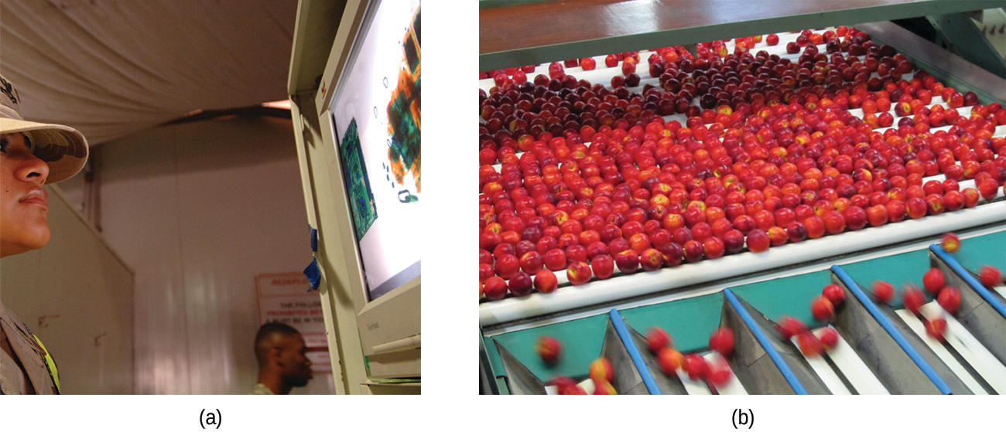
Figure 21.28 Common commercial uses of radiation include (a) X-ray examination of luggage at an airport and (b) preservation of food. (credit a: modification of work by the Department of the Navy; credit b: modification of work by the US Department of Agriculture)
Americium-241, an α emitter with a half-life of 458 years, is used in tiny amounts in ionization-type smoke detectors (Figure 21.29). The α emissions from Am-241 ionize the air between two electrode plates in the ionizing chamber. A battery supplies a potential that causes movement of the ions, thus creating a small electric current. When smoke enters the chamber, the movement of the ions is impeded, reducing the conductivity of the air. This causes a marked drop in the current, triggering an alarm.
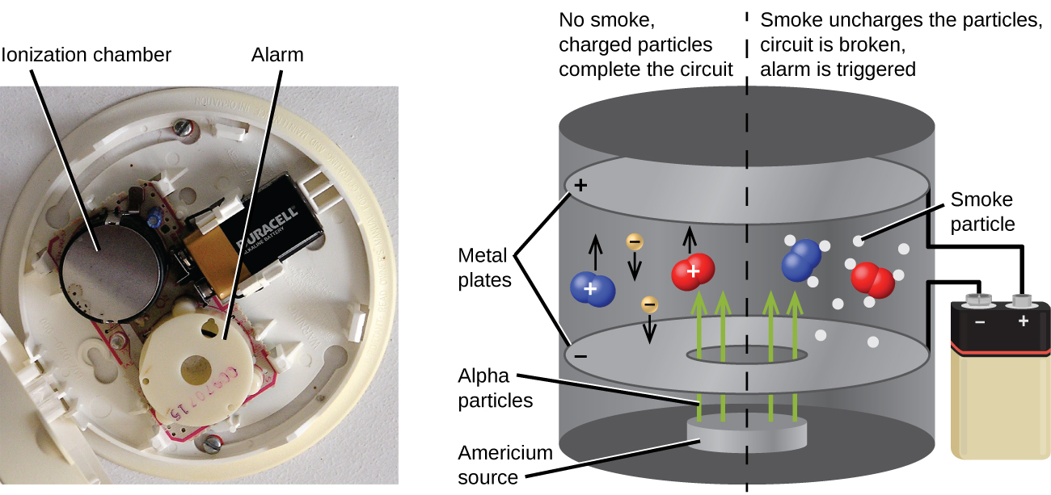
Figure 21.29 Inside a smoke detector, Am-241 emits α particles that ionize the air, creating a small electric current. During a fire, smoke particles impede the flow of ions, reducing the current and triggering an alarm. (credit a: modification of work by “Muffet”/Wikimedia Commons)

