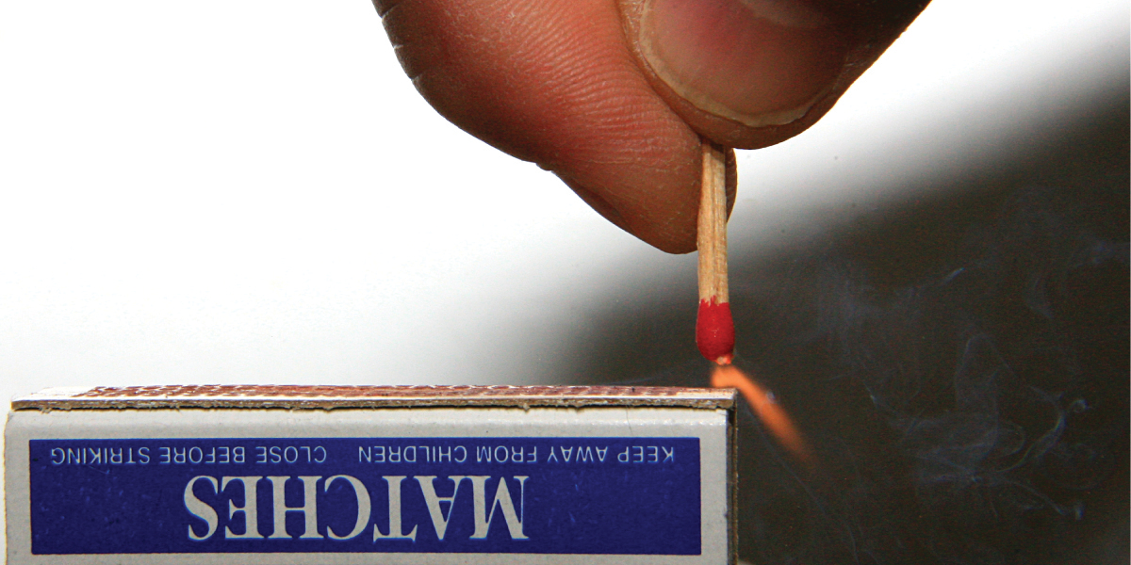
Figure 5.1 Sliding a match head along a rough surface initiates a combustion reaction that produces energy in the form of heat and light. (credit: modification of work by Laszlo Ilyes)

Chapter Outline
5.1 Energy Basics
5.2 Calorimetry
5.3 Enthalpy

Introduction
Chemical reactions, such as those that occur when you light a match, involve changes in energy as well as matter. Societies at all levels of development could not function without the energy released by chemical reactions. In 2012, about 85% of US energy consumption came from the combustion of petroleum products, coal, wood, and garbage. We use this energy to produce electricity (38%); to transport food, raw materials, manufactured goods, and people (27%); for industrial production (21%); and to heat and power our homes and businesses (10%).1 While these combustion reactions help us meet our essential energy needs, they are also recognized by the majority of the scientific community as a major contributor to global climate change.
1
US Energy Information Administration, Primary Energy Consumption by Source and Sector, 2012, http://www.eia.gov/totalenergy/data/monthly/pdf/flow/css_2012_energy.pdf. Data derived from US Energy Information Administration, Monthly Energy Review (January 2014).
Useful forms of energy are also available from a variety of chemical reactions other than combustion. For example, the energy produced by the batteries in a cell phone, car, or flashlight results from chemical reactions. This chapter introduces many of the basic ideas necessary to explore the relationships between chemical changes and energy, with a focus on thermal energy.

