2.2 Evolution of Atomic Theory

Learning Objectives
By the end of this section, you will be able to:
- Outline milestones in the development of modern atomic theory
- Summarize and interpret the results of the experiments of Thomson, Millikan, and Rutherford
- Describe the three subatomic particles that compose atoms
- Define isotopes and give examples for several elements
If matter is composed of atoms, what are atoms composed of? Are they the smallest particles, or is there something smaller? In the late 1800s, a number of scientists interested in questions like these investigated the electrical discharges that could be produced in low-pressure gases, with the most significant discovery made by English physicist J. J. Thomson using a cathode ray tube. This apparatus consisted of a sealed glass tube from which almost all the air had been removed; the tube contained two metal electrodes. When high voltage was applied across the electrodes, a visible beam called a cathode ray appeared between them. This beam was deflected toward the positive charge and away from the negative charge, and was produced in the same way with identical properties when different metals were used for the electrodes. In similar experiments, the ray was simultaneously deflected by an applied magnetic field, and measurements of the extent of deflection and the magnetic field strength allowed Thomson to calculate the charge-to-mass ratio of the cathode ray particles. The results of these measurements indicated that these particles were much lighter than atoms (Figure 2.6).
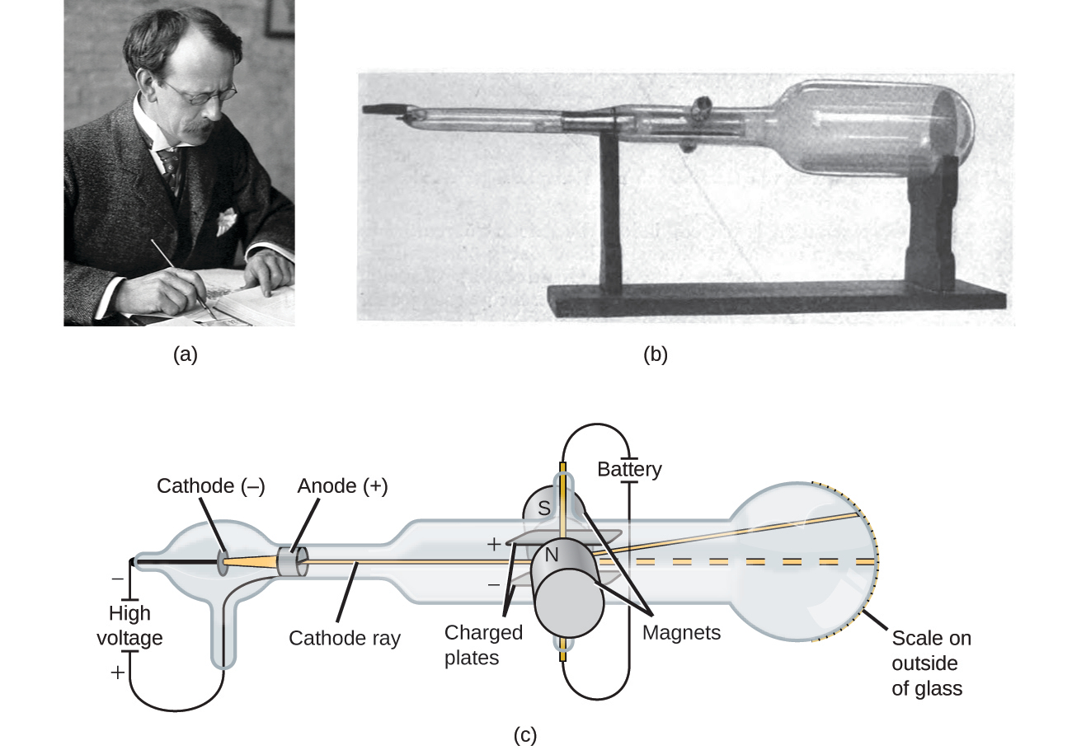
Figure 2.6 (a) J. J. Thomson produced a visible beam in a cathode ray tube. (b) This is an early cathode ray tube, invented in 1897 by Ferdinand Braun. (c) In the cathode ray, the beam (shown in yellow) comes from the cathode and is accelerated past the anode toward a fluorescent scale at the end of the tube. Simultaneous deflections by applied electric and magnetic fields permitted Thomson to calculate the mass-to-charge ratio of the particles composing the cathode ray. (credit a: modification of work by Nobel Foundation; credit b: modification of work by Eugen Nesper; credit c: modification of work by “Kurzon”/Wikimedia Commons)
Based on his observations, here is what Thomson proposed and why: The particles are attracted by positive (+) charges and repelled by negative (−) charges, so they must be negatively charged (like charges repel and unlike charges attract); they are less massive than atoms and indistinguishable, regardless of the source material, so they must be fundamental, subatomic constituents of all atoms. Although controversial at the time, Thomson’s idea was gradually accepted, and his cathode ray particle is what we now call an electron, a negatively charged, subatomic particle with a mass more than one thousand-times less that of an atom. The term “electron” was coined in 1891 by Irish physicist George Stoney, from “electric ion.”

Link to Learning
Click here to hear Thomson describe his discovery in his own voice.
In 1909, more information about the electron was uncovered by American physicist Robert A. Millikan via his “oil drop” experiments. Millikan created microscopic oil droplets, which could be electrically charged by friction as they formed or by using X-rays. These droplets initially fell due to gravity, but their downward progress could be slowed or even reversed by an electric field lower in the apparatus. By adjusting the electric field strength and making careful measurements and appropriate calculations, Millikan was able to determine the charge on individual drops (Figure 2.7).
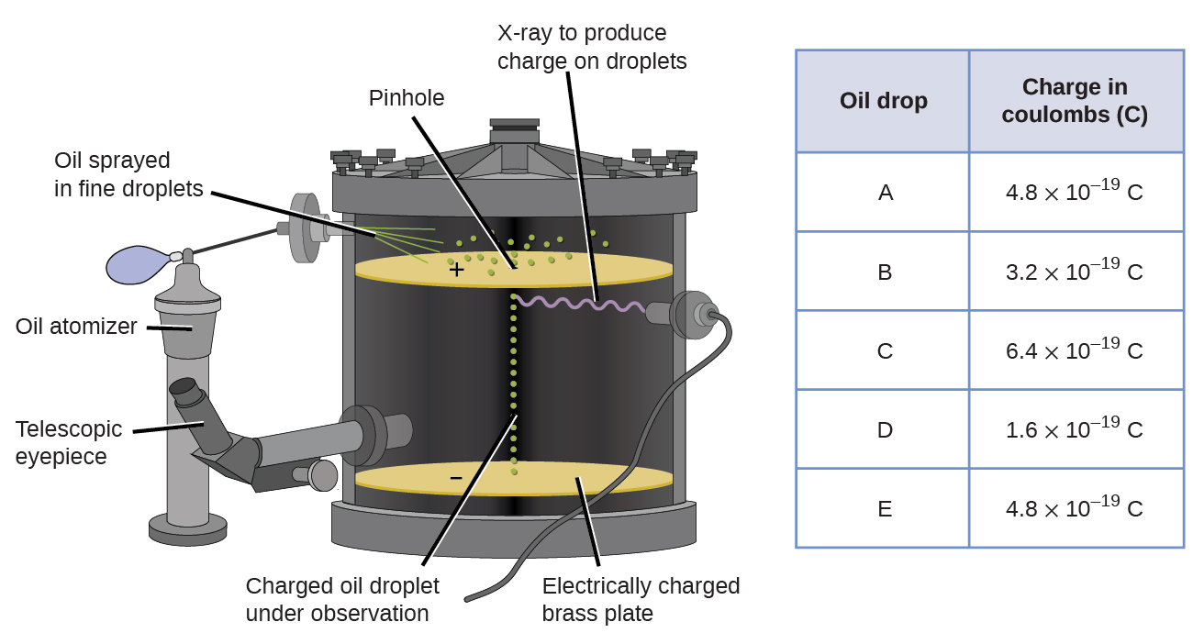
Figure 2.7 Millikan’s experiment measured the charge of individual oil drops. The tabulated data are examples of a few possible values.
Looking at the charge data that Millikan gathered, you may have recognized that the charge of an oil droplet is always a multiple of a specific charge, 1.6 $×$ 10⁻¹⁹ C. Millikan concluded that this value must therefore be a fundamental charge—the charge of a single electron—with his measured charges due to an excess of one electron (1 times 1.6 $×$ 10⁻¹⁹ C), two electrons (2 times 1.6 $×$ 10⁻¹⁹ C), three electrons (3 times 1.6 $×$ 10⁻¹⁹ C), and so on, on a given oil droplet. Since the charge of an electron was now known due to Millikan’s research, and the charge-to-mass ratio was already known due to Thomson’s research (1.759 $×$ 10¹¹ C/kg), it only required a simple calculation to determine the mass of the electron as well.
$\text{Mass of electron}=1.602 × {10}^{−19} \text{C} × \frac{1 \text{kg}}{1.759 × {10}^{11} \text{C}} =9.107 × {10}^{−31} \text{kg}$
Scientists had now established that the atom was not indivisible as Dalton had believed, and due to the work of Thomson, Millikan, and others, the charge and mass of the negative, subatomic particles—the electrons—were known. However, the positively charged part of an atom was not yet well understood. In 1904, Thomson proposed the “plum pudding” model of atoms, which described a positively charged mass with an equal amount of negative charge in the form of electrons embedded in it, since all atoms are electrically neutral. A competing model had been proposed in 1903 by Hantaro Nagaoka, who postulated a Saturn-like atom, consisting of a positively charged sphere surrounded by a halo of electrons (Figure 2.8).
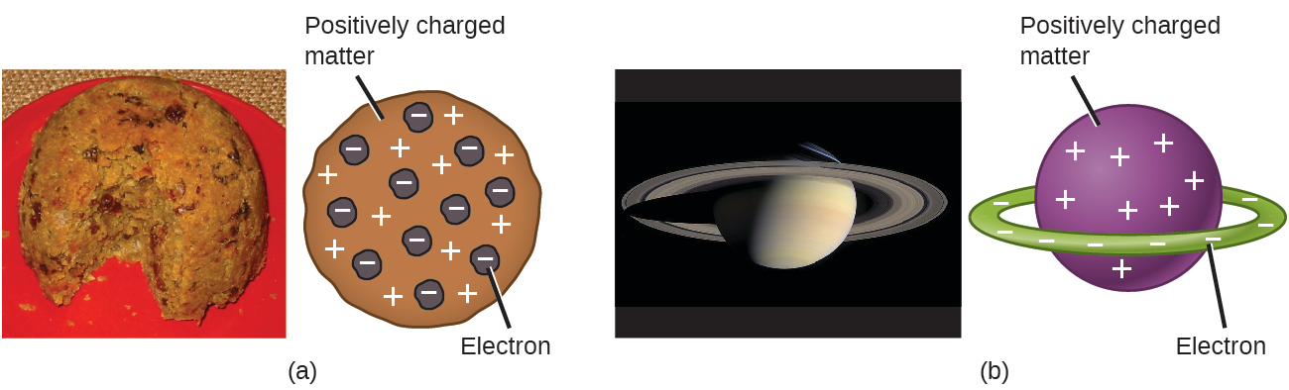
Figure 2.8 (a) Thomson suggested that atoms resembled plum pudding, an English dessert consisting of moist cake with embedded raisins (“plums”). (b) Nagaoka proposed that atoms resembled the planet Saturn, with a ring of electrons surrounding a positive “planet.” (credit a: modification of work by “Man vyi”/Wikimedia Commons; credit b: modification of work by “NASA”/Wikimedia Commons)
The next major development in understanding the atom came from Ernest Rutherford, a physicist from New Zealand who largely spent his scientific career in Canada and England. He performed a series of experiments using a beam of high-speed, positively charged alpha particles (α particles) that were produced by the radioactive decay of radium; α particles consist of two protons and two neutrons (you will learn more about radioactive decay in the chapter on nuclear chemistry). Rutherford and his colleagues Hans Geiger (later famous for the Geiger counter) and Ernest Marsden aimed a beam of α particles, the source of which was embedded in a lead block to absorb most of the radiation, at a very thin piece of gold foil and examined the resultant scattering of the α particles using a luminescent screen that glowed briefly where hit by an α particle.
What did they discover? Most particles passed right through the foil without being deflected at all. However, some were diverted slightly, and a very small number were deflected almost straight back toward the source (Figure 2.9). Rutherford described finding these results: “It was quite the most incredible event that has ever happened to me in my life. It was almost as incredible as if you fired a 15-inch shell at a piece of tissue paper and it came back and hit you.”1
1
Ernest Rutherford, “The Development of the Theory of Atomic Structure,” ed. J. A. Ratcliffe, in Background to Modern Science, eds. Joseph Needham and Walter Pagel, (Cambridge, UK: Cambridge University Press, 1938), 61–74. Accessed September 22, 2014, https://ia600508.us.archive.org/3/items/backgroundtomode032734mbp/backgroundtomode032734mbp.pdf.
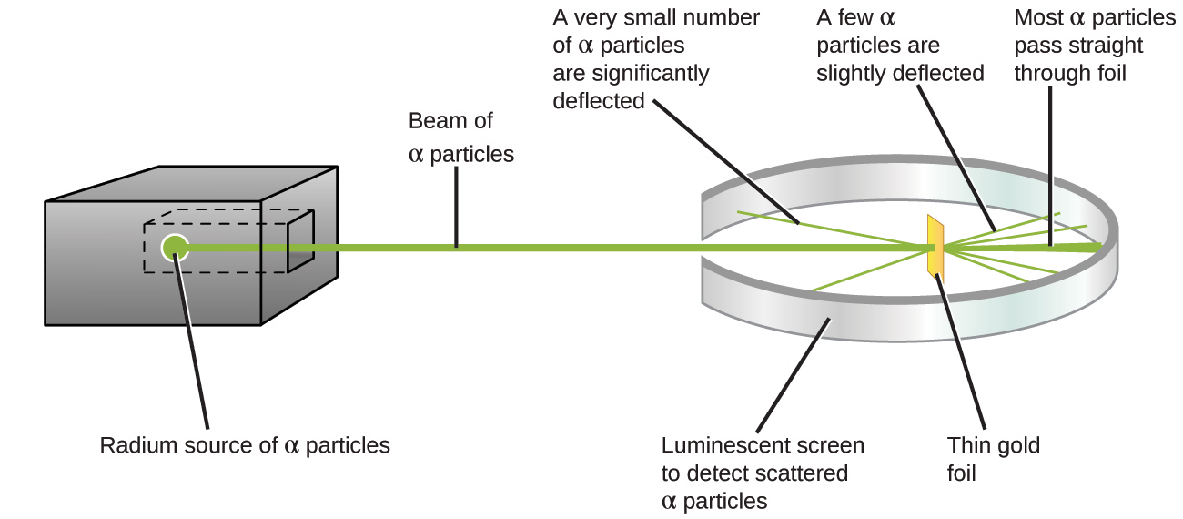
Figure 2.9 Geiger and Rutherford fired α particles at a piece of gold foil and detected where those particles went, as shown in this schematic diagram of their experiment. Most of the particles passed straight through the foil, but a few were deflected slightly and a very small number were significantly deflected.
Here is what Rutherford deduced: Because most of the fast-moving α particles passed through the gold atoms undeflected, they must have traveled through essentially empty space inside the atom. Alpha particles are positively charged, so deflections arose when they encountered another positive charge (like charges repel each other). Since like charges repel one another, the few positively charged α particles that changed paths abruptly must have hit, or closely approached, another body that also had a highly concentrated, positive charge. Since the deflections occurred a small fraction of the time, this charge only occupied a small amount of the space in the gold foil. Analyzing a series of such experiments in detail, Rutherford drew two conclusions:
- The volume occupied by an atom must consist of a large amount of empty space.
- A small, relatively heavy, positively charged body, the nucleus, must be at the center of each atom.

Link to Learning
View this simulation of the Rutherford gold foil experiment. Adjust the slit width to produce a narrower or broader beam of α particles to see how that affects the scattering pattern.
This analysis led Rutherford to propose a model in which an atom consists of a very small, positively charged nucleus, in which most of the mass of the atom is concentrated, surrounded by the negatively charged electrons, so that the atom is electrically neutral (Figure 2.10). After many more experiments, Rutherford also discovered that the nuclei of other elements contain the hydrogen nucleus as a “building block,” and he named this more fundamental particle the proton, the positively charged, subatomic particle found in the nucleus. With one addition, which you will learn next, this nuclear model of the atom, proposed over a century ago, is still used today.
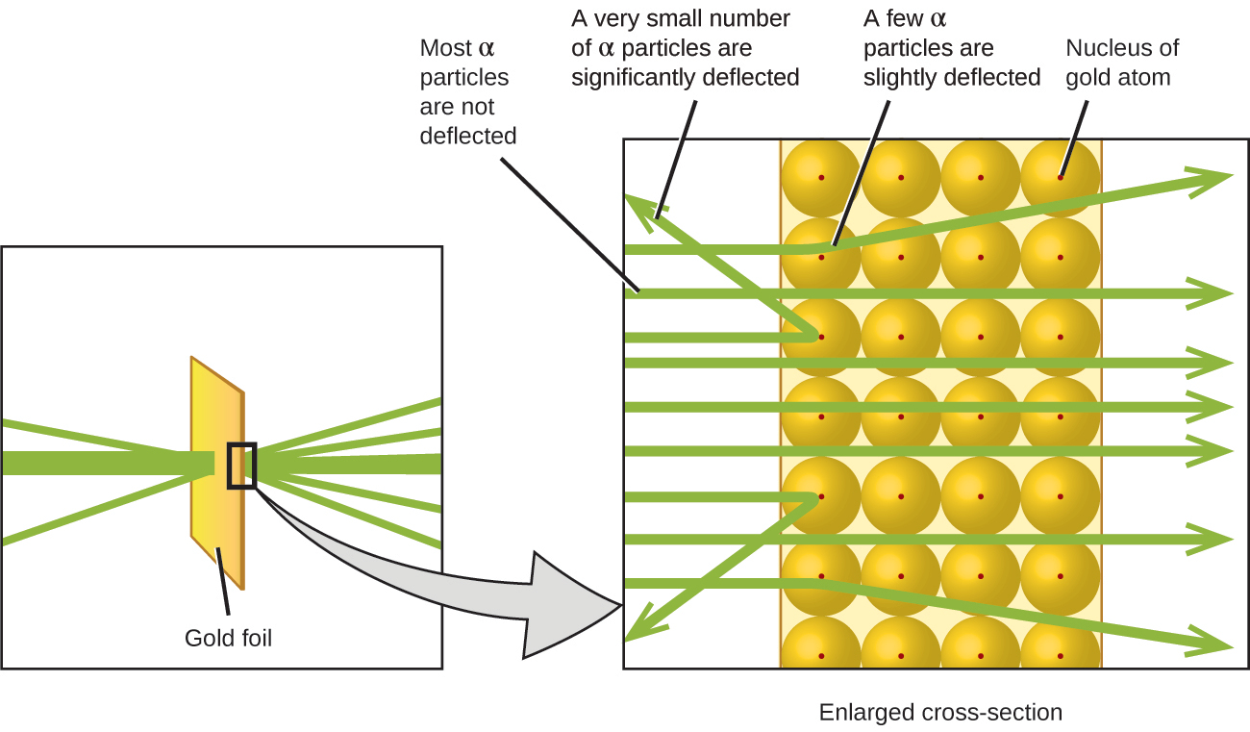
Figure 2.10 The α particles are deflected only when they collide with or pass close to the much heavier, positively charged gold nucleus. Because the nucleus is very small compared to the size of an atom, very few α particles are deflected. Most pass through the relatively large region occupied by electrons, which are too light to deflect the rapidly moving particles.

Link to Learning
The Rutherford Scattering simulation allows you to investigate the differences between a “plum pudding” atom and a Rutherford atom by firing α particles at each type of atom.
Another important finding was the discovery of isotopes. During the early 1900s, scientists identified several substances that appeared to be new elements, isolating them from radioactive ores. For example, a “new element” produced by the radioactive decay of thorium was initially given the name mesothorium. However, a more detailed analysis showed that mesothorium was chemically identical to radium (another decay product), despite having a different atomic mass. This result, along with similar findings for other elements, led the English chemist Frederick Soddy to realize that an element could have types of atoms with different masses that were chemically indistinguishable. These different types are called isotopes—atoms of the same element that differ in mass. Soddy was awarded the Nobel Prize in Chemistry in 1921 for this discovery.
One puzzle remained: The nucleus was known to contain almost all of the mass of an atom, with the number of protons only providing half, or less, of that mass. Different proposals were made to explain what constituted the remaining mass, including the existence of neutral particles in the nucleus. As you might expect, detecting uncharged particles is very challenging, and it was not until 1932 that James Chadwick found evidence of neutrons, uncharged, subatomic particles with a mass approximately the same as that of protons. The existence of the neutron also explained isotopes: They differ in mass because they have different numbers of neutrons, but they are chemically identical because they have the same number of protons. This will be explained in more detail later in this chapter.

