2.3 Atomic Structure and Symbolism

Learning Objectives
By the end of this section, you will be able to:
- Write and interpret symbols that depict the atomic number, mass number, and charge of an atom or ion
- Define the atomic mass unit and average atomic mass
- Calculate average atomic mass and isotopic abundance
The development of modern atomic theory revealed much about the inner structure of atoms. It was learned that an atom contains a very small nucleus composed of positively charged protons and uncharged neutrons, surrounded by a much larger volume of space containing negatively charged electrons. The nucleus contains the majority of an atom’s mass because protons and neutrons are much heavier than electrons, whereas electrons occupy almost all of an atom’s volume. The diameter of an atom is on the order of 10⁻¹⁰ m, whereas the diameter of the nucleus is roughly 10⁻¹⁵ m—about 100,000 times smaller. For a perspective about their relative sizes, consider this: If the nucleus were the size of a blueberry, the atom would be about the size of a football stadium (Figure 2.11).
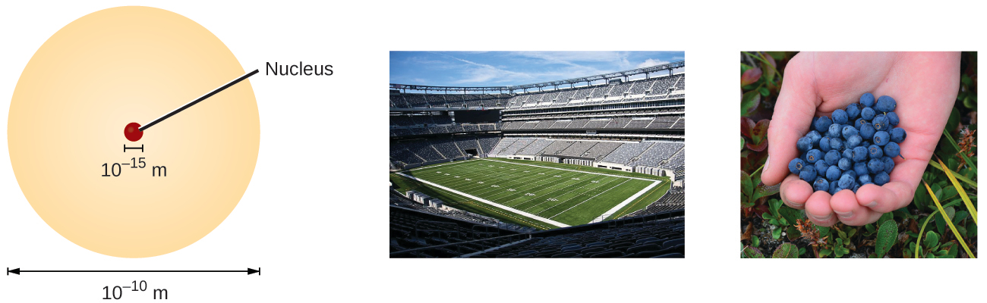
Figure 2.11 If an atom could be expanded to the size of a football stadium, the nucleus would be the size of a single blueberry. (credit middle: modification of work by “babyknight”/Wikimedia Commons; credit right: modification of work by Paxson Woelber)
Atoms—and the protons, neutrons, and electrons that compose them—are extremely small. For example, a carbon atom weighs less than 2 $×$ 10⁻²³ g, and an electron has a charge of less than 2 $×$ 10⁻¹⁹ C (coulomb). When describing the properties of tiny objects such as atoms, we use appropriately small units of measure, such as the unified atomic mass unit (u) and the fundamental unit of charge (e). The unified atomic mass unit is defined as exactly 1/12 of the mass of a single atom of the carbon-12 isotope (more on isotopes is provided later in this section) and is equal to 1.6605 $×$ 10⁻²⁴ g. The dalton (Da) is an alternative mass unit that is equivalent to the u. Many literature resources, including this text, use the older term atomic mass unit (amu) when referring to the u or the Da. The fundamental unit of charge (also called the elementary charge) equals the magnitude of the charge of an electron (e) with e = 1.602 $×$ 10⁻¹⁹ C.
A proton has a mass of 1.0073 amu and a charge of 1+. A neutron is a slightly heavier particle with a mass 1.0087 amu and a charge of zero; as its name suggests, it is neutral. The electron has a charge of 1− and is a much lighter particle with a mass of about 0.00055 amu (it would take about 1800 electrons to equal the mass of one proton). The properties of these fundamental particles are summarized in Table 2.2. (An observant student might notice that the sum of an atom’s subatomic particles does not equal the atom’s actual mass: The total mass of six protons, six neutrons, and six electrons is 12.0993 amu, slightly larger than 12.00 amu. This “missing” mass is known as the mass defect, and you will learn about it in the chapter on nuclear chemistry.)
Properties of Subatomic Particles
Name | Location | Charge (C) | Unit Charge | Mass (amu) | Mass (g)
electron | outside nucleus | −1.602 $×$ 10⁻¹⁹ | 1− | 0.00055 | 0.00091 $×$ 10⁻²⁴
proton | nucleus | 1.602 $×$10⁻¹⁹ | 1+ | 1.00727 | 1.67262 $×$ 10⁻²⁴
neutron | nucleus | 0 | 0 | 1.00866 | 1.67493 $×$ 10⁻²⁴
Table 2.2
The number of protons in the nucleus of an atom is its atomic number (Z). This is the defining trait of an element: Its value determines the identity of the atom. For example, any atom that contains six protons is the element carbon and has the atomic number 6, regardless of how many neutrons or electrons it may have. A neutral atom must contain the same number of positive and negative charges, so the number of protons equals the number of electrons. Therefore, the atomic number also indicates the number of electrons in an atom. The total number of protons and neutrons in an atom is called its mass number (A). The number of neutrons is therefore the difference between the mass number and the atomic number: A – Z = number of neutrons.
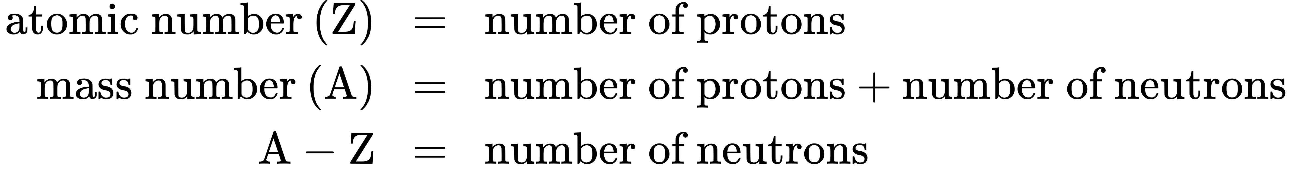
Atoms are electrically neutral if they contain the same number of positively charged protons and negatively charged electrons. When the numbers of these subatomic particles are not equal, the atom is electrically charged and is called an ion. The charge of an atom is defined as follows:
Atomic charge = number of protons − number of electrons
As will be discussed in more detail later in this chapter, atoms (and molecules) typically acquire charge by gaining or losing electrons. An atom that gains one or more electrons will exhibit a negative charge and is called an anion. Positively charged atoms called cations are formed when an atom loses one or more electrons. For example, a neutral sodium atom (Z = 11) has 11 electrons. If this atom loses one electron, it will become a cation with a 1+ charge (11 − 10 = 1+). A neutral oxygen atom (Z = 8) has eight electrons, and if it gains two electrons it will become an anion with a 2− charge (8 − 10 = 2−).

Example 2.3

Composition of an Atom
Iodine is an essential trace element in our diet; it is needed to produce thyroid hormone. Insufficient iodine in the diet can lead to the development of a goiter, an enlargement of the thyroid gland (Figure 2.12).
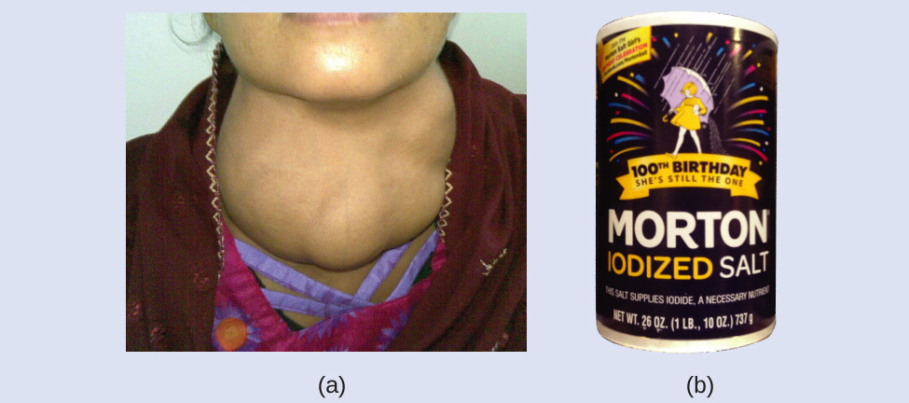
Figure 2.12 (a) Insufficient iodine in the diet can cause an enlargement of the thyroid gland called a goiter. (b) The addition of small amounts of iodine to salt, which prevents the formation of goiters, has helped eliminate this concern in the US where salt consumption is high. (credit a: modification of work by “Almazi”/Wikimedia Commons; credit b: modification of work by Mike Mozart)
The addition of small amounts of iodine to table salt (iodized salt) has essentially eliminated this health concern in the United States, but as much as 40% of the world’s population is still at risk of iodine deficiency. The iodine atoms are added as anions, and each has a 1− charge and a mass number of 127. Determine the numbers of protons, neutrons, and electrons in one of these iodine anions.

Solution
The atomic number of iodine (53) tells us that a neutral iodine atom contains 53 protons in its nucleus and 53 electrons outside its nucleus. Because the sum of the numbers of protons and neutrons equals the mass number, 127, the number of neutrons is 74 (127 − 53 = 74). Since the iodine is added as a 1− anion, the number of electrons is 54 [53 – (1–) = 54].

Check Your Learning
An ion of platinum has a mass number of 195 and contains 74 electrons. How many protons and neutrons does it contain, and what is its charge?

Answer:
78 protons; 117 neutrons; charge is 4+

Chemical Symbols
A chemical symbol is an abbreviation that we use to indicate an element or an atom of an element. For example, the symbol for mercury is Hg (Figure 2.13). We use the same symbol to indicate one atom of mercury (microscopic domain) or to label a container of many atoms of the element mercury (macroscopic domain).
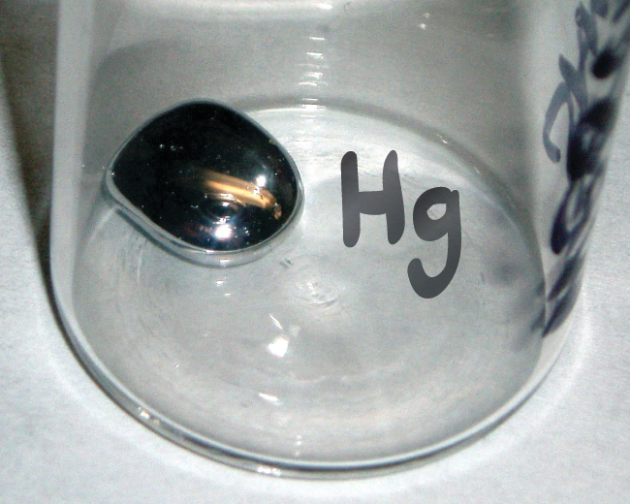
Figure 2.13 The symbol Hg represents the element mercury regardless of the amount; it could represent one atom of mercury or a large amount of mercury.
The symbols for several common elements and their atoms are listed in Table 2.3. Some symbols are derived from the common name of the element; others are abbreviations of the name in another language. Most symbols have one or two letters, but three-letter symbols have been used to describe some elements that have atomic numbers greater than 112. To avoid confusion with other notations, only the first letter of a symbol is capitalized. For example, Co is the symbol for the element cobalt, but CO is the notation for the compound carbon monoxide, which contains atoms of the elements carbon (C) and oxygen (O). All known elements and their symbols are in the periodic table in Figure 2.26 (also found in Appendix A).
Some Common Elements and Their Symbols
Element | Symbol | Element | Symbol
aluminum | Al | iron | Fe (from ferrum)
bromine | Br | lead | Pb (from plumbum)
calcium | Ca | magnesium | Mg
carbon | C | mercury | Hg (from hydrargyrum)
chlorine | Cl | nitrogen | N
chromium | Cr | oxygen | O
cobalt | Co | potassium | K (from kalium)
copper | Cu (from cuprum) | silicon | Si
fluorine | F | silver | Ag (from argentum)
gold | Au (from aurum) | sodium | Na (from natrium)
helium | He | sulfur | S
hydrogen | H | tin | Sn (from stannum)
iodine | I | zinc | Zn
Table 2.3
Traditionally, the discoverer (or discoverers) of a new element names the element. However, until the name is recognized by the International Union of Pure and Applied Chemistry (IUPAC), the recommended name of the new element is based on the Latin word(s) for its atomic number. For example, element 106 was called unnilhexium (Unh), element 107 was called unnilseptium (Uns), and element 108 was called unniloctium (Uno) for several years. These elements are now named after scientists (or occasionally locations); for example, element 106 is now known as seaborgium (Sg) in honor of Glenn Seaborg, a Nobel Prize winner who was active in the discovery of several heavy elements. Element 109 was named in honor of Lise Meitner, who discovered nuclear fission, a phenomenon that would have world-changing impacts; Meitner also contributed to the discovery of some major isotopes, discussed immediately below.

Link to Learning
Visit this site to learn more about IUPAC, the International Union of Pure and Applied Chemistry, and explore its periodic table.

Isotopes
The symbol for a specific isotope of any element is written by placing the mass number as a superscript to the left of the element symbol (Figure 2.14). The atomic number is sometimes written as a subscript preceding the symbol, but since this number defines the element’s identity, as does its symbol, it is often omitted. For example, magnesium exists as a mixture of three isotopes, each with an atomic number of 12 and with mass numbers of 24, 25, and 26, respectively. These isotopes can be identified as ²⁴Mg, ²⁵Mg, and ²⁶Mg. These isotope symbols are read as “element, mass number” and can be symbolized consistent with this reading. For instance, ²⁴Mg is read as “magnesium 24,” and can be written as “magnesium-24” or “Mg-24.” ²⁵Mg is read as “magnesium 25,” and can be written as “magnesium-25” or “Mg-25.” All magnesium atoms have 12 protons in their nucleus. They differ only because a ²⁴Mg atom has 12 neutrons in its nucleus, a ²⁵Mg atom has 13 neutrons, and a ²⁶Mg has 14 neutrons.
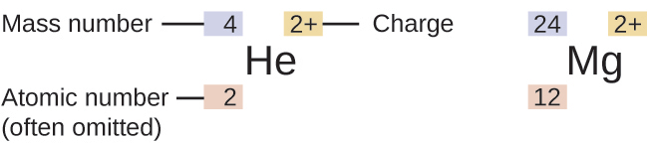
Figure 2.14 The symbol for an atom indicates the element via its usual two-letter symbol, the mass number as a left superscript, the atomic number as a left subscript (sometimes omitted), and the charge as a right superscript.
Information about the naturally occurring isotopes of elements with atomic numbers 1 through 10 is given in Table 2.4. Note that in addition to standard names and symbols, the isotopes of hydrogen are often referred to using common names and accompanying symbols. Hydrogen-2, symbolized ²H, is also called deuterium and sometimes symbolized D. Hydrogen-3, symbolized ³H, is also called tritium and sometimes symbolized T.
Nuclear Compositions of Atoms of the Very Light Elements
Element | Symbol | Atomic Number | Number of Protons | Number of Neutrons | Mass (amu) | % Natural Abundance
hydrogen | $​_{1}^{1}\text{H}$  (protium) | 1 | 1 | 0 | 1.0078 | 99.989
hydrogen | $​_{1}^{2}\text{H}$  (deuterium) | 1 | 1 | 1 | 2.0141 | 0.0115
hydrogen | $​_{1}^{3}\text{H}$  (tritium) | 1 | 1 | 2 | 3.01605 | — (trace)
helium | $​_{2}^{3}\text{He}$ | 2 | 2 | 1 | 3.01603 | 0.00013
helium | $​_{2}^{4}\text{He}$ | 2 | 2 | 2 | 4.0026 | 100
lithium | $​_{3}^{6}\text{Li}$ | 3 | 3 | 3 | 6.0151 | 7.59
lithium | $​_{3}^{7}\text{Li}$ | 3 | 3 | 4 | 7.0160 | 92.41
beryllium | $​_{4}^{9}\text{Be}$ | 4 | 4 | 5 | 9.0122 | 100
boron | $​_{ 5}^{10}\text{B}$ | 5 | 5 | 5 | 10.0129 | 19.9
boron | $​_{ 5}^{11}\text{B}$ | 5 | 5 | 6 | 11.0093 | 80.1
carbon | $​_{ 6}^{12}\text{C}$ | 6 | 6 | 6 | 12.0000 | 98.89
carbon | $​_{ 6}^{13}\text{C}$ | 6 | 6 | 7 | 13.0034 | 1.11
carbon | $​_{ 6}^{14}\text{C}$ | 6 | 6 | 8 | 14.0032 | — (trace)
nitrogen | $​_{ 7}^{14}\text{N}$ | 7 | 7 | 7 | 14.0031 | 99.63
nitrogen | $​_{ 7}^{15}\text{N}$ | 7 | 7 | 8 | 15.0001 | 0.37
oxygen | $​_{ 8}^{16}\text{O}$ | 8 | 8 | 8 | 15.9949 | 99.757
oxygen | $​_{ 8}^{17}\text{O}$ | 8 | 8 | 9 | 16.9991 | 0.038
oxygen | $​_{ 8}^{18}\text{O}$ | 8 | 8 | 10 | 17.9992 | 0.205
fluorine | $​_{ 9}^{19}\text{F}$ | 9 | 9 | 10 | 18.9984 | 100
neon | $​_{10}^{20}\text{Ne}$ | 10 | 10 | 10 | 19.9924 | 90.48
neon | $​_{10}^{21}\text{Ne}$ | 10 | 10 | 11 | 20.9938 | 0.27
neon | $​_{10}^{22}\text{Ne}$ | 10 | 10 | 12 | 21.9914 | 9.25
Table 2.4

Link to Learning
Use this Build an Atom simulator to build atoms of the first 10 elements, see which isotopes exist, check nuclear stability, and gain experience with isotope symbols.

Atomic Mass
Because each proton and each neutron contribute approximately one amu to the mass of an atom, and each electron contributes far less, the atomic mass of a single atom is approximately equal to its mass number (a whole number). However, the average masses of atoms of most elements are not whole numbers because most elements exist naturally as mixtures of two or more isotopes.
The mass of an element shown in a periodic table or listed in a table of atomic masses is a weighted, average mass of all the isotopes present in a naturally occurring sample of that element. This is equal to the sum of each individual isotope’s mass multiplied by its fractional abundance.
average mass=i​fractional abundance × isotopic massi
For example, the element boron is composed of two isotopes: About 19.9% of all boron atoms are ¹⁰B with a mass of 10.0129 amu, and the remaining 80.1% are ¹¹B with a mass of 11.0093 amu. The average atomic mass for boron is calculated to be:
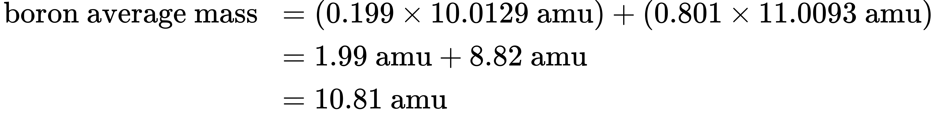
It is important to understand that no single boron atom weighs exactly 10.8 amu; 10.8 amu is the average mass of all boron atoms, and individual boron atoms weigh either approximately 10 amu or 11 amu.

Example 2.4

Calculation of Average Atomic Mass
A meteorite found in central Indiana contains traces of the noble gas neon picked up from the solar wind during the meteorite’s trip through the solar system. Analysis of a sample of the gas showed that it consisted of 91.84% ²⁰Ne (mass 19.9924 amu), 0.47% ²¹Ne (mass 20.9940 amu), and 7.69% ²²Ne (mass 21.9914 amu). What is the average mass of the neon in the solar wind?

Solution
The average mass of a neon atom in the solar wind is 20.15 amu. (The average mass of a terrestrial neon atom is 20.1796 amu. This result demonstrates that we may find slight differences in the natural abundance of isotopes, depending on their origin.)

Check Your Learning
A sample of magnesium is found to contain 78.70% of ²⁴Mg atoms (mass 23.98 amu), 10.13% of ²⁵Mg atoms (mass 24.99 amu), and 11.17% of ²⁶Mg atoms (mass 25.98 amu). Calculate the average mass of a Mg atom.

Answer:
24.31 amu
We can also do variations of this type of calculation, as shown in the next example.

Example 2.5

Calculation of Percent Abundance
Naturally occurring chlorine consists of ³⁵Cl (mass 34.96885 amu) and ³⁷Cl (mass 36.96590 amu), with an average mass of 35.453 amu. What is the percent composition of Cl in terms of these two isotopes?

Solution
The average mass of chlorine is the fraction that is ³⁵Cl times the mass of ³⁵Cl plus the fraction that is ³⁷Cl times the mass of ³⁷Cl.
$\text{average mass}=\left(\text{fraction of} ​^{35}\text{Cl} × \text{mass of} ​^{35}\text{Cl}\right)+\left(\text{fraction of} ​^{37}\text{Cl} × \text{mass of} ​^{37}\text{Cl}\right)$
If we let x represent the fraction that is ³⁵Cl, then the fraction that is ³⁷Cl is represented by 1.00 − x.
(The fraction that is ³⁵Cl + the fraction that is ³⁷Cl must add up to 1, so the fraction of ³⁷Cl must equal 1.00 − the fraction of ³⁵Cl.)
Substituting this into the average mass equation, we have:
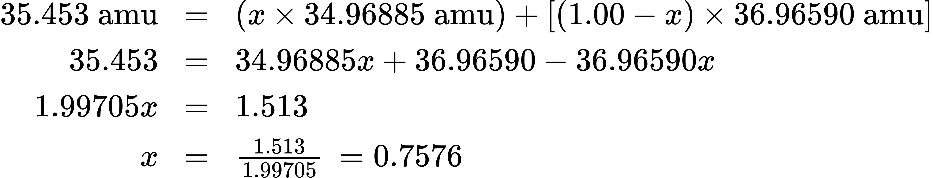
So solving yields: x = 0.7576, which means that 1.00 − 0.7576 = 0.2424. Therefore, chlorine consists of 75.76% ³⁵Cl and 24.24% ³⁷Cl.

Check Your Learning
Naturally occurring copper consists of ⁶³Cu (mass 62.9296 amu) and ⁶⁵Cu (mass 64.9278 amu), with an average mass of 63.546 amu. What is the percent composition of Cu in terms of these two isotopes?

Answer:
69.15% Cu-63 and 30.85% Cu-65

Link to Learning
Visit this site to make mixtures of the main isotopes of the first 18 elements, gain experience with average atomic mass, and check naturally occurring isotope ratios using the Isotopes and Atomic Mass simulation.
As you will learn, isotopes are important in nature and especially in human understanding of science and medicine. Let's consider just one natural, stable isotope: Oxygen-18, which is noted in the table above and is referred to as one of the environmental isotopes. It is important in paleoclimatology, for example, because scientists can use the ratio between Oxygen-18 and Oxygen-16 in an ice core to determine the temperature of precipitation over time. Oxygen-18 was also critical to the discovery of metabolic pathways and the mechanisms of enzymes. Mildred Cohn pioneered the usage of these isotopes to act as tracers, so that researchers could follow their path through reactions and gain a better understanding of what is happening. One of her first discoveries provided insight into the phosphorylation of glucose that takes place in mitochondria. And the methods of using isotopes for this research contributed to entire fields of study.
The occurrence and natural abundances of isotopes can be experimentally determined using an instrument called a mass spectrometer. Mass spectrometry (MS) is widely used in chemistry, forensics, medicine, environmental science, and many other fields to analyze and help identify the substances in a sample of material. In a typical mass spectrometer (Figure 2.15), the sample is vaporized and exposed to a high-energy electron beam that causes the sample’s atoms (or molecules) to become electrically charged, typically by losing one or more electrons. These cations then pass through a (variable) electric or magnetic field that deflects each cation’s path to an extent that depends on both its mass and charge (similar to how the path of a large steel ball rolling past a magnet is deflected to a lesser extent than that of a small steel ball). The ions are detected, and a plot of the relative number of ions generated versus their mass-to-charge ratios (a mass spectrum) is made. The height of each vertical feature or peak in a mass spectrum is proportional to the fraction of cations with the specified mass-to-charge ratio. Since its initial use during the development of modern atomic theory, MS has evolved to become a powerful tool for chemical analysis in a wide range of applications.
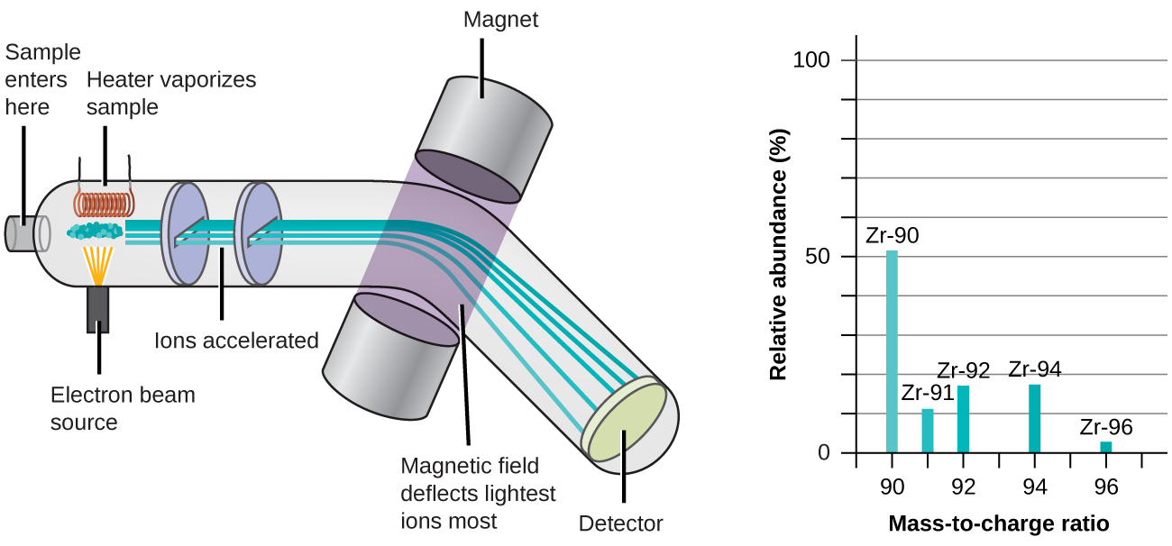
Figure 2.15 Analysis of zirconium in a mass spectrometer produces a mass spectrum with peaks showing the different isotopes of Zr.

Link to Learning
See an animation that explains mass spectrometry. Watch this video from the Royal Society for Chemistry for a brief description of the rudiments of mass spectrometry.

