2.4 Chemical Formulas

Learning Objectives
By the end of this section, you will be able to:
- Symbolize the composition of molecules using molecular formulas and empirical formulas
- Represent the bonding arrangement of atoms within molecules using structural formulas
A molecular formula is a representation of a molecule that uses chemical symbols to indicate the types of atoms followed by subscripts to show the number of atoms of each type in the molecule. (A subscript is used only when more than one atom of a given type is present.) Molecular formulas are also used as abbreviations for the names of compounds.
The structural formula for a compound gives the same information as its molecular formula (the types and numbers of atoms in the molecule) but also shows how the atoms are connected in the molecule. The structural formula for methane contains symbols for one C atom and four H atoms, indicating the number of atoms in the molecule (Figure 2.16). The lines represent bonds that hold the atoms together. (A chemical bond is an attraction between atoms or ions that holds them together in a molecule or a crystal.) We will discuss chemical bonds and see how to predict the arrangement of atoms in a molecule later. For now, simply know that the lines are an indication of how the atoms are connected in a molecule. A ball-and-stick model shows the geometric arrangement of the atoms with atomic sizes not to scale, and a space-filling model shows the relative sizes of the atoms.
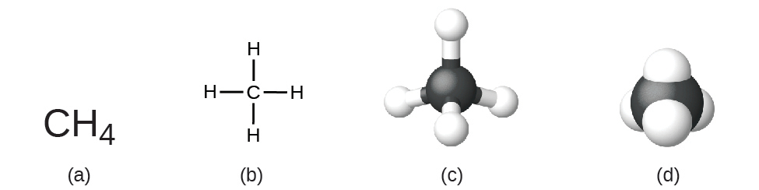
Figure 2.16 A methane molecule can be represented as (a) a molecular formula, (b) a structural formula, (c) a ball-and-stick model, and (d) a space-filling model. Carbon and hydrogen atoms are represented by black and white spheres, respectively.
Although many elements consist of discrete, individual atoms, some exist as molecules made up of two or more atoms of the element chemically bonded together. For example, most samples of the elements hydrogen, oxygen, and nitrogen are composed of molecules that contain two atoms each (called diatomic molecules) and thus have the molecular formulas H₂, O₂, and N₂, respectively. Other elements commonly found as diatomic molecules are fluorine (F₂), chlorine (Cl₂), bromine (Br₂), and iodine (I₂). The most common form of the element sulfur is composed of molecules that consist of eight atoms of sulfur; its molecular formula is S₈ (Figure 2.17).
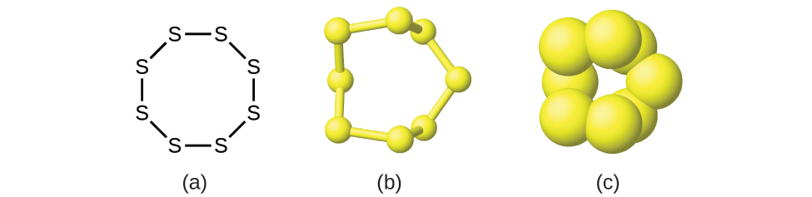
Figure 2.17 A molecule of sulfur is composed of eight sulfur atoms and is therefore written as S₈. It can be represented as (a) a structural formula, (b) a ball-and-stick model, and (c) a space-filling model. Sulfur atoms are represented by yellow spheres.
It is important to note that a subscript following a symbol and a number in front of a symbol do not represent the same thing; for example, H₂ and 2H represent distinctly different species. H₂ is a molecular formula; it represents a diatomic molecule of hydrogen, consisting of two atoms of the element that are chemically bonded together. The expression 2H, on the other hand, indicates two separate hydrogen atoms that are not combined as a unit. The expression 2H₂ represents two molecules of diatomic hydrogen (Figure 2.18).
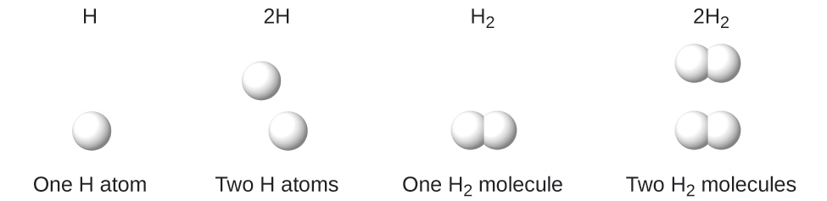
Figure 2.18 The symbols H, 2H, H₂, and 2H₂ represent very different entities.
Compounds are formed when two or more elements chemically combine, resulting in the formation of bonds. For example, hydrogen and oxygen can react to form water, and sodium and chlorine can react to form table salt. We sometimes describe the composition of these compounds with an empirical formula, which indicates the types of atoms present and the simplest whole-number ratio of the number of atoms (or ions) in the compound. For example, titanium dioxide (used as pigment in white paint and in the thick, white, blocking type of sunscreen) has an empirical formula of TiO₂. This identifies the elements titanium (Ti) and oxygen (O) as the constituents of titanium dioxide, and indicates the presence of twice as many atoms of the element oxygen as atoms of the element titanium (Figure 2.19).
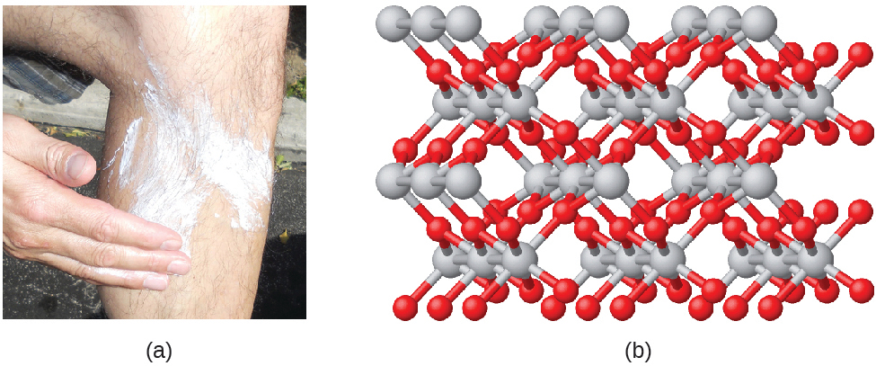
Figure 2.19 (a) The white compound titanium dioxide provides effective protection from the sun. (b) A crystal of titanium dioxide, TiO₂, contains titanium and oxygen in a ratio of 1 to 2. The titanium atoms are gray and the oxygen atoms are red. (credit a: modification of work by “osseous”/Flickr)
As discussed previously, we can describe a compound with a molecular formula, in which the subscripts indicate the actual numbers of atoms of each element in a molecule of the compound. In many cases, the molecular formula of a substance is derived from experimental determination of both its empirical formula and its molecular mass (the sum of atomic masses for all atoms composing the molecule). For example, it can be determined experimentally that benzene contains two elements, carbon (C) and hydrogen (H), and that for every carbon atom in benzene, there is one hydrogen atom. Thus, the empirical formula is CH. An experimental determination of the molecular mass reveals that a molecule of benzene contains six carbon atoms and six hydrogen atoms, so the molecular formula for benzene is C₆H₆ (Figure 2.20).
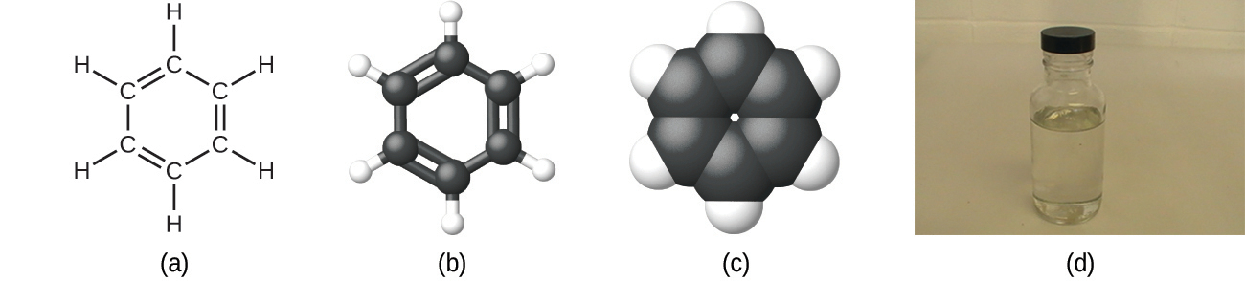
Figure 2.20 Benzene, C₆H₆, is produced during oil refining and has many industrial uses. A benzene molecule can be represented as (a) a structural formula, (b) a ball-and-stick model, and (c) a space-filling model. (d) Benzene is a clear liquid. (credit d: modification of work by Sahar Atwa)
If we know a compound’s formula, we can easily determine the empirical formula. (This is somewhat of an academic exercise; the reverse chronology is generally followed in actual practice.) For example, the molecular formula for acetic acid, the component that gives vinegar its sharp taste, is C₂H₄O₂. This formula indicates that a molecule of acetic acid (Figure 2.21) contains two carbon atoms, four hydrogen atoms, and two oxygen atoms. The ratio of atoms is 2:4:2. Dividing by the lowest common denominator (2) gives the simplest, whole-number ratio of atoms, 1:2:1, so the empirical formula is CH₂O. Note that a molecular formula is always a whole-number multiple of an empirical formula.
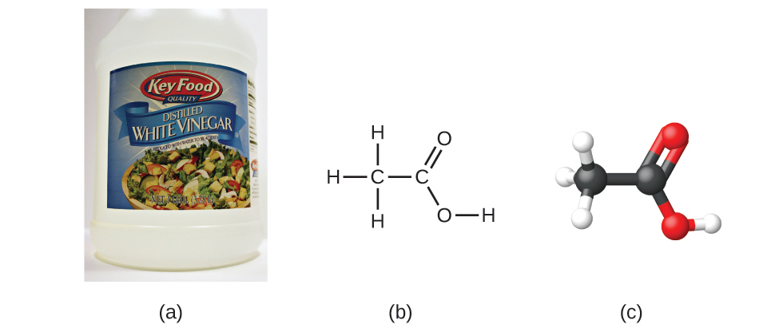
Figure 2.21 (a) Vinegar contains acetic acid, C₂H₄O₂, which has an empirical formula of CH₂O. It can be represented as (b) a structural formula and (c) as a ball-and-stick model. (credit a: modification of work by “HomeSpot HQ”/Flickr)

Example 2.6

Empirical and Molecular Formulas
Molecules of glucose (blood sugar) contain 6 carbon atoms, 12 hydrogen atoms, and 6 oxygen atoms. What are the molecular and empirical formulas of glucose?

Solution
The molecular formula is C₆H₁₂O₆ because one molecule actually contains 6 C, 12 H, and 6 O atoms. The simplest whole-number ratio of C to H to O atoms in glucose is 1:2:1, so the empirical formula is CH₂O.

Check Your Learning
A molecule of metaldehyde (a pesticide used for snails and slugs) contains 8 carbon atoms, 16 hydrogen atoms, and 4 oxygen atoms. What are the molecular and empirical formulas of metaldehyde?

Answer:
Molecular formula, C₈H₁₆O₄; empirical formula, C₂H₄O

Link to Learning
You can explore molecule building using an online simulation.

Portrait of a Chemist

Paula Hammond
You’ve learned about the evolution of atomic theory, and you’ve started to explore different chemical structures. These structures result in molecules attracting or repelling each other, or help them arrange into our cell membranes or lead them to either spread into thin films or clump into solid masses.
What do these structures mean to scientists, and to us? Essentially, everything. It’s the structure and makeup of a molecule on a virus surface that allows it to attach to one of our cells, and it’s the structure and makeup of antibodies—substances created by our immune system—that block that attachment. Chlorophyll’s structure enables it to use the sun’s energy to make glucose. Chemists and chemical engineers don’t simply observe and understand these structures—they can create new ones.

Figure 2.22 Paula Hammond pioneered new techniques to precisely formulate chemical structures. Hammond’s work applies to cancer treatments, wound healing, cataract medicine, and fuel cells. Widely recognized as a leader in the field, she has won numerous awards and has been elected to various prestigious positions and fellowships by her peers and the U.S. government. She chairs the chemical engineering department at MIT, which is usually ranked as one of the best engineering and science institutions in the world. (credit: modification of work by The White House)
Paula Hammond does exactly that to solve challenging problems ranging from cancer to energy consumption. She is the chair of the department of chemical engineering at Massachusetts Institute of Technology, and leads a research team focused on assembling unique molecular structures. They have created cancer drug carriers—nanoparticle-sized coatings that enable medicines to travel into tumors without being affected by its defenses—that can deliver pharmaceuticals directly into cancerous tumors. They build these “stealth” molecules layer by layer; using certain properties of electricity and chemical behavior, they can “tune” the coatings to address particular cancers and other variables. This precision approach is necessary to treat cancers more effectively and with less harm to the patient. The company Hammond founded uses similar technology to release medication into cataract patients’ eyes, as well as to improve wound healing.
While Hammond’s research team is composed of established and leading experts such as herself, students certainly play a role. College research labs are typically full of PhD, graduate, and even undergraduate students who participate in the work. And thus chemists and chemical engineers who use their knowledge to solve problems are also supporting the next generation of creators and problem-solvers.
It is important to be aware that it may be possible for the same atoms to be arranged in different ways: Compounds with the same molecular formula may have different atom-to-atom bonding and therefore different structures. For example, could there be another compound with the same formula as acetic acid, C₂H₄O₂? And if so, what would be the structure of its molecules?
If you predict that another compound with the formula C₂H₄O₂ could exist, then you demonstrated good chemical insight and are correct. Two C atoms, four H atoms, and two O atoms can also be arranged to form a methyl formate, which is used in manufacturing, as an insecticide, and for quick-drying finishes. Methyl formate molecules have one of the oxygen atoms between the two carbon atoms, differing from the arrangement in acetic acid molecules. Acetic acid and methyl formate are examples of isomers—compounds with the same chemical formula but different molecular structures (Figure 2.23). Note that this small difference in the arrangement of the atoms has a major effect on their respective chemical properties. You would certainly not want to use a solution of methyl formate as a substitute for a solution of acetic acid (vinegar) when you make salad dressing.
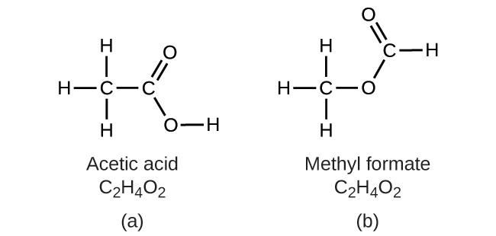
Figure 2.23 Molecules of (a) acetic acid and methyl formate (b) are structural isomers; they have the same formula (C₂H₄O₂) but different structures (and therefore different chemical properties).
Many types of isomers exist (Figure 2.24). Acetic acid and methyl formate are structural isomers, compounds in which the molecules differ in how the atoms are connected to each other. There are also various types of spatial isomers, in which the relative orientations of the atoms in space can be different. For example, the compound carvone (found in caraway seeds, spearmint, and mandarin orange peels) consists of two isomers that are mirror images of each other. S-(+)-carvone smells like caraway, and R-(−)-carvone smells like spearmint.
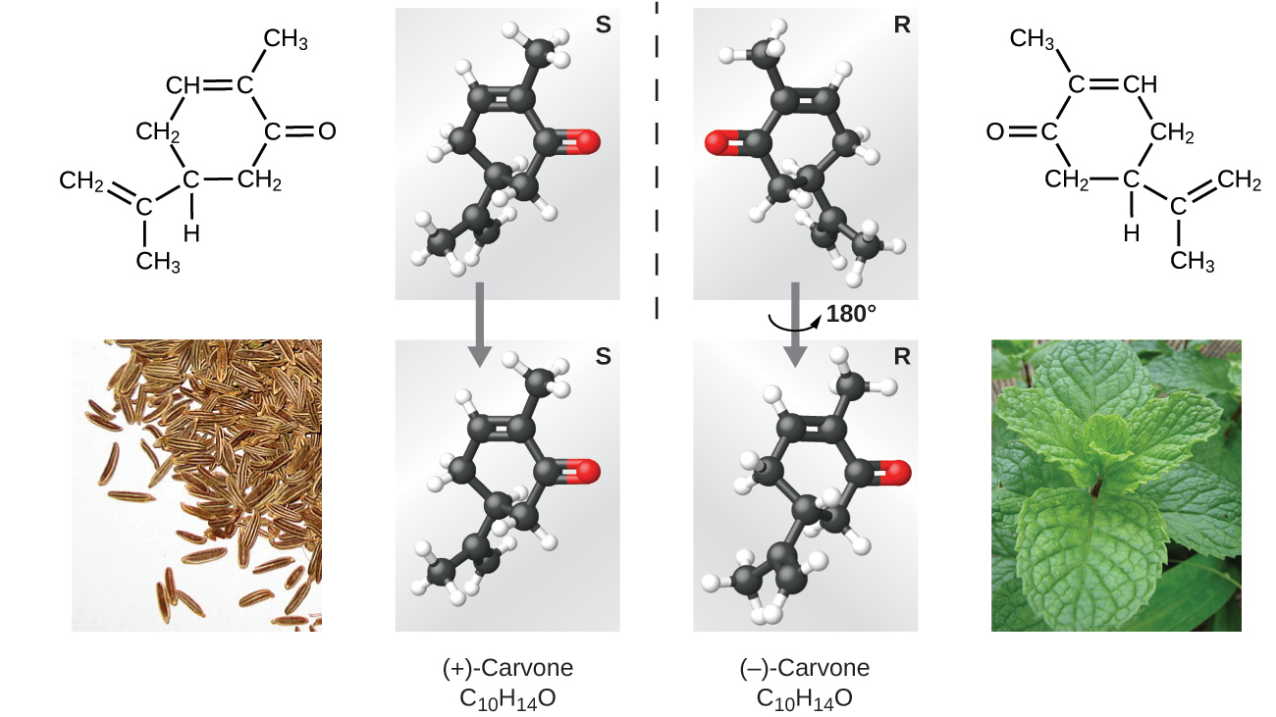
Figure 2.24 Molecules of carvone are spatial isomers; they only differ in the relative orientations of the atoms in space. (credit bottom left: modification of work by “Miansari66”/Wikimedia Commons; credit bottom right: modification of work by Forest & Kim Starr)

Link to Learning
Select this link to view an explanation of isomers, spatial isomers, and why they have different smells (select the video titled “Mirror Molecule: Carvone”).

