4.1 Writing and Balancing Chemical Equations

Learning Objectives
By the end of this section, you will be able to:
- Derive chemical equations from narrative descriptions of chemical reactions.
- Write and balance chemical equations in molecular, total ionic, and net ionic formats.
An earlier chapter of this text introduced the use of element symbols to represent individual atoms. When atoms gain or lose electrons to yield ions, or combine with other atoms to form molecules, their symbols are modified or combined to generate chemical formulas that appropriately represent these species. Extending this symbolism to represent both the identities and the relative quantities of substances undergoing a chemical (or physical) change involves writing and balancing a chemical equation. Consider as an example the reaction between one methane molecule (CH₄) and two diatomic oxygen molecules (O₂) to produce one carbon dioxide molecule (CO₂) and two water molecules (H₂O). The chemical equation representing this process is provided in the upper half of Figure 4.2, with space-filling molecular models shown in the lower half of the figure.
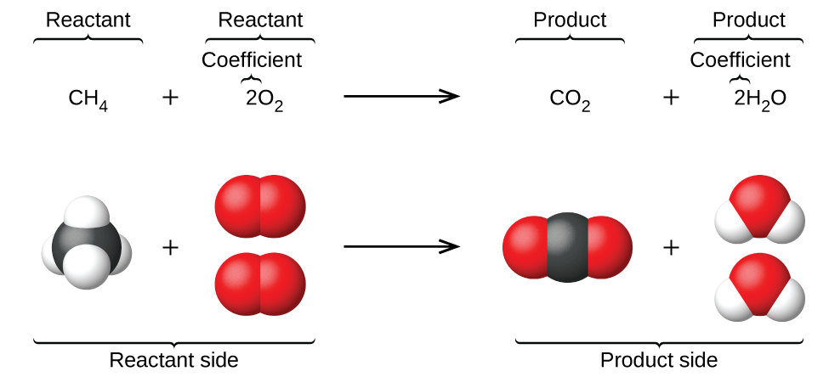
Figure 4.2 The reaction between methane and oxygen to yield carbon dioxide and water (shown at bottom) may be represented by a chemical equation using formulas (top).
This example illustrates the fundamental aspects of any chemical equation:
- The substances undergoing reaction are called reactants, and their formulas are placed on the left side of the equation.
- The substances generated by the reaction are called products, and their formulas are placed on the right side of the equation.
- Plus signs (+) separate individual reactant and product formulas, and an arrow $\text{(⟶)}$ separates the reactant and product (left and right) sides of the equation.
- The relative numbers of reactant and product species are represented by coefficients (numbers placed immediately to the left of each formula). A coefficient of 1 is typically omitted.
It is common practice to use the smallest possible whole-number coefficients in a chemical equation, as is done in this example. Realize, however, that these coefficients represent the relative numbers of reactants and products, and, therefore, they may be correctly interpreted as ratios. Methane and oxygen react to yield carbon dioxide and water in a 1:2:1:2 ratio. This ratio is satisfied if the numbers of these molecules are, respectively, 1-2-1-2, or 2-4-2-4, or 3-6-3-6, and so on (Figure 4.3). Likewise, these coefficients may be interpreted with regard to any amount (number) unit, and so this equation may be correctly read in many ways, including:
- One methane molecule and two oxygen molecules react to yield one carbon dioxide molecule and two water molecules.
- One dozen methane molecules and two dozen oxygen molecules react to yield one dozen carbon dioxide molecules and two dozen water molecules.
- One mole of methane molecules and 2 moles of oxygen molecules react to yield 1 mole of carbon dioxide molecules and 2 moles of water molecules.
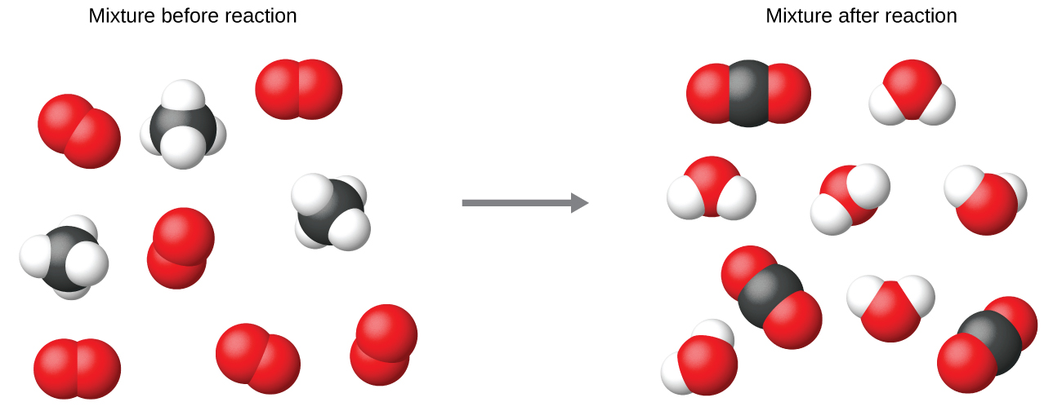
Figure 4.3 Regardless of the absolute numbers of molecules involved, the ratios between numbers of molecules of each species that react (the reactants) and molecules of each species that form (the products) are the same and are given by the chemical reaction equation.

Balancing Equations
The chemical equation described in section 4.1 is balanced, meaning that equal numbers of atoms for each element involved in the reaction are represented on the reactant and product sides. This is a requirement the equation must satisfy to be consistent with the law of conservation of matter. It may be confirmed by simply summing the numbers of atoms on either side of the arrow and comparing these sums to ensure they are equal. Note that the number of atoms for a given element is calculated by multiplying the coefficient of any formula containing that element by the element’s subscript in the formula. If an element appears in more than one formula on a given side of the equation, the number of atoms represented in each must be computed and then added together. For example, both product species in the example reaction, CO₂ and H₂O, contain the element oxygen, and so the number of oxygen atoms on the product side of the equation is
$\left(1 {\text{CO}}_{2} \text{molecule} × \frac{\text{2 O atoms}}{{\text{CO}}_{2} \text{molecule}}\right) + \left(2 {\text{H}}_{2}\text{O molecules} × \frac{\text{1 O atom}}{{\text{H}}_{2}\text{O molecule} }\right) = \text{4 O atoms}$
The equation for the reaction between methane and oxygen to yield carbon dioxide and water is confirmed to be balanced per this approach, as shown here:
${\text{CH}}_{4}+2{\text{O}}_{2} → {\text{CO}}_{2}+2{\text{H}}_{2}\text{O}$
Element | Reactants | Products | Balanced?
C | 1 $×$ 1 = 1 | 1 $×$ 1 = 1 | 1 = 1, yes
H | 4 $×$ 1 = 4 | 2 $×$ 2 = 4 | 4 = 4, yes
O | 2 $×$ 2 = 4 | (1 $×$ 2) + (2 $×$ 1) = 4 | 4 = 4, yes
A balanced chemical equation often may be derived from a qualitative description of some chemical reaction by a fairly simple approach known as balancing by inspection. Consider as an example the decomposition of water to yield molecular hydrogen and oxygen. This process is represented qualitatively by an unbalanced chemical equation:
${\text{H}}_{2}\text{O} → {\text{H}}_{2}+{\text{O}}_{2} \text{(unbalanced)}$
Comparing the number of H and O atoms on either side of this equation confirms its imbalance:
Element | Reactants | Products | Balanced?
H | 1 $×$ 2 = 2 | 1 $×$ 2 = 2 | 2 = 2, yes
O | 1 $×$ 1 = 1 | 1 $×$ 2 = 2 | 1 ≠ 2, no
The numbers of H atoms on the reactant and product sides of the equation are equal, but the numbers of O atoms are not. To achieve balance, the coefficients of the equation may be changed as needed. Keep in mind, of course, that the formula subscripts define, in part, the identity of the substance, and so these cannot be changed without altering the qualitative meaning of the equation. For example, changing the reactant formula from H₂O to H₂O₂ would yield balance in the number of atoms, but doing so also changes the reactant’s identity (it’s now hydrogen peroxide and not water). The O atom balance may be achieved by changing the coefficient for H₂O to 2.
$2{\text{H}}_{2}\text{O} → {\text{H}}_{2}+{\text{O}}_{2} \text{(unbalanced)}$
Element | Reactants | Products | Balanced?
H | 2 $×$ 2 = 4 | 1 $×$ 2 = 2 | 4 ≠ 2, no
O | 2 $×$ 1 = 2 | 1 $×$ 2 = 2 | 2 = 2, yes
The H atom balance was upset by this change, but it is easily reestablished by changing the coefficient for the H₂ product to 2.
$2{\text{H}}_{2}\text{O} → 2{\text{H}}_{2}+{\text{O}}_{2} \text{(balanced)}$
Element | Reactants | Products | Balanced?
H | 2 $×$ 2 = 4 | 2 $×$ 2 = 4 | 4 = 4, yes
O | 2 $×$ 1 = 2 | 1 $×$ 2 = 2 | 2 = 2, yes
These coefficients yield equal numbers of both H and O atoms on the reactant and product sides, and the balanced equation is, therefore:
$2{\text{H}}_{2}\text{O} → 2{\text{H}}_{2}+{\text{O}}_{2}$

Example 4.1

Balancing Chemical Equations
Write a balanced equation for the reaction of molecular nitrogen (N₂) and oxygen (O₂) to form dinitrogen pentoxide.

Solution
First, write the unbalanced equation.
${\text{N}}_{2}+ {\text{O}}_{2} → {\text{N}}_{2}{\text{O}}_{5} \text{(unbalanced)}$
Next, count the number of each type of atom present in the unbalanced equation.
Element | Reactants | Products | Balanced?
N | 1 $×$ 2 = 2 | 1 $×$ 2 = 2 | 2 = 2, yes
O | 1 $×$ 2 = 2 | 1 $×$ 5 = 5 | 2 ≠ 5, no
Though nitrogen is balanced, changes in coefficients are needed to balance the number of oxygen atoms. To balance the number of oxygen atoms, a reasonable first attempt would be to change the coefficients for the O₂ and N₂O₅ to integers that will yield 10 O atoms (the least common multiple for the O atom subscripts in these two formulas).
${\text{N}}_{2}+5{\text{O}}_{2} → 2{\text{N}}_{2}{\text{O}}_{5} \text{(unbalanced)}$
Element | Reactants | Products | Balanced?
N | 1 $×$ 2 = 2 | 2 $×$ 2 = 4 | 2 ≠ 4, no
O | 5 $×$ 2 = 10 | 2 $×$ 5 = 10 | 10 = 10, yes
The N atom balance has been upset by this change; it is restored by changing the coefficient for the reactant N₂ to 2.
$2{\text{N}}_{2}+5{\text{O}}_{2} → 2{\text{N}}_{2}{\text{O}}_{5}$
Element | Reactants | Products | Balanced?
N | 2 $×$ 2 = 4 | 2 $×$ 2 = 4 | 4 = 4, yes
O | 5 $×$ 2 = 10 | 2 $×$ 5 = 10 | 10 = 10, yes
The numbers of N and O atoms on either side of the equation are now equal, and so the equation is balanced.

Check Your Learning
Write a balanced equation for the decomposition of ammonium nitrate to form molecular nitrogen, molecular oxygen, and water. (Hint: Balance oxygen last, since it is present in more than one molecule on the right side of the equation.)

Answer:
$2{\text{NH}}_{4}{\text{NO}}_{3} → 2{\text{N}}_{2}+{\text{O}}_{2}+4{\text{H}}_{2}\text{O}$
It is sometimes convenient to use fractions instead of integers as intermediate coefficients in the process of balancing a chemical equation. When balance is achieved, all the equation’s coefficients may then be multiplied by a whole number to convert the fractional coefficients to integers without upsetting the atom balance. For example, consider the reaction of ethane (C₂H₆) with oxygen to yield H₂O and CO₂, represented by the unbalanced equation:
${\text{C}}_{2}{\text{H}}_{6}+{\text{O}}_{2} → {\text{H}}_{2}\text{O}+{\text{CO}}_{2} \text{(unbalanced)}$
Following the usual inspection approach, one might first balance C and H atoms by changing the coefficients for the two product species, as shown:
${\text{C}}_{2}{\text{H}}_{6}+{\text{O}}_{2} → 3{\text{H}}_{2}\text{O}+2{\text{CO}}_{2} \text{(unbalanced)}$
This results in seven O atoms on the product side of the equation, an odd number—no integer coefficient can be used with the O₂ reactant to yield an odd number, so a fractional coefficient, $\frac{7}{2},$ is used instead to yield a provisional balanced equation:
${\text{C}}_{2}{\text{H}}_{6}+ \frac{7}{2} {\text{O}}_{2} → 3{\text{H}}_{2}\text{O}+2{\text{CO}}_{2}$
A conventional balanced equation with integer-only coefficients is derived by multiplying each coefficient by 2:
$2{\text{C}}_{2}{\text{H}}_{6}+7{\text{O}}_{2} → 6{\text{H}}_{2}\text{O}+4{\text{CO}}_{2}$
Finally with regard to balanced equations, recall that convention dictates use of the smallest whole-number coefficients. Although the equation for the reaction between molecular nitrogen and molecular hydrogen to produce ammonia is, indeed, balanced,
$3{\text{N}}_{2}+9{\text{H}}_{2} → 6{\text{NH}}_{3}$
the coefficients are not the smallest possible integers representing the relative numbers of reactant and product molecules. Dividing each coefficient by the greatest common factor, 3, gives the preferred equation:
${\text{N}}_{2}+3{\text{H}}_{2} → 2{\text{NH}}_{3}$

Link to Learning
Use this interactive tutorial for additional practice balancing equations.

Additional Information in Chemical Equations
The physical states of reactants and products in chemical equations very often are indicated with a parenthetical abbreviation following the formulas. Common abbreviations include s for solids, l for liquids, g for gases, and aq for substances dissolved in water (aqueous solutions, as introduced in the preceding chapter). These notations are illustrated in the example equation here:
$2\text{Na}\left(s\right)+2{\text{H}}_{2}\text{O}\left(l\right) → 2\text{NaOH}\left(aq\right)+{\text{H}}_{2}\left(g\right)$
This equation represents the reaction that takes place when sodium metal is placed in water. The solid sodium reacts with liquid water to produce molecular hydrogen gas and the ionic compound sodium hydroxide (a solid in pure form, but readily dissolved in water).
Special conditions necessary for a reaction are sometimes designated by writing a word or symbol above or below the equation’s arrow. For example, a reaction carried out by heating may be indicated by the uppercase Greek letter delta (Δ) over the arrow.
${\text{CaCO}}_{3}\left(s\right) \overset{\text{Δ}}{→} \text{CaO}\left(s\right)+{\text{CO}}_{2}\left(g\right)$
Other examples of these special conditions will be encountered in more depth in later chapters.

Equations for Ionic Reactions
Given the abundance of water on earth, it stands to reason that a great many chemical reactions take place in aqueous media. When ions are involved in these reactions, the chemical equations may be written with various levels of detail appropriate to their intended use. To illustrate this, consider a reaction between ionic compounds taking place in an aqueous solution. When aqueous solutions of CaCl₂ and AgNO₃ are mixed, a reaction takes place producing aqueous Ca(NO₃)₂ and solid AgCl:
${\text{CaCl}}_{2}\left(aq\right)+2{\text{AgNO}}_{3}\left(aq\right) → \text{Ca}\left({\text{NO}}_{3}\right)​_{2}\left(aq\right)+2\text{AgCl}\left(s\right)$
This balanced equation, derived in the usual fashion, is called a molecular equation because it doesn’t explicitly represent the ionic species that are present in solution. When ionic compounds dissolve in water, they may dissociate into their constituent ions, which are subsequently dispersed homogenously throughout the resulting solution (a thorough discussion of this important process is provided in the chapter on solutions). Ionic compounds dissolved in water are, therefore, more realistically represented as dissociated ions, in this case:
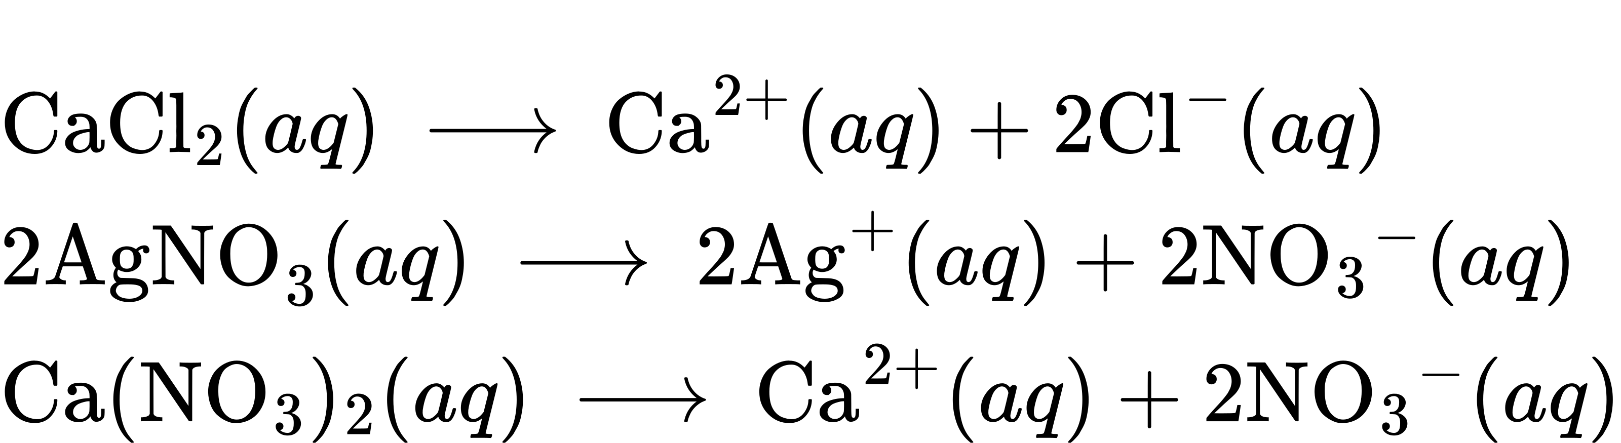
Unlike these three ionic compounds, AgCl does not dissolve in water to a significant extent, as signified by its physical state notation, s.
Explicitly representing all dissolved ions results in a complete ionic equation. In this particular case, the formulas for the dissolved ionic compounds are replaced by formulas for their dissociated ions:
${\text{Ca}}^{2+}\left(aq\right)+2{\text{Cl}}^{\text{−}}\left(aq\right)+2{\text{Ag}}^{\text{+}}\left(aq\right)+2{\text{NO}}_{3}​^{\text{−}}\left(aq\right) → {\text{Ca}}^{2+}\left(aq\right)+2{\text{NO}}_{3}​^{\text{−}}\left(aq\right)+2\text{AgCl}\left(s\right)$
Examining this equation shows that two chemical species are present in identical form on both sides of the arrow, Ca²⁺(aq) and ${\text{NO}}_{3}​^{\text{−}}\left(aq\right).$ These spectator ions—ions whose presence is required to maintain charge neutrality—are neither chemically nor physically changed by the process, and so they may be eliminated from the equation to yield a more succinct representation called a net ionic equation:
Following the convention of using the smallest possible integers as coefficients, this equation is then written:
${\text{Cl}}^{\text{−}}\left(aq\right)+{\text{Ag}}^{\text{+}}\left(aq\right) → \text{AgCl}\left(s\right)$
This net ionic equation indicates that solid silver chloride may be produced from dissolved chloride and silver(I) ions, regardless of the source of these ions. These molecular and complete ionic equations provide additional information, namely, the ionic compounds used as sources of Cl⁻ and Ag⁺.

Example 4.2

Ionic and Molecular Equations
When carbon dioxide is dissolved in an aqueous solution of sodium hydroxide, the mixture reacts to yield aqueous sodium carbonate and liquid water. Write balanced molecular, complete ionic, and net ionic equations for this process.

Solution
Begin by identifying formulas for the reactants and products and arranging them properly in chemical equation form:
${\text{CO}}_{2}\left(aq\right)+\text{NaOH}\left(aq\right) → {\text{Na}}_{2}{\text{CO}}_{3}\left(aq\right)+{\text{H}}_{2}\text{O}\left(l\right) \text{(unbalanced)}$
Balance is achieved easily in this case by changing the coefficient for NaOH to 2, resulting in the molecular equation for this reaction:
${\text{CO}}_{2}\left(aq\right)+2\text{NaOH}\left(aq\right) → {\text{Na}}_{2}{\text{CO}}_{3}\left(aq\right)+{\text{H}}_{2}\text{O}\left(l\right)$
The two dissolved ionic compounds, NaOH and Na₂CO₃, can be represented as dissociated ions to yield the complete ionic equation:
${\text{CO}}_{2}\left(aq\right)+2{\text{Na}}^{\text{+}}\left(aq\right)+2{\text{OH}}^{\text{−}}\left(aq\right) → 2{\text{Na}}^{\text{+}}\left(aq\right)+{\text{CO}}_{3}​^{2−}\left(aq\right)+{\text{H}}_{2}\text{O}\left(l\right)$
Finally, identify the spectator ion(s), in this case Na⁺(aq), and remove it from each side of the equation to generate the net ionic equation:

Check Your Learning
Diatomic chlorine and sodium hydroxide (lye) are commodity chemicals produced in large quantities, along with diatomic hydrogen, via the electrolysis of brine, according to the following unbalanced equation:
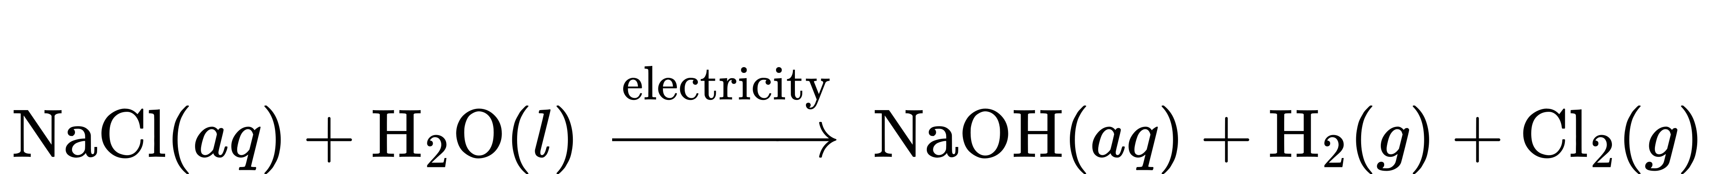
Write balanced molecular, complete ionic, and net ionic equations for this process.

Answer:
$2\text{NaCl}\left(aq\right)+2{\text{H}}_{2}\text{O}\left(l\right) → 2\text{NaOH}\left(aq\right)+{\text{H}}_{2}\left(g\right)+{\text{Cl}}_{2}\left(g\right) \left(\text{molecular}\right)$
$2{\text{Na}}^{\text{+}}\left(aq\right)+2{\text{Cl}}^{\text{−}}\left(aq\right)+2{\text{H}}_{2}\text{O}\left(l\right) → 2{\text{Na}}^{\text{+}}\left(aq\right)+2{\text{OH}}^{\text{−}}\left(aq\right)+{\text{H}}_{2}\left(g\right)+{\text{Cl}}_{2}\left(g\right) \left(\text{complete ionic}\right)$
$2{\text{Cl}}^{\text{−}}\left(aq\right)+2{\text{H}}_{2}\text{O}\left(l\right) → 2{\text{OH}}^{\text{−}}\left(aq\right)+{\text{H}}_{2}\left(g\right)+{\text{Cl}}_{2}\left(g\right) \text{(net ionic)}$

