3.4 Other Units for Solution Concentrations

Learning Objectives
By the end of this section, you will be able to:
- Define the concentration units of mass percentage, volume percentage, mass-volume percentage, parts-per-million (ppm), and parts-per-billion (ppb)
- Perform computations relating a solution’s concentration and its components’ volumes and/or masses using these units
The previous section introduced molarity, a very useful measurement unit for evaluating the concentration of solutions. However, molarity is only one measure of concentration. This section will describe some other units of concentration that are commonly used in various applications, either for convenience or by convention.

Mass Percentage
Earlier in this chapter, percent composition was introduced as a measure of the relative amount of a given element in a compound. Percentages are also commonly used to express the composition of mixtures, including solutions. The mass percentage of a solution component is defined as the ratio of the component’s mass to the solution’s mass, expressed as a percentage:
$\text{mass percentage}= \frac{\text{mass of component}}{\text{mass of solution}} × 100\%$
Mass percentage is also referred to by similar names such as percent mass, percent weight, weight/weight percent, and other variations on this theme. The most common symbol for mass percentage is simply the percent sign, %, although more detailed symbols are often used including %mass, %weight, and (w/w)%. Use of these more detailed symbols can prevent confusion of mass percentages with other types of percentages, such as volume percentages (to be discussed later in this section).
Mass percentages are popular concentration units for consumer products. The label of a typical liquid bleach bottle (Figure 3.17) cites the concentration of its active ingredient, sodium hypochlorite (NaOCl), as being 7.4%. A 100.0-g sample of bleach would therefore contain 7.4 g of NaOCl.
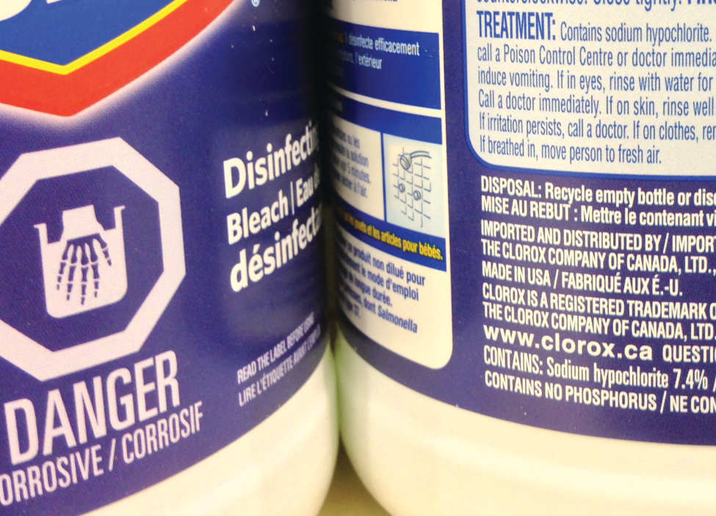
Figure 3.17 Liquid bleach is an aqueous solution of sodium hypochlorite (NaOCl). This brand has a concentration of 7.4% NaOCl by mass.

Example 3.22

Calculation of Percent by Mass
A 5.0-g sample of spinal fluid contains 3.75 mg (0.00375 g) of glucose. What is the percent by mass of glucose in spinal fluid?

Solution
The spinal fluid sample contains roughly 4 mg of glucose in 5000 mg of fluid, so the mass fraction of glucose should be a bit less than one part in 1000, or about 0.1%. Substituting the given masses into the equation defining mass percentage yields:
$\% \text{glucose}= \frac{3.75 \text{mg glucose} × \frac{1 \text{g}}{1000 \text{mg}} }{5.0 \text{g spinal fluid}} =0.075\%$
The computed mass percentage agrees with our rough estimate (it’s a bit less than 0.1%).
Note that while any mass unit may be used to compute a mass percentage (mg, g, kg, oz, and so on), the same unit must be used for both the solute and the solution so that the mass units cancel, yielding a dimensionless ratio. In this case, the solute mass unit in the numerator was converted from mg to g to match the units in the denominator. Alternatively, the spinal fluid mass unit in the denominator could have been converted from g to mg instead. As long as identical mass units are used for both solute and solution, the computed mass percentage will be correct.

Check Your Learning
A bottle of a tile cleanser contains 135 g of HCl and 775 g of water. What is the percent by mass of HCl in this cleanser?

Answer:
14.8%

Example 3.23

Calculations using Mass Percentage
“Concentrated” hydrochloric acid is an aqueous solution of 37.2% HCl that is commonly used as a laboratory reagent. The density of this solution is 1.19 g/mL. What mass of HCl is contained in 0.500 L of this solution?

Solution
The HCl concentration is near 40%, so a 100-g portion of this solution would contain about 40 g of HCl. Since the solution density isn’t greatly different from that of water (1 g/mL), a reasonable estimate of the HCl mass in 500 g (0.5 L) of the solution is about five times greater than that in a 100 g portion, or 5 $×$ 40 = 200 g. In order to derive the mass of solute in a solution from its mass percentage, the mass of the solution must be known. Using the solution density given, convert the solution’s volume to mass, and then use the given mass percentage to calculate the solute mass. This mathematical approach is outlined in this flowchart: 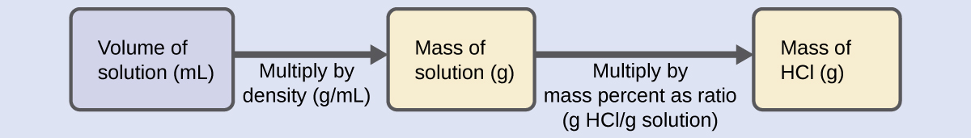
For proper unit cancellation, the 0.500-L volume is converted into 500 mL, and the mass percentage is expressed as a ratio, 37.2 g HCl/g solution:
$\text{500 mL solution} \left(\frac{1.19 \text{g solution}}{\text{mL solution}}\right) \left(\frac{37.2 \text{g HCl}}{100 \text{g solution}}\right) = 221 \text{g HCl}$
This mass of HCl is consistent with our rough estimate of approximately 200 g.

Check Your Learning
What volume of concentrated HCl solution contains 125 g of HCl?

Answer:
282 mL

Volume Percentage
Liquid volumes over a wide range of magnitudes are conveniently measured using common and relatively inexpensive laboratory equipment. The concentration of a solution formed by dissolving a liquid solute in a liquid solvent is therefore often expressed as a volume percentage, %vol or (v/v)%:
$\text{volume percentage}= \frac{\text{volume solute}}{\text{volume solution}} × 100\%$

Example 3.24

Calculations using Volume Percentage
Rubbing alcohol (isopropanol) is usually sold as a 70%vol aqueous solution. If the density of isopropyl alcohol is 0.785 g/mL, how many grams of isopropyl alcohol are present in a 355 mL bottle of rubbing alcohol?

Solution
Per the definition of volume percentage, the isopropanol volume is 70% of the total solution volume. Multiplying the isopropanol volume by its density yields the requested mass:
$\left(355 \text{mL solution}\right) \left(\frac{70 \text{mL isopropyl alcohol}}{100 \text{mL solution}}\right) \left(\frac{0.785 \text{g isopropyl alcohol}}{1 \text{mL isopropyl alcohol}}\right) = 195 \text{g isopropyl alchol}$

Check Your Learning
Wine is approximately 12% ethanol (CH₃CH₂OH) by volume. Ethanol has a molar mass of 46.06 g/mol and a density 0.789 g/mL. How many moles of ethanol are present in a 750-mL bottle of wine?

Answer:
1.5 mol ethanol

Mass-Volume Percentage
“Mixed” percentage units, derived from the mass of solute and the volume of solution, are popular for certain biochemical and medical applications. A mass-volume percent is a ratio of a solute’s mass to the solution’s volume expressed as a percentage. The specific units used for solute mass and solution volume may vary, depending on the solution. For example, physiological saline solution, used to prepare intravenous fluids, has a concentration of 0.9% mass/volume (m/v), indicating that the composition is 0.9 g of solute per 100 mL of solution. The concentration of glucose in blood (commonly referred to as “blood sugar”) is also typically expressed in terms of a mass-volume ratio. Though not expressed explicitly as a percentage, its concentration is usually given in milligrams of glucose per deciliter (100 mL) of blood (Figure 3.18).
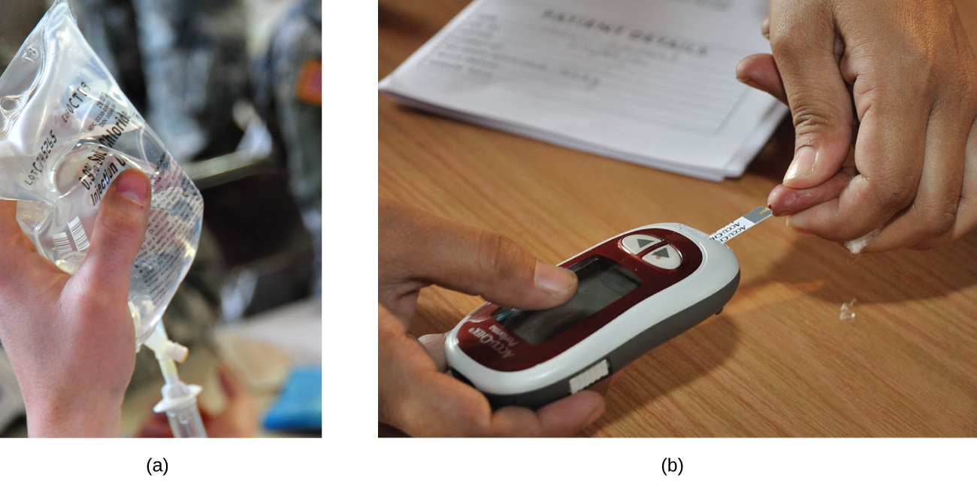
Figure 3.18 “Mixed” mass-volume units are commonly encountered in medical settings. (a) The NaCl concentration of physiological saline is 0.9% (m/v). (b) This device measures glucose levels in a sample of blood. The normal range for glucose concentration in blood (fasting) is around 70–100 mg/dL. (credit a: modification of work by “The National Guard”/Flickr; credit b: modification of work by Biswarup Ganguly)

Parts per Million and Parts per Billion
Very low solute concentrations are often expressed using appropriately small units such as parts per million (ppm) or parts per billion (ppb). Like percentage (“part per hundred”) units, ppm and ppb may be defined in terms of masses, volumes, or mixed mass-volume units. There are also ppm and ppb units defined with respect to numbers of atoms and molecules.
The mass-based definitions of ppm and ppb are given here:
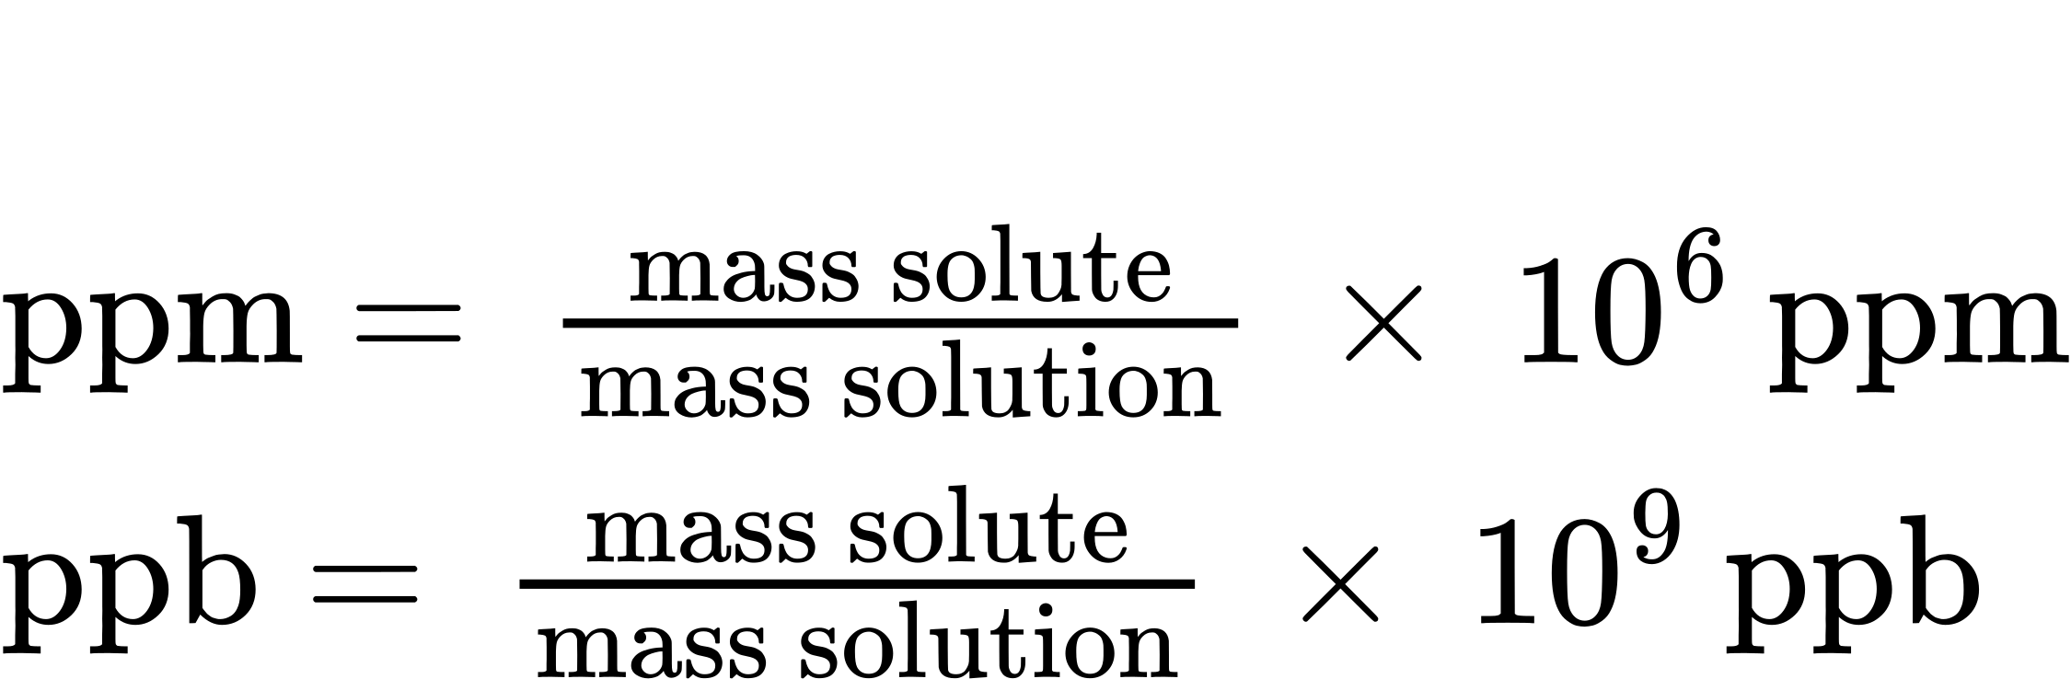
Both ppm and ppb are convenient units for reporting the concentrations of pollutants and other trace contaminants in water. Concentrations of these contaminants are typically very low in treated and natural waters, and their levels cannot exceed relatively low concentration thresholds without causing adverse effects on health and wildlife. For example, the EPA has identified the maximum safe level of fluoride ion in tap water to be 4 ppm. Inline water filters are designed to reduce the concentration of fluoride and several other trace-level contaminants in tap water (Figure 3.19).
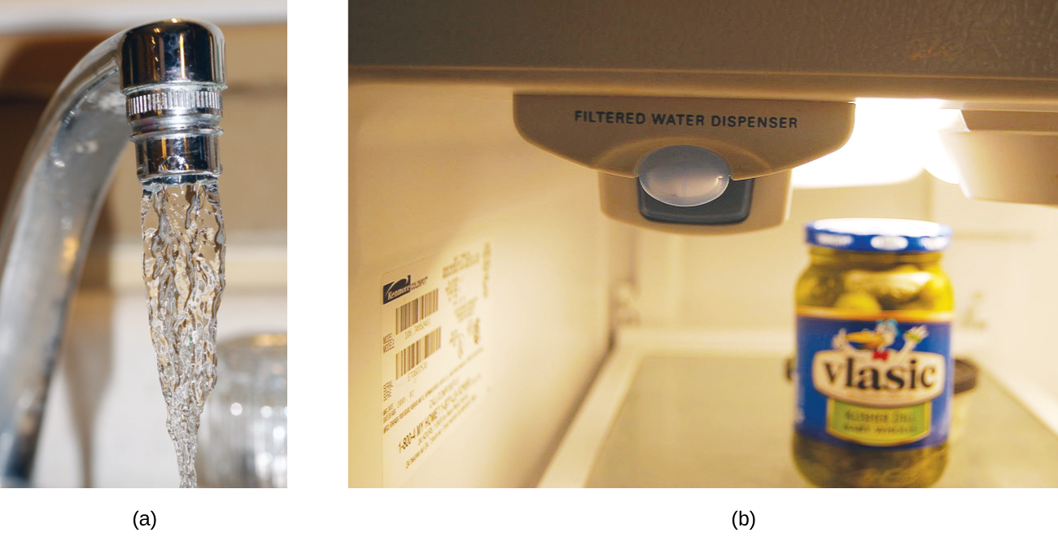
Figure 3.19 (a) In some areas, trace-level concentrations of contaminants can render unfiltered tap water unsafe for drinking and cooking. (b) Inline water filters reduce the concentration of solutes in tap water. (credit a: modification of work by Jenn Durfey; credit b: modification of work by “vastateparkstaff”/Wikimedia commons)

Example 3.25

Calculation of Parts per Million and Parts per Billion Concentrations
According to the EPA, when the concentration of lead in tap water reaches 15 ppb, certain remedial actions must be taken. What is this concentration in ppm? At this concentration, what mass of lead (μg) would be contained in a typical glass of water (300 mL)?

Solution
The definitions of the ppm and ppb units may be used to convert the given concentration from ppb to ppm. Comparing these two unit definitions shows that ppm is 1000 times greater than ppb (1 ppm = 10³ ppb). Thus:
$15 \text{ppb} × \frac{1 \text{ppm}}{{10}^{3} \text{ppb}} =0.015 \text{ppm}$
The definition of the ppb unit may be used to calculate the requested mass if the mass of the solution is provided. Since the volume of solution (300 mL) is given, its density must be used to derive the corresponding mass. Assume the density of tap water to be roughly the same as that of pure water (~1.00 g/mL), since the concentrations of any dissolved substances should not be very large. Rearranging the equation defining the ppb unit and substituting the given quantities yields:
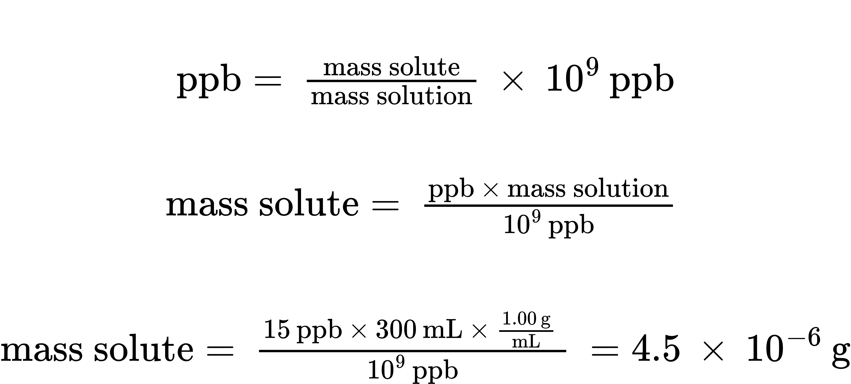
Finally, convert this mass to the requested unit of micrograms:
$4.5 × {10}^{−6} \text{g} × \frac{1 \text{μg}}{{10}^{−6} \text{g}} =4.5 \text{μg}$

Check Your Learning
A 50.0-g sample of industrial wastewater was determined to contain 0.48 mg of mercury. Express the mercury concentration of the wastewater in ppm and ppb units.

Answer:
9.6 ppm, 9600 ppb

