Appendix E Water Properties
Water Density (g/mL) at Different Temperatures (°C)
Temperature | Density (g/mL)
0 | 0.9998395
4 | 0.9999720 (density maximum)
10 | 0.9997026
15 | 0.9991026
20 | 0.9982071
22 | 0.9977735
25 | 0.9970479
30 | 0.9956502
40 | 0.9922
60 | 0.9832
80 | 0.9718
100 | 0.9584
Table E1
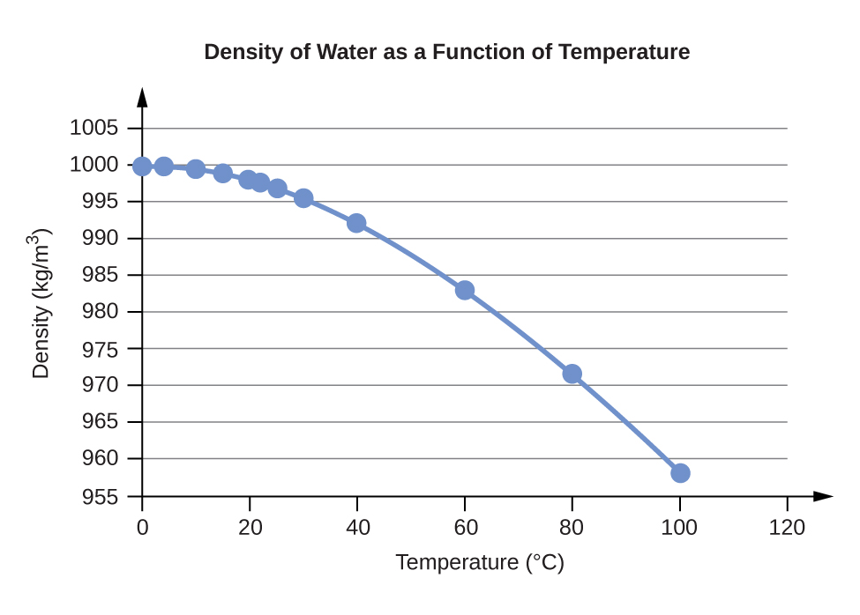
Water Vapor Pressure at Different Temperatures (°C)
Temperature | Vapor Pressure (torr) | Vapor Pressure (Pa)
0 | 4.6 | 613.2812
4 | 6.1 | 813.2642
10 | 9.2 | 1226.562
15 | 12.8 | 1706.522
20 | 17.5 | 2333.135
22 | 19.8 | 2639.776
25 | 23.8 | 3173.064
30 | 31.8 | 4239.64
35 | 42.2 | 5626.188
40 | 55.3 | 7372.707
45 | 71.9 | 9585.852
50 | 92.5 | 12332.29
55 | 118.0 | 15732
60 | 149.4 | 19918.31
65 | 187.5 | 24997.88
70 | 233.7 | 31157.35
75 | 289.1 | 38543.39
80 | 355.1 | 47342.64
85 | 433.6 | 57808.42
90 | 525.8 | 70100.71
95 | 633.9 | 84512.82
100 | 760.0 | 101324.7
Table E2
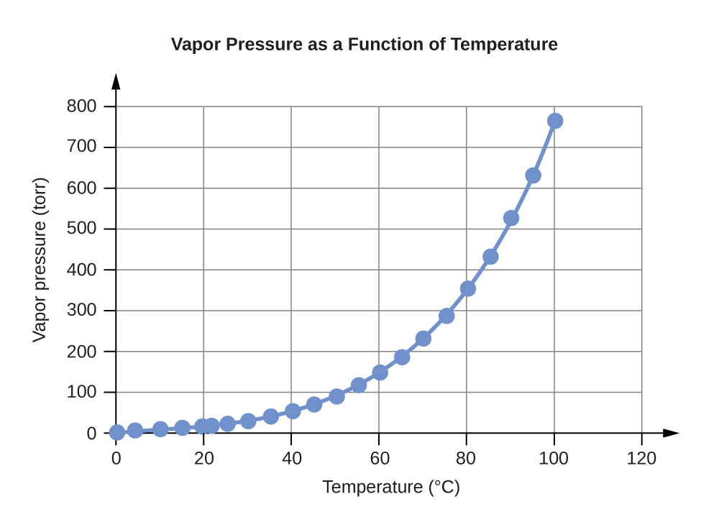
Water K_{w} and pK_{w} at Different Temperatures (°C)
Temperature | K_{w} 10^{–14} | pK_{w}1  1  pK_{w} = –log₁₀(K_{w})
0 | 0.112 | 14.95
5 | 0.182 | 14.74
10 | 0.288 | 14.54
15 | 0.465 | 14.33
20 | 0.671 | 14.17
25 | 0.991 | 14.00
30 | 1.432 | 13.84
35 | 2.042 | 13.69
40 | 2.851 | 13.55
45 | 3.917 | 13.41
50 | 5.297 | 13.28
55 | 7.080 | 13.15
60 | 9.311 | 13.03
75 | 19.95 | 12.70
100 | 56.23 | 12.25
Table E3
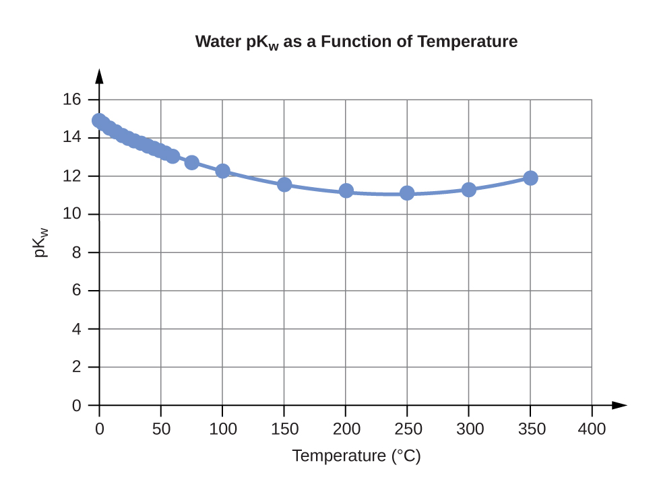
Specific Heat Capacity for Water
C°(H₂O(l)) = 4.184 J∙g⁻¹∙°C⁻¹
C°(H₂O(s)) = 2.093 J∙g⁻¹∙C⁻¹
C°(H₂O(g)) = 1.864 J∙g⁻¹∙C⁻¹
Table E4
Standard Water Melting and Boiling Temperatures and Enthalpies of the Transitions
 | Temperature (K) | ΔH (kJ/mol)
melting | 273.15 | 6.088
boiling | 373.15 | 40.656 (44.016 at 298 K)
Table E5
Water Cryoscopic (Freezing Point Depression) and Ebullioscopic (Boiling Point Elevation) Constants
K_{f} = 1.86°C∙kg∙mol⁻¹ (cryoscopic constant)
K_{b} = 0.51°C∙kg∙mol⁻¹ (ebullioscopic constant)
Table E6
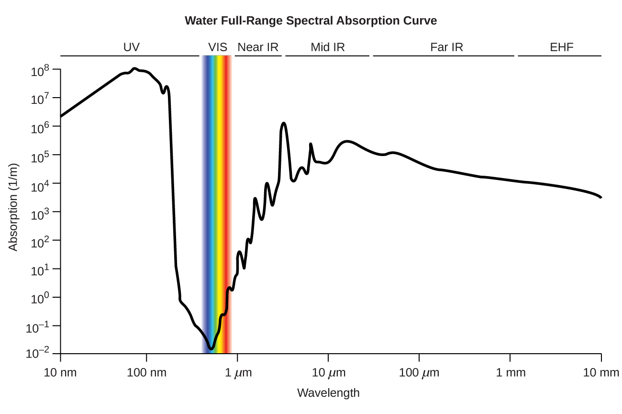
Figure E1 The plot shows the extent of light absorption versus wavelength for water. Absorption is reported in reciprocal meters and corresponds to the inverse of the distance light may travel through water before its intensity is diminished by 1/e (~37%).

