Appendix H Ionization Constants of Weak Acids
Ionization Constants of Weak Acids
Acid | Formula | K_{a} at 25 °C | Lewis Structure
acetic | CH₃CO₂H | 1.8 $×$ 10⁻⁵ | 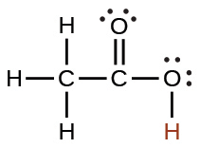
arsenic | H₃AsO₄ | 5.5 $×$ 10⁻³ | 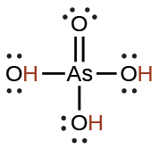
arsenic | 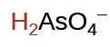 | 1.7 $×$ 10⁻⁷
arsenic | 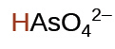 | 3.0 $×$ 10⁻¹²
arsenous | H₃AsO₃ | 5.1 $×$ 10⁻¹⁰ | 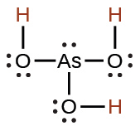
boric | H₃BO₃ | 5.4 $×$ 10⁻¹⁰ | 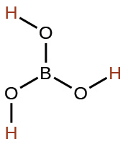
carbonic | H₂CO₃ | 4.3 $×$ 10⁻⁷ | 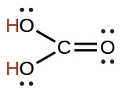
carbonic | 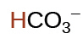 | 4.7 $×$ 10⁻¹¹
formic | HCO₂H | 1.8 $×$ 10⁻⁴ | 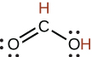
hydrazoic | HN₃ | 2.5 $×$ 10⁻⁵ | 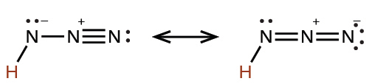
hydrocyanic | HCN | 4.9 $×$ 10⁻¹⁰
hydrofluoric | HF | 6.4 $×$ 10⁻⁴
hydrogen peroxide | H₂O₂ | 2.4 $×$ 10⁻¹² | 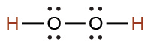
hydrogen selenide | H₂Se | 1.29 $×$ 10⁻⁴
hydrogen selenide | HSe– | 1 $×$ 10⁻¹²
hydrogen sulfate ion | 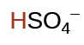 | 1.2 $×$ 10⁻² | 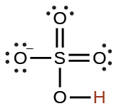
hydrogen sulfide | H₂S | 8.9 $×$ 10⁻⁸
hydrogen sulfide | HS– | 1.0 $×$ 10⁻¹⁹
hydrogen telluride | H₂Te | 2.3 $×$ 10⁻³
hydrogen telluride | HTe– | 1.6 $×$ 10⁻¹¹
hypobromous | HBrO | 2.8 $×$ 10⁻⁹
hypochlorous | HClO | 2.9 $×$ 10⁻⁸
isocyanic | HCNO | 2 $×$ 10⁻⁴ | 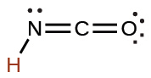
nitrous | HNO₂ | 4.6 $×$ 10⁻⁴ | 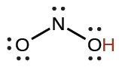
oxalic | H₂C₂O₄ | 6.0 $×$ 10⁻² | 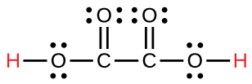
oxalic | 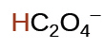 | 6.1 $×$ 10⁻⁵
phosphoric | H₃PO₄ | 7.5 $×$ 10⁻³ | 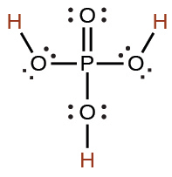
phosphoric | 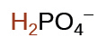 | 6.2 $×$ 10⁻⁸
phosphoric | 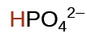 | 4.2 $×$ 10⁻¹³
phosphorous | H₃PO₃ | 5 $×$ 10⁻² | 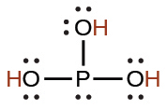
phosphorous | 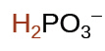 | 2.0 $×$ 10⁻⁷
sulfurous | H₂SO₃ | 1.6 $×$ 10⁻² | 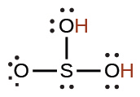
sulfurous | 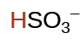 | 6.4 $×$ 10⁻⁸
Table H1

