Appendix I Ionization Constants of Weak Bases
Ionization Constants of Weak Bases
Base | Lewis Structure | K_{b} at 25 °C
ammonia | 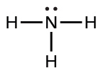 | 1.8 $×$ 10⁻⁵
dimethylamine | 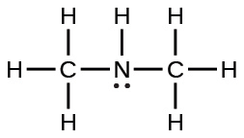 | 5.9 $×$ 10⁻⁴
methylamine | 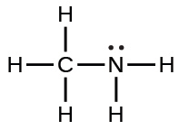 | 4.4 $×$ 10⁻⁴
phenylamine (aniline) | 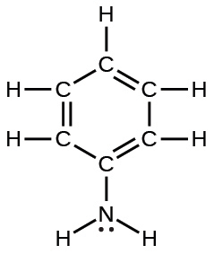 | 4.3 $×$ 10⁻¹⁰
trimethylamine | 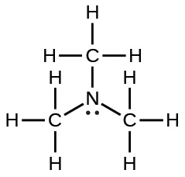 | 6.3 $×$ 10⁻⁵
Table I1

